Batch: B2 Roll No.: 16010122158

Experiment / assignment / tutorial No. 7

Grade: AA / AB / BB / BC / CC / CD /DD

Signature of the Staff In-charge with date

Title: Implementation of BST & Binary tree traversal techniques.

Objective: To Understand and Implement Binary Search Tree, Preorder, Postorder and Inorder Traversal Techniques.

Expected Outcome of Experiment:

CO | Outcome
1 | Explain the different data structures used in problem solving

Books/ Journals/ Websites referred:
- Fundamentals Of Data Structures In C – Ellis Horowitz, Satraj Sahni, Susan Anderson-Fred
- An Introduction to data structures with applications – Jean Paul Tremblay,
Paul G. Sorenson
- Data Structures A Pseudo Approach with C – Richard F. Gilberg & Behrouz A. Forouzan
- https://www.geeksforgeeks.org/binary-tree-data-structure/
- https://www.thecrazyprogrammer.com/2015/03/c-program-for-binary-search-tree-insertion.html

Abstract:
A tree is a non- linear data structure used to represent hierarchical relationship existing among several data items. It is a finite set of one or more data items such that, there is a special data item called the root of the tree. Its remaining data items are partitioned into number of mutually exclusive subsets, each of which is itself a tree, and they are called subtrees.

A binary tree is a finite set of nodes. It is either empty or It consists a node called root with two disjoint binary trees-Left subtree, Right subtree. The Maximum degree of any node is 2
A Binary Search Tree is a node-based binary tree data structure in which the left subtree of a node contains only nodes with keys lesser than the node’s key. The right subtree of a node contains only nodes with keys greater than the node’s key. The left and right subtree each must also be a binary search tree.
Related Theory: -
Unlike linear data structures (Array, Linked List, Queues, Stacks, etc) which have only one logical way to traverse them, trees can be traversed in different ways. The following are the generally used methods for traversing trees:

Pre-order Traversal of BST
Also known as NLR traversal.
Pre order traversal is used to create a copy of the tree. Pre order traversal is also used to get prefix expressions on an expression tree.

Post-order Traversal of BST
Also known as LRN traversal.
Post order traversal is used to delete the tree. Post order traversal is also useful to get the postfix expression of an expression tree.

In-order Traversal of BST
Also known as LNR traversal.
In the case of binary search trees (BST), In order traversal gives nodes in non-decreasing order. To get nodes of BST in non-increasing order, a variation of In order traversal where In order traversal is reversed can be used.

Diagram for Traversal of BST:
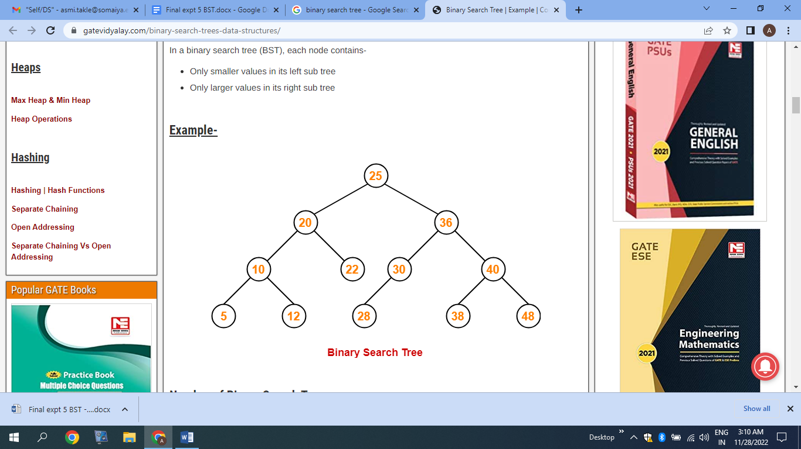

Pre-order Traversal:
25, 20, 10, 5, 12, 22, 36, 30, 28, 40, 38, 48

Post-order Traversal of BST
5, 12, 10, 22, 20, 28, 30, 38, 48, 40, 36, 25

In-order Traversal of BST
5, 10, 12, 20, 22, 25, 28, 30, 36, 38, 40, 48

Algorithm for Implementation of BST & Binary tree traversal techniques:
Pre-order:
- Visit the root.
- Traverse the left subtree, i.e., call Preorder(left->subtree)
- Traverse the right subtree, i.e., call Preorder(right->subtree)
{
If t! =0 then
{
Visit(t);
Preorder(t->lchild);
Preorder(t->rchild);
}
}

Post-order:
- Traverse the left subtree, i.e., call Postorder(left->subtree)
- Traverse the right subtree, i.e., call Postorder(right->subtree)
- Visit the root
{
If t! =0 then
{
Postorder(t->lchild);
Postorder(t->rchild);
Visit(t);
}
}

In-order:
- Traverse the left subtree, i.e., call Inorder(left->subtree)
- Visit the root.
- Traverse the right subtree, i.e., call Inorder(right->subtree)
{
If t! =0 then
{
Inorder(t->lchild);
Visit(t);
Inorder(t->rchild);
}
}

Implementation Details:
Enlist all the Steps followed and various options explored.
- Created a binary search tree according to input from user.
- Traversed the created binary tree by
- Pre order Traversal
- Post order Traversal
- In order Traversal

Assumptions made for Input:
The tree traversed is a perfect binary tree.
Program source code for Implementation of BST & Binary tree traversal techniques:

Output Screenshots for Each Operation:
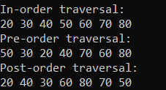
Conclusion:
Successfully implemented.
Understood and implemented Binary Search Tree and Preorder, Postorder and Inorder Traversal Techniques.
A tree is a non- linear data structure used to represent hierarchical relationship existing among several data items.

PostLab Questions:
- Illustrate 2 Applications of Trees.
- Binary Expression Trees
A binary tree used to evaluate an expression. The operators are stored at the interior node and the operands are stored at the leaf node.
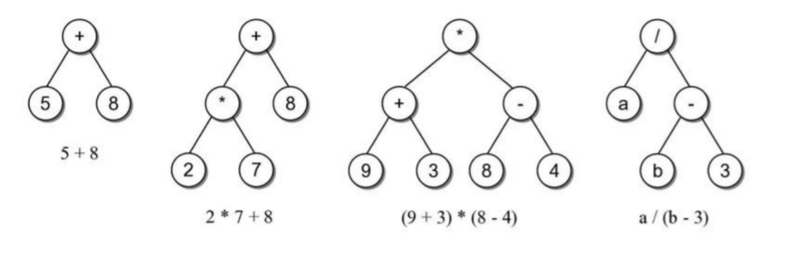
- Working with Morse Code
The organization of morse code is done in the form of a binary tree.
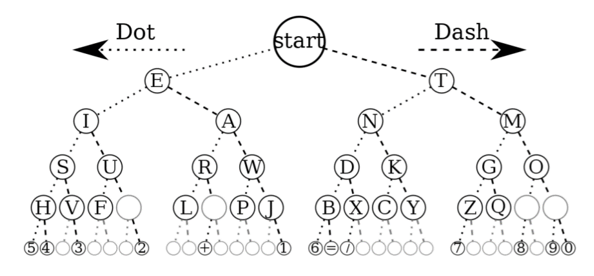

- Compare and Contrast between B Tree and B+ Tree?
B-Tree is known as a self-balancing tree as its nodes are sorted in the inorder traversal. In B-tree, a node can have more than two children. B-tree has a height of logM N (Where ‘M’ is the order of tree and N is the number of nodes). And the height is adjusted automatically at each update. In the B-tree data is sorted in a specific order, with the lowest value on the left and the highest value on the right. To insert the data or key in B-tree is more complicated than a binary tree. Some conditions must be held by the B-Tree:
- All the leaf nodes of the B-tree must be at the same level.
- Above the leaf nodes of the B-tree, there should be no empty sub-trees.
- B- tree’s height should lie as low as possible.

B+ tree eliminates the drawback B-tree used for indexing by storing data pointers only at the leaf nodes of the tree. Thus, the structure of leaf nodes of a B+ tree is quite different from the structure of internal nodes of the B tree. It may be noted here that, since data pointers are present only at the leaf nodes, the leaf nodes must necessarily store all the key values along with their corresponding data pointers to the disk file block, to access them. Moreover, the leaf nodes are linked to providing ordered access to the records. The leaf nodes, therefore form the first level of the index, with the internal nodes forming the other levels of a multilevel index. Some of the key values of the leaf nodes also appear in the internal nodes, to simply act as a medium to control the searching of a record.
Basis of Comparision | B tree | B+ tree
Pointers | All internal and leaf nodes have data pointers | Only leaf nodes have data pointers
Search | Since all keys are not available at leaf, search often takes more time. | All keys are at leaf nodes, hence search is faster and more accurate.
Redundant Keys | No duplicate of keys is maintained in the tree. | Duplicate of keys are maintained and all nodes are present at the leaf.
Insertion | Insertion takes more time and it is not predictable sometimes. | Insertion is easier and the results are always the same.
Deletion | Deletion of the internal node is very complex and the tree has to undergo a lot of transformations. | Deletion of any node is easy because all node are found at leaf.
Leaf Nodes | Leaf nodes are not stored as structural linked list. | Leaf nodes are stored as structural linked list.
Access | Sequential access to nodes is not possible | Sequential access is possible just like linked list
Height | For a particular number nodes height is larger | Height is lesser than B tree for the same number of nodes
Application | B-Trees used in Databases, Search engines | B+ Trees used in Multilevel Indexing, Database indexing
Number of Nodes | Number of nodes at any intermediary level ‘l’ is 2^{l}. | Each intermediary node can have n/2 to n children.

