Structure name or Structure Tag
Structure elements or members
Structure Definition or Template: defines a format called template to represent information.
Template is terminated with semicolon.
Structure Variable

SYNTAX:

struct tagname
{
datatype member1;
datatype member2;
--- ----
datatype member;
};

Declaring Structure Variables:
Structure tag

1) struct book
Structure members
{
char name[20] ;
float price ;
int pages ;
Structure variables
} ;
struct book b1, b2, b3 ;

2) struct book
{
char name[20] ;
float price ;
int pages ;
} b1, b2, b3 ;

Type-Defined Structures:
1)typedef struct Books {
char title[50];
char author[50];
char subject[100];
int book_id;
} Book;
Book b1,b2;

2) struct Books {
char title[50];
char author[50];
char subject[100];
int book_id;
};
Struct Books b1,b2;

3) typedef struct
{int x;
int y;
}Dot;
Dot left,right;

STRUCTURE INITIALIZATION
1)struct tablets
{
int count;
float average_weight;
int m_date,m_month,m_year;
int ex_date,ex_month,ex_year;
}batch1={2000,25.3,07,11,2004};
int main()
{
printf(“\n count=%d,av_wt=%f”,batch1.count,batch1.average_weight);
printf(“\nmfg-date=%d/%d/%d”,batch1.m_date,batch1.m_month,batch1.m_year);
printf("\nexp-date=%d/%d/%d", batch1.ex_date, batch1.ex_month, batch1.ex_year);
return 0;
}
O/P-
Count=2000,av_wt=25.3
mfg-date=7/11/2004
exp-date=0/0/0

Partial Initialization-There are eight members in the structure whereas there are 5 initializing constants. The remaining members are assigned the default value of zero.

2)#include <stdio.h>
struct tablets
{
int count;
float average_weight;
int m_date, m_month, m_year;
int ex_date, ex_month, ex_year;
};
struct tablets batch1={2000,25.3,07,11,2004,06,10,2007};
int main()
{
printf("\ncount=%d, av_wt=%f mg.",batch1.count, batch1.average_weight);
printf("\nmfg-date= %d/%d/%d",batch1.m_date,batch1.m_month, batch1.m_year);
printf("\nexp-date= %d/%d/%d",batch1.ex_date,batch1.ex_month, batch1.ex_year);
return 0;
}
O/P-
Count=2000,av_wt=25.3
mfg-date=7/11/2004
exp-date=6/10/2007

3) struct games_ticket
{
int value=500;
int seat_num=52;
int date,month,year;
}fan1;

The initialization statements inside the struct template are not permitted in C.
The structure tag i.e games_ticket is not a variable name. It is just a name given to the structure template. The statement games_ticket.value=500; will cause the compiler to generate an error.

DEFINING AND ASSIGNING VALUES TO STRUCTURE MEMBERS
Program
struct personal
{
char name[20];
int day;
char month[10];
int year;
float salary;
};
Structure variable name
main()
{
struct personal person;
printf("Input Values\n");
scanf("%s %d %s %d %f",person.name,&person.day,person.month,
&person.year,&person.salary);
printf("%s %d %s %d %f\n",person.name,person.day,person.month, person.year,person.salary);
}
Accessing structure elements
Create a structure to specify data on books given below: name,price,pages.
Input the data for 3 books from the user and print it.

main( )
{
struct book
{
char name[20] ;
float price ;
NO &
int pages ;
} ;
struct book b1, b2, b3 ;
printf ( "\nEnter names, prices & no. of pages of 3 books\n" ) ;
scanf ( "%s %f %d", b1.name, &b1.price, &b1.pages ) ;
scanf ( "%s %f %d",b2.name, &b2.price, &b2.pages ) ;
scanf ( "%s %f %d",b3.name, &b3.price, &b3.pages ) ;
printf ( "\nAnd this is what you entered" ) ;
printf ( "\n%s %f %d", b1.name, b1.price, b1.pages ) ;
printf ( "\n%s %f %d", b2.name, b2.price, b2.pages ) ;
printf ( "\n%s %f %d", b3.name, b3.price, b3.pages ) ;
}
And here is the output...
Enter names, prices and no. of pages of 3 books
And this is what you entered
Abc 100.00 354
Csd 256.50 682
Fgh 233.70 512
WAP that prints x-y coordinates of the two ends of a line segment using structures.
#include<stdio.h>
typedef struct
{int x;
int y;
}Dot;
Dot left,right;
int main()
{
printf(“\n enter x & y coordinates of left and right “);
scanf(“%d%d%d%d”,&left.x,&left.y,&right.x,&right.y);
printf(“\n Left: x=%d, y=%d”,Right: x=%d,y=%d”,left.x,left.y,right.x,right.y);
return 0;
}
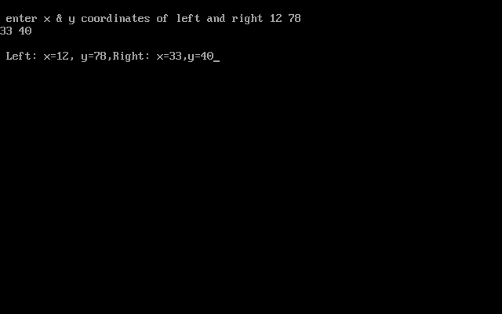

SAME PROGRAM WITHOUT TYPEDEF
#include<stdio.h>
#include<conio.h>
struct
{int x;
int y;
}Dot;
Dot left,right;
int main()
{
clrscr();
printf("\n enter x & y coordinates of left and right ");
scanf("%d%d%d%d",&left.x,&left.y,&right.x,&right.y);
printf("\n Left: x=%d, y=%d,Right: x=%d,y=%d",left.x,left.y,right.x,right.y
);
return 0;
}
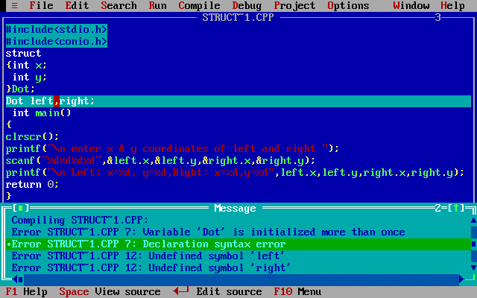

COPYING AND COMPARING STRUCTURE VARIABLES
Two variables of the same structure type can be copied into another of the same type, just like ordinary variables
For eg-
person1=person2;
However statements like-
Person1==person2
Person1!=person2
Are not permitted. C does not allow logical operators on structure variables, we may do so by comparing members individually.

COMPARISON OF STRUCTURE VARIABLES

Program
struct class
{
int number;
char name[20];
float marks;
};

main()
{
int x; struct class student1 = {111,"Rao",72.50}; struct class student2 = {222,"Reddy", 67.00};
COPYING ALLOWED
struct class student3;
student3 = student2;
x = ((student3.number == student2.number) && student3.marks == student2.marks))?1:0; if(x == 1)
{
printf("\nstudent2 and student3 are same\n\n");
printf("%d %s %f\n", student3.number,
student3.name,student3.marks);
}
else
{
printf("\nstudent2 and student3 are different\n\n");
}
}

Output

student2 and student3 are same

222 Reddy 67.000000

COMPARISON OF INDIVIDUAL MEMBERS OF STRUCTURES.

#include <stdio.h>

struct employee

{

char grade;

int basic;

float allowance;

};

int main()

{

struct employee ramesh = {'b', 5750, 818.75};

struct employee vivek = {'b', 6500, 812.5};

if(ramesh.grade!= vivek.grade)

printf("Ramesh and Vivek are employed on different grades");

else if((ramesh.basic+ramesh.allowance)>(vivek.basic+vivek.allowance))

printf("Ramesh is senior and his total remuneration is Rs%f",(ramesh.basic+ramesh. allowance));

else if((ramesh.basic+ramesh.allowance)==(vivek.basic+vivek.allowance))

printf("Ramesh and Vivek get the same total remuneration of Rs%f",(ramesh.basic+ramesh.allowance));

else

printf("Vivek is senior and his total remuneration is Rs%f",(vivek.basic+vivek.allowance));

return 0;

}

W.A.C PROGRAM TO ADD TWO DISTANCES (IN INCH-FEET SYSTEM)USING STRUCTURES
This program takes two distances in inch-feet system and stores in data members of two structure variables. Then, this program calculates the sum of two distances and displays it.
Source code to add two distance using structure
#include <stdio.h>
struct Distance{
int feet;
float inch;
}d1,d2,sum;
int main(){
printf("Enter information for 1st distance\n");
printf("Enter feet: ");
scanf("%d",&d1.feet);
printf("Enter inch: ");
scanf("%f",&d1.inch);
printf("\nEnter information for 2nd distance\n");
printf("Enter feet: ");
scanf("%d",&d2.feet);
printf("Enter inch: ");
scanf("%f",&d2.inch);
sum.feet=d1.feet+d2.feet;
sum.inch=d1.inch+d2.inch;

/* If inch is greater than 12, changing it to feet. */
if (sum.inch>12.0)
{
sum.inch=sum.inch-12.0;
++sum.feet;
}
printf("\nSum of distances=%d\'-%f\"",sum.feet,sum.inch);
return 0;
}
Output
Enter information for 1st distance
Enter feet: 12
Enter inch: 3.45

Enter information for 1st distance
Enter feet: 12
Enter inch: 9.2

Sum of distances=25'-0.6"
In this program, a structure Distance is defined with inch and feet as its members. Then, three variables(d1, d2 and sum) of struct Distance type is created. Two variables(d1 and d2) are used for taking distance from user and the sum of two distance is stored in variable sum and then, displayed.

ARRAY OF Structures

struct <struct_tag_name>

{

<data type member1>;

<data type member2>;

<data type member3>;

.

.

.

}structure_variable[index];

Or

Struct struct_tag_name struct_variable[index];

As there can be arrays of basic types such as integers and floats, there can also be arrays of sructures.

This means that the structure variable would be an array of objects, each of which contains the member elements declared within the structure template.

Program)

#include<stdio.h>
struct test1
{
char a;
int i;
}m[3];
int main()
{
int n;
for(n=0;n<=2;n++)
{
printf("\n Enter char, int :");
/* input the values of array of structures */
scanf("%c%d",&m[n].a,&m[n].i);
}

printf("The structure elements are as follows:\n");
for(n=0;n<=2;n++)
{
/* output the values of array of structures */
printf("\n a=%c, i=%d", m[n].a, m[n].i);
}
return 0;
}

W.A.P to Create a structure to specify student data given below: name, roll number and marks. Further create an array of structures to read data of 10 students from the user and also display it.

#include <stdio.h>
struct student{
char name[50];
int roll;
float marks;
};
int main(){
struct student s[10];
int i;
printf("Enter information of students:\n");
for(i=0;i<10;++i)
{
s[i].roll=i+1;
printf("\nFor roll number %d\n",s[i].roll);
printf("Enter name: ");
scanf("%s",s[i].name);
printf("Enter marks: ");
scanf("%f",&s[i].marks);
printf("\n");
}
printf("Displaying information of students:\n\n");
for(i=0;i<10;++i)
{
printf("\nInformation for roll number %d:\n",i+1);
printf("Name: ");
puts(s[i].name);
printf("Marks: %f",s[i].marks);
}
return 0;
}

Output
Enter information of students:
For roll number 1
Enter name: Tom
Enter marks: 98

For roll number 2
Enter name: Jerry
Enter marks: 89
.
.
.
Displaying information of students:

Information for roll number 1:
Name: Tom
Marks: 98

HOW STRUCTURE ELEMENTS ARE STORED

Whatever be the elements of a structure, they are always stored in contiguous memory locations. The following program would
illustrate this:

/* Memory map of structure elements */
main( )
{
struct book
{
char name ;
float price ;
int pages ;
} ;
struct book b1 = { 'B', 130.00, 550 } ;

printf ( "\nAddress of name = %u", &b1.name ) ;
printf ( "\nAddress of price = %u", &b1.price ) ;
printf ( "\nAddress of pages = %u", &b1.pages ) ;
}

Here is the output of the program...
Address of name = 65518
Address of price = 65519
Address of pages = 65523

Actually the structure elements are stored in memory as shown in the figure below:
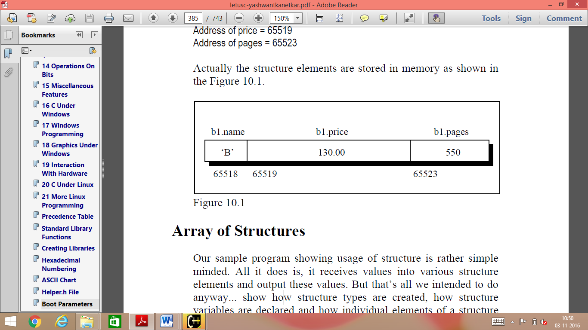

NESTING OF STRUCTURES

A structure can be placed within another structure.

In other words, a structure can contain other structures as members. The dot operator in conjunction with the structure variables are used to access the members of the innermost as well as the outermost structures.

#include <stdio.h>

struct outer /* declaration of outer structure */

{

int out1; /* member of outer structure */

float out2; /* member of outer structure */

struct inner /* declaration of inner structure */

{

int in1; /* member of inner structure */

float in2; /* member of inner structure */

}invar; /* structure_variable of inner structure*/

};

int main()

{

struct outer outvar; /* declaring structure_variable of outer */

outvar.out1= 2; /* assigning values to members */

outvar.out2= 10.57; /* assigning values to members */

outvar.invar.in1= 2* outvar.out1;

outvar.invar.in2= outvar.out2 + 3.65;

printf(" out1=%d, out2=%f, in1=%d, in2=%f",outvar.out1, outvar.out2,outvar.invar.in1,outvar.invar.in2);

return 0;

}

An innermost member in a nested structure can be accessed by chaining all the concerned structure variables, from outermost to innermost , with the member using the dot operator.

PGM2)

What happens when the first structure type is declared outside and before the second structure type and is incorporated as a member of the second structure type?

#include <stdio.h>

struct first /* declaration of first structure */

{

int in1; /* member of first */

float in2; /* member of first */

};

struct second /* declaration of second structure */

{

int out1; /* member of second */

float out2; /* member of second */

struct first inf; /* structure_variable of first structure */

};

int main()

{

struct second outs; /* structure_variable of second structure */

outs.out1= 2; /* assigning values to members */

outs.out2= 10.57; /* assigning values to members */

outs.inf.in1= 2* outs.out1;

outs.inf.in2= outs.out2 + 3.65;

printf(" out1=%d, out2=%f, in1=%d, in2=%f",

outs.out1, outs.out2, outs.inf.in1,

outs.inf.in2);

return 0;

}

7)There is a structure called employee that holds information like employee code, name, date of joining. Write a program to create an array of the structure and enter some data into it. Then ask the user to enter current date. Display the names of those employees whose tenure is 3 or more than 3 years according to the given current date.
Solution:
#include<stdio.h>
#include<conio.h>
#define N 3
void main() {
struct employee {
int code;
char name[20];
int dd; int mm; int yy;
} e[N];
int d,m,y,i;
clrscr();
for(i=0;i<N;i++) {
printf("\tEnter employee data:\n");
printf("\t*********************\n");
printf("\nEnter employee code: ");
scanf("%d",&e[i].code);
printf("\n\nEnter employee name: ");
scanf("%s",e[i].name);
printf("\n\nEnter date of joining (dd mm yy): ");
scanf("%d%d%d",&e[i].dd,&e[i].mm,&e[i].yy);
}
clrscr();
printf("\nenter current date(dd mm yy): \n\n");
scanf("%d%d%d",&d,&m,&y);
clrscr();
for(i=0;i<N;i++) {
if((y-(e[i].yy))>=3) {

printf("%s\n",e[i].name);
}
}
getch();
}

8)Write a program that compares two given dates. To store date use structure say date that contains three members namely date, month and year. If the dates are equal then display message as "Equal" otherwise "Unequal".

Solution:

#include<stdio.h>
#include<conio.h>

void main() {

struct date {
int date;
int month;
int year;
}d1;

int d,m,y,i;
clrscr();

printf("enter the date to save in structure: \n\n");

printf("Enter the date: ");
scanf("%d",&d1.date);

printf("\n\nEnter the month: ");
scanf("%d",&d1.month);

printf("\n\nEnter the year: ");
scanf("%d",&d1.year);

clrscr();

printf("\nenter the date to compare with structure:\n\n");

printf("Enter the date: ");
scanf("%d",&d);

printf("\n\nEnter the month: ");
scanf("%d",&m);

printf("\n\nEnter the year: ");
scanf("%d",&y);

if(d==d1.date && m==d1.month && y==d1.year) {

printf("\n\ndates are equal\n\n");

}

else {

printf("\n\ndates are unequal\n\n");

}

getch();

}

9) A record contains name of cricketer, his age, number of test matches that he has played and the average runs that he has scored in each test match. Create an array of structure to hold records of 20 such cricketers and then write a program to read these records and arrange them in ascending order by average runs.

Solution:
#include<stdio.h>
#include<conio.h>
#include<string.h>

void main() {

struct cricketer {
char name[50];
int age;
int match;
float avrn;
};
struct cricketer c[20],temp;
int i,j;
clrscr();

for(i=0;i<20;i++) {

printf("Enter data of cricketer %d\n\n\n",i+1);

printf("Name: ");
gets(c[i].name);

printf("\n\nAge: ");
scanf("%d",&c[i].age);

printf("\n\nMatches: ");
scanf("%d",&c[i].match);

printf("\n\nAverage runs: ");
scanf("%f",&c[i].avrn);

clrscr();

}
/*******************/
/* selection sort */
/*******************/
for(i=0;i<20-1;i++) {
for(j=i+1;j<20;j++) {
if(c[i].avrn > c[j].avrn) {
temp=c[i];
c[i]=c[j];
c[j]=temp;
}
}
}

printf("Sorted records:\n\n");

for(i=0;i<20;i++) {

printf("%d\t%s\t%d\t%d\t%f\n\n\n",i+1,c[i].name,c[i].age,c[i].match,c[i].avrn);

}

CUSTOMIZED FOR 3 PLAYERS
#include<stdio.h>
#include<conio.h>
#include<string.h>

void main() {

struct cricketer {
char name[50];
int age;
int match;
int avrn;
};
struct cricketer c[3],temp;
int i,j;
clrscr();

for(i=0;i<3;i++) {

printf("Enter data of cricketer %d\n\n\n",i+1);

printf("Name: ");
scanf("%s",c[i].name);

printf("\n\nAge: ");
scanf("%d",&c[i].age);

printf("\n\nMatches: ");
scanf("%d",&c[i].match);

printf("\n\nAverage runs: ");
scanf("%d",&c[i].avrn);
printf("INSIDE FOR I =%d\n",i);
//clrscr();
}
printf("oUTSIDE SCANNING LOOP\n");
/*******************/
/* sorting records */
/*******************/
for(i=0;i<3-1;i++) {
for(j=i+1;j<3;j++) {
if(c[i].avrn > c[j].avrn) {
temp=c[i];
c[i]=c[j];
c[j]=temp;
}
}
}

printf("Sorted records:\n\n");

for(i=0;i<3;i++) {

printf("%d\t%s\t%d\t%d\t%d\n",i+1,c[i].name,c[i].age,c[i].match,c[i].avrn);

}
}
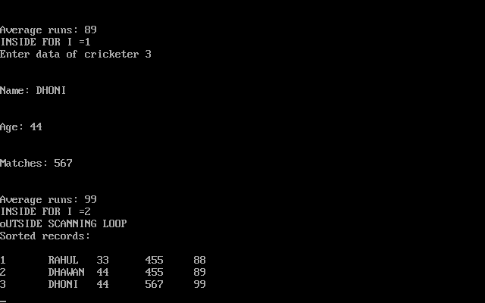

Pgm)
An employee record contains employee number, name of employee, his basic pay, allowances, deductions to be made from his salary and his net pay. Create an array of structure to hold the records of n such employees, Calculate the net payment for all the records. Write a program to read and print these records. Further read a name from the user, and Display the details of all those employees having the same name.

#include<stdio.h>

#include<conio.h>

#include<string.h>

struct emp

{

int empno ;

char name[10] ;

int bpay, allow, ded, npay ;

} e[10] ;

void main()

{

int i, n ;

char chk_name[10];

clrscr() ;

printf("Enter the number of employees : ") ;

scanf("%d", &n) ;

for(i = 0 ; i < n ; i++)

{

printf("\nEnter the employee number : ") ;

scanf("%d", &e[i].empno) ;

printf("\nEnter the name : ") ;

scanf("%s", e[i].name) ;

printf("\nEnter the basic pay, allowances & deductions:");

scanf("%d%d%d", &e[i].bpay, &e[i].allow, &e[i].ded) ;

e[i].npay = e[i].bpay + e[i].allow - e[i].ded ;

}

printf("\nEmp. No. Name \t Bpay \t Allow \t Ded \t Npay \n\n") ;

for(i = 0 ; i < n ; i++)

{

printf("%d \t %s \t %d \t %d \t %d \t %d \n", e[i].empno,

e[i].name, e[i].bpay, e[i].allow, e[i].ded, e[i].npay) ;

}

printf("enter the name to be checked\n");

scanf("%s",chk_name);

printf("The details of the employees with the name=%s is \n:",chk_name);

for(i=0;i<n;i++)

{

if(strcmp(e[i].name,chk_name)==0)

{

printf("%d \t %s \t %d \t %d \t %d \t %d \n", e[i].empno, e[i].name, e[i].bpay, e[i].allow, e[i].ded, e[i].npay) ;

}

}

getch() ;

}

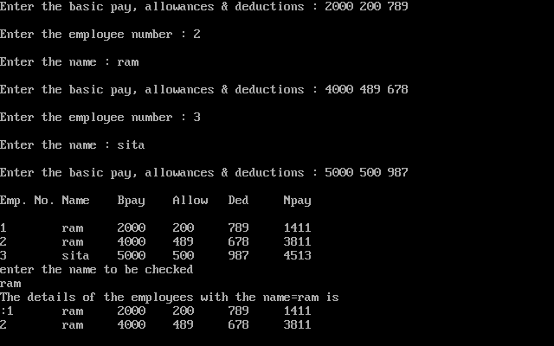

PGM) Create a structure to specify data of customers in a bank. The data to be stored is: Account number, Name, Balance in account. Assume maximum of 200 customers in the bank.
If a customer requests for withdrawal or deposit, it is given in the form:
Acct. no, code (1 for deposit, 0 for withdrawal),amount.
If the balance is less than 100 then the bank doesn’t allow any withdrawal.
Write a menu driven program to give a messsage, “The balance is insufficient for the specified withdrawal”.

Solution:

#include<stdio.h>

#include<conio.h>

#define N 2

struct bank {

int acn;

char name[20];

int bal; /* defined out of main() */

};

void main() {

struct bank b[N];

int i, lw=100,ch2,ac,am;

clrscr();

for(i=0;i<N;i++) { /* inputting customer data */

printf("\tEnter information of customers \n");

printf("\t******************************\n\n");

printf("enter account no.: ");

scanf("%d",&b[i].acn);

printf("\n\nenter customer name: ");

scanf("%s",&b[i].name);

printf("\n\nenter balance: ");

scanf("%d",&b[i].bal);

}

clrscr();

printf("enter your account number: ");

scanf("%d",&ac);

for(i=0;i<N;i++)

{

if((b[i].acn)==ac)

{

clrscr();

printf("\tHello %s\n",b[i].name);

printf("\n\n");

printf("\n\nenter your choice\n");

printf("\n1: deposit:\n");

printf("\n0: withdrawl:\n\n");

scanf("%d",&ch2);

switch(ch2)

{

case 0:

clrscr();

if(b[i].bal<lw) {

printf("\n\nsorry! account balance is too low for withdrawl.\n");

break;

}

else {

printf("\n\nenter amount for withdrawl: ");

scanf("%d",&am);

}

if(b[i].bal<am) {

printf("\n\nyou don't have enough balance for withdrawl.\n");

}

else {

b[i].bal=b[i].bal-am;

printf("\n\nwithdrawl was successful.\n");

}

break;

case 1:

clrscr();

printf("\n\nenter amount to deposite: ");

scanf("%d",&am);

b[i].bal=b[i].bal+am;

printf("\n\ncash deposited successfully.\n\n");

break;

}

}

}

getch();

}

STRUCTURE AND FUNCTIONS

An entire structure can be passed as a function argument just like any other variable. When a structure is passed as an argument, each member is copied. Infact, each member is passed by value. In case a member is an array, a copy of this array is also passed.

This can prove to be inefficient where structures are large or functions are called frequently. Passing and working with pointers to large structures may be more efficient in such cases.

The syntax is:

struct structure_tag function_name(struct structure_tag structure_variable)

Several variations to this syntax can be made. A function may receive a structure but may return a void or some other data type.

PROGRAM TO ADD TWO COMPLEX NUMBERS BY PASSING STRUCTURE TO A FUNCTION AND RESULT IS DISPLAYED IN MAIN

Source Code to Add Two Complex Number
Method 1)
#include <stdio.h>
typedef struct complex{
float real;
float imag;
}complex;

complex add(complex n1,complex n2);

int main(){
complex n1,n2,temp;
printf("For 1st complex number \n");
printf("Enter real and imaginary respectively:\n");
scanf("%f%f",&n1.real,&n1.imag);
printf("\nFor 2nd complex number \n");
printf("Enter real and imaginary respectively:\n");
scanf("%f%f",&n2.real,&n2.imag);
temp=add(n1,n2);
printf("Sum=%f+%fi",temp.real,temp.imag);
return 0;
}
complex add(complex n1,complex n2){
complex temp;
temp.real=n1.real+n2.real;
temp.imag=n1.imag+n2.imag;
return(temp);
}
Output
For 1st complex number
Enter real and imaginary respectively: 2.3
4.5

For 2nd complex number
Enter real and imaginary respectively: 3.4
5
Sum=5.7+9.5i
In this program structures n1 and n2 are passed as an argument of function add(). This function computes the sum and returns the structure variable temp to the main() function.

METHOD 2)
#include <stdio.h>
struct complex{
float real;
float imag;
};

struct complex add(struct complex n1,struct complex n2);

int main(){
struct complex n1,n2,temp;
printf("For 1st complex number \n");
printf("Enter real and imaginary respectively:\n");
scanf("%f%f",&n1.real,&n1.imag);
printf("\nFor 2nd complex number \n");
printf("Enter real and imaginary respectively:\n");
scanf("%f%f",&n2.real,&n2.imag);
temp=add(n1,n2);
printf("Sum=%f+%fi",temp.real,temp.imag);
return 0;
}
struct complex add(struct complex n1,struct complex n2)
{
Struct complex temp;
temp.real=n1.real+n2.real;
temp.imag=n1.imag+n2.imag;
return(temp);
}

PROGRAM TO MULTIPLY TWO COMPLEX NUMBERS BY PASSING STRUCTURE TO A FUNCTION AND RESULT IS DISPLAYED IN MAIN
#include <stdio.h>
typedef struct complex{
float real;
float imag;
}complex;

complex mul(complex n1,complex n2);

int main(){
complex n1,n2,temp;
printf("For 1st complex number \n");
printf("Enter real and imaginary respectively:\n");
scanf("%f%f",&n1.real,&n1.imag);
printf("\nFor 2nd complex number \n");
printf("Enter real and imaginary respectively:\n");
scanf("%f%f",&n2.real,&n2.imag);
temp=mul(n1,n2);
printf("Sum=%f+%fi",temp.real,temp.imag);
return 0;
}
complex mul(complex n1,complex n2){
complex temp;
temp.real=n1.real*n2.real-n1.imag*n2.imag;
temp.imag=n1.real*n2.imag+n1.imag*n2.real;
return(temp);
}

#include<stdio.h>
typedef struct COMPLEX{
int a;
int b;
}Complex;
Complex multiply(Complex,Complex);
int main(){
int a1,b1,a2,b2;
Complex x,y,z;
printf("Enter first complex number : ");
scanf("%d%d",&a1,&b1);
printf("\nEnter second complex number : ");
scanf("%d%d",&a2,&b2);
x.a = a1; x.b = b1;
y.a = a2; y.b = b2;

z = multiply(x,y);
printf("After multiplication: %d+%di",z.a,z.b);
return 0;
}
Complex multiply(Complex x,Complex y){
Complex z;
z.a = x.a*y.a - x.b*y.b;
z.b = x.a*y.b + x.b*y.a;
return z;
}

POINTER TO STRUCTURES

What is a structure pointer?

Like primitive types, we can have pointer to a structure. If we have a pointer to structure, members are accessed using arrow ( -> ) operator.

#include<stdio.h>
struct Point
{
int x, y;
};
int main()
{
struct Point p1 = {1, 2};
// p2 is a pointer to structure p1
struct Point *p2 = &p1;
// Accessing structure members using structure pointer
printf("%d %d", p2->x, p2->y);
return 0;
}

Example program for C structure using pointer:
In this program, “record1″ is normal structure variable and “ptr” is pointer structure variable. As you know, Dot(.) operator is used to access the data using normal structure variable and arrow(->) is used to access data using pointer variable.
#include <stdio.h>
#include <string.h>

struct student
{
int id;
char name[30];
float percentage;
};

int main()
{
int i;
struct student record1 = {1, "Raju", 90.5};
struct student *ptr;

ptr = &record1;

printf("Records of STUDENT1: \n");
printf(" Id is: %d \n", ptr->id);
printf(" Name is: %s \n", ptr->name);
printf(" Percentage is: %f \n\n", ptr->percentage);

return 0;
}

Output:
Records of STUDENT1:
Id is: 1
Name is: Raju
Percentage is: 90.500000

Example Program using a pointer to structure illustrating the initialization of the members in the structure
#include <stdio.h>
#include <stdlib.h>
struct test1 /** declaration of structure "test" */
{
char a;
int i;
float f;
};
int main()
{
struct test1 *pt; /* declaring pointer to the structure */
pt=(struct test1 *)malloc(sizeof(struct test1));
pt->a='K'; /* initializing char a */
pt->i=15; /* initializing int i */
pt->f=27.89; /* initializing float f */
printf("\n a=%c, i=%d, f=%f",pt->a,pt->i,pt->f);
printf("\n Enter new char, int, float:");
scanf("%c %d %f",&pt->a,&pt->i,&pt->f); /* input for members */
printf("\n a=%c, i=%d, f=%f",pt->a,pt->i,pt->f);
return 0;
}
/* function to link-in floating point emulator */
void linkfloat()
{
float a,*x;
x=&a;
a=*x;
}

Source Code Demonstrate the Dynamic Memory Allocation for Structure
#include <stdio.h>

//structure definition
struct student{
char name[50];
int age;
int rollno;
};
//main function
int main(){
//pointer to structure declaration
struct student *ptr;

//allocating memory at run time
ptr = (struct student*)malloc(sizeof(struct student));

//check memory availability
if( ptr == NULL){
printf("Unable to allocate memory!!!\n");
exit(0);
}

//reading values of the structure
printf("Enter student details...\n");
printf("Name? ");
scanf("%[^\n]", ptr->name); //reads string with spaces
printf("Age? ");
scanf("%d", &ptr->age);
printf("Roll number? ");
scanf("%d", &ptr->rollno);

//printing the details
printf("\nEntered details are...\n");
printf("Name: %s\n", ptr->name);
printf("Age: %d\n", ptr->age);
printf("Roll number: %d\n", ptr->rollno);

//freeing dynamically allocated memory
free(ptr);

return 0;
}

#include <stdio.h>
#include<stdlib.h>
struct name {
int a;
char c[30];
};
int main(){
struct name *ptr;
int i,n;
printf("Enter n: ");
scanf("%d",&n);

/* Allocates the memory for n structures with pointer ptr pointing to the base address. */
ptr=(struct name*)malloc(n*sizeof(struct name));
for(i=0;i<n;++i){
printf("Enter string and integer respectively:\n");
scanf("%s%d",&(ptr+i)->c, &(ptr+i)->a);
}
printf("Displaying Infromation:\n");
for(i=0;i<n;++i)
printf("%s\t%d\t\n",(ptr+i)->c,(ptr+i)->a);
return 0;
}

Output
Enter n: 2
Enter string and integer respectively:
Programming
22
Enter string and integer respectively:
Structure
33
Displaying Information:
Programming 22
Structure 33

