Batch: A2 Roll No.: 16010122034

Experiment 01

Title: Data Collection and finalizing dataset from problem domain

Objective:

1. To learn how to collect the dataset

2. To learn sources of dataset

3. To assess the dataset based on Metrics to Measure Data Quality

4. To finalize the features of dataset

Course Outcome:

CO1: Learn how to locate and download datasets, extract insights from that data and present their findings in a variety of different formats.

Books/ Journals/ Websites referred:
https://www.kaggle.com/datasets/iamsouravbanerjee/data-science-salaries-2023

Resources used:
Kaggle Dataset : https://www.kaggle.com/datasets/iamsouravbanerjee/data-science-salaries-2023
Excel Sheet

Theory:
Source of Dataset : Kaggle
Dimensions of the dataset : 11 columns, 3684 rows
Summary :
The "Data Science Salaries" dataset offers valuable insights into salary trends and fluctuations within the data science field from 2020 to 2023. It empowers data professionals, researchers, and organizations to analyze and grasp the prevailing salary landscape within the data science domain over this four-year span. This dataset functions as a valuable asset for individuals seeking career guidance, companies interested in evaluating their compensation strategies, and researchers investigating the ever-evolving dynamics of the data science job market
The dataset includes information about Job Title, Employment Type, Experience Level, Expertise Level, Salary, Salary Currency, Company Location, Salary in USD, Employee Residence, Company Size, and Year. This information provides a comprehensive view of job-related details, compensation levels, company characteristics, and temporal aspects, offering valuable insights for analyzing and understanding the dataset.
Sample View :
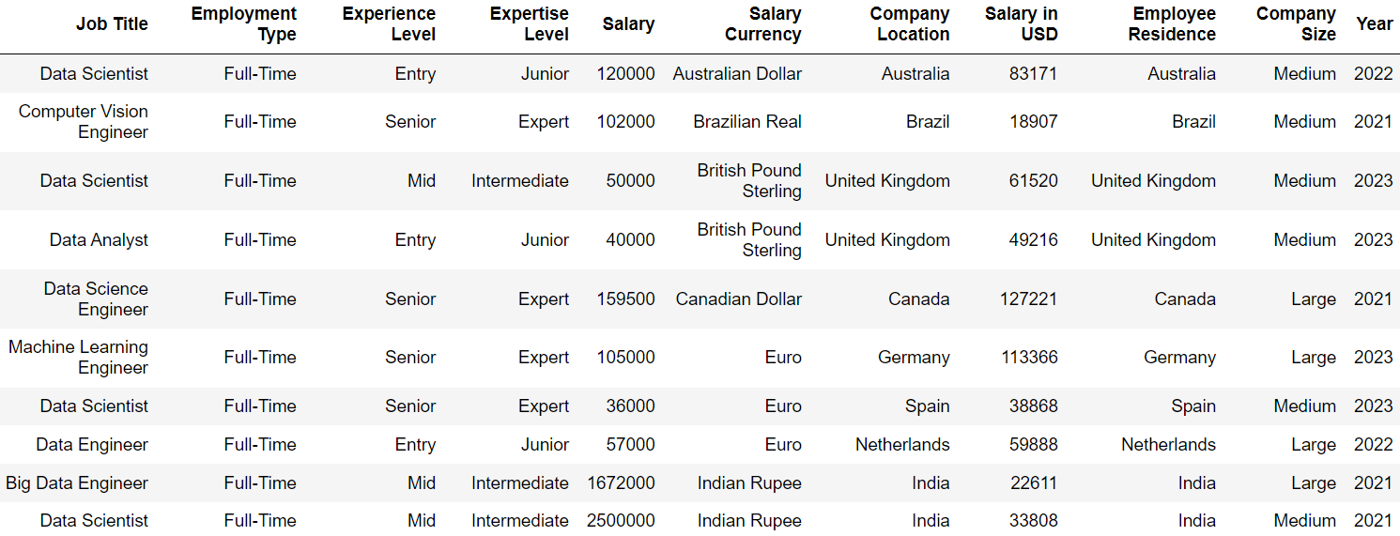

Problem domain:
Salaries of jobs in the Data Science domain.

Motivation for selected domain: This Dataset gave us insight into the Real time salary figure for different Data science roles along with their job experience, with the companies placed in different locations.
Justification for choosing the above data set: As an aspiring data scientist, this data is of tremendous value as it helps me plan for the future.

Data Dictionary:

1) Work Year: The salary that was paid to the employee in that year (For the finalized dataset we have selected the year 2021)

2) Job Title: Employment Role

3) Experience Level: The experience level of the employee in the job

Roles:
EN Entry-level
Junior MI Mid-level
Intermediate SE Senior-level
Expert EX Executive-level
Director

4) Employment type: Type of employment (For the finalized dataset we have chosen FT as the employment type)

PT - Part-time
FT - Full-time
CT - Contract
FL - Freelance

5) Salary in USD: Salaries in different currencies converted in USD

6) Salary: Total salary paid

7) Salary Currency: Currency salary was paid in

8) Remote ratio: It is the amount of work done remotely.

0 – No remote work (less than 20%)

50 – Partially remote

100 – Fully remote (more than 80%)

9) Employee residence: Country the employee resided in

10) Company location: Country of the employer’s main office or contracting branch

11) Company size: (For the finalized dataset we have selected the company size to be M)

S – Less than 50 employees

M – About 50 – 250 employees

L – More than 250 employees
Brainstormed features of the data set:

The salary data is provided in the respective currency and also for uniformity it is converted and presented in USD.

The dataset is from the work year 2020-2023 and is updated weekly.

Companies of three different sizes are shown – S, M and L

Although more data for companies of S and L size should have been added for a clearer picture.

Conclusion (Students should write in their own words):

I learnt how to locate and download datasets, assess the data and extract insights from that data and present their findings in a variety of different formats.

Post Lab Question:

Explain Role of Data in the Application Design.

Ans : Data forms the cornerstone of our product development process. It can quickly inform development priorities for enhanced user experience, improved user satisfaction and increased adoption rates. In order to keep up with the times, your designs need to be based on data

Write different types of Data with Example.

Ans : Mainly there are two types of Data:

Quantitative Data: Data that can be expressed in numbers i.e., it can be quantified. Quantitative data is discrete (values are integers or whole numbers) and continuous i.e., used to represent measurements.

Qualitative Data: Data that cannot be expressed in terms of numbers. For example: images, symbols etc. Qualitative data is nominal (do not have natural ordering) or ordinal (have natural ordering) and categorical i.e., used to represent characteristics.

