Batch: A2 Roll No.: 16010122034

Experiment 06

Title: Working with Geospatial data

Objective:

Search/locate and download the geospatial Data (Use same dataset if it contains location information)

To learn how to visualize geospatial data in Tableau

Apply heat map

Try various forms of heat maps

Analyse the visualization and write your interpretation after observation on heat-map

Course Outcome:

CO1: Learn how to locate and download datasets, extract insights from that data and present their findings in a variety of different formats.

CO3 Apply data visualization best practices

Books/ Journals/ Websites referred:
https://www.ibm.com/in-en/topics/geospatial-data

Resources used:
Tableau

Theory:
Geospatial data typically combines location information (usually coordinates on the earth) and attribute information (the characteristics of the object, event or phenomena concerned) with temporal information (the time or life span at which the location and attributes exist). The location provided may be static in the short term (for example, the location of a piece of equipment, an earthquake event, children living in poverty) or dynamic (for example, a moving vehicle or pedestrian, the spread of an infectious disease).

Definition: Geospatial data is information that describes objects, events or other features with a location on or near the surface of the earth.

Following points should be written by students

Observation after plotting data
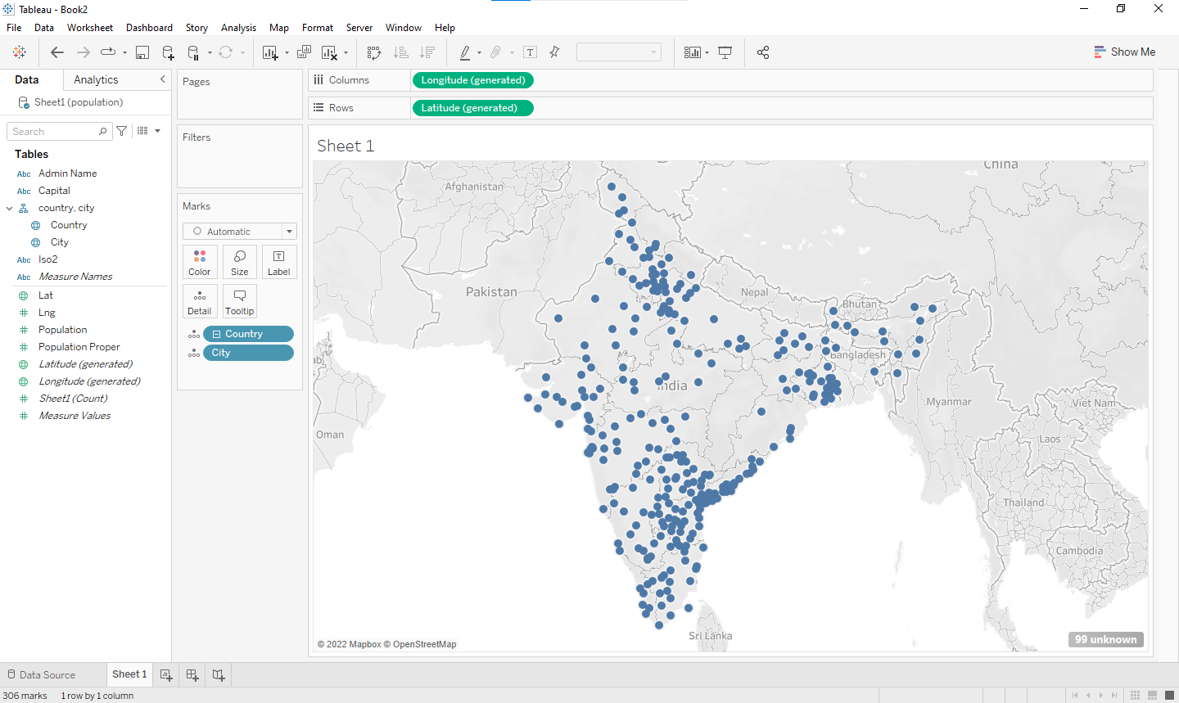

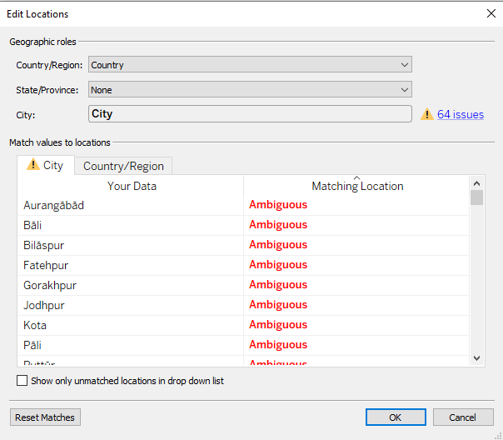

Observation after plotting various forms of heat maps like based on visualization Que
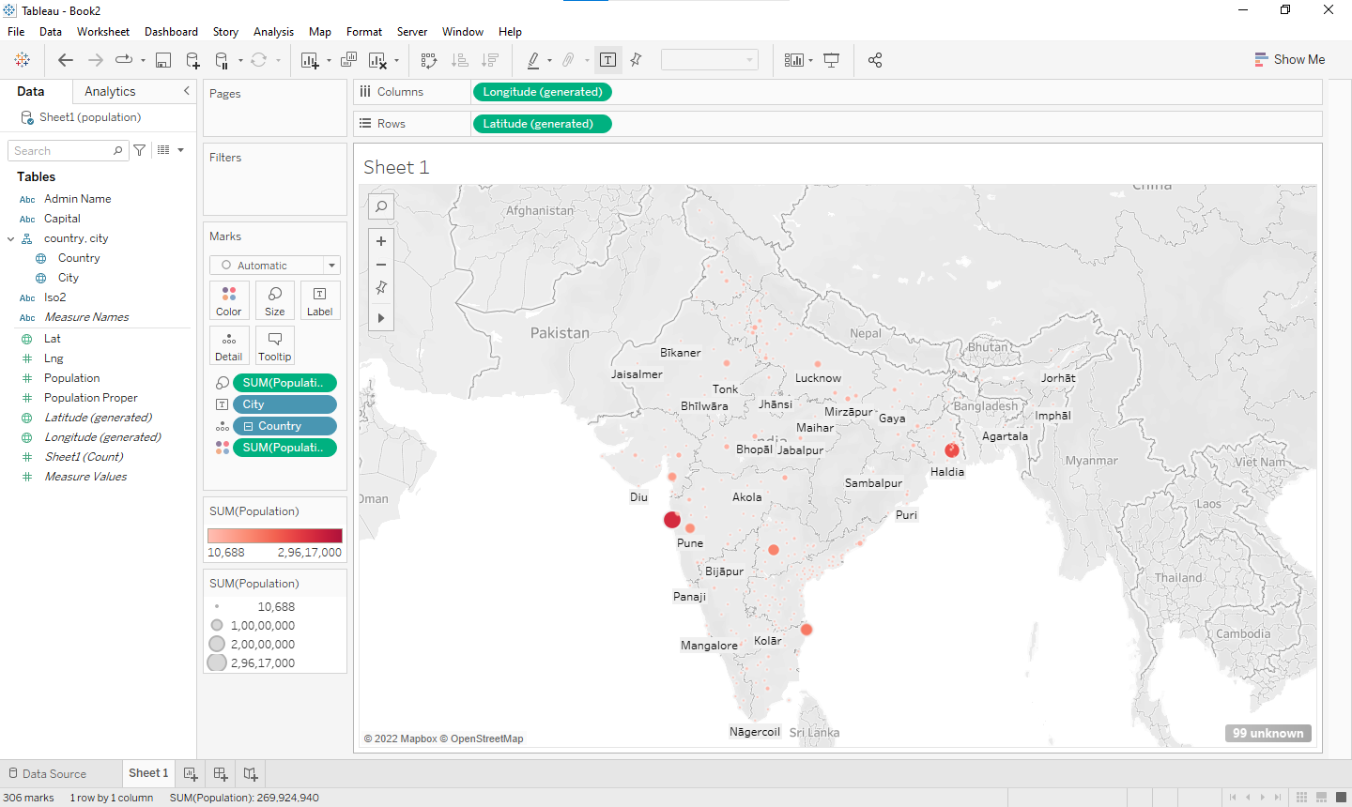

Interpretation of visualized map
Graph represents the population in various cities in India.
Population is highest in Mumbai city followed by Kolkata city.

Note: Detail observation needed along screenshots wherever required

Conclusion (Students should write in their own words, comparative conclusion needed):

Downloaded the geospatial Data and learnt to visualize geospatial data in Tableau.

Explored various types of heatmaps and analyzed the visualization.

Post Lab Question:

Explain the Choropleth maps.
A choropleth map is a type of statistical thematic map that uses color corresponding with an aggregate summary of a geographic characteristic within spatial enumeration units, such as population density of per-capita income. Choropleth maps provide an easy way to visualize how a variable varies across a geographic area or show the level of variability within a region.

Date: 22/10/2023
Signature of faculty in-charge

