Batch: B2 Roll No.: 16010122158

Experiment 02

Title: Dataset pre-processing

Objective:

1. To learn how to prepare the dataset

2. To learn various steps in Data -Preprocessing

Course Outcome:

CO1: Learn how to locate and download datasets, extract insights from that data and present their findings in a variety of different formats.

Books/ Journals/ Websites referred:
https://www.kaggle.com/datasets/jessemostipak/hotel-booking-demand

Resources used:
https://www.kaggle.com/datasets/jessemostipak/hotel-booking-demand
MS-Excel
______________________________________________________________________

Theory (About Data Preprocessing):
Data cleaning is a part of data preprocessing where errors in the data are identified and fixed such as removing or replacing null or missing values, removal of duplicated and/or irrelevant data from the dataset. Cleaned data yields more accurate results and allows us to make more precise predictions.

Following points should be written by students

Different steps in Data Preprocessing:

Finding missing, null values

Replacing missing, null values with statistical parameters

Encoding categorical data

Normalization

Note: Student can use any technology like Tableau, Tableau-Prep, PowerBI, Google spreadsheet, excel, R programming, Python, Java any other technology for preprocessing.

Platform used by the student: MS-Excel

Working (Paste the code and Output for each Data Preprocessing task):

Original Dataset:

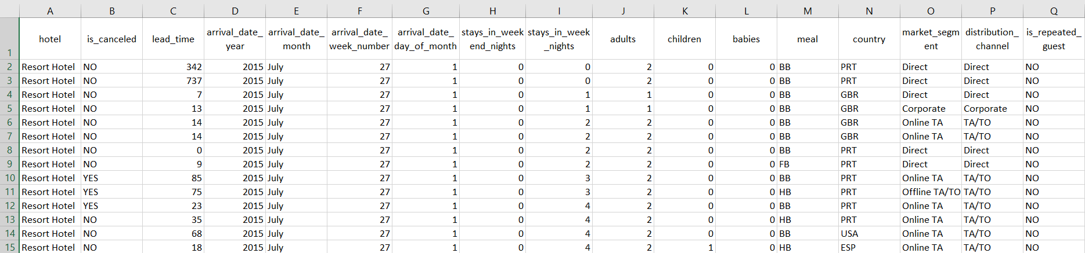

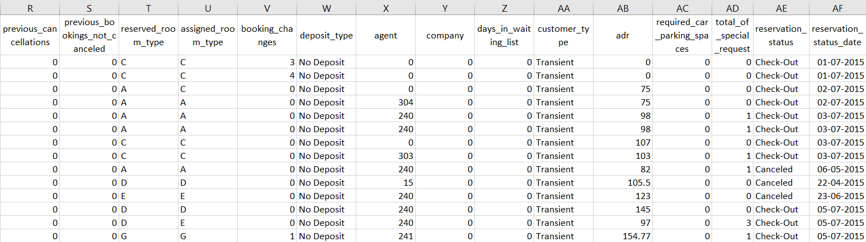

Removing unwanted columns:
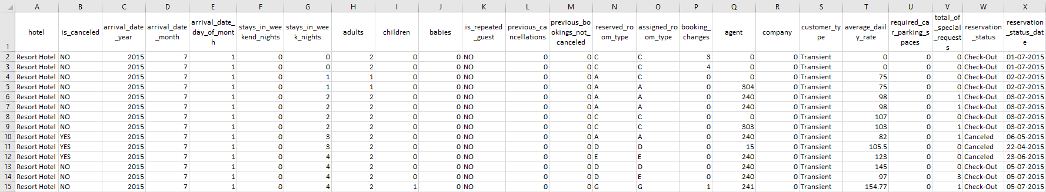

Merging year, month, day column into date column:
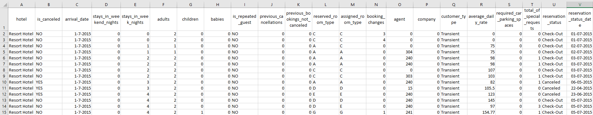

Finding and replacing missing or null values:
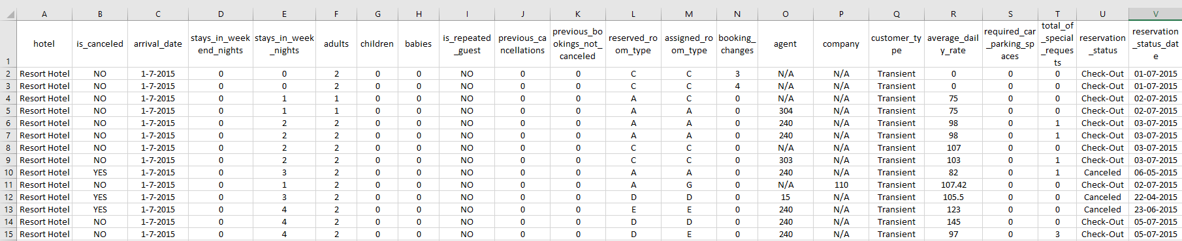
Encoding categorical data:
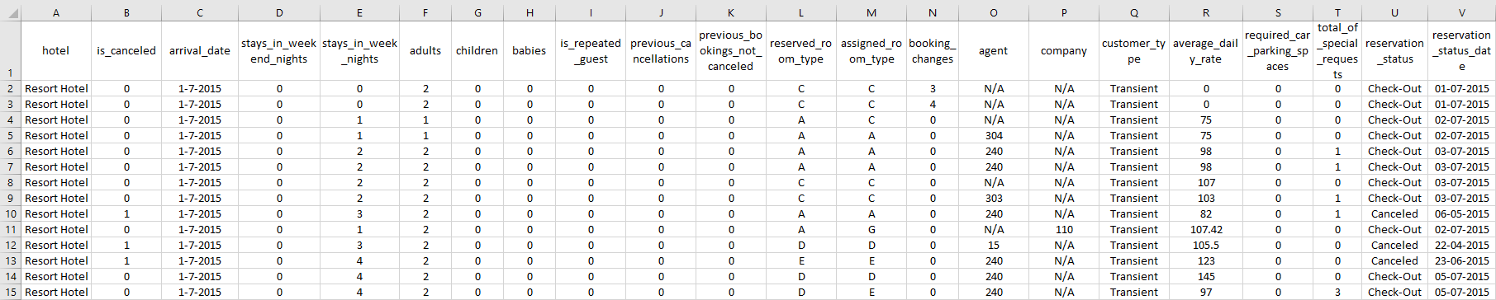

Conclusion (Students should write in their own words):
Data cleaning is a part of data preprocessing where errors in the data are identified and fixed such as removing or replacing null or missing values, removal of duplicated and/or irrelevant data from the dataset. Cleaned data yields more accurate results and allows us to make more precise predictions.

Post Lab Question:

Write the importance of Data Preprocessing
Data preprocessing is the process of transforming raw data into a useful, understandable format. Real-world or raw data usually has inconsistent formatting, human errors, and can also be incomplete. Data preprocessing resolves such issues and makes datasets more complete and efficient to perform data analysis.

