Batch: H2-1 Roll No.: 16010122158

Experiment 04

Title: Introduction to various charts

Objective:

1. To learn how to use various charts for visualizing preprocessed data

Pie chart

Donut chart

Lollypop chart

Boxplot

Bubble chart

Bump Chart

Funnel chart

Water Chart

Bar chart /column chart / Stacked chart

Area Chart

Pareto chart

Tree maps

Scatter plot

Gantt chart

Word map

2. To learn following concepts

Parameters

Combine, Sets

Label, Title and caption

Working with metadata

Working with filter

Font, Size, colour, and Border,

Calculated field, Number function, string function

Conditional formatting, logical function

Exporting the charts

3. To learn interpretation of each charts/plots

Course Outcome:

CO1: Learn how to locate and download datasets, extract insights from that data and present their findings in a variety of different formats.

CO3: Apply data visualization best practices

Books/ Journals/ Websites referred:
https://www.kaggle.com/datasets/shekpaul/global-superstore

Resources used:
Tableau, Excel, Dataset

Theory (About various charts explored):

Charts enable you to visually compare multiple sets of data. Charts can help people better understand and remember information. Different types of charts require different measures and dimensions and provide different insights into the data.

Following points should be written by students

Different charts explored for data visualization:

Bar Chart

Line Chart

Pie Chart

Scatter Plot

Packed Bubble Chart

Donut Chart

Working: Using tableau software

Exported of each chart output with variations explored on your dataset

Interpretation (what each chart signifies)

BAR CHART
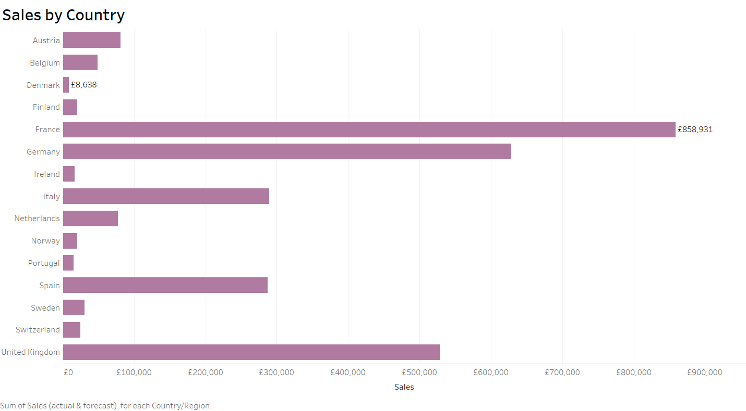
LINE CHART
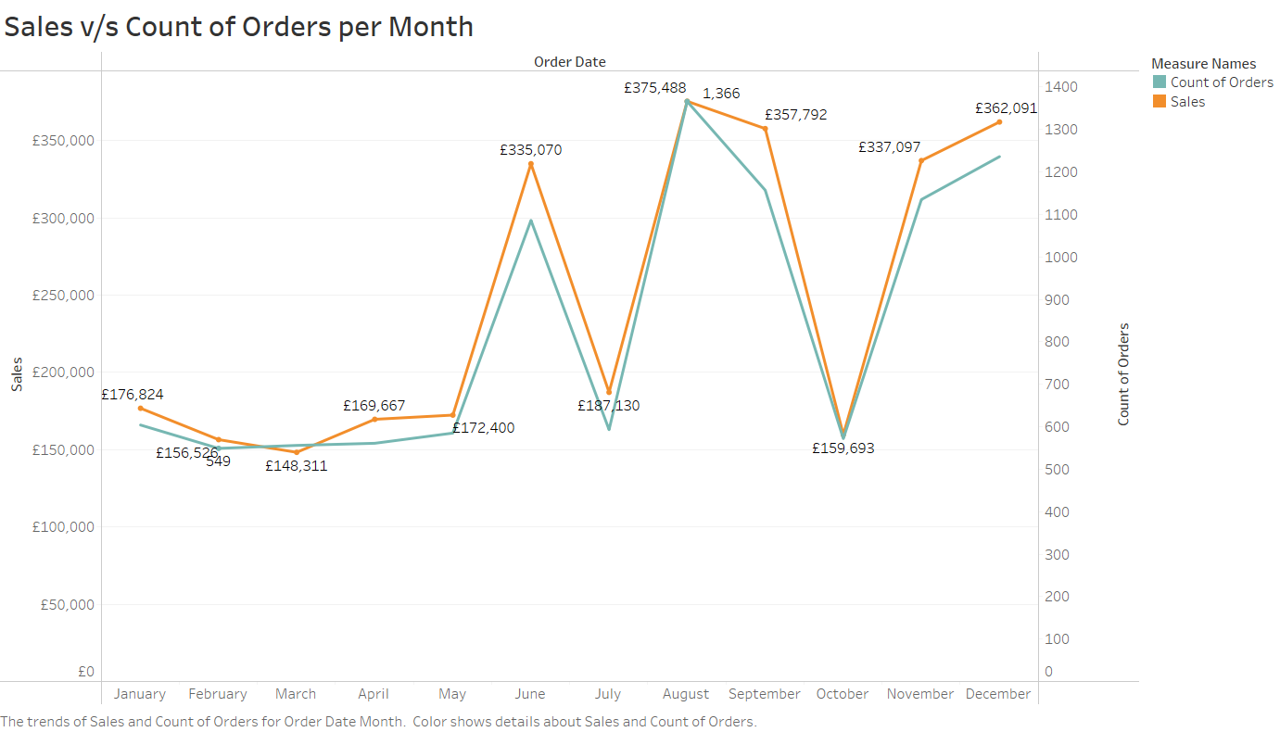

PIE CHART
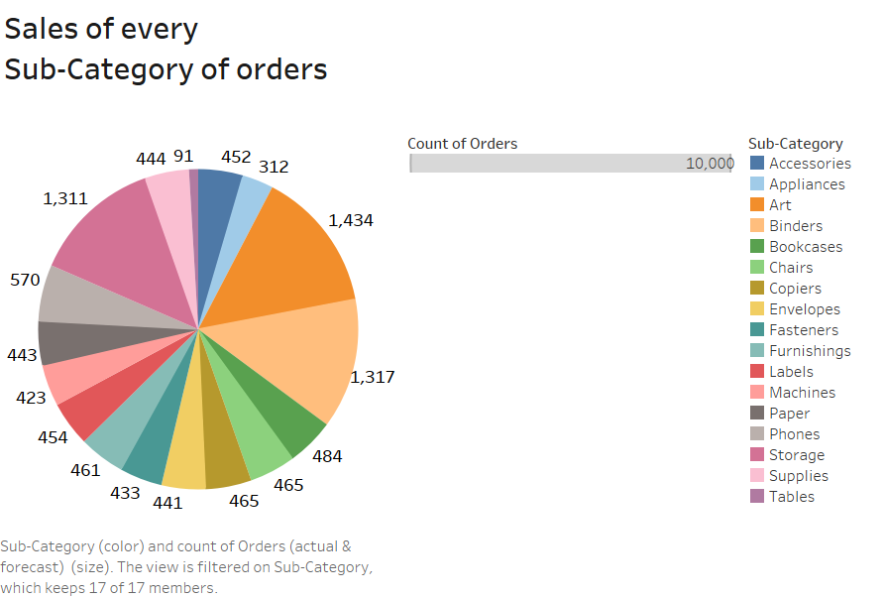
SCATTER PLOT
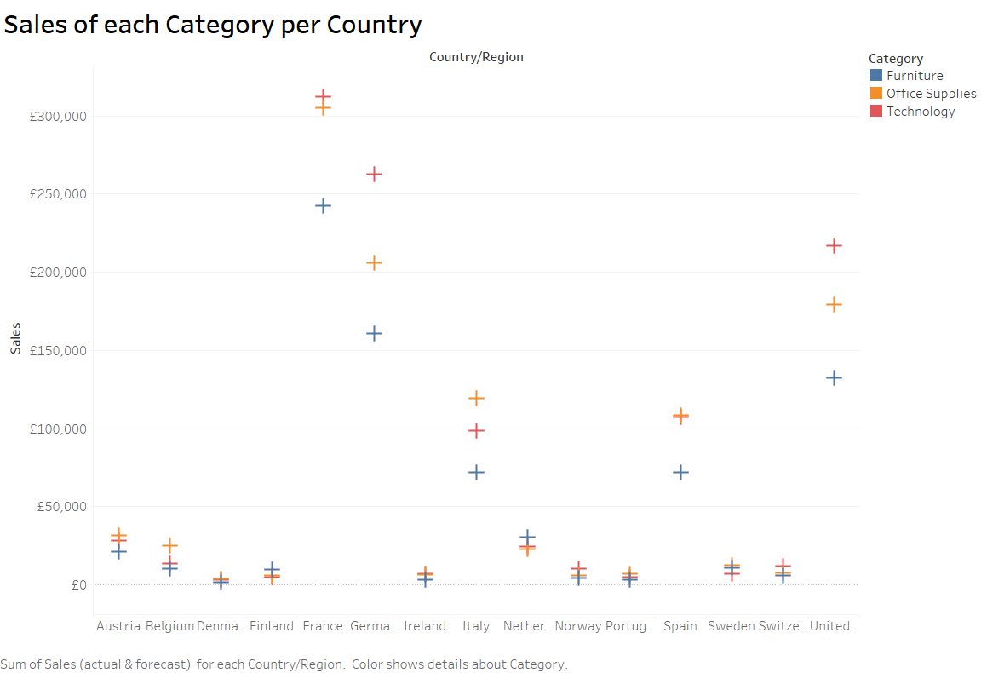

PACKED BUBBLE CHART
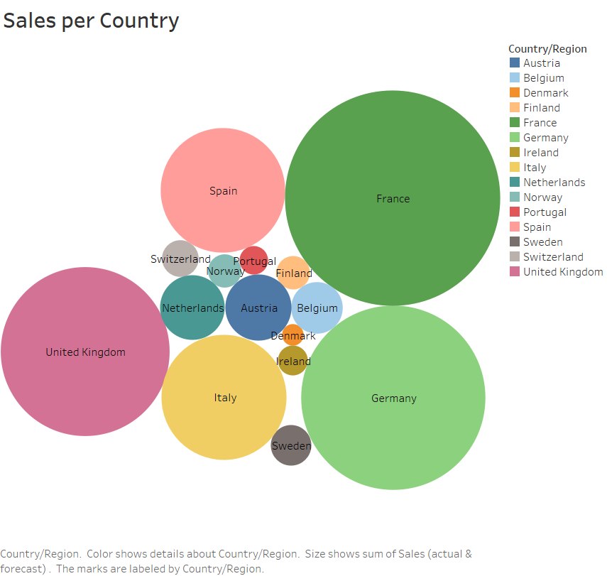

Conclusion (Students should write in their own words):

Tableau offers various charts for visualizing pre-processed data like Bar, Pie, Line, Scatter and Packed Bubble chart. These charts make it easier to interpret data as it removes the noise by highlighting trends and outliers.

Date: 17/10/2023 Signature of faculty in-charge

Post Lab Question:

What are different data types supported in Tableau software?
The data types supported by Tableau are:
String
Integer
Date
Date and Time
Boolean
Geographic
Cluster group or mixed

Which chart is most appropriate for visualizing your preprocessed dataset? Justify
Different charts can be useful to analyze the data in different ways.
For the following dataset, a bar chart would be most appropriate as it allows us to compare the sales by market, category, sub-category or region with each other while showing even the slightest difference between similar selling products.
A donut chart could also be helpful to compare the sales from each category or subcategory as compared to the whole.

