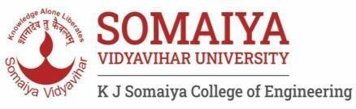

K. J. Somaiya College of Engineering, Mumbai-77
(A Constituent College of Somaiya Vidyavihar University)

Department of Computer Engineering

Scheme for Internal Assessment (IA)
2023-2024
Branch | Computer Engineering | Semester | III
Course Name & Course Code | Object Oriented Programming Methodology | Academic year | August – December 2023
Faculty In-charges | Prof.Smita Sankhe  Prof.Sheetal Pereira  Dr. Ayesha Hakim  Prof. Kaustubh Kulkarni | Year | S.Y B.Tech.

Distribution of Marks | The student will be evaluated based on two tasks of 10 marks each. If any of the tasks given is not completed / submitted / shown / evaluated, then the marks awarded for that task will be zero.  IA 1: Quiz  IA 2: Concept wise Debugging of test cases
Sr. No. | Task | Description of task | Schedule | CO Mapped
1. | Quiz |  | Last week of  September 2023 | 1,2,3
2. | Concept wise Debugging of test cases |  | Third week of October  2023. | 1,2,3,4
Marks out of 20 will be calculated based on marks obtained in above activities

Faculty In-charges:
Prof.Smita Sankhe
Prof.Sheetal Pereira
Dr. Ayesha Hakim
Prof. Kaustubh Kulkarni Date: 12/07/2023

