Course Name: | Object Oriented Programming Methodology | Semester: | III
Date of Performance: | 18/08/2023 | Batch No: | B2
Faculty Name: | Prof. Kiran Thale | Roll No: | 16010122158
Faculty Sign & Date: |  | Grade/Marks: | ___/25

Experiment No: 2
Title: Control Statements

Aim and Objective of the Experiment:
Create a class MyMath. The class contains the following static methods.
i) power (x, y) – to compute x y
ii) fact (x) – to compute x!
Write a program to find the following series.
- e^{x} = 1 +(x/1!)+ (x2/2!) + (x3/3!) + (x4/4!) + … upto n terms (n given by user).
- (1+x)^{n} = 1 +(nx/1!)+ ((n(n-1)x2)/2!) ........ upto n terms (n given by user).

Note: Do not make use of inbuilt functions. Use the functions of user defined class MyMath.

COs to be achieved:
CO2: Explore arrays, vectors, classes and objects in C++ and Java.

Tools used:
JDK, VScode / Eclipse

Theory:
Java basic constructs (like if else statement, control structures, and data types
Programming languages provide various control structures that allow for more complicated execution paths.
A loop statement allows us to execute a statement or group of statements multiple times and following is the general form of a loop statement in most of the programming languages –
Sr.No. | Loop & Description
1 | while loop  Repeats a statement or group of statements while a given condition is true. It tests the condition before executing the loop body.
2 | for loop  Execute a sequence of statements multiple times and abbreviates the code that manages the loop variable.
3 | do...while loop  Like a while statement, except that it tests the condition at the end of the loop body.

Loop Control Statements
Loop control statements change execution from its normal sequence. When execution leaves a scope, all automatic objects that were created in that scope are destroyed.
Java supports the following control statements. Click the following links to check their details.
Sr.No. | Control Statement & Description
1 | break statement  Terminates the loop or switch statement and transfers execution to the statement immediately following the loop or switch.
2 | continue statement  Causes the loop to skip the remainder of its body and immediately retest its condition prior to reiterating.

Class Diagram:
myMath
static power(int x)
double static factorial(int x)
long static main(String [] args)

Algorithm:
1. Start with displaying the menu to the user.

2. Accept a choice from the user and check if it is valid.

3. If choice 1 is selected, accept x and n.

4. Calculate the first series by using for loop and power and factorial functions.

5. If choice 2 is selected, again ask for x and n, after which use the formula involving factorial and power functions to calculate the result.

6. Terminate the program.

Code:
import java.util.Scanner;
public class MyMath {
public static long power(int x, int y) {

long result = 1;
for (int i = 1; i <= y; i++) {
result *= x;
}
return result;
}
public static long fact(int x, long fact){
if (x == 0 || x == 1) {
return 1;
}
return x * fact(x - 1);
}
public static long fact(int x) {

return fact(x, 1);
}

public static void main(String[] args) {

Scanner sc = new Scanner(System.in);
System.out.println("type 1 or 2 and press enter: "); System.out.println("e^x up to n terms"); System.out.println("(1+x)^n up to n terms"); int choice;

while (true) {
System.out.println("Enter your choice: "); choice = sc.nextInt();
if (choice == 1 || choice == 2) { break;
}
System.out.println(":");
}
switch (choice) {
case 1:
System.out.println("Enter x: "); int x = sc.nextInt();
System.out.println("Enter n: "); int n = sc.nextInt();
double result = 0;
for (int i = 0; i < n; i++) { result += power(x, i) / fact(i); }
System.out.println("Result: " + result);
break;
case 2:
System.out.println("Enter x: "); int x1 = sc.nextInt();
System.out.println("Enter n: ");
int n1 = sc.nextInt();
double result1 = 1;
for (int i = 1; i <= n1; i++) {
result1 += (fact(n1) / fact(n1-i)) * power(x1, i) / fact(i);
}
System.out.println("Result: " + result1);
break;
default:
System.out.println("Invalid choice, Try again!");
}
sc.close();
}
}

Output:
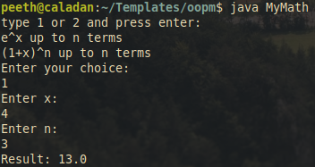
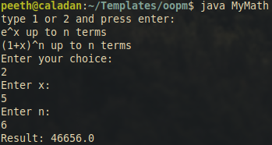

Post Lab Subjective/Objective type Questions:
- Write a program to find the largest of three numbers using the if-else construct.
import java.util.Scanner;
public class Largest{
public static void main(String[] args){
Scanner in=new Scanner(System.in);
System.out.println("Enter three numbers: ");
int a=in.nextInt();
int b=in.nextInt();
int c=in.nextInt();
if(a>b && a>c){
System.out.println(a+" is the largest number.");
}
else if(b>a && b>c){
System.out.println(b+" is the largest number.");
}
else{
System.out.println(c+" is the largest number.");
}
}

Output
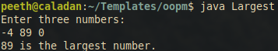
- Write a program to determine the sum of the following series for a given value of n:
1+½+⅓+....+1/n
import java.util.Scanner;
public class Series {
public static void main(String[] args){
Scanner in=new Scanner(System.in);
System.out.println("Enter the number of terms: ");
int n=in.nextInt();
double sum=0.0;
for(int i=1;i<=n;i++){
sum+=1.0/i;
}
System.out.println("Sum of the series is: "+sum);
}
}
Output:
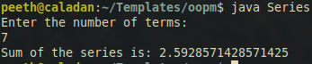

Conclusion:
In conclusion, this Java experiment involved the creation of a user-defined class named "MyMath," which contained static methods for calculating power and factorial.

These methods were then utilized to compute two mathematical series: "ex" and "(1+x)^n," as specified in the experiment description.
The "power" method allowed us to calculate the power of a given number, and the "fact" method enabled the calculation of factorials, both of which were crucial for the subsequent series calculations.

The program successfully computed the "ex" and "(1+x)^n" series up to the user-specified number of terms, thereby demonstrating the power and flexibility of user-defined classes and methods.

Signature of faculty in-charge with Date:

