Course Name: | Object Oriented Programming Methodology | Semester: | III
Date of Performance: | 23/08/2023 | Batch No: | B2
Faculty Name: | Prof. Kiran Thale | Roll No: | 16010122158
Faculty Sign & Date: |  | Grade/Marks: | ___/25

Experiment No: 3
Title: Multi-dimensional Arrays (Jagged Array)

Aim and Objective of the Experiment:
Write a program which stores information about n players in a two dimensional array.
The array should contain the number of rows equal to the number of players.
Each row will have a number of columns equal to the number of matches played by that player which may vary from player to player.
The program should display player number (index +1), runs scored in all matches and its batting average as output. (It is expected to assign columns to each row dynamically after getting value from the user.

COs to be achieved:
CO2: Explore arrays, vectors, classes and objects in C++ and Java.

Tools used:
JDK, VScode / Eclipse

Theory:
Arrays
Multi-Dimensional Array:
10 12 43 11 22
20 45 56 1 33
30 67 32 14 44
40 12 87 14 55
50 86 66 13 66
60 53 44 12 11
A multi-dimensional array is one that can hold all the values above. You set them up like this:
int[ ][ ] numbers = new int[6][5];
The first set of square brackets is for the rows and the second set of square brackets is for the columns. In the above line of code, we're telling Java to set up an array with 6 rows and 5 columns.
aryNumbers[0][0] = 10;
aryNumbers[0][1] = 12;
aryNumbers[0][2] = 43;
aryNumbers[0][3] = 11;
aryNumbers[0][4] = 22;
So the first row is row 0. The columns then go from 0 to 4, which is 5 items.

Class Diagram:
Class Name | Exp3
Variables | -
Functions | main

Algorithm:
1. Start
2. Take n Input
3. Initialize 2D array row
4. Loop n times
- Take number of matches as input
- Initialize column as number of matches +1
- Store first element of every row as jersey number
Loop m times
- Take number of runs as input
- Store in 2D array
5. Print Player Stats
- Print Player Number
- Print number of matches
- Calculate total runs and print
- Print Batting Average i.e. Total runs/ Number of matches

Code:
import java.util.Scanner;
class Runs {
public static void main(String[] args) {
Scanner sc = new Scanner(System.in);

System.out.println("Enter the Number of players:");
int n = sc.nextInt();

int players[][];
players[][] = new int[n][];

for(int i=0; i<n; i++){
System.out.println("Enter number of matches played by player " + (i + 1) + ": ");
int matches = sc.nextInt();
players[i] = new int[matches];

for(int j=0; j < matches; j++){
System.out.println("Enter the runs made by player " + (i + 1) + "in match " + (j + 1) + ": ");
players[i][j] = sc.nextInt();
}
}

System.out.println("\nRuns made by each player in the matches they played:");
for (int i = 0; i < n ; i++){
System.out.print("Player " + (i + 1) + ": ");
int total = 0;
for (int j : players[i]){
total += j;
System.out.print(j + " ");
}
System.out.print("Average: " + (total / player[i].length));
System.out.println();
}
}
}

Output:
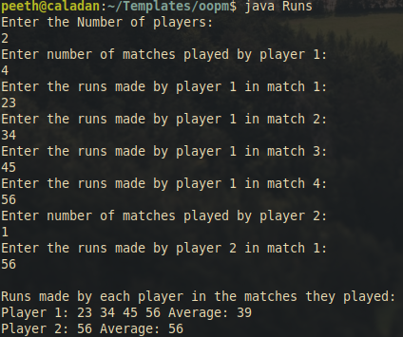

Post Lab Subjective/Objective type Questions:
- Create a jagged array of integers. This array should consist of two 2-D arrays. First 2-D array should contain 3 rows having length of 4, 3, and 2 respectively. Second 2-D array should contain 2 rows with length 3 and 4 respectively.
public class Jagged {
public static void main(String[]args){
int arr1[][]=new int[3][];
arr1[0]=new int[4];
arr1[1]=new int[3];
arr1[2]=new int[2];
int arr2[][]=new int[2][];
arr2[0]=new int[3];
arr2[1]=new int[4];
System.out.println("array 1");
for(int i=0;i<arr1.length;i++){
for(int j=0;j<arr1[i].length;j++){
System.out.print(arr1[i][j]+" ");
}
System.out.println();
}
System.out.println("\narray 2");
for(int i=0;i<arr2.length;i++){
for(int j=0;j<arr2[i].length;j++){
System.out.print(arr2[i][j]+" ");
}
System.out.println();
}
}
}
Output
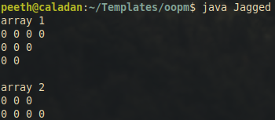
- Consider the following code

int number[] = new int[5];

After execution of this statement, which of the following are true?
(A) number[0] is undefined
(B) number[5] is undefined
(C) number[4] is null
(D) number[2] is 0
(E) number.length() is 5

(i) (C) & (E)
(ii) (A) & (E)
(iii) (E)
(iv) (B), (D) & (E)

Ans: (iv) (B), (D) & (E)

- Write a program to create an array where i^{th} row has i columns.
class RowsColumns {
public static void main(String[]args){
int arr1[][]=new int[5][];
for (int i=0;i<arr1.length;i++){
arr1[i]=new int[i+1];
for(int j=0;j<arr1[i].length;j++)
System.out.print(arr1[i][j]+" ");
System.out.println();
}
}
}

Output
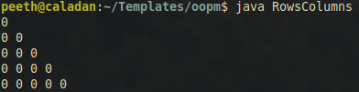

Conclusion:
The primary objective of this experiment was to use a two-dimensional array to represent this data, where the number of rows corresponds to the number of players, and each row can have a variable number of columns representing the matches played by each player.

The experiment successfully showcased the dynamic allocation of columns to each row, allowing flexibility in accommodating varying numbers of matches played by different players. This flexibility is essential in real-world scenarios where players participate in different numbers of matches.

The program effectively displayed the player number, runs scored in all matches, and their batting average as output. This demonstrated the program's ability to perform calculations and data display, showcasing a practical application of arrays in managing sports statistics.

Signature of faculty in-charge with Date:

