Course Name: | Object Oriented Programming Methodology | Semester: | III
Date of Performance: | 25/08/2023 | Batch No: | B2
Faculty Name: | Prof. Kiran Thale | Roll No: | 16010122158
Faculty Sign & Date: |  | Grade/Marks: | ___/25

Experiment No: 4
Title: Array of objects

Aim and Objective of the Experiment:
Write a program which accepts information about n no of customers from the user.
Create an array of objects to store account_id, name, balance.
Your program should provide following functionalities
- To add account
- To delete any account detail
- To display account details.

COs to be achieved:
CO1: Understand the features of object oriented programming compared with procedural approach with C++ and Java
CO2: Explore arrays, vectors, classes and objects in C++ and Java.

Tools used:
JDK, VScode / Eclipse

Theory:
Arrays of Objects:

Unlike traditional array which store values like string, integer, Boolean, etc. array of objects stores objects. The array elements store the location of reference variables of the object.

For example:

class Student
{
int rno;
String name;
float avg;
}
Student(int r, String name, float average)
{
rno=r;
this.name=name;
avg=average;
}
Student studentArray[] = new Student[n];

The above statement creates the array which can hold references to n number of Student objects. It doesn't create the Student objects themselves. They have to be created separately using the constructor of the Student class. The studentArray contains n number of memory spaces in which the address of n Student objects may be stored.
for (int i=0; i<studentArray.length; i++)
{
studentArray[i]=new Student(r,name,average);
}

The above for loop creates n Student objects and assigns their reference to the array elements. Now, a statement like the following would be valid.
studentArray[i].r=1001;

Class Diagram:
Customer
account_id:int
name:String
balance:String
add_account(Scanner sc):Customer
delete_account(Customer[] customers, int index, int len):Customer[]
display_accounts(Customer[] customers, int len)

Algorithm:
- Input number of customer records.
- Create customer records by taking the id, name and balance of accounts from the user.
- Take input action to do:
  - Add account: Check if there is space to add another record. If there is space then take input of id, name, balance of account and add account. Jump back to Step 3.
  - Delete account: Check if there is at least one account to delete. Delete account specified by user. Jump back to Step 3.
  - Display accounts: Display all the records of stored records. Jump back to Step 3.
  - Exit Program

Code:
import java.util.Scanner;
class Customer{
int account_id;
String name;
int balance;
Customer(int id, String name, int balance){
account_id = id;
this.name = name;
this.balance = balance;
}
static Customer add_account(Scanner sc){
System.out.println("\n\n###\n\nEnter the account ID of the Customer: ");
int id = sc.nextInt();
System.out.println("Enter the name of the customer: ");
String name = sc.next();
System.out.println("Enter the balance of the account: ");
int balance = sc.nextInt();
System.out.println("###");
Customer customer = new Customer(id, name, balance);
return customer;
}
static Customer[] delete_account(Customer[] customers, int index, int len){
for(int i = index; i < len - 1; i++){
customers[i] = customers[i + 1];
}
customers[len - 1] = null;
return customers;
}
static void display_accounts(Customer[] customers, int len){
System.out.println("Account ID\tCustomer Name\tBalance");
for(int i = 0; i < len; i++){
if(customers[i] == null)
Return;
System.out.println(customers[i].account_id + "\t" + customers[i].name + "\t" + customers[i].balance);
}
}
public static void main(String[] args){
Scanner sc = new Scanner(System.in);
System.out.println("Enter the number of records you wish to have: ");
int num = sc.nextInt();
Customer[] customers = new Customer[num];
for(int i = 0; i < num; i++){
customers[i] = add_account(sc);
}
int top = num;
while(true){
System.out.println("\n\n###\n\nEnter the corresponding option to perform that option:\n[1] Add Account\n[2] Delete Account\n[3] Display Account details\n[4] Exit");
int option = sc.nextInt();
switch(option){
case 1:
if(top == num){
System.out.println("\n\nThere is no more space left to add an account. Please delete an account to make space to add a new account.\n\n");
break;
}
add_account(sc);
break;
case 2:
System.out.println("\n\nEnter the index of the account to delete: ");
int index = sc.nextInt();
customers = delete_account(customers, index, num);
break;
case 3:
display_accounts(customers, num);
break;
case 4:
System.exit(0);
default:
System.out.println("\n\nIncorrect Option.");
}
}
}
}

Output:
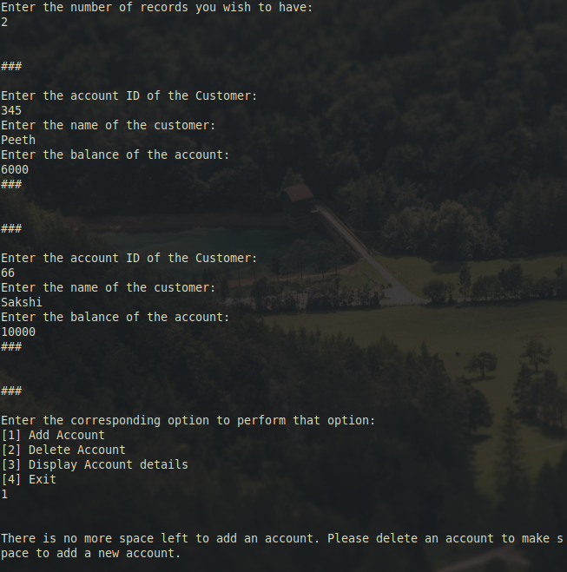

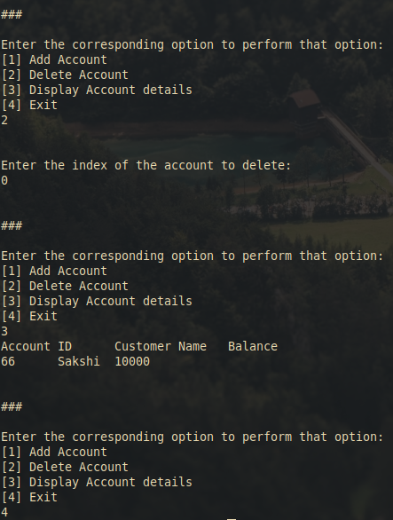

Post Lab Subjective/Objective type Questions:
- If an array of objects is of size 10 and a data value have to be retrieved from 5th object then ________________ syntax should be used.

a) Array_Name[4].data_variable_name;
b) Data_Type Array_Name[4].data_variable_name;
c) Array_Name[4].data_variable_name.value;
d) Array_Name[4].data_variable_name(value);
Answer : a

- The Object array is created in _____________________
a) Heap memory
b) Stack memory
c) HDD
d) ROM

Answer : a

Conclusion:
This Java experiment enabled us to successfully implement a customer management system that allows users to interact with customer data. The program's core functionality included the following:

1. Adding Accounts: Users could input information about 'n' customers, including their account IDs, names, and balances. This information was stored in an array of objects, with each object representing a customer.

2. Deleting Accounts: The program allowed users to delete customer details by removing the corresponding object from the array. This feature offered a way to manage and modify the customer database as needed.

3. Displaying Account Details: Users could view account details, enabling them to retrieve and display information about all the customers stored in the array.

Signature of faculty in-charge with Date:

