Course Name: | Object Oriented Programming Methodology | Semester: | III
Date of Performance: | 06/10/2023 | Batch No: | B2
Faculty Name: | Prof. Kiran Thale | Roll No: | 16010122158
Faculty Sign & Date: |  | Grade/Marks: | ___/25

Experiment No: 6
Title: Case Study ( Class Diagram )

Aim and Objective of the Experiment:
Draw class Diagram for the chosen Case Study. Clearly show
  - Attributes
  - Multiplicities between classes
  - Aggregations/compositions/Association between classes
  - Generalization between classes in the class diagram.
And show the implementation of aggregation, association, composition and generalization between the classes.

COs to be achieved:
CO1: Understand the features of object oriented programming compared with procedural approach with C++ and Java.
CO2: Explore arrays, vectors, classes and objects in C++ and Java.
CO3: Implement scenarios using object oriented concepts (Drawing class diagram, relationship between classes, sequence diagram)
CO4: Explore the interface, exceptions, multithreading, packages

Tools used:
JDK, VScode / Eclipse

Theory:
Pre Lab/ Prior Concepts:

Define Class, Methods and Object.

A class in Java is a set of objects which shares common characteristics/ behavior and common properties/ attributes. It is a user-defined blueprint or prototype from which objects are created.

Properties of Java Classes:
- Class is not a real-world entity. It is just a template or blueprint or prototype from which objects are created.
- Class does not occupy memory.
- Class is a group of variables of different data types and a group of methods.
- A Class in Java can contain:
  - Data member
  - Method
  - Constructor
  - Nested Class
  - Interface
The method in Java or Methods of Java is a collection of statements that perform some specific task and return the result to the caller. A Java method can perform some specific task without returning anything. Java Methods allow us to reuse the code without retyping the code. In Java, every method must be part of some class that is different from languages like C, C++, and Python.
1. A method is like a function i.e. used to expose the behavior of an object.
2. It is a set of codes that perform a particular task.
An object in Java is a basic unit of Object-Oriented Programming and represents real-life entities. Objects are the instances of a class that are created to use the attributes and methods of a class. A typical Java program creates many objects, which as you know, interact by invoking methods. An object consists of :
- State: It is represented by attributes of an object. It also reflects the properties of an object.
- Behavior: It is represented by the methods of an object. It also reflects the response of an object with other objects.
- Identity: It gives a unique name to an object and enables one object to interact with other objects.

Understanding of Aggregation, Association, Composition and Generalization between classes

Aggregation: The relationship between the whole and part, and the whole and part can be separated.

Aggregate relations also represent the relationship between the whole and part of the class, member objects are part of the overall object, but the member object can exist independently from the overall object.
For example, bus drivers and work clothes and hats are part of the overall relationship, but they can be separated. Work clothes and hats can be worn on other drivers. Bus drivers can also wear other work clothes and hats.
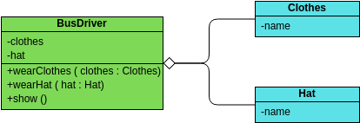

Association: Indicates that a property of a class holds a reference to an instance (or instances) of another class.

Association is the most commonly used relationship between a class and a class, which means that there is a connection between one type of object and another type of object. Combinations and aggregations also belong to associative relations , but relations between classes of affiliations are weaker than the other two.

There are four kinds of associations : two-way associations , one-way associations , self-association , and multiple-number associations .

For example: cars and drivers, one car corresponds to a particular driver, and one driver can drive multiple cars.

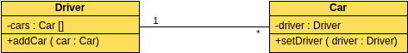

Composition: The relationship between the whole and the part, but the whole and the part cannot be separated .
The combination relationship represents the relationship between the whole and part of the class, and the overall and part have a consistent lifetime. Once the overall object does not exist, some of the objects will not exist, and they will all die in the same life. For example, a person is composed of a head and a body. The two are inseparable and coexist.
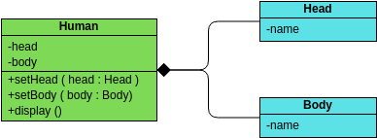

Generalization is used to describe the relationship between parent and child classes. A parent class is also called a base class, and a subclass is also called a derived class.

In the inheritance relationship, the subclass inherits all the functions of the parent class, and the parent class has all the attributes, methods, and subclasses. Subclasses contain additional information in addition to the same information as the parent class.

For example: buses, taxis, and cars are cars, they all have names, and they can all be on the road.
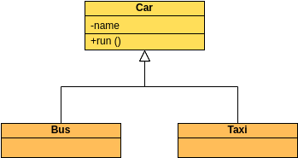

List Of Classes:

Issue
Ebook
Book
DataManager
MailFormatException
java.lang.Exception
Librarian

Identify Attributes for each class:

Issue : issuerName, issuerMail, issuerAddress, issuerIdentificationMethod
Ebook : fileSize
Book : name, author, quantity
DataManager : catalog, digitalCatalog,issueList
Librarian : data

Identify List of Methods in each classes:

Issue : display
DataManager : searchDigitalCatalog, searchPhysicalCatalog
MailFormatException : MailFormatException
Librarian : verifyNum, verifyMail, issueBook, addBook, returnBook, removeBook

Class Diagram:
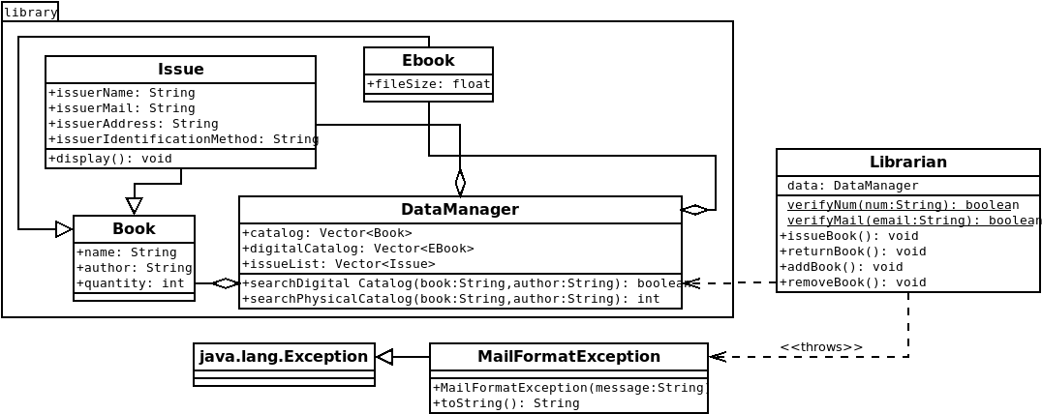

Algorithm:
Step 1: Start
Step 2: Input what action to perform from the user from the following options: Add Book to catalog or digital library, remove book from catalog or digital library, issue book or return book
Step 3: If the user wishes to add a book to the catalog, then input the details of the book and the number of books to add to the library. Make an object of the book with these details and store it in the catalog vector.
Step 4: If the user wishes to add a book to the digital catalog, then input the details of the book and the size of the ebook. Make an object of the ebook with these details and store it in the digital catalog vector.
Step 5: If the user wishes to remove a book from the catalog, then input the details of the book they wish to remove. Check if the book exists in the catalog and if it does then remove it from the catalog vector.
Step 6: If the user wishes to remove an ebook, then input the details of the ebook and check if it exists in the digital library. If it does, remove it from the digital library.
Step 6: If the user wishes to issue a book, then input the details of the book and check if it exists in the digital library. If it does then share the book with them online. If it does not, then check the catalog for the book. If it is available in the catalog, ask the user for the quantity of the book to be issued. If the quantity of the book is more than the amount of books in the library then prompt the user about the same, else issue the books the user wants and add the details of the issuer as well as the book to the issue list vector in the form of an issue object. If the book is not available in the catalog then prompt the user about the same.
Step 7: If the user wishes to return a book, then input the details of the issuer and the book. If the issue exists in the issue list, then accept the books being returned and increment the library’s catalog accordingly.
Step 8: Go to step 2
Step 9: End

Code:
Librarian Class
import java.util.Scanner;

import java.util.regex.Matcher;
import java.util.regex.Pattern;

import library.*;

class MailFormatException extends Exception{
public MailFormatException(String message){
super(message);
}

public String toString(){
return getMessage();
}
}

public class Librarian{
DataManager data = new DataManager();

static boolean verifyMail(String email){
// Regular Expression to check if mail is of valid format
String emailRegex = "^[a-zA-Z0-9_+&*-]+(?:\\.[a-zA-Z0-9_+&*-]+)*@(?:[a-zA-Z0-9-]+\\.)+[a-zA-Z]{2,7}$";
Pattern pat = Pattern.compile(emailRegex);
if (email == null)
return false;
return pat.matcher(email).matches();
}

static boolean verifyNum(String num){
for (int i = 0; i < num.length(); i++){
if (Character.isDigit(num.charAt(i)) == false){
return false;
}
}
return true;
}

void issueBook(Scanner sc){
System.out.println("\nBook/E-Book Issue Processing");

System.out.println("Enter name of book: ");
String bookName = sc.nextLine();

System.out.println("Enter name of book's author: ");
String author = sc.nextLine();

System.out.println("Enter the e-mail id of issuer: ");
String mail;

while(true){
try{
mail = sc.nextLine();
if(verifyMail(mail)){
break;
}
throw new MailFormatException("The Inputted E-Mail ID is of an invalid format.");
}
catch(MailFormatException e){
System.out.println(e.toString());
System.out.println("Enter a valid e-mail: ");
continue;
}
}

if(data.searchDigitalCatalog(bookName, author)){
System.out.println("Access for " + bookName + " by " + author + "granted to " + mail);
return;
}
else{
int index = data.searchPhysicalCatalog(bookName, author);
if(index > -1){
DataManager.Book issueBook = data.catalog.get(index);

int num;
while(true){
System.out.println("Enter the number of copies to be issued[must be >0]: ");
String copies = sc.nextLine();

if(verifyNum(copies)){
num = Integer.parseInt(copies);
if(num > 0){
break;
}
}
System.out.println("The input given is not valid. It must be a number more than zero");
}

if(issueBook.quantity < num){
System.out.println("Only " + issueBook.quantity + " of this book are available. Do you want to issue them all [y/N]?");
String choice = sc.nextLine();
if(choice.equals("y") == false)
return;
num = issueBook.quantity;
}

System.out.println("Enter the name of the Issuer: ");
String iname = sc.nextLine();

System.out.println("Enter the Issuer's address: ");
String iaddr = sc.nextLine();

System.out.println("Enter the Form of Identification shown: ");
String ikyc = sc.nextLine();

data.issueList.add(data.new Issue(bookName, author, num, iname, mail, iaddr, ikyc));

issueBook.quantity -= num;

return;
}
}

System.out.println(bookName + " by " + author + " is unavailable.");
}

void returnBook(Scanner sc){
System.out.println("Enter name of person returning the book: ");
String rname = sc.nextLine();

System.out.println("Following are the list of issues by people with the same name:");

for (int i = 0; i < data.issueList.size(); i++){
if(rname.equals(data.issueList.get(i).issuerName)){
System.out.println("\nIssue Number " + (i + 1));
data.issueList.get(i).display();
}
}

int rnum;
while(true){
System.out.println("Enter the associated Issue Number with the books being returned or 0 if no option matches: ");
String inum = sc.nextLine();

if(verifyNum(inum)){
rnum = Integer.parseInt(inum) - 1;
break;
}
System.out.println("The input given is not valid.");
}

if(rnum > 0){
String bookName = data.issueList.get(rnum).name;
String author = data.issueList.get(rnum).author;
int index = data.searchPhysicalCatalog(bookName, author);
data.catalog.get(index).quantity += data.issueList.get(rnum).quantity;
data.issueList.removeElementAt(rnum);
}
}

void addBook(Scanner sc){
System.out.println("Enter the name of the book: ");
String bookName = sc.nextLine();

System.out.println("Enter the name of the author: ");
String author = sc.nextLine();

int quantity;
while(true){
System.out.println("Enter the quantity: ");
String quan = sc.nextLine();

if(verifyNum(quan)){
quantity = Integer.parseInt(quan);
if(quantity > 0){
break;
}
}
System.out.println("The input given is not valid.");
}

int index = data.searchPhysicalCatalog(bookName, author);
if(index > -1){
data.catalog.get(index).quantity += quantity;
}
else{
data.catalog.add(data.new Book(bookName, author, quantity));
}

System.out.println(quantity + " " + bookName + " by " + author + " added to the record.");
}

void removeBook(Scanner sc){
System.out.println("Enter the name of the book: ");
String bookName = sc.nextLine();

System.out.println("Enter the name of the author: ");
String author = sc.nextLine();

int quantity;
int index = data.searchPhysicalCatalog(bookName, author);
if(index > -1){
System.out.println("Quantity of " + bookName + " by " + author + " in records: " + data.catalog.get(index).quantity);
while(true){
System.out.println("Enter quantity to remove from records[0-" +data.catalog.get(index).quantity + "]: ");
String quan = sc.nextLine();

if(verifyNum(quan)){
quantity = Integer.parseInt(quan);
break;
}
System.out.println("The input given is not valid.");
}
data.catalog.get(index).quantity -= quantity;
System.out.println(quantity + " " + bookName + " by " + author + " removed from the record.");
}
else{
System.out.println(bookName + " by " + author + " does not exist in records.");
}
}

void addEbook(Scanner sc){
System.out.println("Enter the name of the book: ");
String bookName = sc.nextLine();

System.out.println("Enter the name of the author: ");
String author = sc.nextLine();

if(data.searchDigitalCatalog(bookName, author)){
System.out.println(bookName + " by " + author + " already exists in the digital record.");
}
else{
System.out.println("Enter the File Size of the book in Mb");
float mb = sc.nextFloat();

data.digitalCatalog.add(data.new Ebook(bookName, author, mb));
System.out.println(bookName + " by " + author + " added to the digital record.");
}
}

void removeEbook(Scanner sc){
System.out.println("Enter the name of the book: ");
String bookName = sc.nextLine();

System.out.println("Enter the name of the author: ");
String author = sc.nextLine();

if(data.searchDigitalCatalog(bookName, author)){
for(int i = 0; i < data.digitalCatalog.size(); i++){
if(bookName.equals(data.digitalCatalog.get(i).name) && author.equals(data.digitalCatalog.get(i).author)){
data.digitalCatalog.removeElementAt(i);
break;
}
}
System.out.println(bookName + " by " + author + " removed from the digital record.");
}
else{
System.out.println(bookName + " by " + author + " does not exist in records.");
}

}

public static void main(String[] args){
Scanner sc = new Scanner(System.in);
Librarian lib = new Librarian();
while(true){
System.out.println("Enter Associated Number to Execute that Action: ");
System.out.println("[1] Add Book to Catalog");
System.out.println("[2] Remove Book from Catalog");
System.out.println("[3] Add Book to Digital Catalog");
System.out.println("[4] Remove Book from Digital Catalog");
System.out.println("[5] Issue Book");
System.out.println("[6] Return Book");

String option = sc.nextLine();

switch(option){
case "1":
lib.addBook(sc);
break;
case "2":
lib.removeBook(sc);
break;
case "3":
lib.addEbook(sc);
break;
case "4":
lib.removeEbook(sc);
break;
case "5":
lib.issueBook(sc);
break;
case "6":
lib.returnBook(sc);
break;
default:
System.out.println("Enter a valid option");
}
System.out.println();
}
}
}

DataManager Class
package library;

import java.util.Vector;

public class DataManager{
public Vector<Book> catalog = new Vector<Book>(3, 2);
public Vector<Ebook> digitalCatalog = new Vector<Ebook>(3, 2);
public Vector<Issue> issueList = new Vector<Issue>(3, 2);

public boolean searchDigitalCatalog(String book, String author){
for(Ebook ebook : digitalCatalog){
if(book.equals(ebook.name) && author.equals(ebook.author)){
String formattedFileSize = String.format("%.02f", ebook.fileSize);
System.out.println(book + " by " + author + " [of size " + formattedFileSize + " Mb] is present in Digital Catalog.");
return true;
}
}
return false;
}

public int searchPhysicalCatalog(String book, String author){
for(int i = 0; i < catalog.size(); i++){
if(book.equals(catalog.get(i).name) && author.equals(catalog.get(i).author)){
if(catalog.get(i).quantity > 1){
System.out.println(catalog.get(i).quantity + " copies of " + book + " by " + author + " is available in the Physical Catalog.");
}
else{
System.out.println("A copy of " + book + " by " + author + " is available in the Physical Catalog.");
}
return i;
}
}
return -1;
}

public class Book{
public String name;
public String author;
public int quantity;

public Book(String name, String author, int quantity){
this.name = name;
this.author = author;
this.quantity = quantity;
}
}

public class Ebook extends Book{
public float fileSize;

public Ebook(String name, String author, float size){
super(name, author, 1);
fileSize = size;
}
}

public class Issue extends Book{
public String issuerName;
public String issuerMail;
public String issuerAddress;
public String issuerIdentificationMethod;

public Issue(String name, String author, int quantity, String iname, String imail, String iaddr, String ikyc){
super(name, author, quantity);
issuerName = iname;
issuerMail = imail;
issuerAddress = iaddr;
issuerIdentificationMethod = ikyc;
}

public void display(){
System.out.println("Details of the Issue of " + quantity + " " + name + " by " + author);
System.out.println("Issuer's Name: " + issuerName);
System.out.println("Issuer's E-mail id: " + issuerMail);
System.out.println("Issuer's Address: " + issuerAddress);
System.out.println("Method of Identification: " + issuerIdentificationMethod);
System.out.println();
}
}
}

Output:
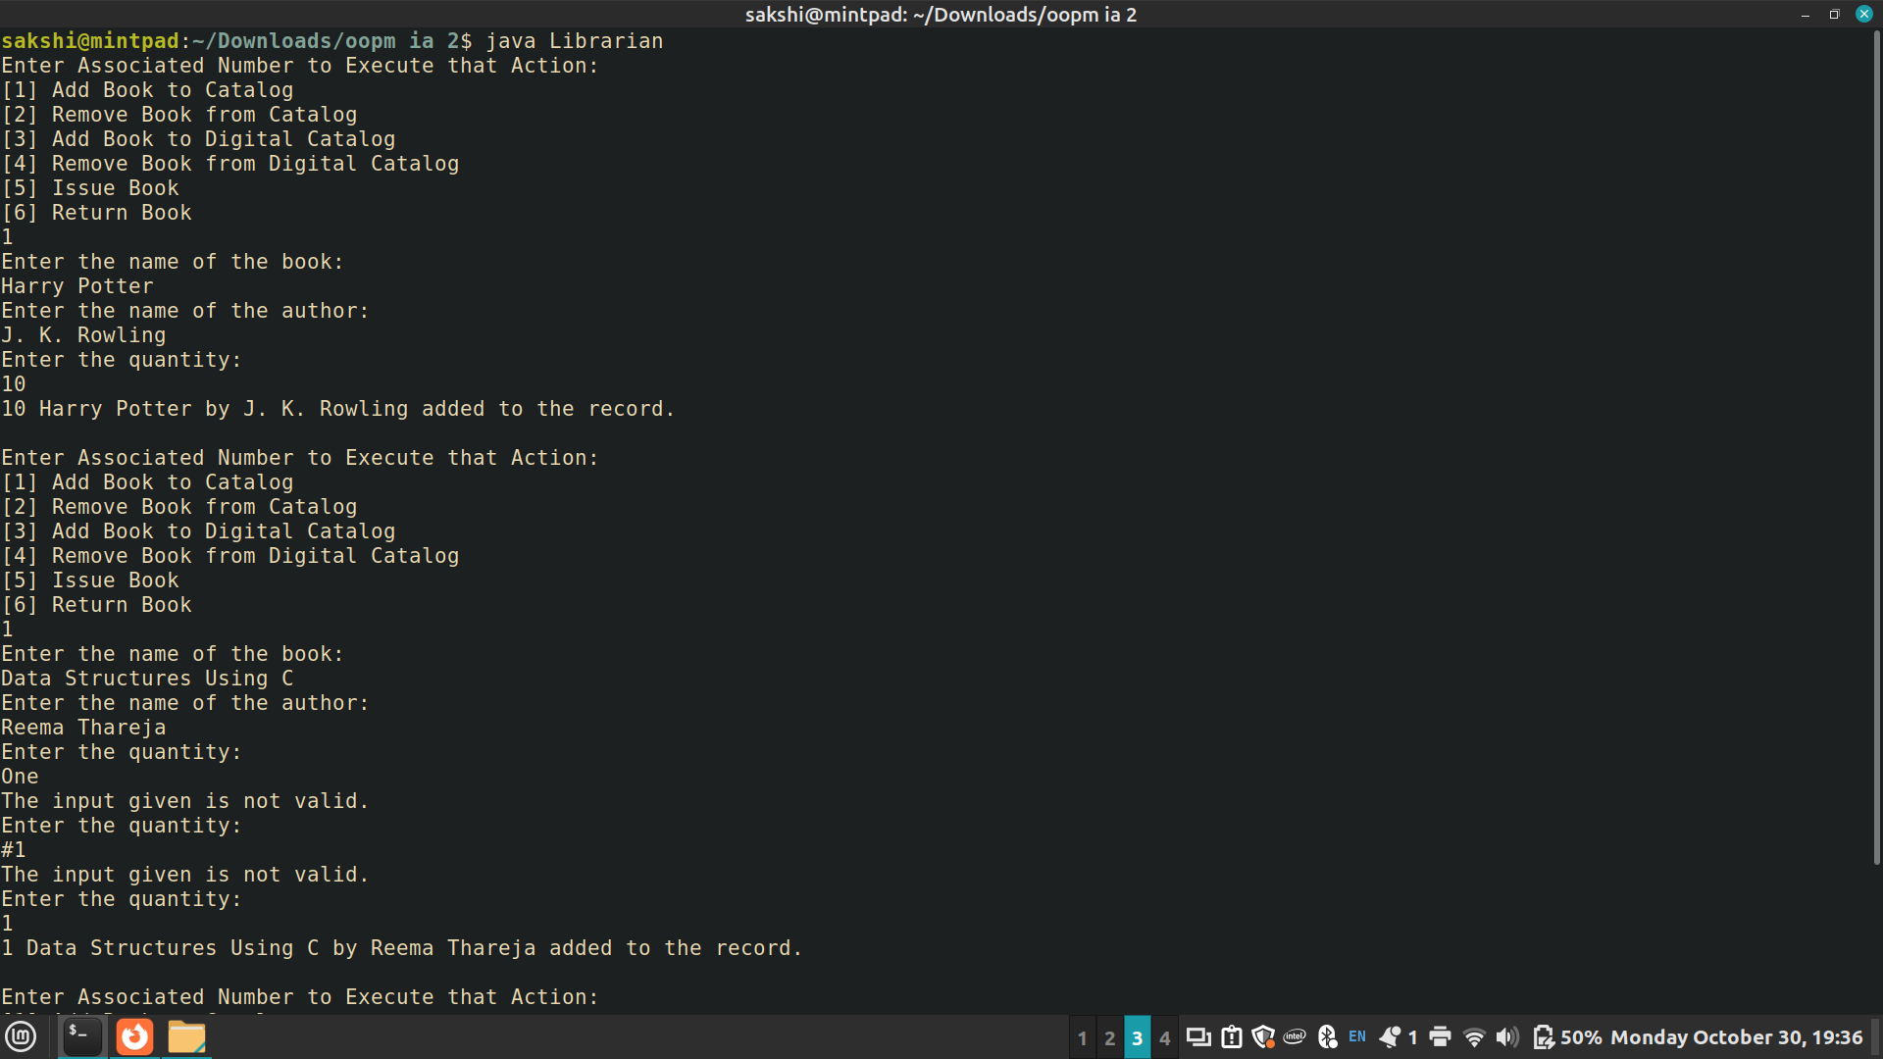

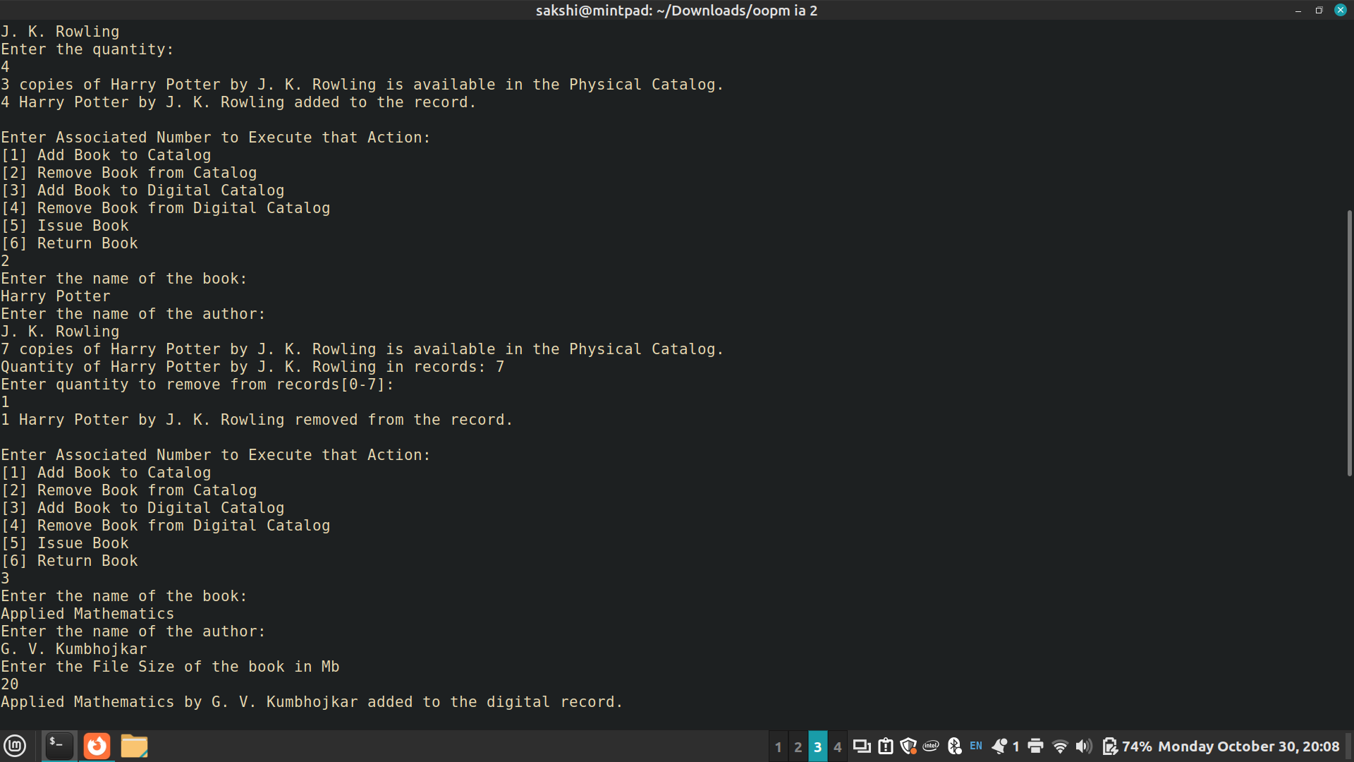



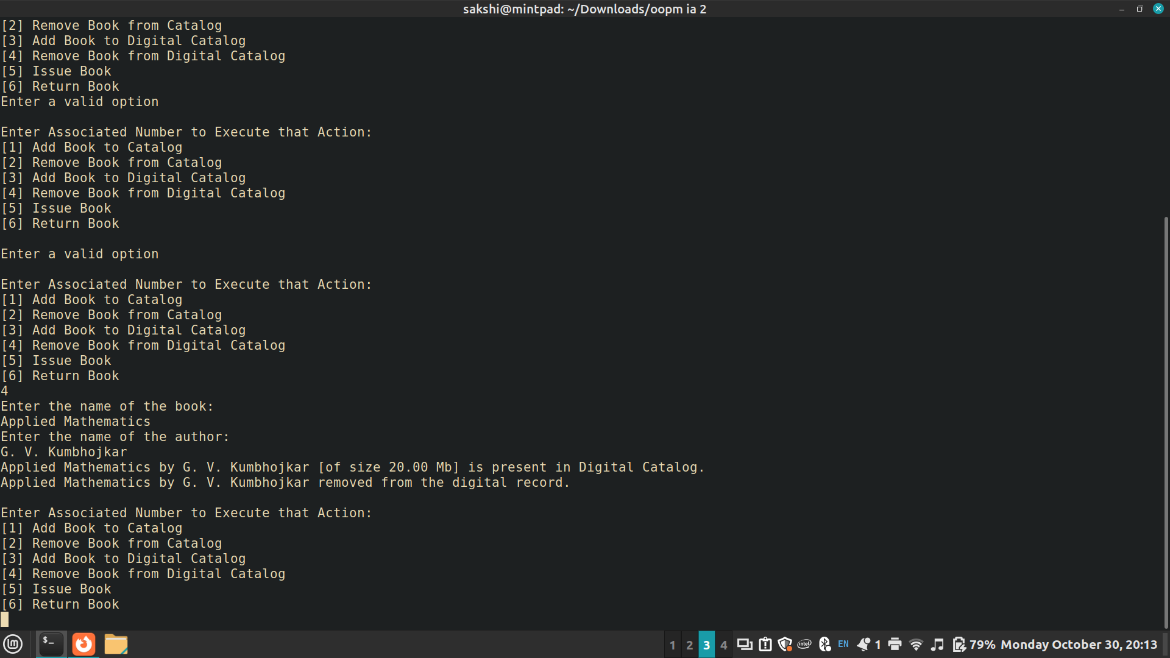

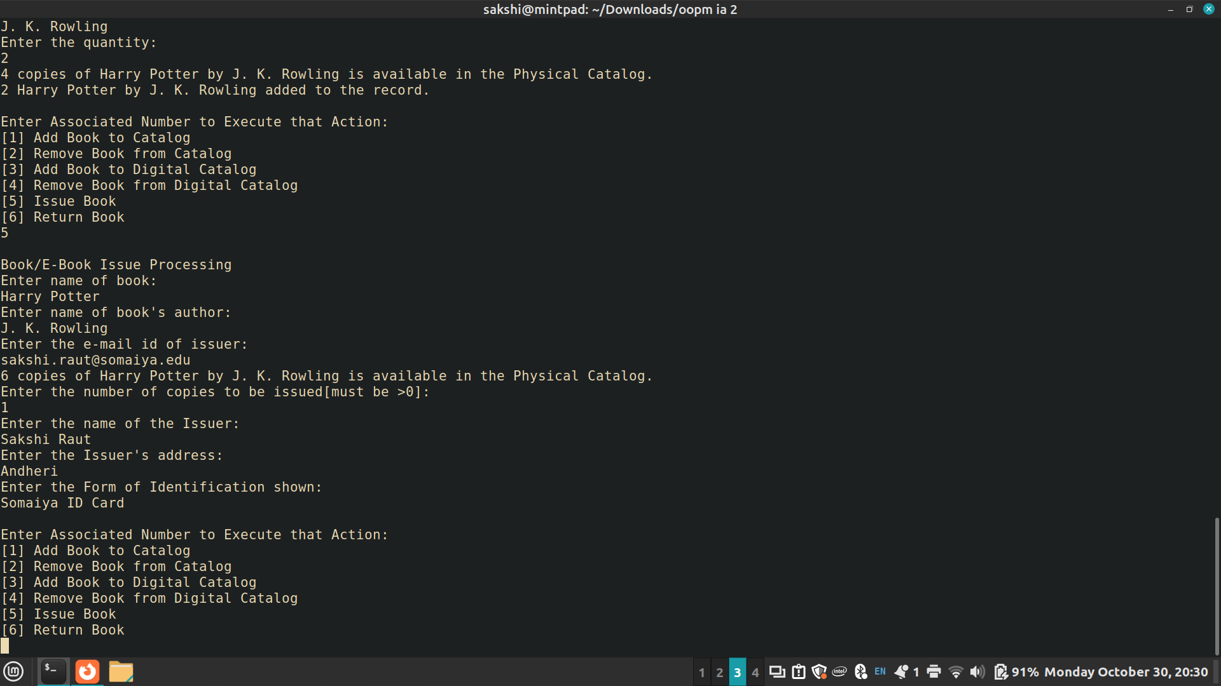

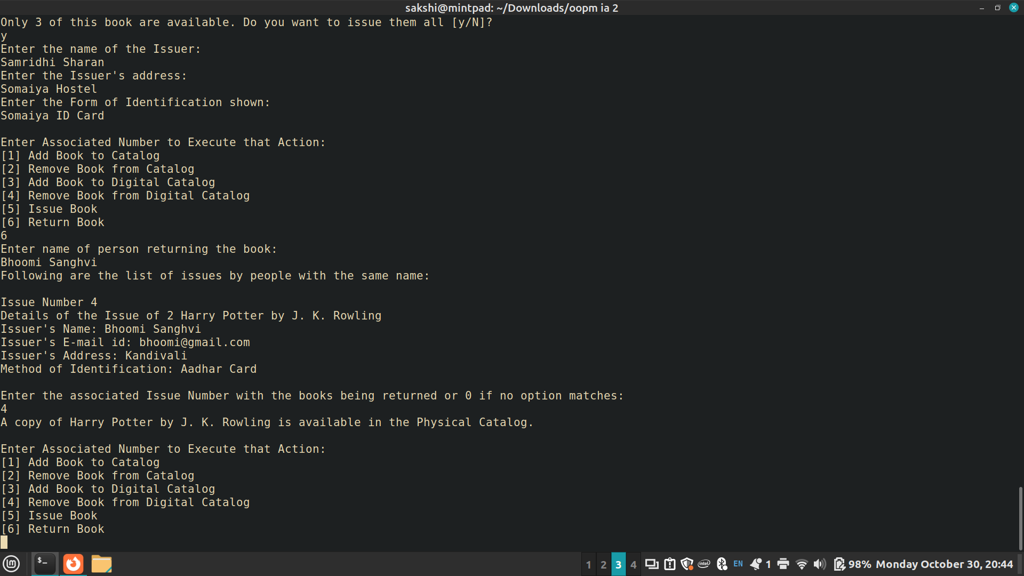

Post Lab Subjective/Objective type Questions:
1. Consider the following class:
public class TypeOfVariable{
public static int a;
int b,c;
public void printValue(){
int x = 10;
}
public static void main(String args[]){
TypeOfVariable object=new TypeOfVariable();
object.printValue();
}
}
- What are the class/static variables?
‘a’ is a class variable.

- What are the instance variables?
‘b’ and ‘c’ are instance variables

- What are local variables?
‘x’ is a local variable in the printValue method and ‘object’ is a local variable in the main method.

2. What is the output from the following code:
public class Test
{
static int x = 11;
private int y = 33;
public void method1(int x)
{
Test t = new Test();
this.x = 22;
y = 44;

System.out.println("Test.x: " + Test.x);
System.out.println("t.x: " + t.x);
System.out.println("t.y: " + t.y);
System.out.println("y: " + y);
}

public static void main(String args[])
{
Test t = new Test();
t.method1(5);
}
}

Output:
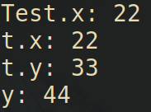

Conclusion:
A well-designed library management program offers numerous benefits to both library staff and patrons. It allows librarians to manage their collections effectively, track inventory, and offer a range of services to their patrons. Furthermore, it enhances the overall library experience for users by providing easy access to resources, cataloging, and self-checkout options.

In conclusion, this code serves as a simple library catalog management system, and it can be used for educational purposes to understand Java programming concepts such as custom exceptions, regular expressions, user input validation, and class interactions. When presenting this code, you can highlight its modularity and error-handling capabilities, making it a useful tool for library management.

Signature of faculty in-charge with Date:

