Class Diagram

Introduction to UML
- UML (Unified Modeling Language) is a graphical language for modeling the structure and behavior of object-oriented systems.
- UML is widely used in industry to design, develop and document complex software.
- We will focus on creating UML class diagrams, which describe the internal structure of classes and relationships between classes.

Classes
- A class diagram contains a rectangle for each class. It is divided into three parts.
- The name of the class.
- The names and types of the fields.
- The names, return types, and parameters of the methods.

Example
- For example, a Person class and a Book class might be modeled like this:
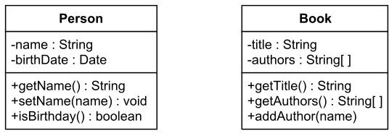

Marks for
UML-supported visibility types

Mark | Visibility type
+ | Public
# | Protected
- | Private
~ | Package

Example Explained
- The class diagram indicates that a Person object has private fields named name and birthDate, and that it has public methods named getName, setName and isBirthday.
- A Book object has private fields named title and authors.
- A Book object also has public methods named getTitle, getAuthors and addAuthor.

Use Relationships
- Often, objects and/or methods of one class use objects/methods from another class.
- For example, a person might read and/or own a book, and these relationships might be modeled in the UML diagram, so that they will be implemented in the corresponding program.
- UML class diagrams include the following types of use-relationships, in order from weakest to strongest.
- Dependency
- Unidirectional Association
- Bidirectional Association

Dependency
- An object of one class might use an object of another class in the code of a method.
- If the object is not stored in any field, then this is modeled as a dependency relationship.
- For example, the Person class might have a hasRead method with a Book parameter that returns true if the person has read the book (perhaps by checking some database).

Dependency Example
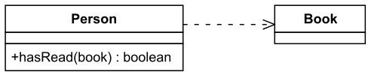

Unidirectional Association
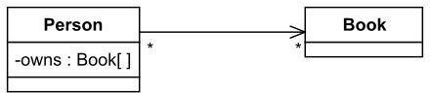

Unidirectional Association
- An object might store another object in a field.
- For example, people own books, which might be modeled by an owns field in Person objects.
- However, a book might be owned by a very large number of people, so the reverse direction might not be modeled.
- The *'s in the figure indicate that a book might be owned any number of people, and that a person can own any number of books.

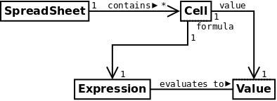

Navigability
- Navigability arrows indicate whether, given one instance participating in a relationship, it is possible to determine the instances of the other class that are related to it.
- The diagram in the previous slide suggests that, given a spreadsheet, we can locate all of the cells that it contains, but that we cannot determine from a cell in what spreadsheet it is contained.
- Given a cell, we can obtain the related expression and value, but given a value (or
expression) we cannot find the cell of which those are attributes.

Bidirectional Association
- Two objects might store each other in fields. For example, in addition to a Person object listing all the books that the person owns, a Book object might list all the people that own it.
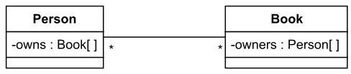

Aggregation

- Denoted by an arrowhead drawn as an unfilled diamond, aggregation can be read as “is part of” or, in the opposite direction as “has a”.
- This diagram suggests that cells are part of a spreadsheet and that an expression and a value are each part of a cell.

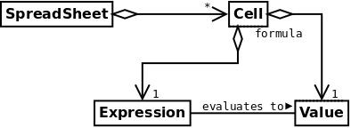

Another example of aggregation
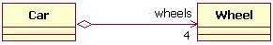

Composition
- The composition relationship is just another form of the aggregation relationship, but the child (part) class's instance lifecycle is dependent on the parent (whole) class's instance lifecycle.
- In the following, which shows a composition relationship between a Company class and a Department class, notice that the composition relationship is drawn like the aggregation relationship, but this time the diamond shape is filled.
- In the relationship modeled in the figure, a Company class instance will always have at least one Department class instance.
- Because the relationship is a composition relationship, when the Company instance is removed/destroyed, the Department instance is automatically removed/destroyed as well.
- Another important feature of composition is that the part class can only be related to one instance of the parent class (e.g. the Company class in our example).

Example of composition
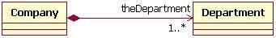

Inheritance Relationships: Generalization
- A class extends another class.
- For example, the Book class might extend the Document class, which also might include the Email class.
- The Book and Email classes inherit the fields and methods of the Document class (possibly modifying the methods), but might add additional fields and methods.

Generalization example
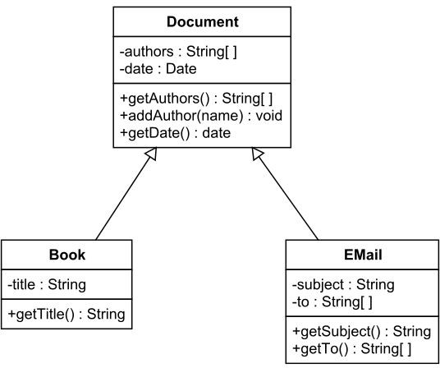

Inheritance Relationships: Realization
- A class implements an interface.
- For example, the Owner interface might specify methods for acquiring property and disposing of property.
- The Person and Corporation classes need to implement these methods, possibly in very different ways.

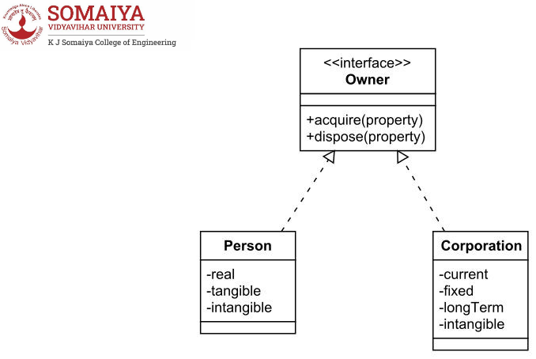
Realization Example

Association Class
- In modeling an association, there are times when you need to include another class because it includes valuable information about the relationship.
- For this you would use an association class that you tie to the primary association. An association class is represented like a normal class.
- The difference is that the association line between the primary classes intersects a dotted line connected to the association class.

Association class example
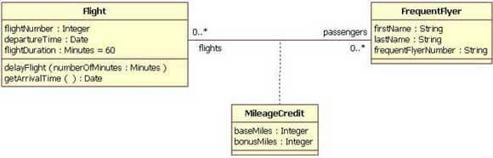
Reflexive associations
- A class can also be associated with itself, using a reﬂexive association.
- An Employee class could be related to itself through the manager/manages role.
- When a class is associated to itself, this does not mean that a class's instance is related to itself, but that an instance of the class is related to another instance of the class.


