Chapter 10: Exception Handling
Exception-Handling Fundamentals
- Exception: an abnormal condition that arises in a code sequence at run time/ run time error
- Java exception is an object that describes an exceptional (that is, error) condition
- When an exceptional condition arises, an object representing that exception is created and thrown in the method that caused the error
- Exception can be
- generated by the Java run-time system (relate to fundamental errors that violate the rules of the Java language)
- Manually generated (typically used to report some error condition to the caller of a method)

Keywords for exception handling
- try block contains program statements that are to be to monitored for exceptions
- If an exception occurs within the try block, it is thrown
- catch block contain statements that catch this exception and handle it in some rational manner
- System-generated exceptions are automatically thrown by the Java runtime system.
- throw is used to manually throw an exception
- throws clause is used to specify any exception that is thrown out of a method
- finally block contains code that absolutely must be executed after a try block completes

General form of an exception-handling
block
try {
// block of code to monitor for errors
}
catch (ExceptionType1 exOb) {
// exception handler for ExceptionType1
}
catch (ExceptionType2 exOb) {
// exception handler for ExceptionType2
}
// ...
finally {
// block of code to be executed after try block ends
}
Exception Types
- All exception types are subclasses of the built-in class Throwable
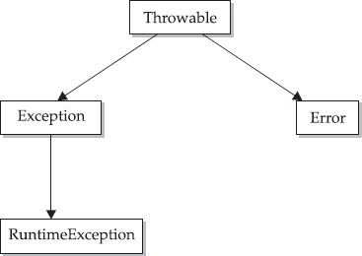
- Below Throwable are two subclasses that partition exceptions into two branches
- Exception class: used for exceptional conditions that user programs should catch
- RuntimeException etc are subclasses of Exception
- Error class: used by the Java run- time system to indicate errors having to do with the run-time environment (eg Stack overflow)

Uncaught Exceptions
- Uncaught exception :caught by the default handler (provided by the Java run-time system) that
- displays a string describing the exception
- prints a stack trace from the point at which the exception occurred
- terminates the program

Using try and catch
- Exception handling benefits
- allows you to fix the error
- prevents the program from automatically terminating

Displaying a Description of an Exception
- Throwable overrides the toString( ) method (defined by Object) so that it returns a string containing a description of the exception

Multiple catch Clauses
- Use when more than one exception could be raised by a single piece of code
- When an exception is thrown, each catch statement is inspected in order, and the first one whose type matches that of the exception is executed
- All others are bypassed
- execution continues after the try / catch block
- NOTE: exception subclasses must come before any of their superclasses because a catch statement that uses a superclass will catch exceptions of that type plus any of its subclasses

Nested try Statements
- a try statement can be inside the block of another try
- Each time a try statement is entered, the context of that exception is pushed on the stack
- If an inner try statement does not have a catch handler for a particular exception, the stack is unwound and the next try statement’s catch handlers are inspected for a match
- This continues until one of the catch statements succeeds, or until all of the nested try statements are exhausted
- If no catch statement matches, then the Java run-time system will handle the exception

throw
- To throw an exception explicitly, use the throw statement
- flow of execution stops immediately after the throw statement
- nearest enclosing try block is inspected to see if it has a catch statement that matches the type of exception and control is transferred to that statement
- No match: next enclosing try statement is inspected, and so on
- no matching catch found in any block: default exception handler halts the program and prints the stack trace

throws
- If method can cause an exception that it does not handle
- Then method’s declaration must include a throws clause (that lists the types of exceptions that a method might throw)
- Necessary for all exceptions, except Error or RuntimeException, or any of their subclasses

finally
- finally creates a block of code that will be executed after a try /catch block has completed and before the code following the try/catch block
- finally block will execute whether or not an exception is thrown
- If an exception is thrown, the finally block will execute even if no catch statement matches the exception
- useful for closing file handles and freeing up any other resources
- finally clause is optional

Java’s Built-in Exceptions
Java’s Unchecked RuntimeException Subclasses Defined in java.lang
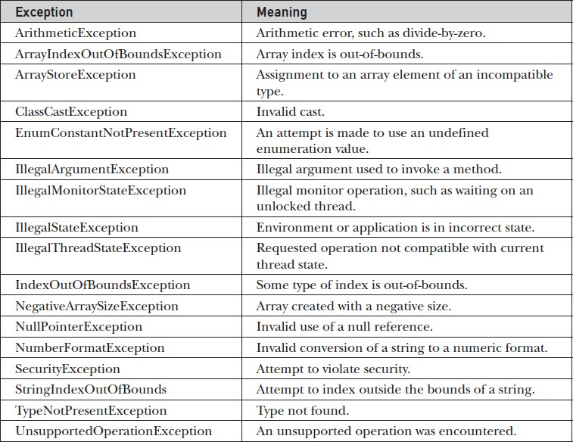

Java’s Built-in Exceptions
Java’s Checked Exceptions Defined in java.lang

