Java packages
- package: A collection of related classes.
- 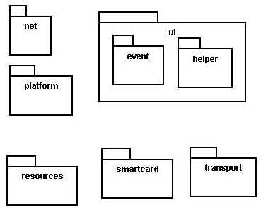
- Can also "contain" sub-packages.
- Sub-packages can have similar names, but are not actually contained inside.
- java.awt does not contain java.awt.event

Uses of Java packages:
- group related classes together
- as a namespace to avoid name collisions
- provide a layer of access / protection
- keep pieces of a project down to a manageable size

Packages and directories
- package directory (folder)
- class file
- A class named D in package a.b.c should reside in this file: a/b/c/D.class
- (relative to the root of your project.
- The "root" directory of the package hierarchy is determined by your
class path or the directory from which java was run.

Classpath
- class path: The location(s) in which Java looks for class files.
Can include:
- the current "working directory" from which you ran javac / java
- other folders
- JAR archives
- URLs
- Can set class path manually when running java at command line:
- java -cp /home/stepp/libs:/foo/bar/jbl MyClass

A package declaration
package name;
public class name { ...

Example:
package pacman.model;
public class Ghost extends Sprite {
...
}

- File Sprite.java should go in the folder pacman/model .

Importing a package
import packageName.*; // all classes

Example:
package pacman.gui;
import pacman.model.*;
public class PacManGui {
...
Ghost blinky = new Ghost();
}

- PacManGui must import the model package in order to use it.

Importing a class
import packageName.className; // one class

Example:
package pacman.gui;
import pacman.model.Sprite;
public class PacManGui {
Ghost blinky = new Ghost();
}

- Importing single classes has high precedence:
- if you import .*, a same-named class in the current dir will override
- if you import .className, it will not

Static import
import | static | packageName.className.*;
- Static import allows you to refer to the members of another class without writing that class's name.
- Should be used rarely and only with classes whose contents are entirely static "utility" code.

Referring to packages
packageName.className

Example:
java.util.Scanner console =
new java.util.Scanner(java.lang.System.in);

- You can use a type from any package without importing it if you write its full name.
- Sometimes this is useful to disambiguate similar names.
- Example: java.awt.List and java.util.List
- Or, explicitly import one of the classes.

The default package
- Compilation units (files) that do not declare a package are put into a default, unnamed, package.
- Classes in the default package:
- Cannot be imported
- Cannot be used by classes in other packages

- Many editors discourage the use of the default package.
- Package java.lang is implicitly imported in all programs by default.
- import java.lang.*;

Package access
- Java provides the following access modifiers:
- public : Visible to all other classes.
- private : Visible only to the current class (and any nested types).
- protected : Visible to the current class, any of its subclasses, and any other types within the same package.
- default (package): Visible to the current class and any other types within the same package.
- To give a member default scope, do not write a modifier:

package pacman.model;
public class Sprite {
int points; | // | visible | to | pacman.model.*
String name; | // | visible | to | pacman.model.*

