Batch: C2 Roll No.: 16010121200

Experiment / assignment / tutorial No. 1

Grade: AA / AB / BB / BC / CC / CD /DD

Signature of the Staff In-charge with date

TITLE: Study of PCI and SCSI.

AIM: To Study and learn PCI and SCSI
______________________________________________________________________
Expected OUTCOME of Experiment : (Mention CO/CO’s attained here )

CO1: Describe and define the structure of a computer with buses structure and detail
working of the arithmetic logic unit and its sub modules
______________________________________________________________________Books/ Journals/ Websites referred:

- https://www.techopedia.com/definition/8815/peripheral-component-interconnect-bus-pci-bus
- https://www.techopedia.com/definition/331/small-computer-system-interface-scsi
- http://www.csun.edu/~edaasic/roosta/BUS_Structures.pdf
- W.Stallings William “Computer Organization and Architecture: Designing for Performance”, Pearson Prentice Hall Publication, 7thEdition. C.

Pre Lab/ Prior Concepts:
Microcomputer buses which communicate with peripheral devices or a memory location through communication lines called buses.
The major parts of microcomputers are central processing unit (CPU), memory, and input and output unit. To connect these parts together through three sets of parallel lines, called buses. These three buses are Address bus, data bus, and Control bus.

Address Bus:
The address bus consists of 16, 20, 24, or more parallel signal lines, through which the CPU sends out the address of the memory location. This memory location is used for writing to or reading from. The number of memory locations depends on 2 to the power N address lines. Example, a CPU with 16 address lines can address 216 or 65,536 memory locations. When the CPU reads data from or writes data to a port. The port address is also sent out on the address bus. This is unidirectional. This means that the CPU can send data to a memory location or I/O ports.

Data Bus:
The data bus consists of 8, 16, 32 or more parallel signal lines. The data bus lines are bidirectional. This means that the CPU can read data from memory or from a I/O port as well as send data to a memory location or to a I/O port. In a system, many output devices are connected to the data bus, but only one device at a time will be enabled to the output.

Control Bus:
The control bus consists of 4-10 parallel signal lines. The CPU sends out signals on the control bus to enable the outputs of addressed memory devices or port devices. Typically control bus signals are memory read, memory write, I/O read and I/O write. To read data from a memory location, the CPU sends out the address of the desired data on the address bus and then sends out a memory read signal on the control bus. The memory read signal enables the addressed memory device to output the data onto the data bus where it is read by the CPU.

PCI Bus:
Peripheral Component Interconnect (PCI) is a common connection interface for attaching computer peripherals to a PC's motherboard.
A PCI bus lets you change different peripherals that are attached to the computer system. Usually, there are three or four PCI slots on a motherboard. With PCI, you can unplug the component you want to swap and plug in the new one in the PCI slot. If you have an open slot, you can add another peripheral like a second hard drive.
PCI bus has address bus, control bus and data bus so it is a system bus.

Architecture:
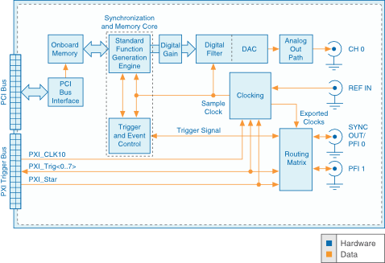
Advantages of PCI :
- You can interface a greatest of five components to the PCI and moreover supplant each of them by settling gadgets on the motherboard.
- Different PCI buses on the same computer.
- PCI transport will improve the speed of the exchanges from 33MHz to 133 MHz with a transfer rate of 1 gigabyte per second.
- The PCI can handle gadgets employing a maximum of 5 volts and the pins utilized can exchange more than one flag through one stick.
Disadvantages of PCI :
- PCI Graphics Card cannot get to system memory.
- PCI does not support pipelines.

SCSI bus:
The Small Computer System Interface (SCSI) is a set of parallel interface standards developed by the American National Standards Institute (ANSI) for attaching printers, disk drives, scanners and other peripherals to computers. SCSI is supported by all major operating systems.

Architecture:
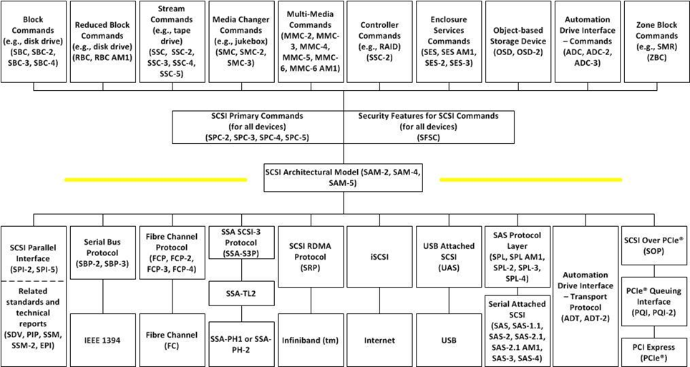
Advantages of SCSI:
- SCSI has its own controller for simpler troubleshooting and less dependency on other devices for proper performance.
- Data exchanges occur through a single cable, thus streamlining the connection.
- SCSI devices can work with a variety of computers.
- SCSI equipment is highly accessible, making it easy to replace and upgrade older SCSI components.
Disadvantages of SCSI:
- SCSI drives can be costly.
- The interface itself can be difficult to configure, with peripherals and will likely require IT professionals for proper management and installation.
- SCSI performance degrades with time.
Our System Configuration:
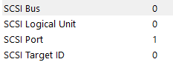
Post Lab Descriptive Questions

Q1 . Differentiate between PCI and SCSI Bus

PCI | SCSI
Standard that describes how to connect the peripheral components of a system together in a structured and controlled way. | Standard for physically connecting and transferring data between computers and peripheral devices.
Example of an internal parallel bus. | Example of an external parallel bus.
Backplane Bus Type | I/O Bus Type
Centralized Bus Architecture | Distributed Bus Architecture
Synchronous 33-66 MHz | Synchronous and asynchronous 5-10 MHz

Q2. List two applications each of PCI and SCSI Bus

PCI:
Because each PCI design is unique, programmable logic devices provide an ideal solution for PCI design.
Typical PCI cards used in PCs include: network cards, sound cards, modems, extra ports such as Universal Serial Bus (USB) or serial, TV tuner cards and hard disk drive host adapters.
SCSI:
Multiple peripherals hung on one SCSI bus can work simultaneously. SCSI interface can transmit data synchronously and asynchronously.
It is also commonly used to interconnect optical drives, tape drives, disk arrays, scanners, printers, and other targets to a wide range of terminals, computers, and other hosts.

Date: 26/08/2022 Signature of faculty in-charge

