Batch: C2 Roll No.: 16010121200

Experiment / assignment / tutorial No. 2

Grade: AA / AB / BB / BC / CC / CD /DD

Signature of the Staff In-charge with date

TITLE: To study and implement Booth’s Multiplication Algorithm.

AIM: Booth’s Algorithm for Multiplication
______________________________________________________________________

Expected OUTCOME of Experiment: (Mention CO/CO’s attained here)

CO1: Describe and define the structure of a computer with buses structure and detail
working of the arithmetic logic unit and its sub modules
_____________________________________________________________________

Books/ Journals/ Websites referred:

- Carl Hamacher, Zvonko Vranesic and Safwat Zaky, “Computer Organization”, Fifth Edition, TataMcGraw-Hill.
- William Stallings, “Computer Organization and Architecture: Designing for Performance”, Eighth Edition, Pearson.
3. Dr. M. Usha, T. S. Srikanth, “Computer System Architecture and Organization”, First Edition, Wiley-India.
_____________________________________________________________________

Pre Lab/ Prior Concepts:
It is a powerful algorithm for signed number multiplication which generates a 2n bit product and treats both positive and negative numbers uniformly. Also the efficiency of the algorithm is good due to the fact that, block of 1’s and 0’s are skipped over and subtraction/addition is only done if pair contains 10 or 01

Flowchart:

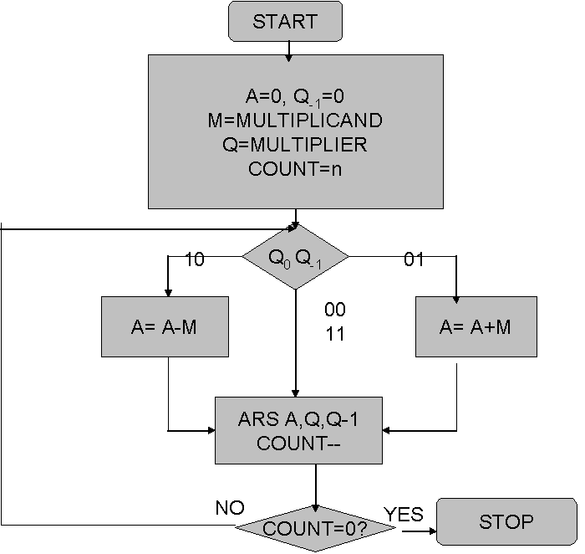

Design Steps:
- Start
- Get the multiplicand (M) and Multiplier (Q) from the user
- Initialize A= Q₋₁ =0
- Convert M and Q into binar
- Compare Q₀ and Q₋₁ and perform the respective operation.
Q₀ Q₋₁ | Operation
00/11 | Arithmetic right shift
01 | A+M and Arithmetic right shift
10 | A-M and Arithmetic right shift
6. Repeat steps 5 till all bits are compared
7. Convert the result to decimal form and display
8. End
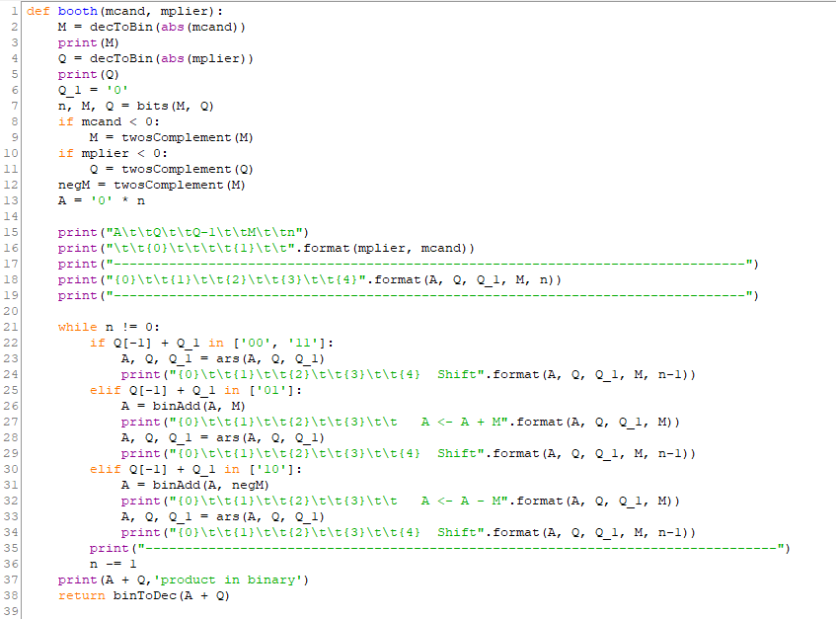
Program Code:

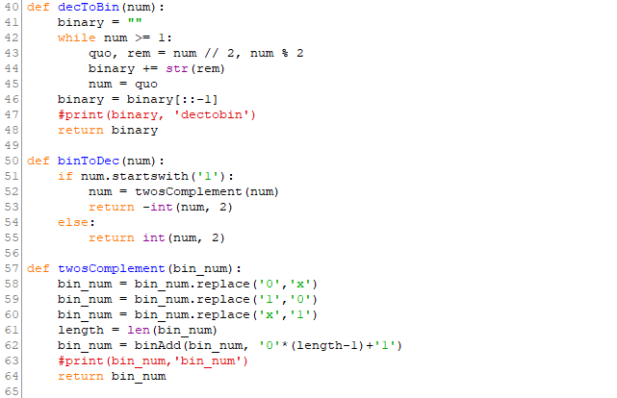

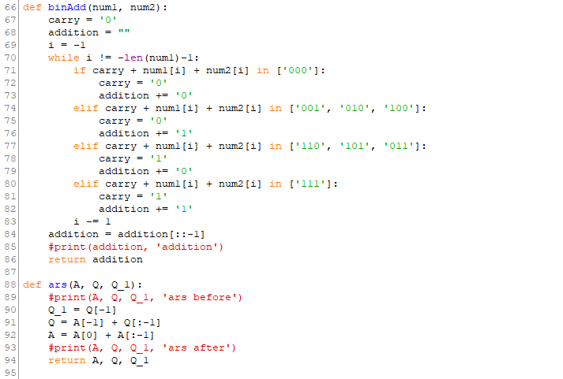

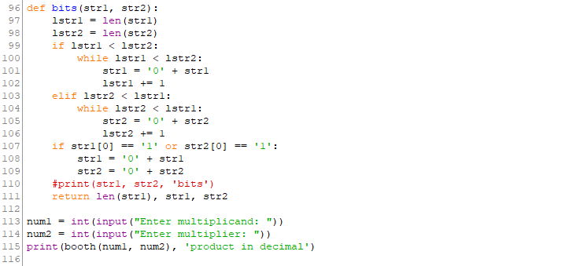

Output:
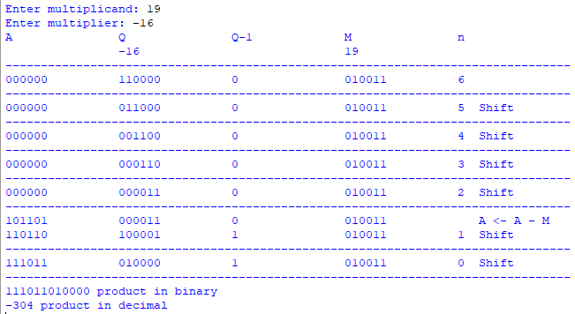

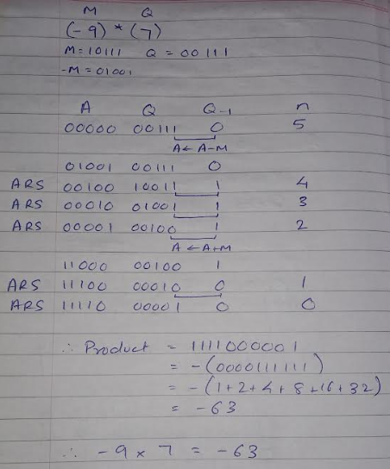
Example: (Handwritten solved problem needs to be uploaded)

Conclusion:
Booth’s algorithm multiplies 2 signed or unsigned integers in 2’s complement.
This approach uses shifts thus requiring fewer additions and subtractions than most straightforward algorithms.
Post Lab Descriptive Questions

- Explain advantages and disadvantages of Booth’s algorithm.
Advantage: It reduces the number of partial products, thus making it extensively used in multiplier with long operands (>16 bits).
Disadvantage: Complexity of the circuit to generate a partial product bit in the Booth encoding.
- Is Booth’s recoding better than Booth’s algorithm? Justify
Although Booth’s recoding is faster than Booth’s algorithm, Booth’s algorithm preserves the sign of the product. Hence Booth’s algorithm is better.

Date: 16/09/2022 Signature of faculty in-charge

