Batch: C2 Roll No.: 16010121200

Experiment / assignment / tutorial No. 3

Grade: AA / AB / BB / BC / CC / CD /DD

Signature of the Staff In-charge with date

TITLE : To study and implement Non-Restoring method of division

AIM : The basis of the algorithm is based on a paper and pencil approach and the operation involves repetitive shifting with addition and subtraction. So the main aim is to depict the usual process in the form of an algorithm.
______________________________________________________________________

Expected OUTCOME of Experiment: (Mention CO/CO’s attained here)

Describe and define the structure of a computer with buses structure and detail
working of the arithmetic logic unit and its sub modules
______________________________________________________________________

Books/ Journals/ Websites referred:

- Carl Hamacher, Zvonko Vranesic and Safwat Zaky, “Computer Organization”, Fifth Edition, TataMcGraw-Hill.
- William Stallings, “Computer Organization and Architecture: Designing for Performance”, Eighth Edition, Pearson.
3. Dr. M. Usha, T. S. Srikanth, “Computer System Architecture and Organization”, First Edition, Wiley-India.
_____________________________________________________________________
Pre Lab/ Prior Concepts:
The Non Restoring algorithm works with any combination of positive numbers.

Flowchart for Non-Restoring Division:
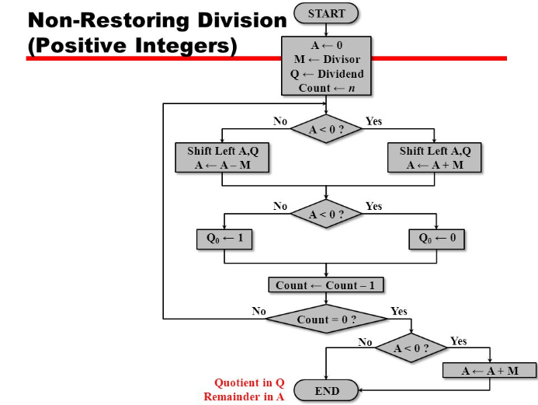

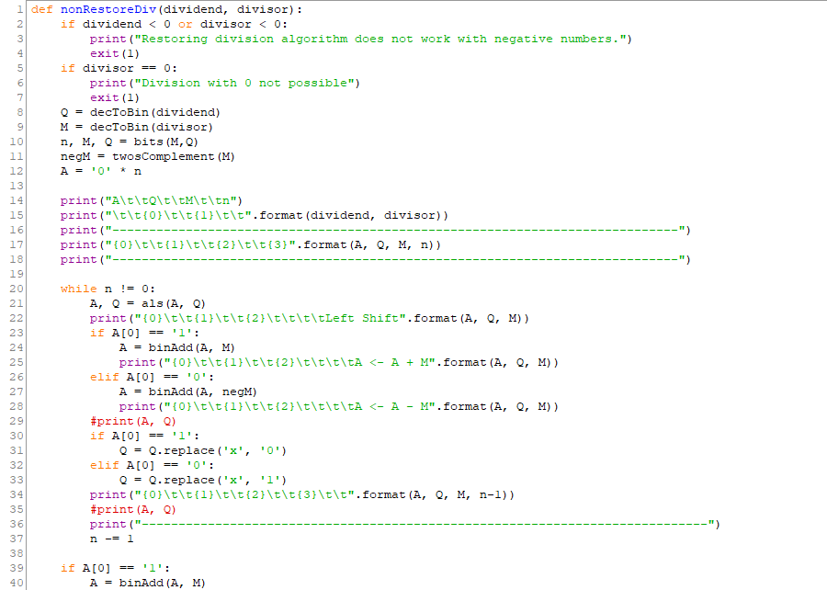
Program Code:

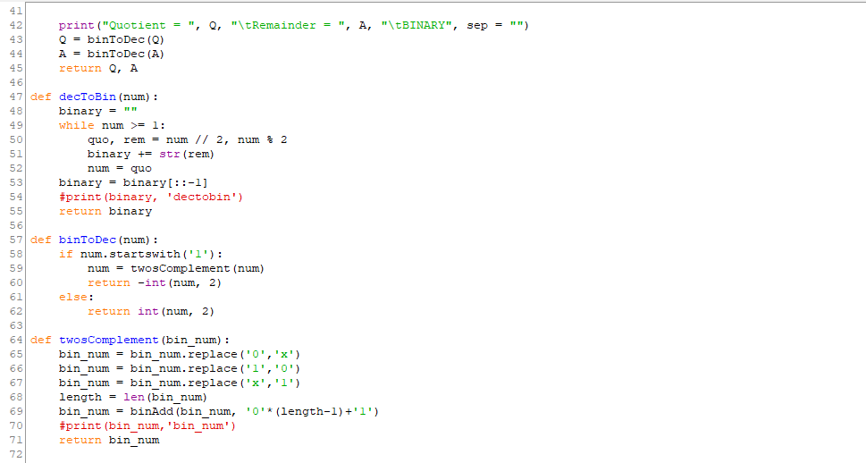

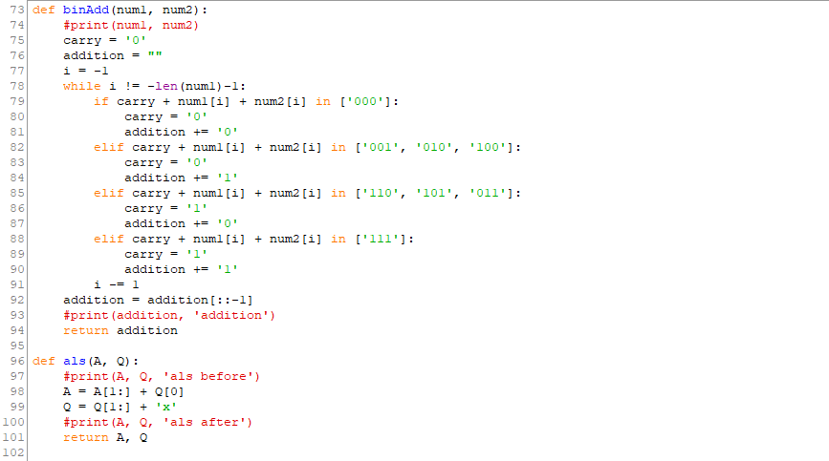

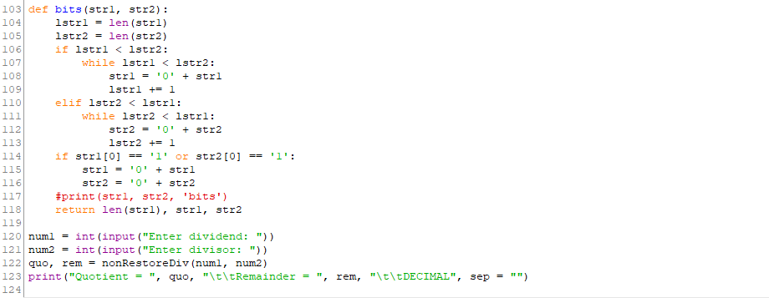

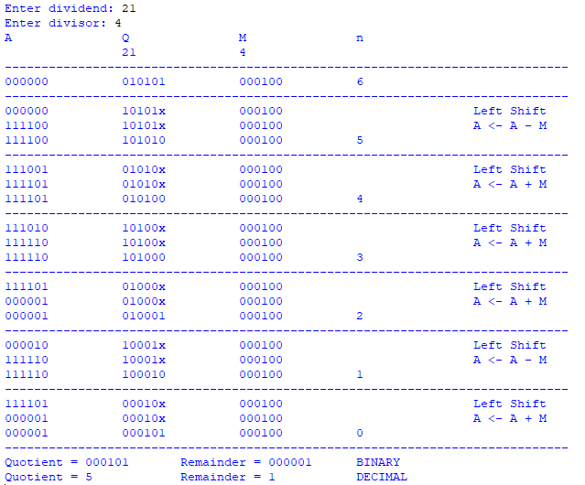
Output:

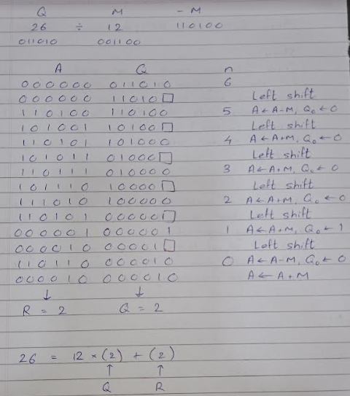
Example: (Handwritten solved problem needs to be uploaded)

Conclusion:
Non-restoring division is carried away assuming fractional numbers and it is assumed that dividend and divisor are positive integers.
The Non-restoring division algorithm is more complex but faster than the Restoring division algorithm.

Post Lab Descriptive Questions
- What are the advantages of non-restoring division over restoring division?
Non-restoring division contains only one decision and addition/subtraction per quotient bit. After performing the subtraction operation, there will not be any restoring steps. Due to this, the number of operations cuts down to half of the operations in restoring division. Because of a smaller number of operations, execution of this algorithm will be faster.

Date: 23/09/2022 Signature of faculty in-charge

