Batch: C2 Roll No.: 16010121200

Experiment / assignment / tutorial No. 4

Grade: AA / AB / BB / BC / CC / CD /DD

Signature of the Staff In-charge with date

TITLE : To study and implement Restoring method of division

AIM : The basis of algorithm is based on paper and pencil approach and the operation involves repetitive shifting with addition and subtraction. So the main aim is to depict the usual process in the form of an algorithm.
______________________________________________________________________

Expected OUTCOME of Experiment: (Mention CO /CO’s attained here)

CO1: Describe and define the structure of a computer with buses structure and detail
working of the arithmetic logic unit and its sub modules
_____________________________________________________________________

Books/ Journals/ Websites referred:

- Carl Hamacher, Zvonko Vranesic and Safwat Zaky, “Computer Organization”, Fifth Edition, TataMcGraw-Hill.
- William Stallings, “Computer Organization and Architecture: Designing for Performance”, Eighth Edition, Pearson.
3. Dr. M. Usha, T. S. Srikanth, “Computer System Architecture and Organization”, First Edition, Wiley-India.
_____________________________________________________________________

Pre Lab/ Prior Concepts:
The Restoring algorithm works with any combination of positive and negative numbers.

Flowchart for Restoring of Division:
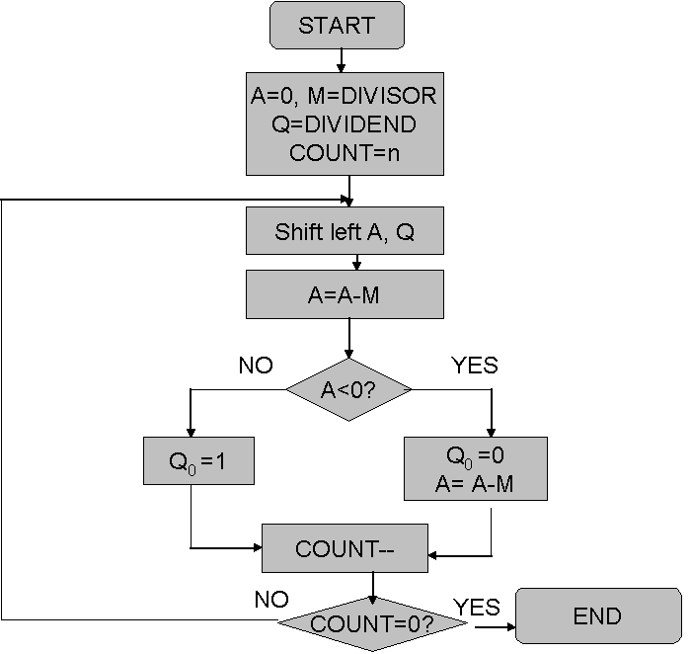

Program Code:
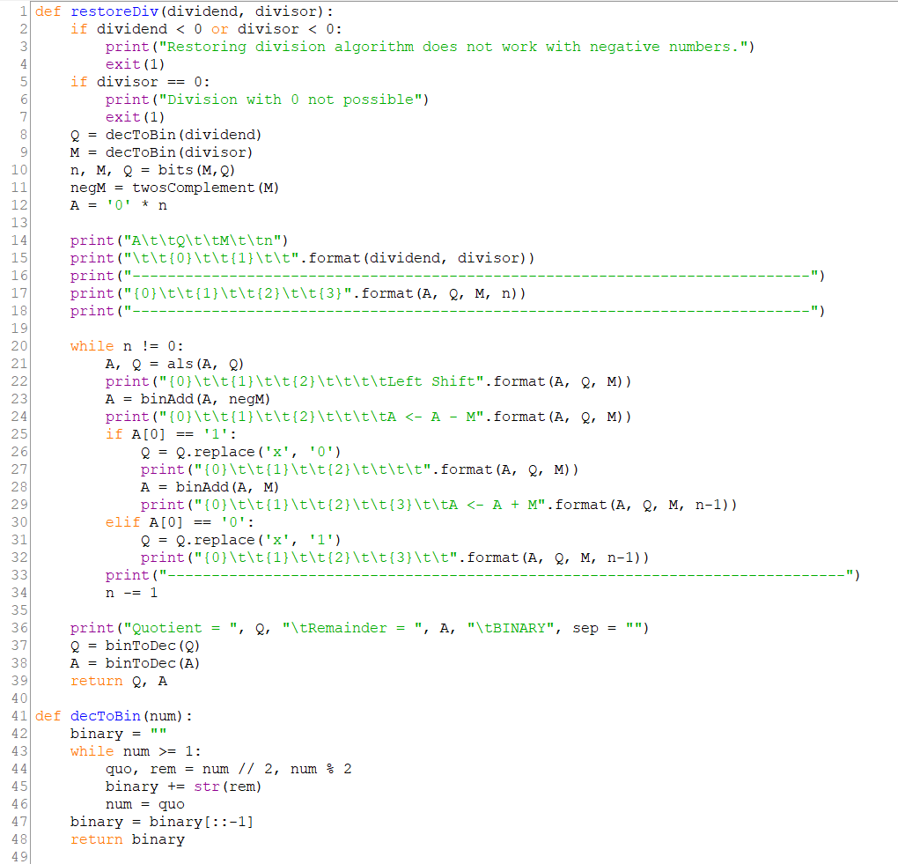
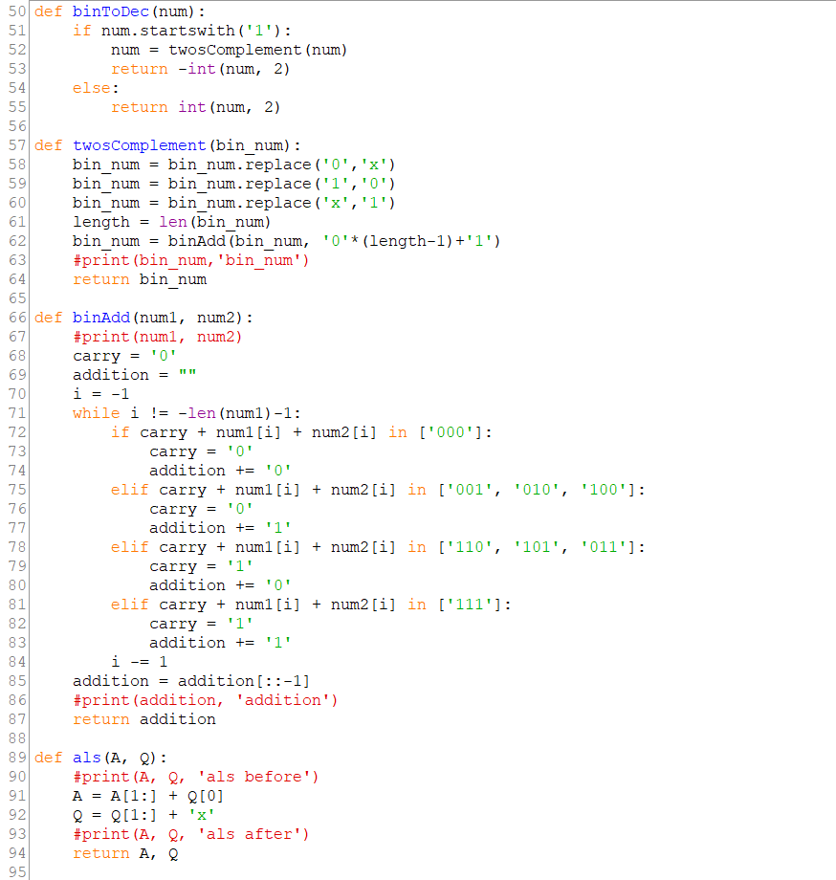
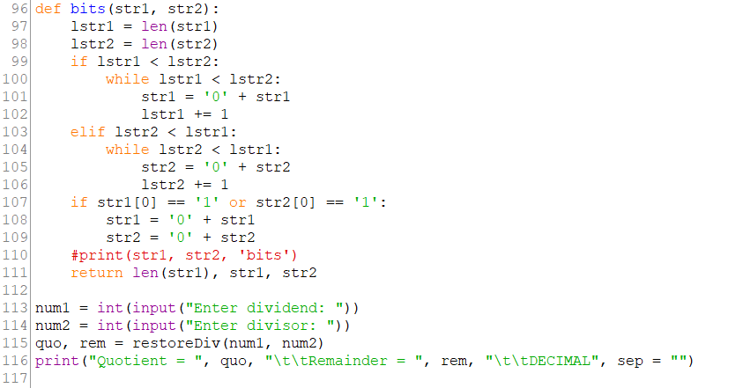
Output:
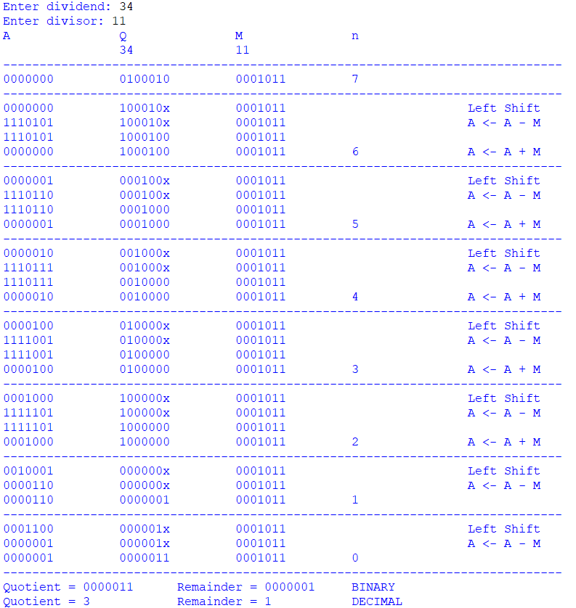
Design Steps:
- Start
- Initialize A=0, M=Divisor, Q=Dividend and count=n (no of bits)
- Left shift A, Q
- If MSB of A and M are same
- Then A=A-M
- Else A=A+M
- If MSB of previous A and present A are same
- Q₀=0 & store present A
- Else Q₀=0 & restore previous A
- Decrement count.
- If count=0 go to 11
- Else go to 3
- STOP

Example:- (Handwritten solved problems needs to be uploaded)
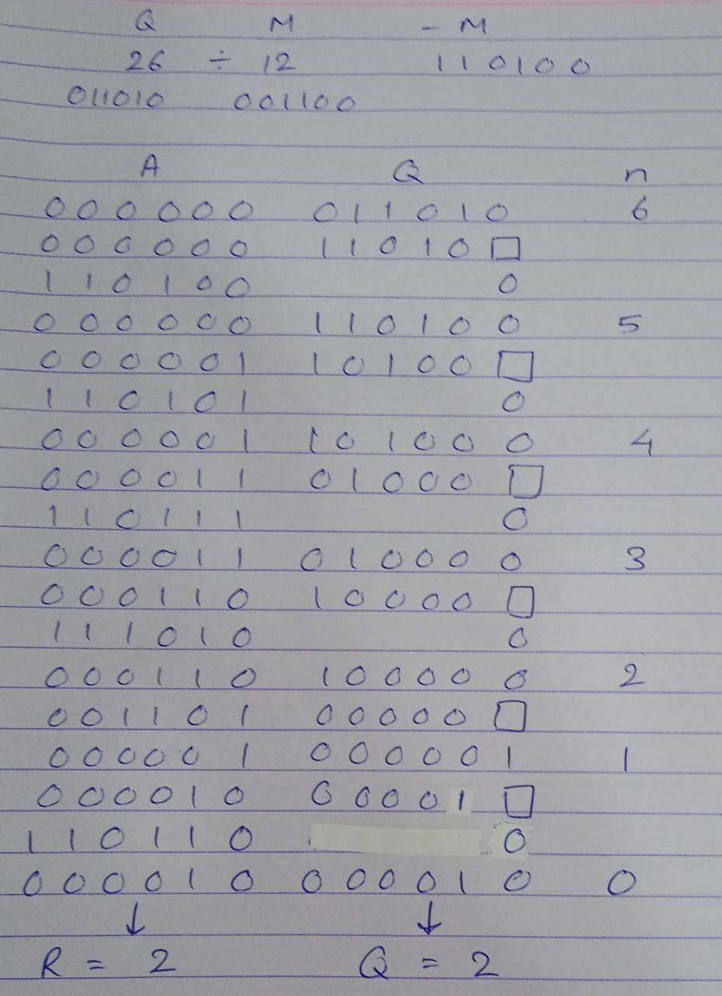
Conclusion:
Restoring division is carried away assuming fractional numbers and it is assumed that dividend and divisor are positive integers.
The value of register A is restored after every iteration, thus the term ‘Restoring’.

Post Lab Descriptive Questions
      - What are the advantages of restoring division over non restoring division?

It is less complex than non-restoring division hence easier to understand.
The Non-restoring division algorithm needs an extra bit in the partial remainder to keep track of the sign. This is not the case with Restoring division.

Date: 7/10/2022 Signature of faculty in-charge

