Batch: B2 Roll No.: 16010122158

Experiment / assignment / tutorial No. 5

Grade: AA / AB / BB / BC / CC / CD /DD

Signature of the Staff In-charge with date

TITLE: Implementation of IEEE-754 floating point representation

AIM: To demonstrate the single and double precision formats to represent floating point numbers.
______________________________________________________________________
Expected OUTCOME of Experiment: (Mention CO attained here)
Describe and define the structure of a computer with buses structure and detail
working of the arithmetic logic unit and its sub modules
___________________________________________________________________
Books/ Journals/ Websites referred:
- Carl Hamacher, Zvonko Vranesic and Safwat Zaky, “Computer Organization”, Fifth Edition, TataMcGraw-Hill.
- William Stallings, “Computer Organization and Architecture: Designing for Performance”, Eighth Edition, Pearson.
_____________________________________________________________________
Pre Lab/ Prior Concepts:
The IEEE Standard for Floating-Point Arithmetic (IEEE 754) is a technical standard for floating-point computation established in 1985 by the Institute of Electrical and Electronics Engineers (IEEE). The standard addressed many problems found in the diverse floating point implementations that made them difficult to use reliably and portably. Many hardware floating point units now use the IEEE 754 standard.
The standard defines:
- arithmetic formats: sets of binary and decimal floating-point data, which consist of finite numbers (including signed zeros and subnormal numbers), infinities, and special "not a number" values (NaNs)
- interchange formats: encodings (bit strings) that may be used to exchange floating-point data in an efficient and compact form
- rounding rules: properties to be satisfied when rounding numbers during arithmetic and conversions
- operations: arithmetic and other operations (such as trigonometric functions) on arithmetic formats
- exception handling: indications of exceptional conditions (such as division by zero, overflow, etc

Program Code:
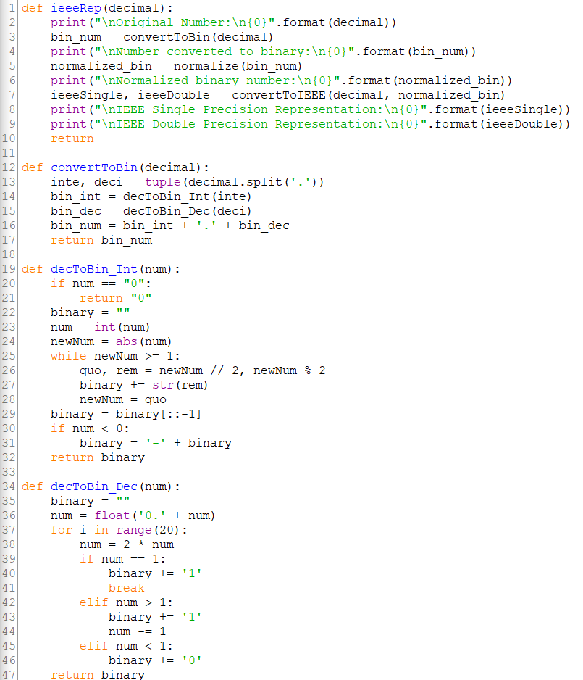

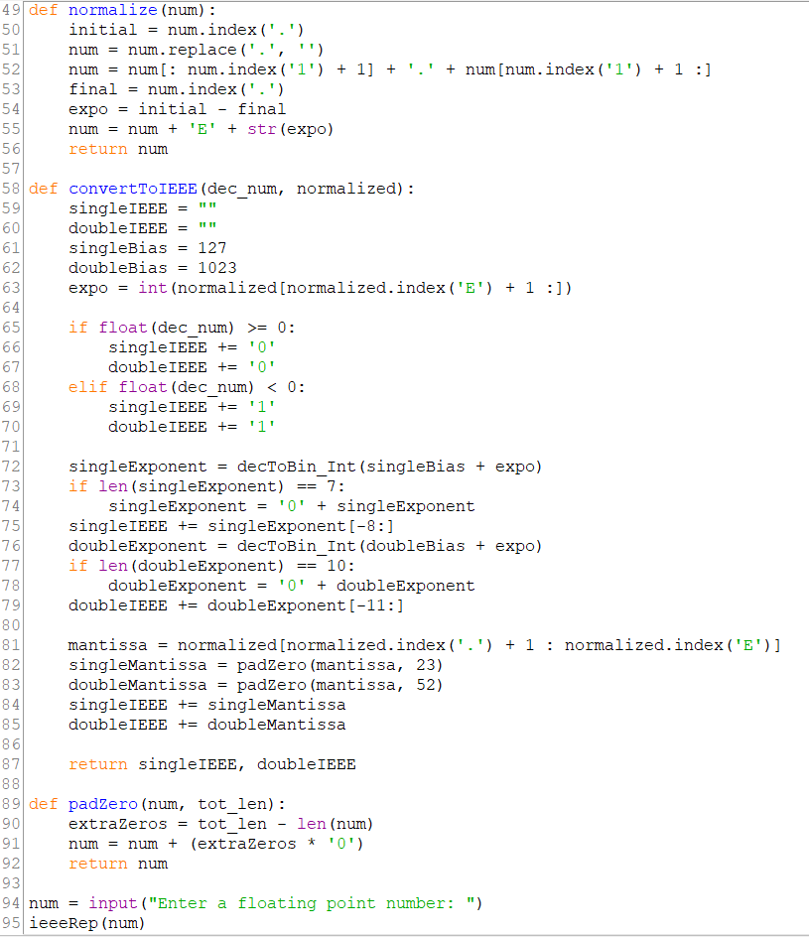
Output:
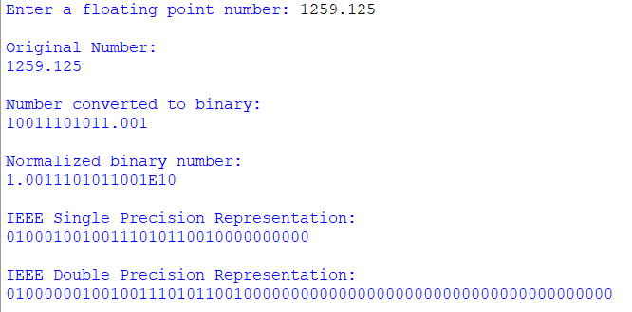

Example (Single Precision – 32-bit representation)
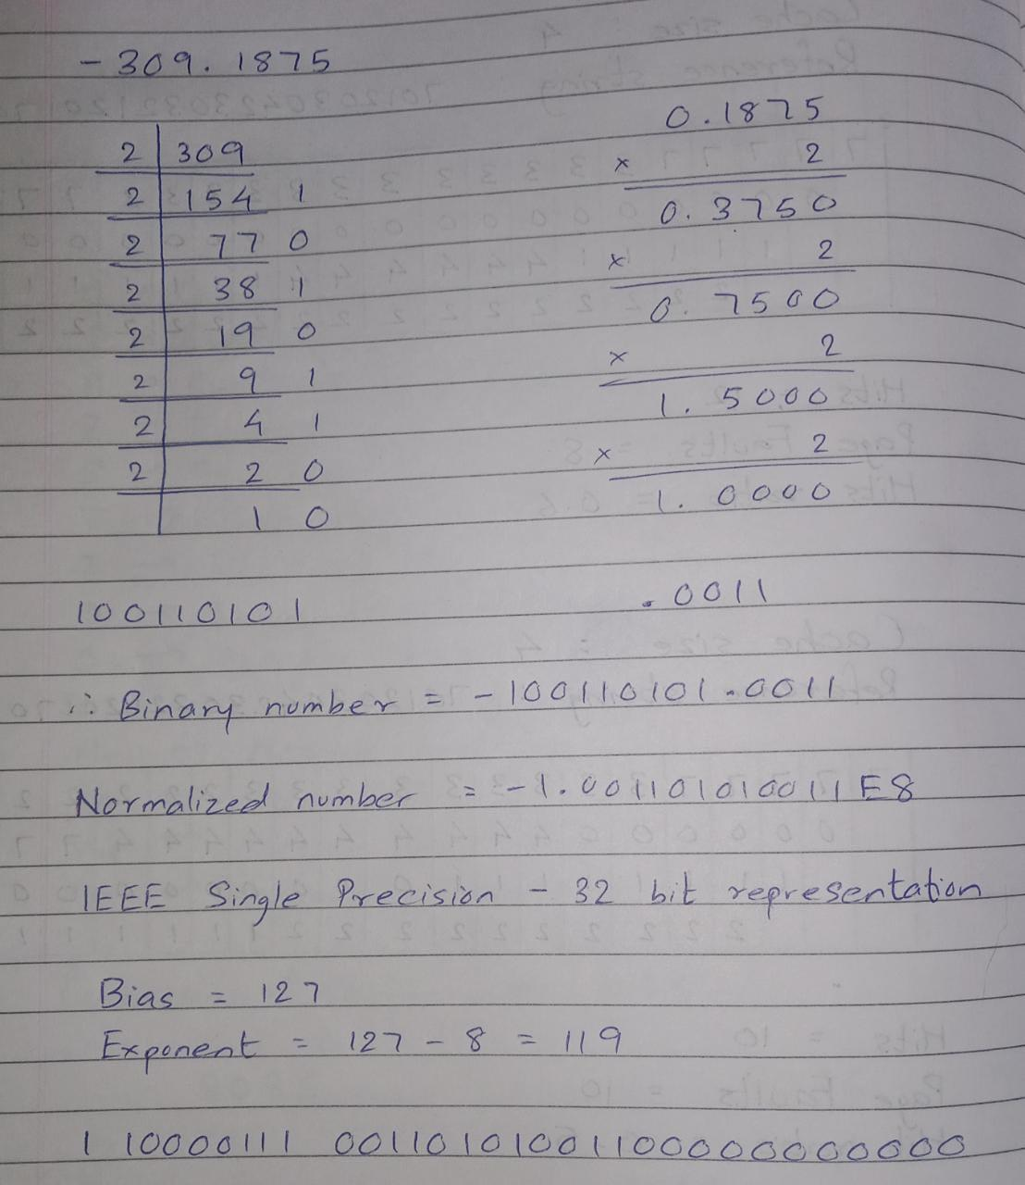

Example (Double Precision – 64-bit representation)
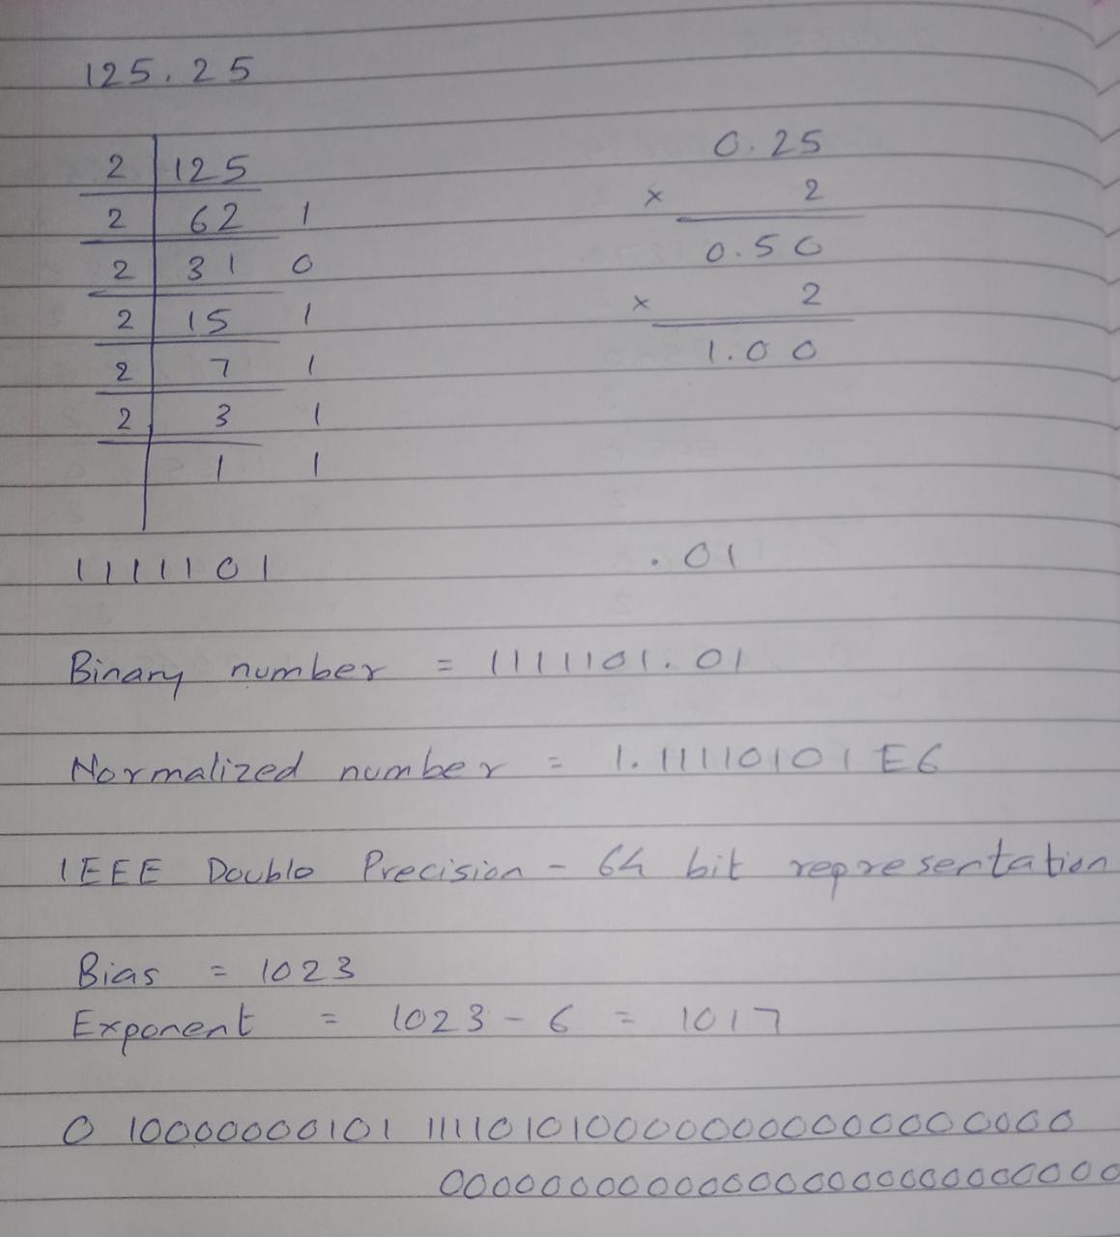
Post Lab Descriptive Questions

      - Give the importance of IEEE-754 representation for floating point numbers?

The IEEE standard defines set formats and operation modes. The standard addressed many problems found in the diverse floating point implementations that made them difficult to use reliably and reduced their portability. All computers conforming to this standard would always calculate the same result for the same computation.

Conclusion:
The IEEE 754 standard specifies two precisions for floating-point numbers. Single precision numbers have 32 bits − 1 for the sign, 8 for the exponent, and 23 for the significand. Double precision numbers use 64 bits − 1 for the sign, 11 for the exponent, and 52 for the significand.

Date: 31/08/2023 Signature of faculty in-charge

