Batch: C2 Roll No.: 16010121200

Experiment / assignment / tutorial No. 6

Grade: AA / AB / BB / BC / CC / CD /DD

Signature of the Staff In-charge with date

TITLE: Implementation of LRU Page Replacement Algorithm.

AIM: The LRU algorithm replaces the least recently used that is the last accessed memory block from user.
______________________________________________________________________
Expected OUTCOME of Experiment: (Mention CO/CO’s attained here)

CO3: Learn and evaluate memory organization and cache structure
___________________________________________________________________
Books/ Journals/ Websites referred:
- Carl Hamacher, Zvonko Vranesic and Safwat Zaky, “Computer Organization”, Fifth Edition, TataMcGraw-Hill.
- William Stallings, “Computer Organization and Architecture: Designing for Performance”, Eighth Edition, Pearson.
_____________________________________________________________________
Pre Lab/ Prior Concepts:

It follows a simple logic, while replacing it will replace that page which has least recently used out of all.
a) A hit is said to be occurred when a memory location requested is already in the cache.
b) When cache is not full, the number of blocks is added.
c) When cache is full, the block is replaced which is recently used

Algorithm:

- Start
- Get input as memory block to be added to cache
- Consider an element of the array
- If cache is not full, add element to the cache array
- If cache is full, check if element is already present
- If it is hit is incremented
- If not, element is added to cache removing least recently used element
- Repeat step 3 to 7 for remaining elements
- Display the cache at very instance of step 8
- Print hit ratio
- End

Program Code:
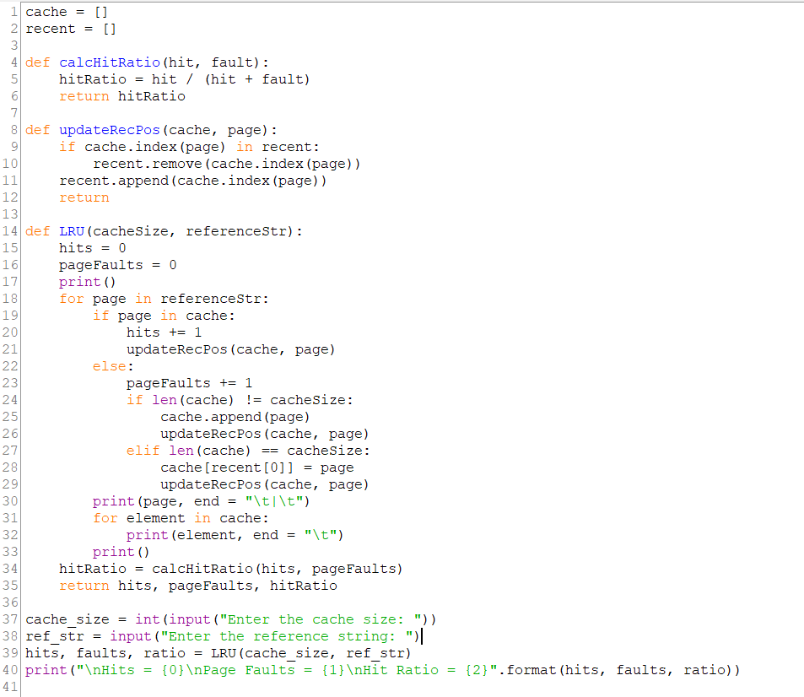

Output:
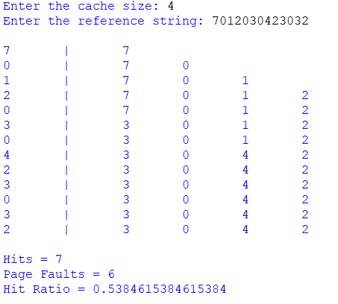

Example:
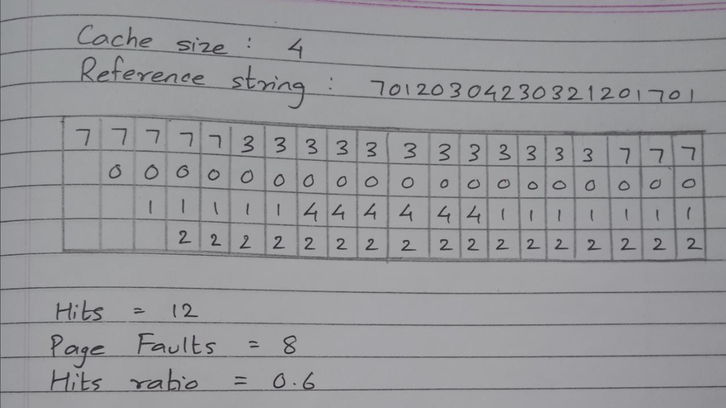

Post Lab Descriptive Questions

1. Define hit rate and miss ratio?
Hit and miss ratios in cache memories are metrics that help you determine cache performance.
Hit: A cache hit refers to the situation where the cache can successfully retrieve data and content that was saved to it, and then display it on a web page.
Miss: A cache miss occurs when the site requests the content from the cache, but after searching for it, the cache determines that content was not saved. That is when the cache saves the content so it is available the next time it’s requested.

Hit ratio: $\frac{Number of hits}{Number of hits + Number of misses}$

2. What is the need for virtual memory?

Virtual Memory increases the capacity of main memory. Virtual memory is not a storage unit, it is a technique. In virtual memory, even such programs which have a larger size than the main memory are allowed to be executed.

Conclusion:
The LRU caching technique is to remove the least recently used page when the cache is full and a new page is referenced which is not there in the cache.
It is better than the FIFO caching technique as it keeps a track of the recently visited pages thus ensuring more hits and less page faults.

Date: 28/10/2022 Signature of faculty in-charge

