Batch: B2 Roll No.: 16010122158

Experiment / assignment / tutorial No. 9

Grade: AA / AB / BB / BC / CC / CD /DD

Signature of the Staff In-charge with date

TITLE: Implement simple addition, subtraction, multiplication and division instructions using TASM.

AIM: Implement simple addition, subtraction, multiplication and division instructions using TASM.
_______________________________________________________________
Expected OUTCOME of Experiment: (Mentions the CO/CO’s attained)

Understand the Central processing unit with addressing modes and working of control unit in depth.

__________________________________________________________________

Books/ Journals/ Websites referred:

1) Microprocessor architecture and applications with 8085: By Ramesh Gaonkar (Penram International Publication).

2) 8086/8088 family: Design Programming and Interfacing: By John Uffenbeck (Pearson Education).

Pre Lab/ Prior Concepts:
Assembler directives: These are statements that direct the assembler to do something

Definition:
Types of Assembler Directives:
ASSUME Directive - The ASSUME directive is used to tell the assembler that the name of the logical segment should be used for a specified segment. The 8086 works directly with only 4 physical segments: a Code segment, a data segment, a stack segment, and an extra segment.

Example:

ASUME CS:CODE ;This tells the assembler that the logical segment named CODE contains the instruction statements for the program and should be treated as a code segment.

ASUME DS:DATA ;This tells the assembler that for any instruction which refers to a data in the data segment, data will found in the logical segment DATA
Start:
It is entry point of the program. without this program won’t run.

END - END directive is placed after the last statement of a program to tell the assembler that this is the end of the program module. The assembler will ignore any statement after an END directive. Carriage return is required after the END directive.

ENDS - This ENDS directive is used with name ofthe segment to indicate the end of that logic segment.

Example:

CODE SEGMENT ;
Hear it Start the logic
;segment containing code
; Some instructions statements to perform the logical
;operation
CODE ENDS ;End of segment named as;CODE

Arithmetic instruction set:
ADD instruction:

Mnemonic | Meaning | Format | Operation | Flags
 |  |  |  | Affected
ADD | Addition | ADD D, S | (S) + (D)🡪(D) | All
 |  |  | Carry🡪(CF)
ADC | Add with | ADC D, S | (S) + (D) +(CF) | All
 | Carry |  | 🡪 (D)
 |  |  | Carry🡪(CF)
Syntax: ADD destination,source
SUB instruction:
Mnemonic | Meaning | Format | Operation | Flags Affected
SUB | Subtract | SUB D, S | (D) - (S)🡪(D) | All
 |  |  | Borrow🡪(CF)
SBB | Subtract with | SBB D, S | (D) - (S) –(CF)🡪(D) | All
 | Borrow

MUL instruction:
Syntax: MUL source

Multiplication | Multiplicand | Operand | Result
(MUL or IMUL) |  | (Multiplier)
Byte * Byte | AL | Register or | AX
 |  | Memory
Word * Word | AX | Register or memory | DX :AX

DIV instruction:
Division | Dividend | Operand | Quotient : Remainder
(DIV or IDIV) |  | (Divisor)
Word / Byte | AX | Register or memory | AL : AH
Dword / Word | DX:AX | Register or memory | AX : DX

The steps to execute a program in TASM are

ASSEMBLING AND EXECUTING THE ROGRAM
- Writing an Assembly Language Program
Assembly level programs generally abbreviated as ALP are written in text editor EDIT.
Type EDIT in front of the command prompt (C:\TASM\BIN) to open an untitled text file.
EDIT<file name>
After typing the program save the file with appropriate file name with an extension .ASM
Ex:Add.ASM

- Assembling an Assembly Language Program
To assumble an ALP we needed executable file called MASM.EXE. Only if this file is in current working directory we can assemble the program. The command is
TASM<filename.ASM>
If the program is free from all syntactical errors, this command will give the OBJECT file.In case of errors it list out the number of errors, warnings and kind of error.
Note: No object file is created until all errors are rectified.
- Linking
After successful assembling of the program we have to link it to get Executable file.
The command is
TLINK<File name.OBJ>
This command results in <Filename.exe>which can be executed in front of the command prompt.
- Executing the Program
Open the program in debugger by the command(note only exe files can be open)by the command.
<Filename.exe>
This will open the program in debugger screen where in you can view the assemble code with the CS and IP values at the left most side and the machine code. Register content,memory content also be viewed using TDoption of the debugger & to execute the program in single steps(F7)

Algorithm for adding the two 8-bit numbers:

DATA SEGMENT
NUM1 DW 1234H
NUM2 DW 1234H
RES DW ?
DATA ENDS
CODE SEGMENT
ASSUME CS:CODE,DS:DATA
START:
MOV AX,DATA
MOV DS,AX
MOV AX,NUM1
MOV BX,NUM2
ADD AX,BX
MOV RES,AX
MOV AH,4CH
INT 21H
CODE ENDS
END START

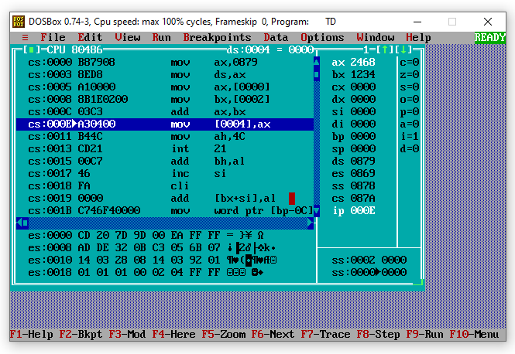

Algorithm for subtracting the two 8 bit numbers:
DATA SEGMENT
NUM1 DW 1234H
NUM2 DW 1234H
RES DW ?
DATA ENDS
CODE SEGMENT
ASSUME CS:CODE,DS:DATA
START:
MOV AX,DATA
MOV DS,AX
MOV AX,NUM1
MOV BX,NUM2
SUB AX,BX
MOV RES,AX
MOV AH,4CH
INT 21H
CODE ENDS
END START

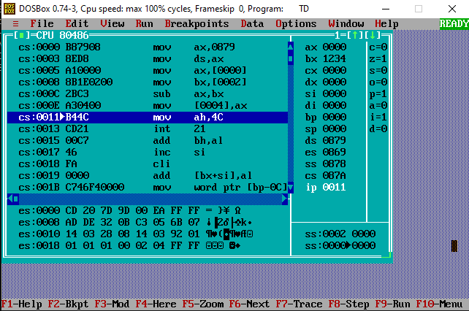

Algorithm for multiplying the two 8 bit numbers:
NUM1 DW 1234H
NUM2 DW 1234H
RES DW ?
DATA ENDS
CODE SEGMENT
ASSUME CS:CODE,DS:DATA
START:
MOV AX,DATA
MOV DS,AX
MOV AX,NUM1
MOV BX,NUM2
MUL BX
MOV RES,AX
MOV AH,4CH
INT 21H
CODE ENDS
END START

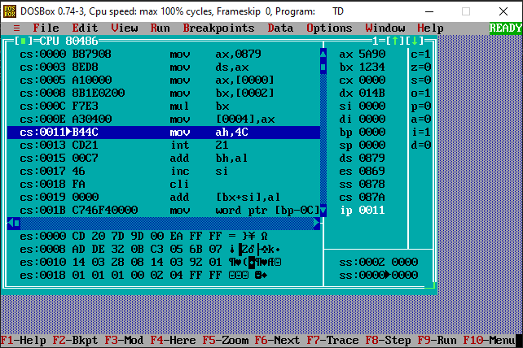

Algorithm for dividing the two 8-bit numbers:
DATA SEGMENT
NUM1 DW 1234H
NUM2 DW 1234H
RES DW ?
DATA ENDS
CODE SEGMENT
ASSUME CS:CODE,DS:DATA
START:
MOV AX,DATA
MOV DS,AX
MOV AX,NUM1
MOV BX,NUM2
DIV BX
MOV RES,AX
MOV AH,4CH
INT 21H
CODE ENDS
END START

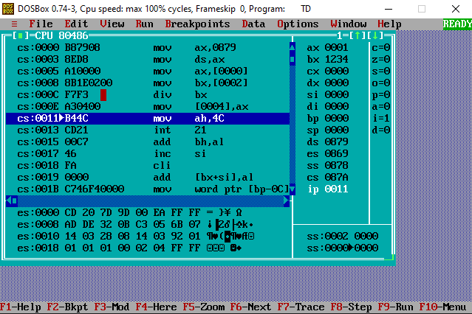
Conclusion:
Understood the Central processing unit with addressing modes and working of control unit in depth.
Implemented simple addition, subtraction, multiplication and division instructions using TASM.

Post Lab Descriptive Questions (Add questions from examination point view)
Explain instructions ADC and SBB with example
In 8085 Instruction set, SBB R is mnemonic used for multi-Byte subtraction. Let us consider the following example on such subtraction
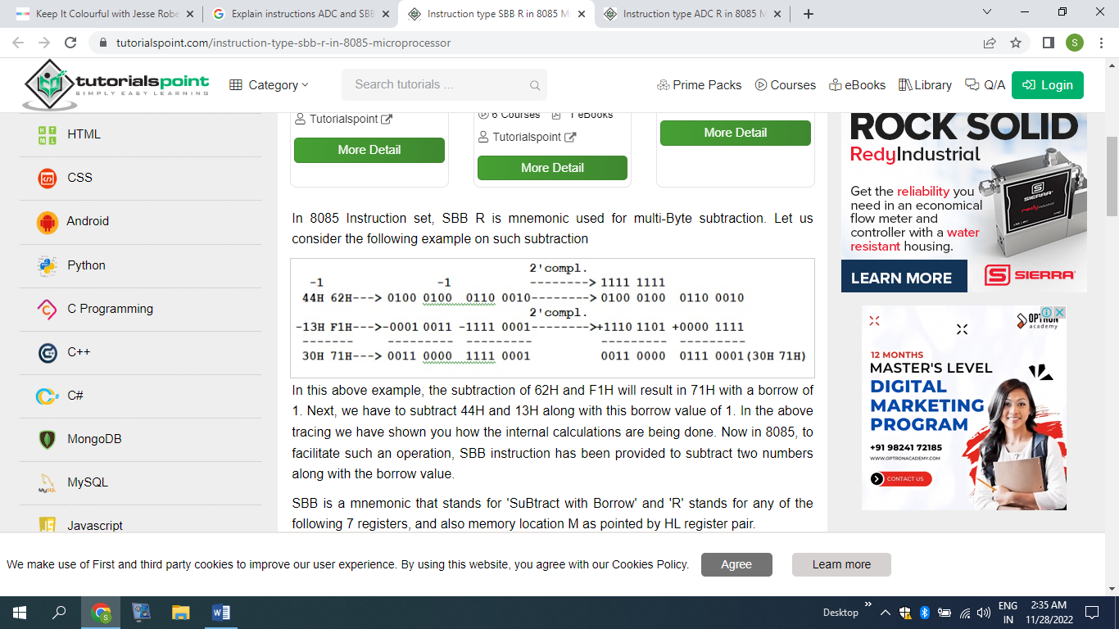
SBB is a mnemonic that stands for 'SuBtract with Borrow' and 'R' stands for any of the following 7 registers, and also memory location M as pointed by HL register pair.
This instruction is used to compute subtraction between contents of R register from the Accumulator's content, along with the carry (borrow) value. The result of the subtraction will be stored in the Accumulator replacing Accumulator’s initial value. As R can have any of the eight values, there are eight opcodes for this type of instruction. It will occupy only 1-Byte in memory.

In 8085 assembly language coding, sometimes there is a requirement to add two numbers and where each of these numbers are having several Bytes in size. As example, let us add the following two 16-bit numbers.
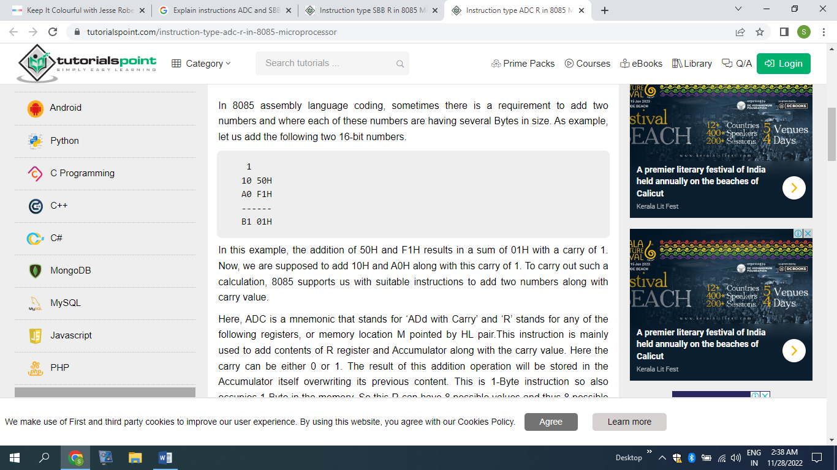
Here, ADC is a mnemonic that stands for ‘ADd with Carry’ and ‘R’ stands for any of the following registers, or memory location M pointed by HL pair.This instruction is mainly used to add contents of R register and Accumulator along with the carry value. Here the carry can be either 0 or 1. The result of this addition operation will be stored in the Accumulator itself overwriting its previous content. This is 1-Byte instruction so also occupies 1-Byte in the memory. So this R can have 8 possible values and thus 8 possible opcodes.

Date: 19/10/2023 Signature of faculty in-charge

