Batch: B2 Roll No.: 16010122158

Experiment / assignment / tutorial No. 10

Grade: AA / AB / BB / BC / CC / CD /DD

Signature of the Staff In-charge with date

TITLE: Study of multiprocessor configuration concepts through Virtual lab

AIM: Understanding Virtual Lab concepts
_______________________________________________________________
Expected OUTCOME of Experiment:

CO4: Summarize Input output techniques and multiprocessor configurations
__________________________________________________________________
Books/ Journals/ Websites referred:
http://vlabs.iitb.ac.in/vlab/labscse.html
http://vlabs.iitb.ac.in/vlab/#
http://www.vlab.co.in/
__________________________________________________________________

Pre Lab/ Prior Concepts:

The main aim of this experiment is to provide remote-access to Labs in various disciplines of Science and Engineering. These Virtual Labs would cater to students at the undergraduate level, post graduate level as well as to research scholars. Also, to enthuse students to conduct experiments by arousing their curiosity. This would help them in learning basic and advanced concepts through remote experimentation. It also provides a complete Learning Management System around the Virtual Labs where the students can avail the various tools for learning, including additional web-resources, video-lectures, animated demonstrations and self-evaluation. We can share costly equipment and resources, which are otherwise available to limited number of users due to constraints on time and geographical distances
Salient Features:

1. Virtual Labs will provide to the students the result of an experiment by one of the following methods (or possibly a combination)
- Modeling the physical phenomenon by a set of equations and carrying out simulations to yield the result of the particular experiment. This can, at-the-best, provide an approximate version of the ‘real-world’ experiment.
- Providing measured data for virtual lab experiments corresponding to the data previously obtained by measurements on an actual system.
- Remotely triggering an experiment in an actual lab and providing the student the result of the experiment through the computer interface. This would entail carrying out the actual lab experiment remotely.
2. Virtual Labs will be made more effective and realistic by providing additional inputs to the students like accompanying audio and video streaming of an actual lab experiment and equipment.

Observations
Title of Study Experiment: Fundamentals of Floating Point Representation of Numbers.
Brief description of experiment under study:
In computers we cannot precisely represent all of the real numbers. However we can still have a useful and effective representation of them with certain loss in precision.
Computers recognize real numbers that contain fractions as floating point numbers. When a calculation includes a floating point number, it is called a "floating point calculation."
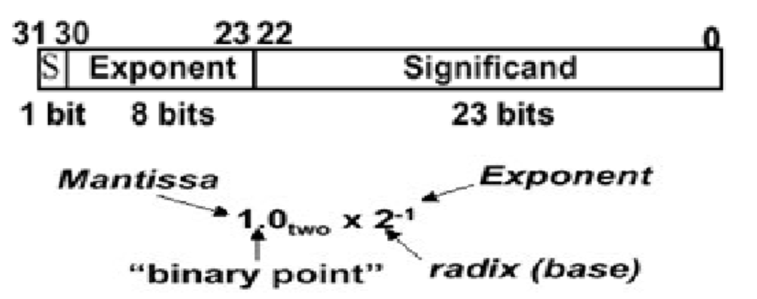
Learning’s recorded:
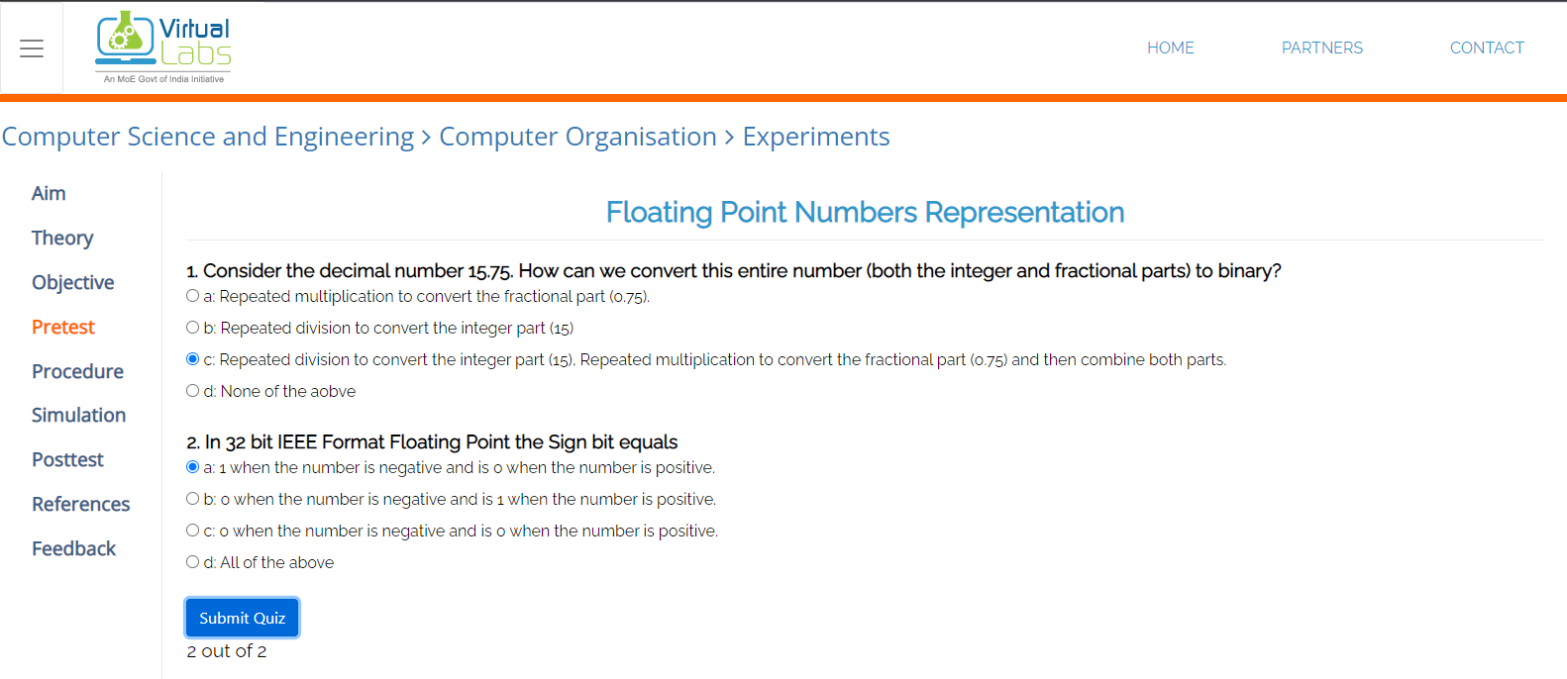
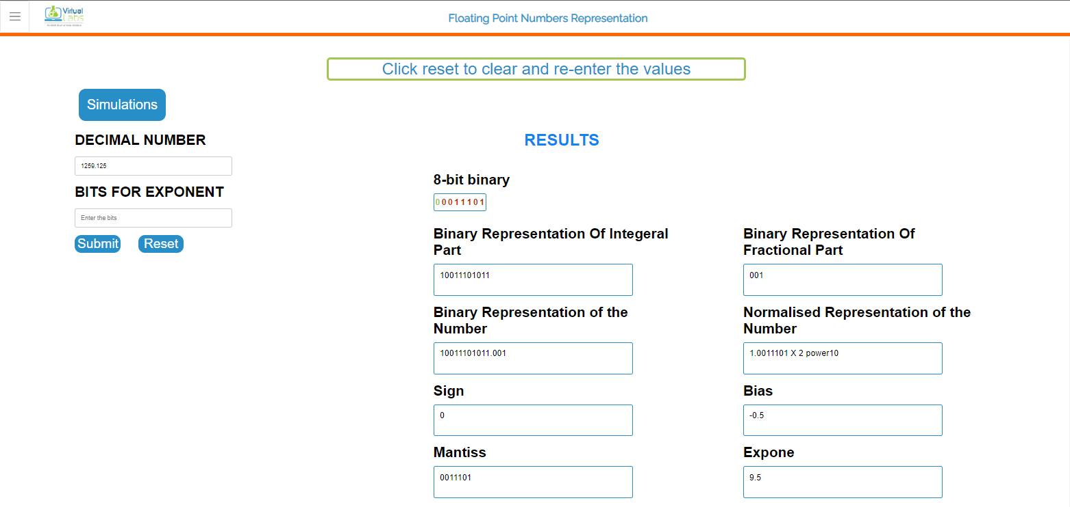
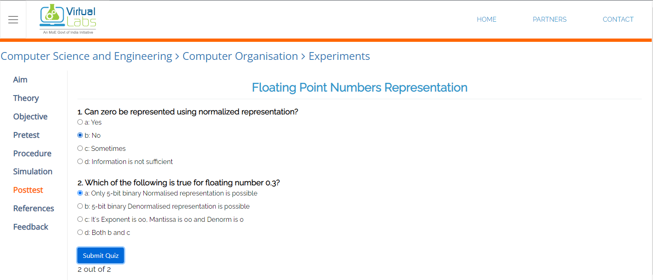

Knowledge gained / Inference Obtained:
Understood the basic concepts of Floating Point Numbers and their conversion to and from decimal form.
Having a specified standard for conversion of floating point numbers makes floating point calculations more reliable and portable.
Post Lab Descriptive Questions

1. What are the applications of the virtual lab case study / tool reviewed by you?

It provides remote-access to Labs in various disciplines of Science and Engineering. Virtual Labs caters to students to provide a complete Learning Management System around the Virtual Labs where the students can avail the various tools for learning, including additional web-resources, video-lectures, animated demonstrations and self evaluation.

To share costly equipment and resources, which are otherwise available to limited number of users due to constraints on time and geographical distances.
Conclusion:
Successfully implemented.
Demonstrated conversion of decimal floating point number into binary floating point number.
Date: 19/10/2023 Signature of faculty in-charge

