Batch: B2 Roll No.: 16010122158

Experiment / assignment / tutorial No. 7

Grade: AA / AB / BB / BC / CC / CD /DD

Signature of the Staff In-charge with date

TITLE :Implementation of FIFO Page Replacement Algorithm

AIM: The FIFO algorithm uses the principle that the block in the set which has been in for the longest time will be replaced

______________________________________________________________________
Expected OUTCOME of Experiment: (Mention CO/CO’s attained here)

CO3: Learn and evaluate memory organization and cache structure
_____________________________________________________________________

Books/ Journals/ Websites referred:
- Carl Hamacher, Zvonko Vranesic and Safwat Zaky, “Computer Organization”, Fifth Edition, TataMcGraw-Hill.
- William Stallings, “Computer Organization and Architecture: Designing for Performance”, Eighth Edition, Pearson.
3. Dr. M. Usha, T. S. Srikanth, “Computer System Architecture and Organization”, First Edition, Wiley-India.
---------------------------------------------------------------------------------------------------------
Pre Lab/ Prior Concepts:

The FIFO algorithm uses the principle that the block in the set which has been in the block for the longest time is replaced. FIFO is easily implemented as a round robin or criteria buffer technique. The data structure used for implementation is a queue. Assume that the number of cache pages is three. Let the request to this cache is shown alongside.

Algorithm:

1. A hit is said to be occurred when a memory location requested is already in the cache.
2. When cache is not full, the number of blocks is added.
3. When cache is full, the block is replaced which was added first

Design Steps:

- Start
- Get input as memory block to be added to cache
- Consider an element of the array
- If cache is not full, add element to the cache array
- If cache is full, check if element is already present
- If it is hit is incremented
- If not, element is added to cache removing first element (which is in first).
- Repeat step 3 to 7 for remaining elements
- Display the cache at very instance of step 8
- Print hit ratio
- End.

Program Code:
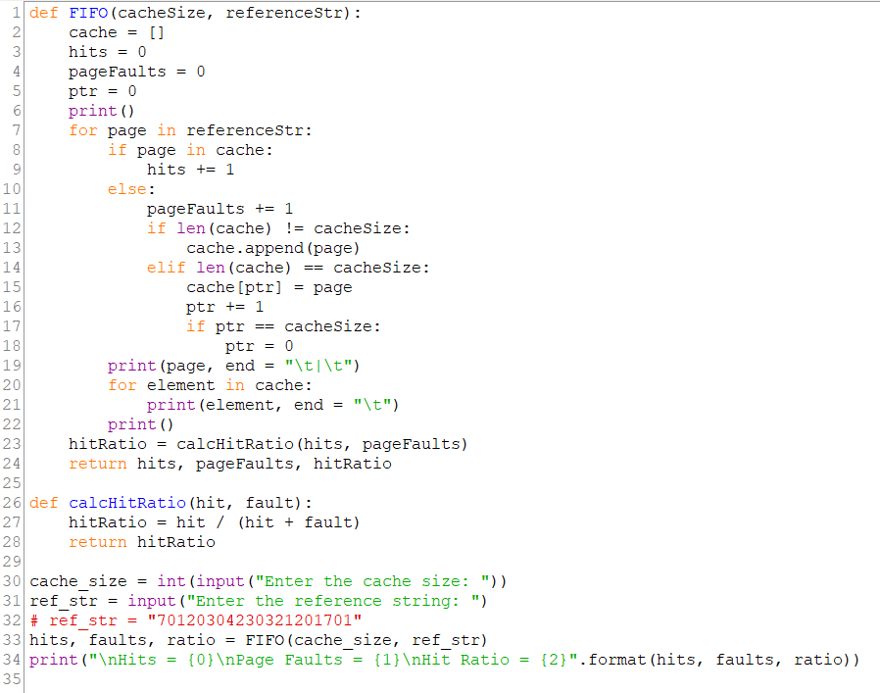

Output:

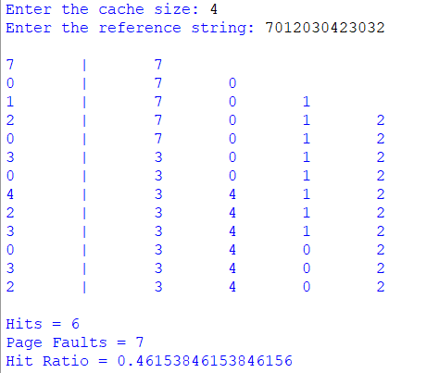

Example:

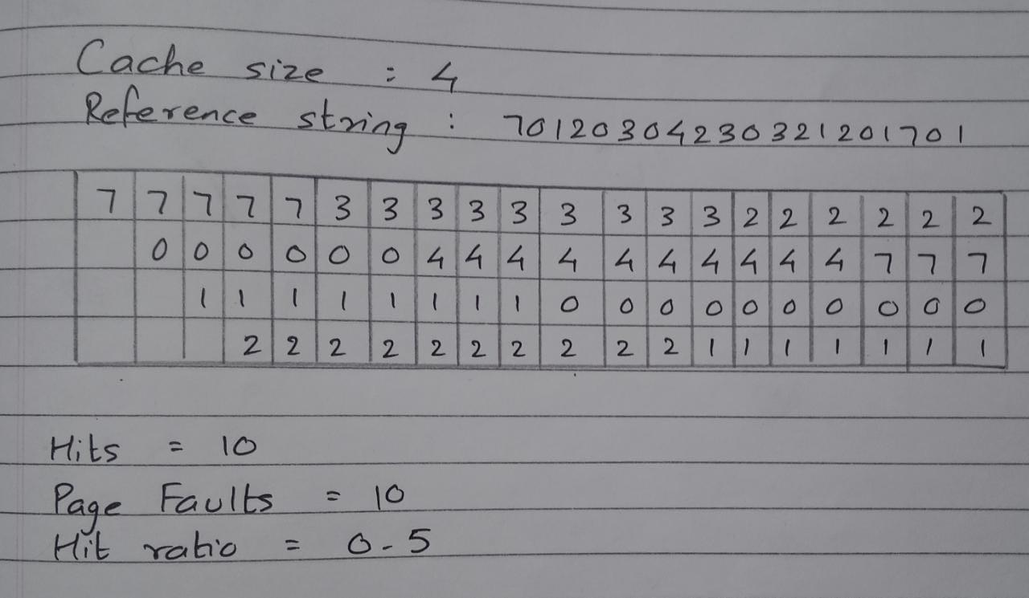
Post Lab Descriptive Questions
1. What is meant by memory interleaving?
Memory Interleaving is a technique for increasing memory speed. It divides memory into a number of modules such that successive words in the address space are placed in different modules.
2. Explain Paging Concept?
Paging is a memory management scheme that eliminates the need for contiguous allocation of physical memory. This scheme permits the physical address space of a process to be non – contiguous.
Conclusion:
The FIFO caching technique is to remove the least recently added page when the cache is full and a new page is referenced which is not there in the cache.

Date: 19/10/2023 Signature of faculty in-charge

