Batch: B2 Roll. No.: 16010122158
Experiment: 9
Grade: AA / AB / BB / BC / CC / CD /DD

Title: Implementation of Searching algorithms

Objective: To understand various searching methods

Expected Outcome of Experiment:

CO | Outcome
CO4 | Demonstrate sorting and searching methods.

Websites/books referred:
- https://www3.ntu.edu.sg/home/ehchua/programming/cpp/DataStructureAlgorithm.html
- https://www.geeksforgeeks.org/what-is-hashing/
_____________________________________________________________________
Abstract: -
Hashing: (Define hashing, collision and list collision handling methods)
Hashing: Hashing is a technique or process of mapping keys, and values into the hash table by using a hash function.
Collision: The situation where a newly inserted key maps to an already occupied slot in hash table is called collision.
Collision handling methods:
- Separate Chaining (Open Hashing): The idea is to make each cell of hash table point to a linked list of records that have same hash function value. Chaining is simple, but requires additional memory outside the table.
- Open Addressing (Closed Hashing): In open addressing, all elements are stored in the hash table itself. Each table entry contains either a record or NIL. When searching for an element, we examine the table slots one by one until the desired element is found, else the element is not in the table.

Code and output screenshots for Linear search:
#include<stdio.h>
#include <stdlib.h>

int main()
{
int a[20], n, i, x;
printf("Enter number of elements: ");
scanf("%d", &n);

printf("Enter array elements: \n");
for(i = 0; i < n; i++)
scanf("%d", &a[i]);

printf("\nEnter element to search: ");
scanf("%d", &x);

for(i = 0; i < n; i++)
if(a[i] == x)
break;

if(i < n)
printf("Element found at index %d", (i+1));
else
printf("Element not found");

return 0;
}

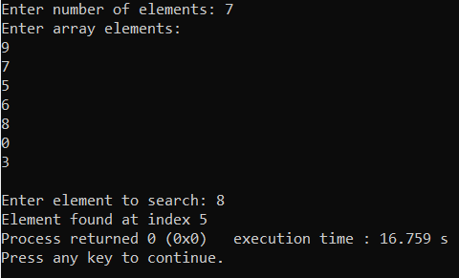

Code and output screenshots for Binary search:
#include<stdio.h>
#include <stdlib.h>

int main()
{
int a[20], n, i, x;
printf("Enter number of elements: ");
scanf("%d", &n);

printf("Enter array elements in sorted ascending order: \n");

for(i = 0; i < n; i++)
scanf("%d", &a[i]);

printf("\nEnter element to search: ");
scanf("%d", &x);

int start = 0;
int end = n - 1;

while(start <= end)
{
int mid = start + (end - start) / 2;
if (a[mid] == x)
i = mid;

if (a[mid] < x)
start = mid + 1;
else
end = mid - 1;
}

if(i < n)
printf("Element found at index %d", (i+1));
else
printf("Element not found");

return 0;
}

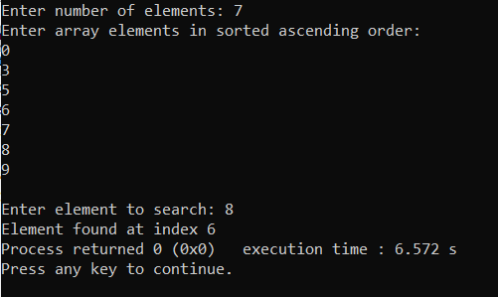
Code and output screenshots for Hash search:
#include <stdio.h>
#include <stdlib.h>
#define CAPACITY 7

int size = 0;

void insert(int hashTable[], int data)
{
int index = data % CAPACITY;
if(hashTable[index] == 0)
{
hashTable[index] = data;
size++;
}
else
{
printf("Collison occured!\n");
}
}

void findElement(int hashTable[], int value)
{
int index = value % CAPACITY;
if(hashTable[index] != value)
{
printf("\nElement not found\n");
}
else
{
printf("\nFound at index %d\n", index);
}
}

int main()
{
int element, i, x;
int hashTable[CAPACITY] = {};

while(size < CAPACITY)
{
printf("Enter element: ");
scanf("%d", &element);
insert(hashTable, element);
}

printf("\nDisplaying hash table:\n");
for(i = 0; i < CAPACITY; i++)
{
printf("%d\t", hashTable[i]);
}

printf("\n\nFind element: ");
scanf("%d", &x);
findElement(hashTable, x);
return 0;
}

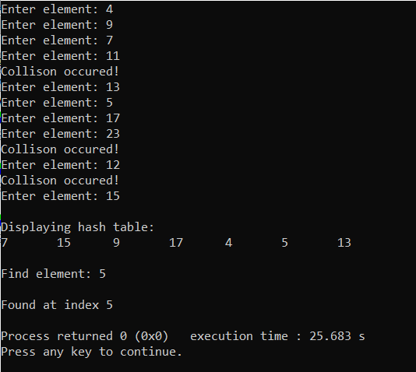

Conclusion:
Various searching algorithms like linear search, binary search and hash search was understood and implemented successfully.

Post Lab Questions:
- Compare and contrast various collision handling methods.
In Open Hashing each cell in the array points to a list containing the collisions. The hashing has produced the same index for all items in the linked list.

In Closed Hashing you use only one array for everything. You store the collisions in the same array. The trick is to use some smart way to jump from collision to collision until you find what you want. And do this in a reproducible / deterministic way.

 | Linear Probing | Quadratic Probing | Double Hashing
Primary Clustering | Yes | No | No
Secondary Clustering | Yes | Yes | No
Number of Probe sequence (m = size of table) | m | m | m^2
Cache Performance | Best | Lies between the two | Poor

- Compare linear search and binary search

Linear Search | Binary Search
The linear search starts searching from the first element and compares each element with a searched element till the element is not found | It finds the position of the searched element by finding the middle element of the array.
In a linear search, the elements don't need to be arranged in sorted order. | The pre-condition for the binary search is that the elements must be arranged in a sorted order.
The linear search can be implemented on any linear data structure such as an array, linked list, etc. | The implementation of binary search is limited as it can be implemented only on those data structures that have two-way traversal.
It is based on the sequential approach. | It is based on the divide and conquer approach.
It is preferable for small-sized data sets. | It is preferable for the large-size data sets.

- Store the given numbers in bucket of size 16, resolve the collisions if any with
  - Linear probing
  - Quadratic hashing
  - Chaining
20, 33, 65, 23, 11, 32, 78, 64, 3, 87, 10, 7

Linear probing:
0 | 32 | 20 = 1*16 + 4  1 probe.  33 = 2*16 + 1  1 probe.  65 = 4*16 + 1  2 probes.  23 = 1*16 + 7  1 probe.  11 = 0*16 + 11  1 probe.  32 = 2*16 + 0  1 probe.  78 = 4*16+14  1 probe.  64 = 4*16+0  4 probes.  3 = 0*16+3  3 probes.  87 = 5*16+7  2 probes.  10 = 0*16+10  1 probe.  7 = 0*16+7  3 probes.
1 | 33
2 | 65
3 | 64
4 | 20
5 | 3
6
7 | 23
8 | 87
9 | 7
10 | 10
11 | 11
12
13
14 | 78
15

Quadratic hashing:
0 | 32 | 20 = 1*16 + 4  4  1 probe.  33 = 2*16 + 1  1  1 probe.  65 = 4*16 + 1  1 2  2 probes.  23 = 1*16 + 7  7  1 probe.  11 = 0*16 + 11  11  1 probe.  32 = 2*16 + 0  0  1 probe.  78 = 4*16+14  14  1 probe.  64 = 4*16+0  0 1 4 9  4 probes.  3 = 0*16+3  3  3 probes.  87 = 5*16+7  7 8  2 probes.  10 = 0*16+10  10  1 probe.  7 = 0*16+7  7 8 11 0 7 0 11 8 7 8 11 0 7 0 11 8  3 probes.
1 | 33
2 | 65
3 | 3
4 | 20
5
6
7 | 23
8 | 87
9 | 64
10 | 10
11 | 11
12
13
14 | 78
15

Chaining:
0 | 32 64 | 20 = 1*16 + 4  33 = 2*16 + 1  65 = 4*16 + 1  23 = 1*16 + 7  11 = 0*16 + 11  32 = 2*16 + 0  78 = 4*16+14  64 = 4*16+0  3 = 0*16+3.  87 = 5*16+7  10 = 0*16+10  7 = 0*16+7
1 | 33 65
2
3 | 3
4 | 20
5
6
7 | 23 87 7
8
9
10 | 10
11 | 11
12
13
14 | 78
15

