Batch: B2 Roll. No.: 16010122158
Experiment: 8
Grade: AA / AB / BB / BC / CC / CD /DD

Title: Using virtual labs to understand the data structures

Objective: Use of virtual labs to understand the concepts and theory with examples and verify the same with practice questions.

Expected Outcome of Experiment:

CO | Outcome
CO1 | Explain the different data structures used in problem solving
CO2 | Apply linear and non-linear data structure in application development
CO3 | Demonstrate sorting and searching methods.

Websites/books referred:
1. https://ds1-iiith.vlabs.ac.in/exp/breadth-first-search/feedback.html
Abstract: the virtual lab experiments help in understanding how various data structures work. They also emphasize on some important applications of various data structures and enable students to get familiarized with how certain applications can benefit from the choice of data structures.
Assigned data structure: (Teacher would assign one of the following to one student)
- Stack - https://ds1-iiith.vlabs.ac.in/exp/stacks-queues/stacks/stackdemo.html
- Infix and postfix - https://ds1-iiith.vlabs.ac.in/exp/infix-postfix/evaluation-of-postfix-expressions/postfix_eval.html
- Queue - https://ds1-iiith.vlabs.ac.in/exp/stacks-queues/stacks/stackdemo.html
- Bubble sort - https://ds1-iiith.vlabs.ac.in/exp/bubble-sort/bubble-sort/bsexercise.html
- Graph DFS - https://ds1-iiith.vlabs.ac.in/exp/depth-first-search/index.html
- Graph BFS - https://ds1-iiith.vlabs.ac.in/exp/breadth-first-search/index.html
- Binary search tree - https://ds1-iiith.vlabs.ac.in/exp/binary-search-trees/bst-insert/bstInsert.html
- Hash tables - https://ds1-iiith.vlabs.ac.in/exp/hash-tables/quadratic-probing/qp_practice.html
- Linked list - https://ds1-iiith.vlabs.ac.in/exp/linked-list/singly-linked-list/sllpractice.html
Aim / learning objective of the assigned exp:
- Study the basic concepts of Graphs and Queues and their representation.
- Study the various Graph traversal algorithms and difference between them.
- Understand the BFS Graph traversal using queues.
- Demonstrate knowledge of time complexity and space complexity of performing a BFS on a given graph.
Concept and algorithm of the application/activity followed:
BFS Algorithm
The algorithm starts with examining the source node and all of its neighbours. In the next step, the neighbours of the nearest node of the source node are explored. The algorithm then explores all neighbours of all the nodes and ensures that each node is visited exactly once and no node is visited twice.
      - Set visited as 0 for all nodes in the Graph.
      - Enqueue the selected source node into the queue.
      - Dequeue a node N from queue and update its visited as 1.
      - Enqueue all the neighbours of node N which are not present in the queue and whose visited is 0.
      - Repeat steps 3 and 4 until queue is empty.
      - EXIT
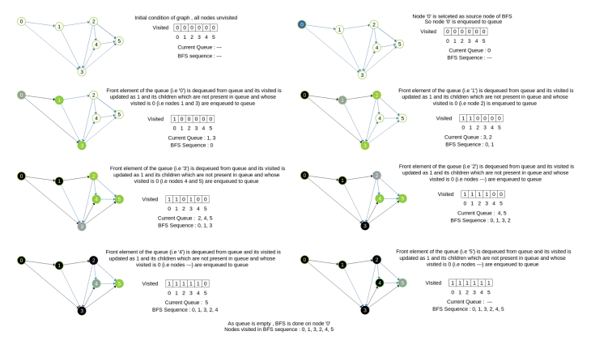
Demo execution screenshots:
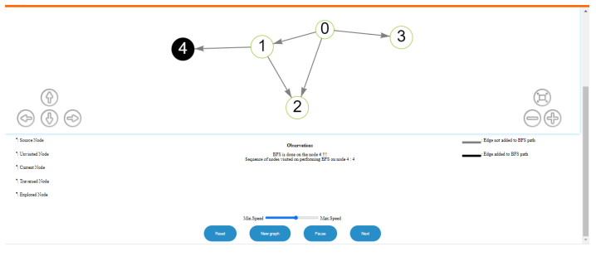
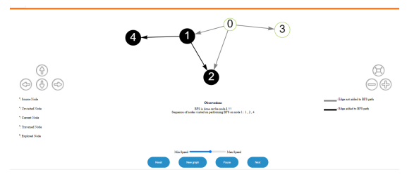
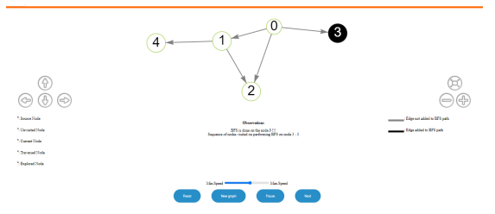
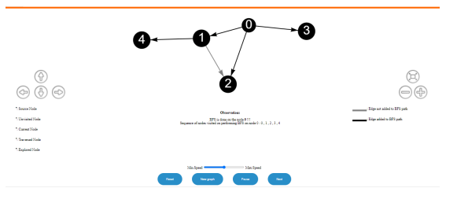

Practice problem screenshots:
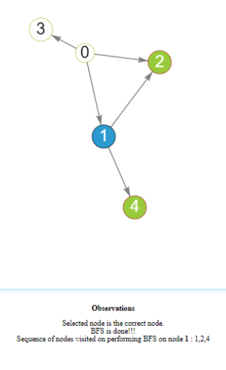
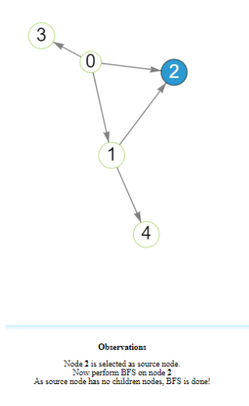

Quiz screenshots:
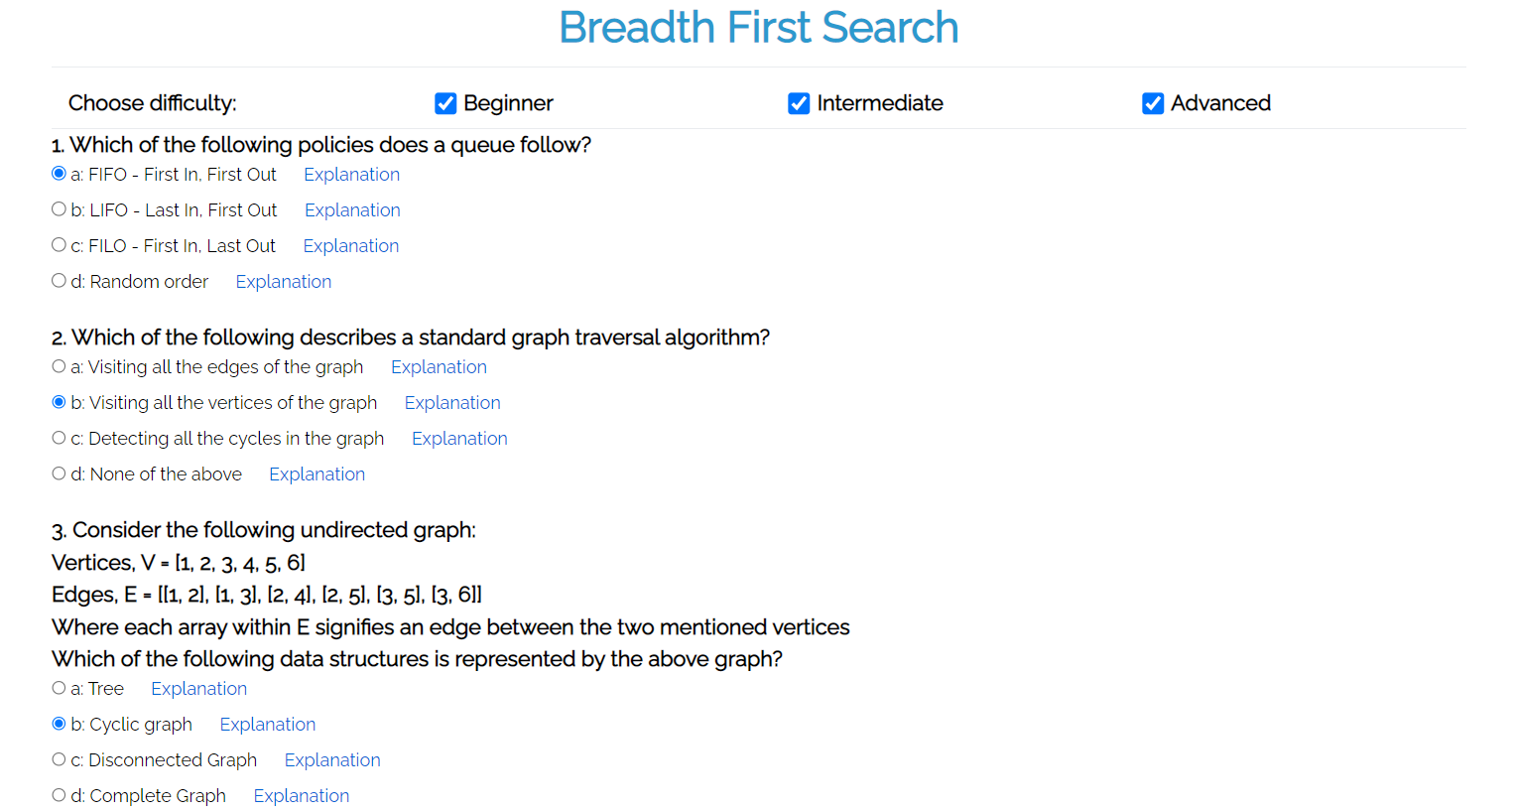
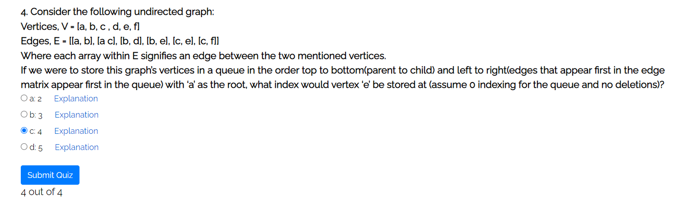
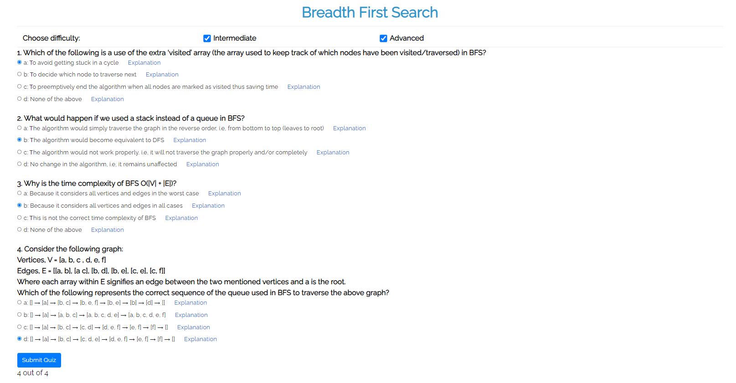
Conclusion and your take away after performing the virtual lab experiment: -
The concept for BFS was understood thoroughly and further was used to solve practice and quiz questions. The use of this technology has helped me a lot in understanding each step of BFS. The graph traversal which is at times very difficult to understand was understood perfectly.

