Batch: C2 Roll No.: 16010121200
Experiment No. 1
Grade: AA / AB / BB / BC / CC / CD /DD

Title: Implementation of Abstract Data Type

Objective: Implementation of ADT without using any standard library function

Expected Outcome of Experiment:

CO | Outcome
CO 1 | Explain the different data structures used in problem solving.

Books/ Journals/ Websites referred:
https://www.britannica.com/technology/computer
https://en.wikipedia.org/wiki/Abstract_data_type#Advantages_of_abstract_data_typing

Abstract:-
(Define ADT. Why are they important in data structures?)
Abstract Data Types (ADTs) store data and allow various operations on the data to access and change it. A mathematical model, together with various operations defined on the model. An ADT is a collection of data and associated operations for manipulating that data. Adts are very important for large scale programming. They package different data structures and operations on them,hiding internal details. Different implementations of the ADT, having all the same properties and abilities, are equivalent and may be used somewhat interchangeably in code that uses the ADT. This gives a great deal of flexibility when using ADT objects in different situations. Encapsulation is also one of the advantages of ADT.

Abstract Data Type for Rational Numbers
[for chosen data type write value definition and operator definition)
Value Definition:
abstract TypeDef<integer, integer>
RATIONALType;
Condition: RATIONALType [1] != 0;

Operator definition:
Abstract RATIONALType makerational<a,b>
integer a,b;
Preconditon:
b != 0;
Postcondition:
makerational [0] = a;
makerational [1] = b;

abstract RATIONALtype add<a,b>
RATIONALType a,b;
Precondition: none
Postcondition:
add[0] = a[0]*b[1]+b[0]*a[1]
add[1] = a[1] * b[1]

abstract RATIONALType mult<a, b>
RATIONALType a,b;
Precondition: none
Postcondition:
mult[0] = = a[0]*b[0]
mult[1] = = a[1]*b[1]
Abstract Boolean
Equal<a,b>
RATIONALType a,b;
Precondition: none
Postcondition: equal =
a[0] * b[1] = = b[0] * a[1];

Implementation Details:
- Enlist all the Steps followed and various options explored.
- Define rational number
- Create the value definition
- Create multiple operator definitions
- Take the appropriate input from the user
- Create an actual rational number
- Choose any operation to be performed on the number
- END

2. Explain your program logic and methods used.
Definition of rational number: p/q where p and q are integers and q != 0.
Methods implemented: Addition, multiplication, comparing
Addition: Adding 2 rational numbers created at the start of code
Multiplication: Multiplying 2 rational numbers created at the start of code.
Comparing: Compare if the 2 numbers are equal. If yes, return True, else False.

3. Explain the Importance of the approach followed by you.
Importance of implementing ADT is it helps to hide the implementation details and only gives required output, thus helping in data abstraction and encapsulation.
ADTs are important for large scale programming.

Program code and Output screenshots:
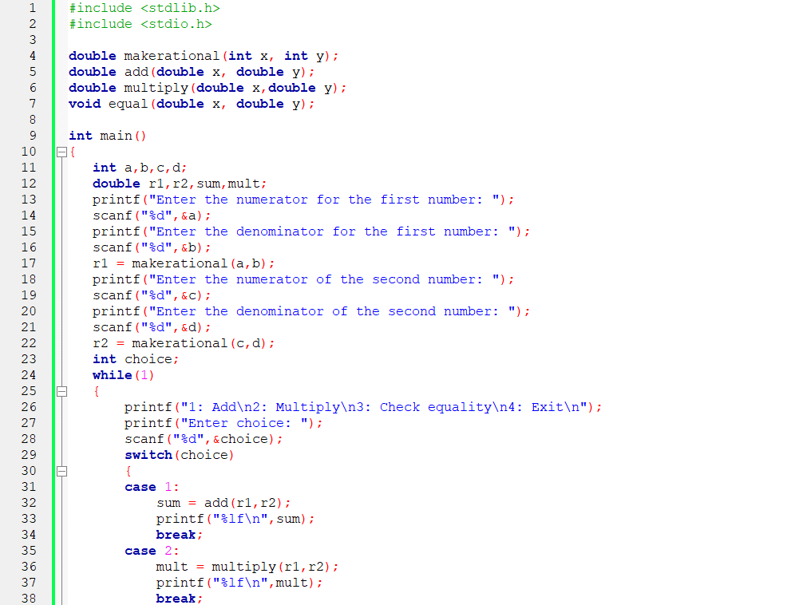
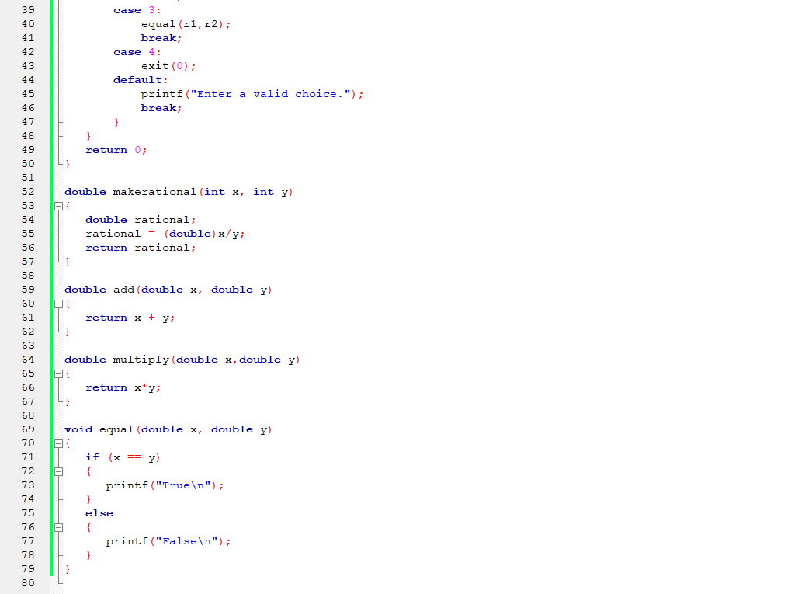
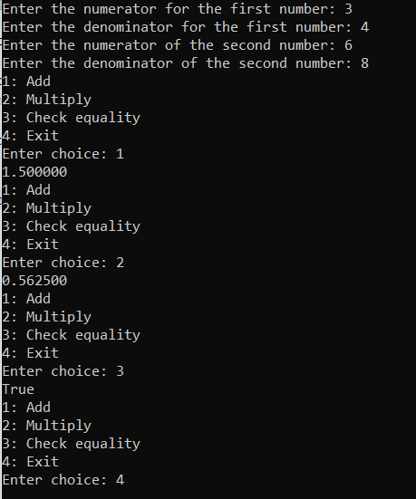

Conclusion:
Abstract data types or ADTs are a mathematical specification of a set of data and the set of operations that can be performed on the data.
Implemented ADT for rational numbers.

