Batch: C2 Roll No.: 16010121200

Experiment / assignment / tutorial No. 4

Grade: AA / AB / BB / BC / CC / CD /DD

Signature of the Staff In-charge with date

Title: Implementation of Basic operations on queue for the assigned application using Array and Linked List- Create, Insert, Delete, Destroy

Objective: To implement Basic Operations on Queue i.e. Create, Push, Pop, Destroy for the given application

Expected Outcome of Experiment:

CO | Outcome
1 | Explain the different data structures used in problem solving

Books/ Journals/ Websites referred:
- Fundamentals Of Data Structures In C – Ellis Horowitz, Satraj Sahni, Susan Anderson-Fred
- An Introduction to data structures with applications – Jean Paul Tremblay,
Paul G. Sorenson
- Data Structures A Pseudo Approach with C – Richard F. Gilberg & Behrouz A. Forouzan

Abstract:
(Define Queue, Enlist queue operations).
A Queue is defined as the collection of elements stored sequentially such that the elements can be deleted from one end known as front end and can be added at another end known as the rear end. The order is First In First Out (FIFO). A good example of a queue is any queue of consumers for a resource where the consumer that came first is served first. The difference between stacks and queues is in removing. In a stack we remove the item the most recently added; in a queue, we remove the item the least recently added.
Queues can be implemented in various formats:
1.The Physical Model
2.Linear Implementation
3.Circular Arrays
Operation | Description
Enqueue() | Process of adding or storing an element to the end of the queue
dequeue() | Process of removing or accessing an element from the front of the queue
peek() | Used to get the element at the front of the queue without removing it
initialize() | Creates an empty queue
isfull() | Checks if the queue is full
isempty() | Check if the queue is empty

List 5 Real Life applications of Queue:
- Cashier line in a store
- When data is transferred asynchronously (data not necessarily received at the same rate as sent) between two processes. Examples include IO Buffers, pipes, file IO, etc.
- Memory Management: The unused memory locations in the case of ordinary queues can be utilized in circular queues.
- Traffic system: In a computer-controlled traffic system, circular queues are used to switch on the traffic lights one by one repeatedly as per the time set.
- CPU Scheduling: Operating systems often maintain a queue of processes that are ready to execute or that are waiting for a particular event to occur.
Define and explain various types of queue with suitable diagram and their application(s):
- Circular Queue is a linear data structure in which the operations are performed based on FIFO (First In First Out) principle and the last position is connected back to the first position to make a circle. It is also called ‘Ring Buffer’.

- Input restricted Queue: In this type of Queue, the input can be taken from one side only(rear) and deletion of elements can be done from both sides(front and rear). This kind of Queue does not follow FIFO. This queue is used in cases where the consumption of the data needs to be in FIFO order but if there is a need to remove the recently inserted data for some reason and one such case can be irrelevant data, performance issue, etc.
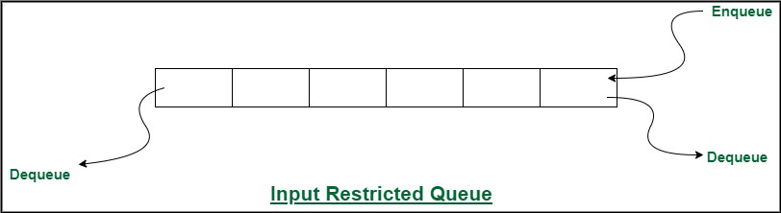

- Output restricted Queue: In this type of Queue, the input can be taken from both sides(rear and front) and the deletion of the element can be done from only one side(front). This queue is used in the case where the inputs have some priority order to be executed and the input can be placed even in the first place so that it is executed first.
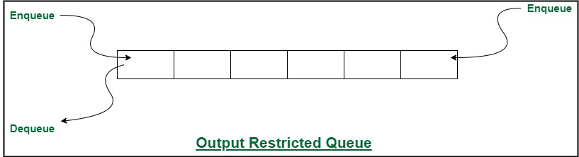

- Double Ended Queue is also a Queue data structure in which the insertion and deletion operations are performed at both the ends (front and rear). That means, we can insert at both front and rear positions and can delete from both front and rear positions. Since Deque supports both stack and queue operations, it can be used as both. The Deque data structure supports clockwise and anticlockwise rotations in O(1) time which can be useful in certain applications. Also, the problems where elements need to be removed and or added both ends can be efficiently solved using Deque.
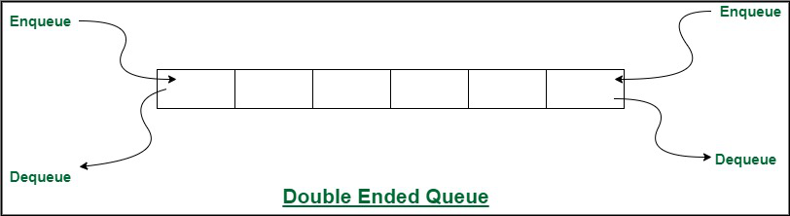

- A priority queue is a special type of queue in which each element is associated with a priority and is served according to its priority. There are two types of Priority Queues. They are:
- a) Ascending Priority Queue: Elements can be inserted arbitrarily but only the smallest element can be removed. For example, suppose there is an array having elements 4, 2, 8 in the same order. So, while inserting the elements, the insertion will be in the same sequence but while deleting, the order will be 2, 4, 8.
- b) Descending priority Queue: Element can be inserted arbitrarily but only the largest element can be removed first from the given Queue. For example, suppose there is an array having elements 4, 2, 8 in the same order. So, while inserting the elements, the insertion will be in the same sequence but while deleting, the order will be 8, 4, 2.

Queue ADT:
The queue supports three fundamental methods:
1. New() ADT: Creates an empty queue
2. Enqueue(S:ADT,o:element):Insert objects o at the rear of the queue.
3. Dequeue(S:ADT): Removes the object from front of the queue,an error occurs if the queue is empty
4. Front(S:ADT):Return but does not remove the first element,an error occurs if the queue is empty

Algorithm for Queue operations using array/Linked list: (Write only the algorithm for assigned type)
- Insertion of Priority Queue:
- Step 1: Create new node with DATA and PRIORITY
- Step 2: Check if HEAD has lower priority. If true, follow Steps 3-4 and end. Else goto Step 5.
- Step 3: NEW -> NEXT = HEAD
- Step 4: HEAD = NEW
- Step 5: Set TEMP to head of the list
- Step 6: While TEMP -> NEXT != NULL and TEMP -> NEXT -> PRIORITY > PRIORITY
- Step 7: TEMP = TEMP -> NEXT
[END OF LOOP]
- Step 8: NEW -> NEXT = TEMP -> NEXT
- Step 9: TEMP -> NEXT = NEW
- Step 10: End
Deleting an element:
- Step 1: Set the head of the list to the next node in the list. HEAD = HEAD -> NEXT.
- Step 2: Free the node at the head of the list
- Step 3: End
Peeking an element:
- Step 1: Return HEAD -> DATA
- Step 2: End
Implementation Details:
- Mention the application assigned to you and explain how you implemented the solution using the assigned type of Queue.

Priority Queue: Every item has a priority associated with it.
An element with high priority is dequeued before an element with low priority.
If two elements have the same priority, they are served according to their order in the queue.
List is created and node is inserted such that list always remains sorted. High priority element is always at the head so that it will always be the first to get deleted.
To insert an element we must traverse the list and find the proper position to insert the node so that the overall order of the priority queue is maintained.
Program source code:
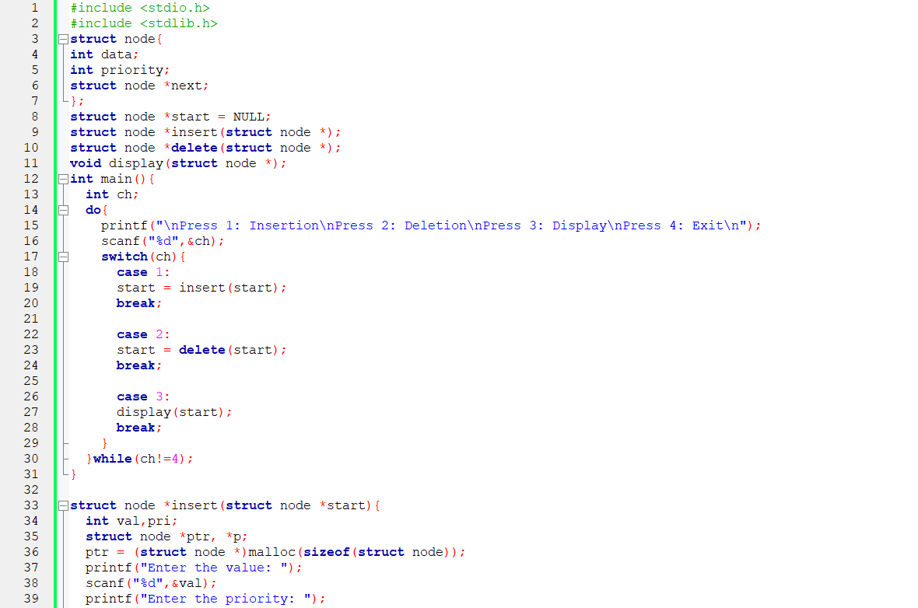
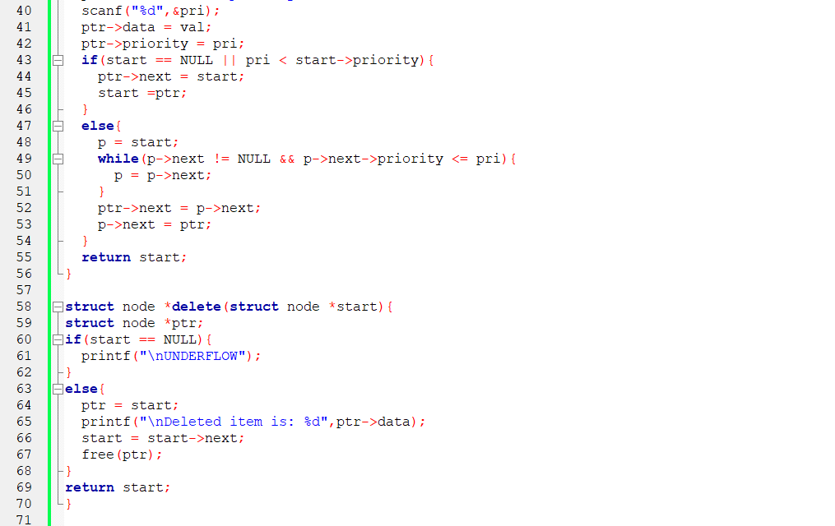
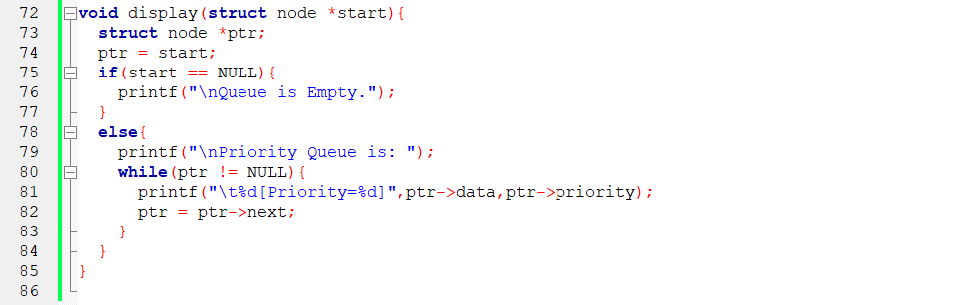

Output Screenshots:
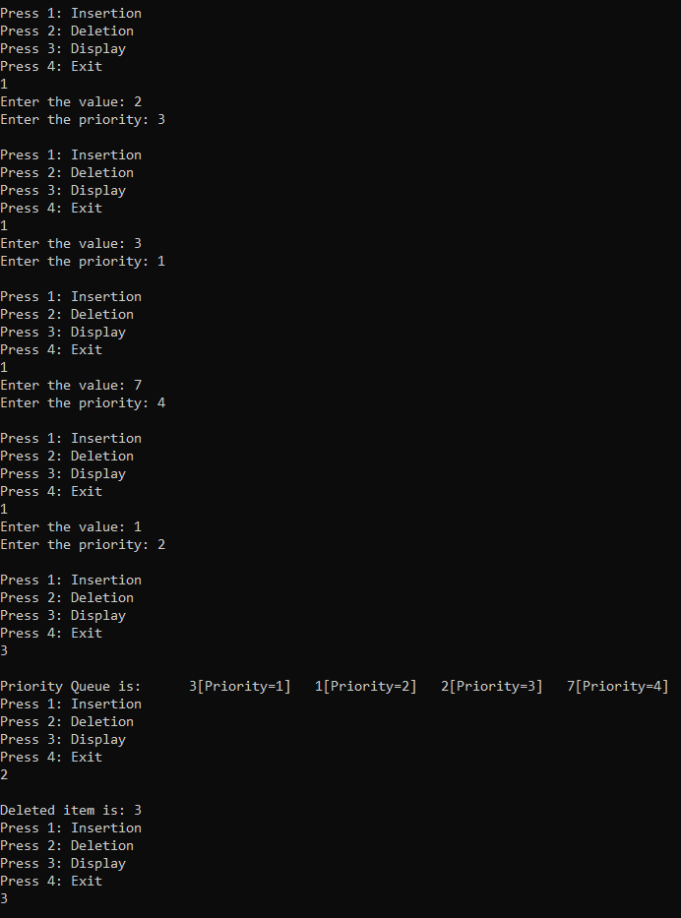
Applications of Queue in computer science:
Various Application of Queue in computer science are:
- CPU Scheduling
- Multiprogramming
- Operation on Data Structure
- Access to Shared Resources
- Multilevel Queue Scheduling
- Buffer Space
- Simulations
Conclusion:

Explored different types of queues and learnt various applications of queues in real life and computer science.
Successfully implemented Priority Queue.

