Batch: C2 Roll. No.: 16010121200
Experiment: 7
Grade: AA / AB / BB / BC / CC / CD /DD

Title: Implementation of Graph traversal menu driven program (DFS and BFS).

Objective: To understand graph as data structure and methods of traversing Graph

Expected Outcome of Experiment:

CO | Outcome
CO2 | Apply linear and non-linear data structure in application development

Websites/books referred:

_____________________________________________________________________
Abstract: - (Definition of Graph, types of graphs, and difference and similarity between graph & tree)
Graph:
A graph is an abstract data structure that is used to implement the mathematical concept of graphs. It is basically a collection of vertices (also called as nodes) and edges that connect these vertices. A graph is often viewed as generalization of the tree structure, where instead of having a purely parent-to-child relationship between tree nodes, any kind of complex relationship can exist.
A graph G is defined as an ordered set (V,E) where V(G) represents the set of vertices and E(G) represent she edges that connect the vertices.
Types of Graphs:
There are various types of graphs depending upon the number of vertices, number of edges, interconnectivity, and their overall structure.
Null Graph: A graph having no edges is called a Null Graph.
Trivial Graph: A graph with only one vertex is called a Trivial Graph.
Non-directed Graph: A non-directed graph contains edges but the edges are not directed ones.
Directed Graph: In a directed graph, each edge has a direction.
Simple Graph: A graph with no loops and no parallel edges is called a simple graph.
Connected Graph: A graph G is said to be connected if there exists a path between every pair of vertices. There should be at least one edge for every vertex in the graph. So that we can say that it is connected to some other vertex at the other side of the edge.
Disconnected Graph: A graph G is disconnected, if it does not contain at least two connected vertices.
Regular Graph: A graph G is said to be regular, if all its vertices have the same degree. In a graph, if the degree of each vertex is ‘k’, then the graph is called a ‘k-regular graph’.
Complete Graph: A simple graph with ‘n’ mutual vertices is called a complete graph and it is denoted by ‘K_{n}’. In the graph, a vertex should have edges with all other vertices, then it called a complete graph.
Cycle Graph: The graph in which the graph is a cycle in itself, the degree of each
vertex is 2.
Cyclic Graph: A graph containing at least one cycle is known as a Cyclic graph.
Directed Acyclic Graph: A Directed Graph that does not contain any cycle.
Bipartite graph: A graph in which vertex can be divided into two sets such that
vertex in each set does not contain any edge between them.

Difference between graph and tree:
Graph | Tree
A node in a graph can have any number of edges. | A tree consists of nodes having any number of child nodes, while a binary tree has at most two child nodes.
There is no unique node called the starting node in a graph. | There is a unique node called root in trees.
A cycle can be present in a graph | No cycle can be present in a tree.
Applications: The graph is used to find the shortest path in networking. | Applications: The tree data structure is preferred for game and decision trees.

Similarity between graph and tree:
Both are non-linear data structures.
Both are a collection of nodes/vertices and edges.

Algorithm for DFS/BFS:
DFS algorithm:
- SET STATUS = 1 (ready state) for each node in G
- Push the starting node A on the stack and set its STATUS = 2 (waiting state)
- Repeat Steps 4 and 5 until STACK is empty
- Pop the top node N. Process it and set its STATUS = 3 (processed state)
- Push on the stack all the neighbours of N that are in the ready state (whose STATUS = 1) and set their STATUS = 2 (waiting state)
[END OF LOOP]
- EXIT

BFS algorithm:
- SET STATUS = 1 (ready state) for each node in G
- Enqueue the starting node A and set its STATUS = 2 (waiting state)
- Repeat Steps 4 and 5 until QUEUE is empty
- Dequeue a node N. Process it and set its STATUS = 3 (processed state).
- Enqueue all the neighbours of N that are in the ready state (whose STATUS = 1) and set their STATUS = 2 (waiting state)
[END OF LOOP]
- EXIT

Code and output screenshots:
Code:
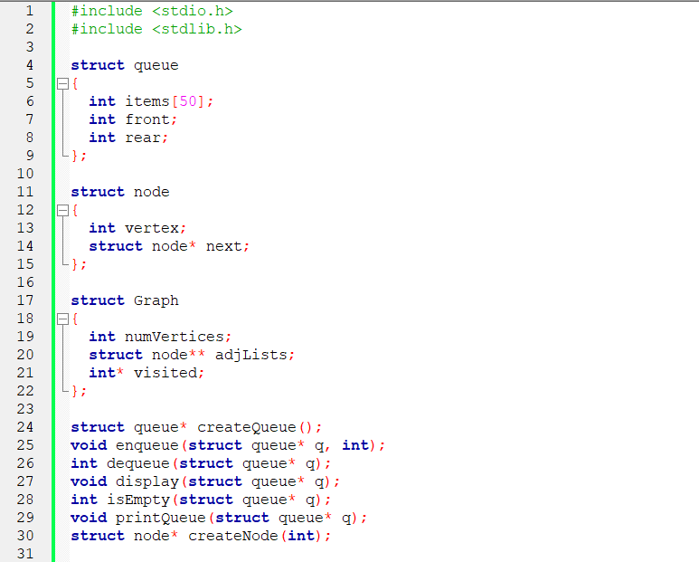
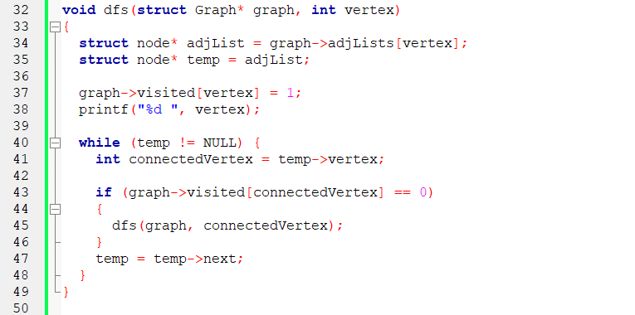
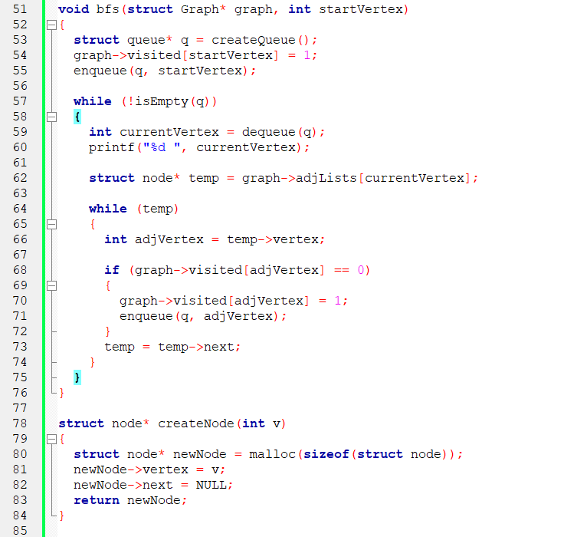
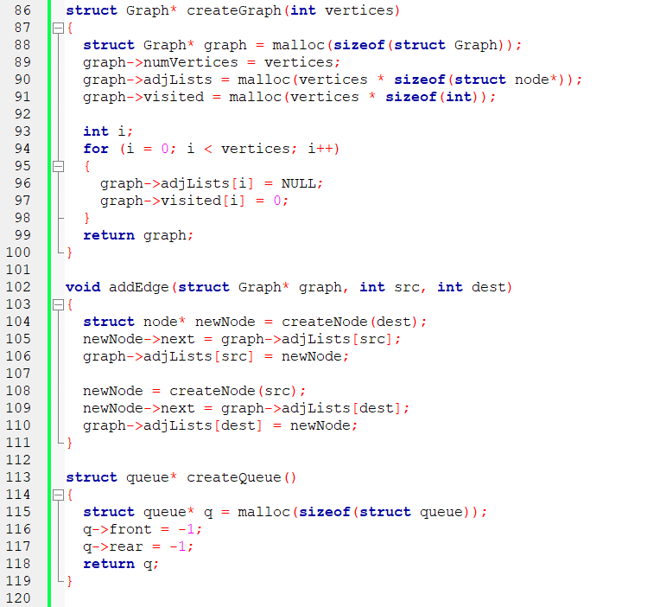
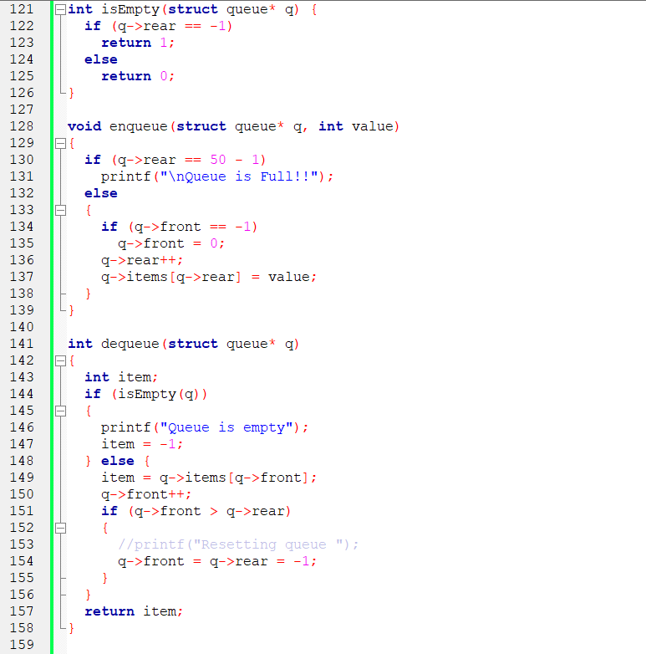
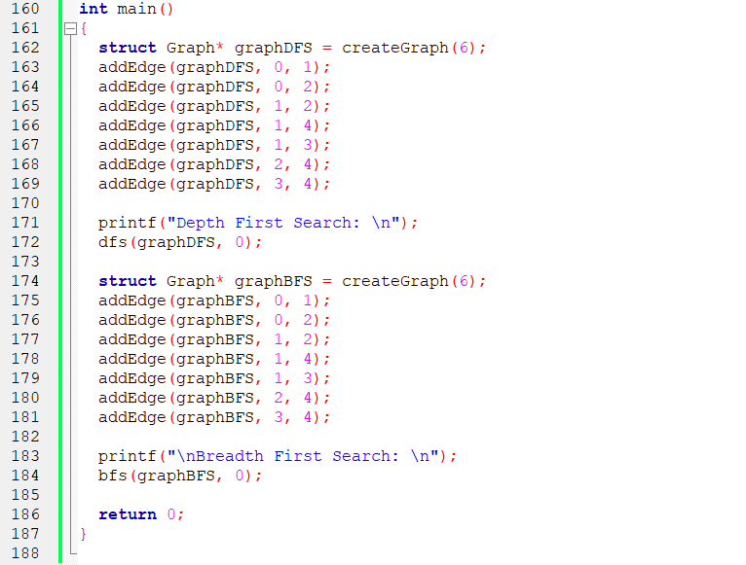
Output:
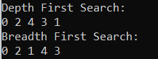
Post lab questions:
- Differentiate between BFS and DFS.

S. No. | BFS | DFS
1. | Breadth First Search. | Depth First Search.
2. | BFS(Breadth First Search) uses Queue data structure for finding the shortest path. | DFS(Depth First Search) uses Stack data structure.
3. | We first walk through all nodes on the same level before moving on to the next level. | We begin at the root node and proceeds through the nodes as far as possible until we reach the node with no unvisited nearby nodes.
4. | BFS is more suitable for searching vertices closer to the given source. | DFS is more suitable when there are solutions away from source.
5. | BFS requires more memory. | DFS requires less memory.
6. | BFS is optimal for finding the shortest path. | DFS is not optimal for finding the shortest path.

- Give sequence of the nodes visited as per BFS and DFS strategy for following example. Source- Arad, Destination- Bucharest (Traversal would stop after destination is reached)

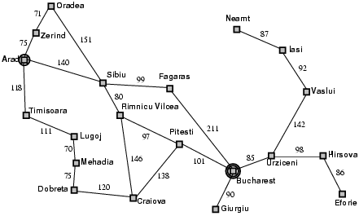

BFS: Arad, Zerind, Timisoara, Sibiu, Oradea, Lugoj, Rimnicu Vilcea, Fagaras, Mehadia, Pitesti, Craiova, Bucharest
DFS: Arad, Zerind, Oradea, Sibiu, Rimnicu Vilcea, Pitesti, Bucharest
Conclusion:

Graphs along with the basic traversal techniques like BFS and DFS were understood properly and implemented successfully.

