Batch: C2 Roll. No.: 16010121200
Experiment: 8
Grade: AA / AB / BB / BC / CC / CD /DD

Title: Implementation of Dictionary using map

Objective: To understand dictionary as a data structure

Expected Outcome of Experiment:

CO | Outcome
CO2 | Describe concepts of advance data structures like set, map & dictionary.

Websites/books referred:
1. Michael T. Goodrich, Roberto Tamassia, and David M. Mount. 2009. Data Structures and Algorithms in C++ (2nd. ed.). Wiley Publishing
_____________________________________________________________________
Abstract:
A dictionary is an abstract data type that defines an unordered collection of data as a set of key-value pairs. Each key, which must be unique, has an associated value. Typically, the keys in a dictionary must be simple types (such as integers or strings) while the values can be of any type.
Standard dictionary operations include:
- retrieve a value associated with a particular key
- insert a new key-value pair into the collection
- remove a key-value pair from the collection
- update a value associated with a key
Using a key allows direct access to items stored within the collection. This provides much quicker access to unordered data than searching through the data set using a linear search and will also outperform a binary search. Key-value retrieval is a technique widely used in various high-performance systems, such as caches and databases.
Dictionary ADT functions: (list and give one line details)
clear() | Removes all the elements from the dictionary
copy() | Returns a copy of the dictionary
fromkeys() | Returns a dictionary with the specified keys and value
get() | Returns the value of the specified key
items() | Returns a list containing a tuple for each key value pair
keys() | Returns a list containing the dictionary's keys
pop() | Removes the element with the specified key
popitem() | Removes the last inserted key-value pair
setdefault() | Returns the value of the specified key. If the key does not exist: insert the key, with the specified value
update() | Updates the dictionary with the specified key-value pairs
values() | Returns a list of all the values in the dictionary

Problem statement:
Given names and phone numbers, assemble a phone book that maps friends' names to their respective phone numbers. You will then be given an unknown number of names to query your phone book for. For each queried, print the associated entry from your phone book on a new line in the form name = phoneNumber; if an entry for is not found, print Not found instead.

Note: Your phone book should be a Dictionary/Map/HashMap data structure.
Input Format
The first line contains an integer, , denoting the number of entries in the phone book.
Each of the subsequent lines describes an entry in the form of space-separated values on a single line. The first value is a friend's name, and the second value is an -digit phone number.
After the lines of phone book entries, there are an unknown number of lines of queries. Each line (query) contains a name to look up, and you must continue reading lines until there is no more input.

Output Format
On a new line for each query, print Not found if the name has no corresponding entry in the phone book; otherwise, print the full and in the format name = phoneNumber.
Source code and output screenshots:
(Students could implement map using singly or doubly linked list. It should handle all possible boundary conditions)
Code:
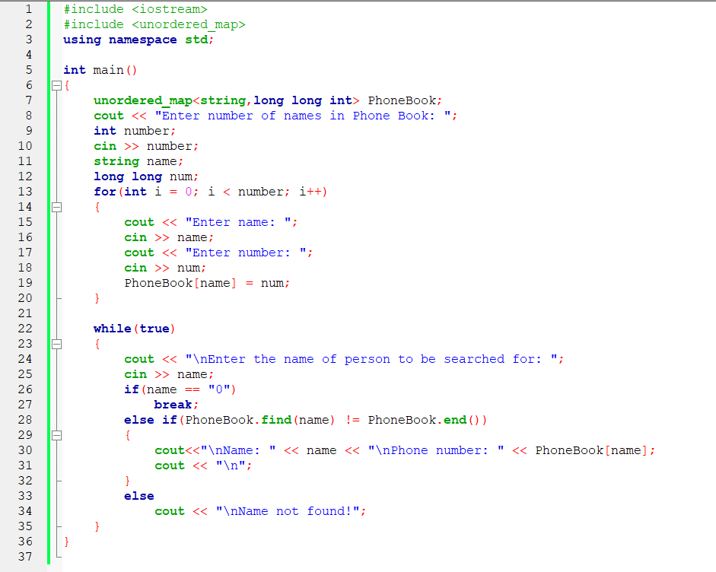

Output:
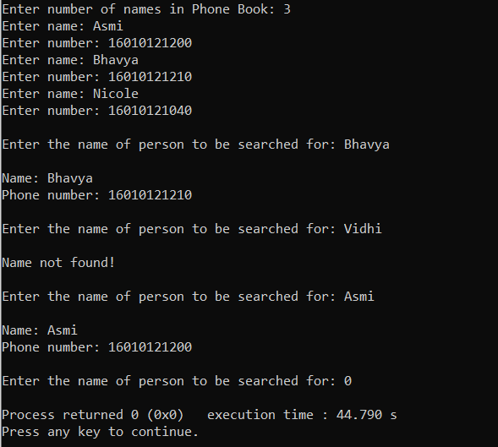
Conclusion:
The hash map data structure was understood and implemented successfully.

Post Lab Questions:

- Give and explain at least one scenario each in which map, dictionary and set would be the most appropriate data structure to use.
Maps, dictionaries and sets are useful in places where we donot wish to store duplicate elements. If duplicate elements are found the structure should either ignore it or update its value. Dictionary and maps are also particularly useful in places where we want to search quickly (Time complexity: O(1)) for a value and thus can be used in places where searching is to be performed quickly and frequently.

- State differences and similarities in set, map and dictionary.

Set | Dictionary
Set data structure is also non-homogeneous data structure but stores in single row | Dictionary is also a non-homogeneous data structure which stores key value pairs
Set can be represented by { } | Dictionary can be represented by { }
Set will not allow duplicate elements | Set will not allow duplicate elements and dictionary doesn’t allow duplicate keys.
Set can use nested among all | Dictionary can use nested among all
Example: {1, 2, 3, 4, 5} | Example: {1, 2, 3, 4, 5}
Set can be created using set() function | Dictionary can be created using dict() function.
Set is mutable i.e we can make any changes in set. But elements are not duplicated. | Dictionary is mutable. But Keys are not duplicated.
Set is unordered | Dictionary is ordered (Python 3.7 and above)
Creating a set  a=set()  b=set(a) | Creating an empty dictionary  d={}

