Batch: C2 Roll. No.: 16010121200
Experiment: 8
Grade: AA / AB / BB / BC / CC / CD /DD

Title: Implementation of map using linked list

Objective: To understand map as a data structure

Expected Outcome of Experiment:

CO | Outcome
CO2 | Describe concepts of advanced data structures like set, map & dictionary.

Websites/books referred:
1. Michael T. Goodrich, Roberto Tamassia, and David M. Mount. 2009. Data Structures and Algorithms in C++ (2nd. ed.). Wiley Publishing
_____________________________________________________________________
Map:
A map allows us to store elements so they can be located quickly using keys. The motivation for such searches is that each element typically stores additional useful information besides its search key, but the only way to get at that information is to use the search key. Specifically, a map stores key-value pairs (k,v), which we call entries, where k is the key and v is its corresponding value. In addition, the map ADT requires that each key be unique, so the association of keys to values defines a mapping. In order to achieve the highest level of generality, we allow both the keys and the values stored in a map to be of any object type. In a map storing student records (such as the student’s name, address, and course grades), the key might be the student’s ID number. In some applications, the key and the value may be the same.
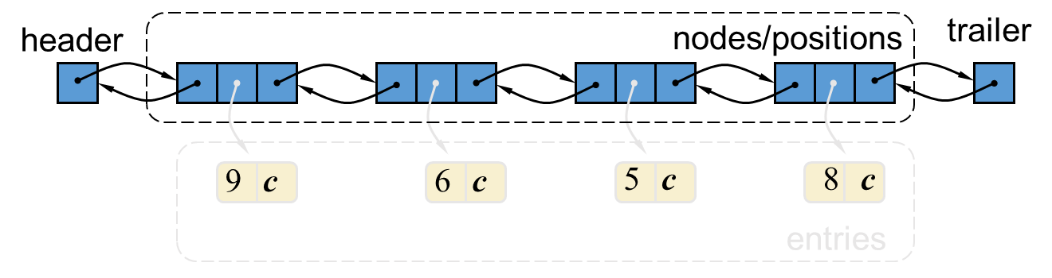
For example, if we had a map storing prime numbers, we could use each number itself as both a key and its value. In either case, we use a key as a unique identifier that is assigned by an application or user to an associated value object. Thus, a map is most appropriate in situations where each key is to be viewed as a kind of unique index address for its value, that is, an object that serves as a kind of location for that value. For example, if we wish to store student records, we would probably want to use student ID objects as keys (and disallow two students having the same student ID). In other words, the key associated with an object can be viewed as an “address” for that object. Indeed, maps are sometimes referred to as associative stores or associative containers, because the key associated with an object determines its “location” in the data structure

Algorithm :
createMap() : Creates a map and initialize it to empty map.
Int size(): Return the number of elements in the map.
Boolean empty(): Return true if the map is empty and false otherwise.
Typedef find(int k): Find the entry with key k and return an iterator to it; if no
such key exists return end.
Void insert(pair(k,v)): If key k is already present on the Map, replaces the value with v; otherwise inserts the pair (k,v) at the beginning.
Typedef erase(int k): Remove the element with key k and return associated value.
Typedef begin(): Return an iterator to the beginning of the map.
Tyepdef end(): Return an iterator just past the end of the map

Source code and output screenshots:
(Students could implement map using singly or doubly linked list. It should handle all possible boundary conditions)
Code:
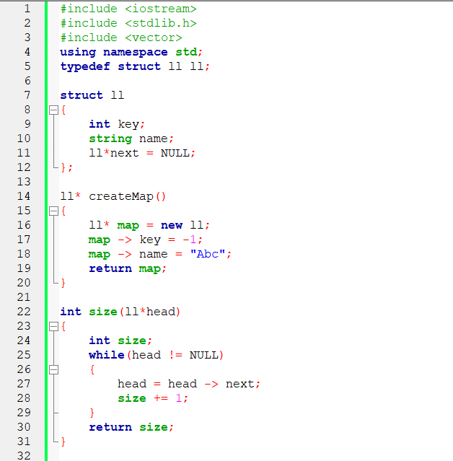
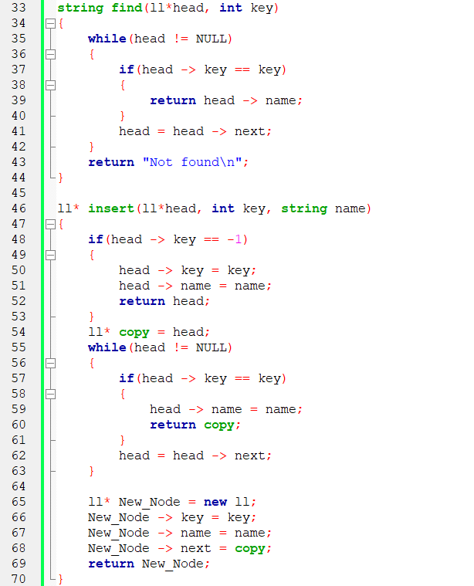
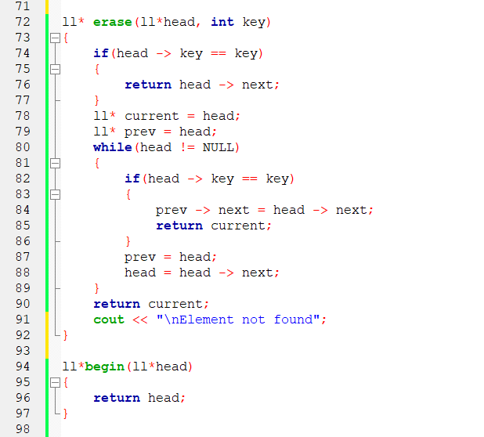
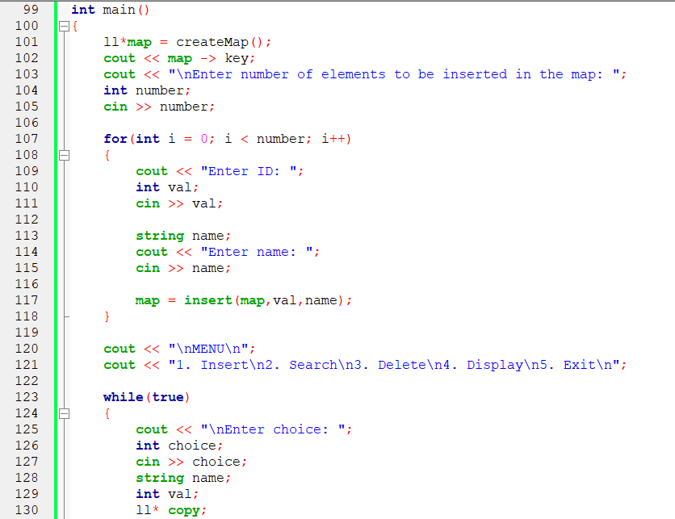

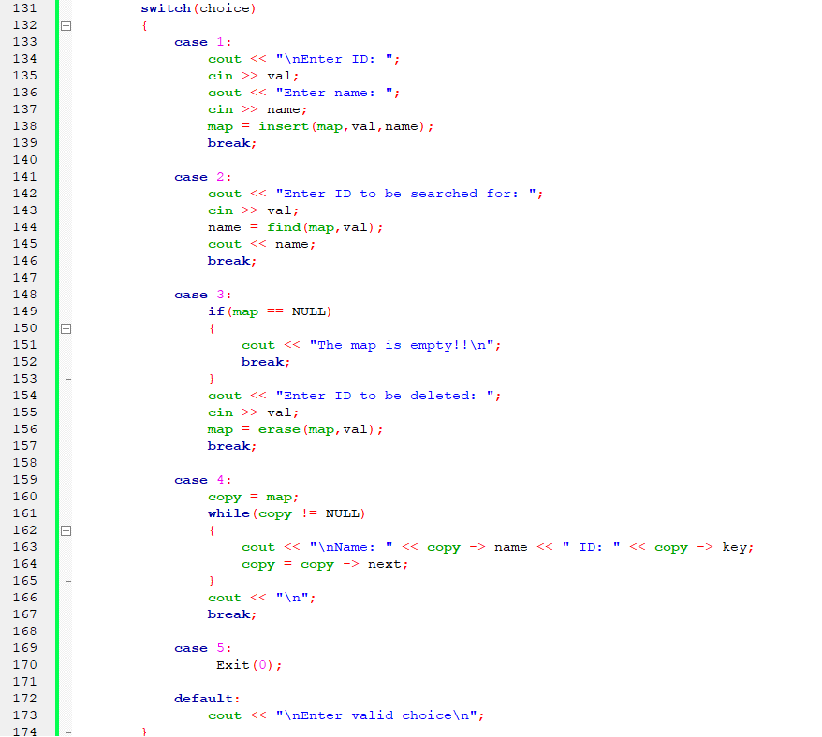

Output:
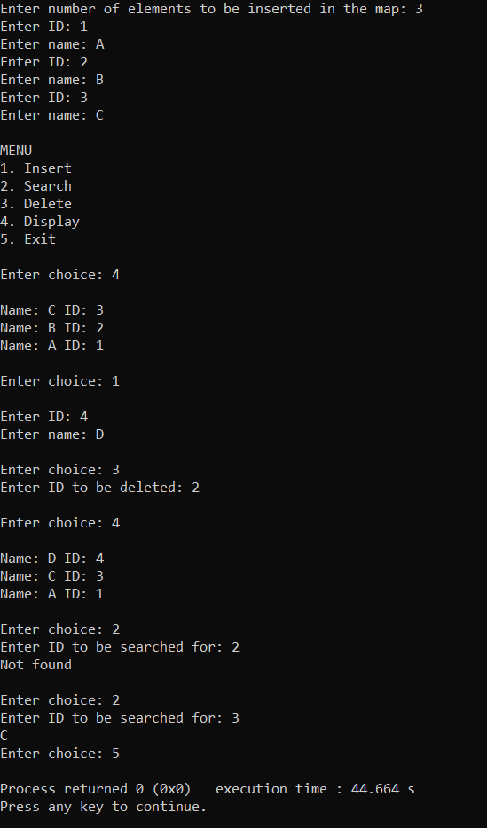

Conclusion:
Understood and successfully implemented map as a data structure.
Post Lab Questions:

- Give and explain at least one scenario each in which map, dictionary and set would be the most appropriate data structure to use.
Map, dictionaries, and sets are useful in places where we do not wish to store duplicate elements. If duplicate elements are found the structure should either ignore it or update its value. Dictionary and maps are also particularly useful in places where we want to search quickly (Time complexity: O(1)) for a value and thus can be used in places where searching is to be performed quickly and frequently .

- Write map as ADT
begin(): returns iterator to the beginning of the map
find(): returns if an element is present or not. If an element is not present it points to end. If it is present returns true
erase(): removes element from the map
clear(): removes all the elements of the map
set(): sets the value of the key to a new value

