Batch: C2 Roll. No.: 16010121200
Experiment: 9
Grade: AA / AB / BB / BC / CC / CD /DD

Title: Implementation of Searching algorithms

Objective: To understand various searching methods

Expected Outcome of Experiment:

CO | Outcome
CO4 | Demonstrate sorting and searching methods.

Websites/books referred:
- https://www3.ntu.edu.sg/home/ehchua/programming/cpp/DataStructureAlgorithm.html
- https://www.geeksforgeeks.org/what-is-hashing/
_____________________________________________________________________
Abstract: -
Searching involves deciding whether a search key is present in the data.
Searching methods (Linear search, binary search, hash search):
Linear Search: In a linear search, the search key is compared with each element of the array linearly. If there is a match, it returns the index of the array between [0, size-1]; otherwise, it returns -1 or the size of of the array (some implementations deal with only positive indexes). Linear search has complexity of O(n).
Binary Search: A binary search (or half-interval search) is applicable only to a sorted array. It compares the search key with the middle element. If there is a match, it returns the element's index. If the search key is less then the middle element, repeat searching on the left half; otherwise, search the right half. If the remaining element to be searched is zero, return "no found". The worst-case and average-case time complexity for binary search is O(log n). The best-case is O(1).
Hash Search: Hashing is a technique or process of mapping keys, and values into the hash table by using a hash function. It is done for faster access to elements. The efficiency of mapping depends on the efficiency of the hash function used.

Algorithm Binary Search:
- Begin with the mid element of the whole array as a search key.
- If the value of the search key is equal to the item then return an index of the search key.
- Or if the value of the search key is less than the item in the middle of the interval, narrow the interval to the lower half.
- Otherwise, narrow it to the upper half.
- Repeatedly check from the second point until the value is found or the interval is empty.
Hashing: (Define hashing, collision and list collision handling methods)
Hashing: Hashing is a technique or process of mapping keys, and values into the hash table by using a hash function.
Collision: The situation where a newly inserted key maps to an already occupied slot in hash table is called collision.
Collision handling methods:
- Separate Chaining (Open Hashing): The idea is to make each cell of hash table point to a linked list of records that have same hash function value. Chaining is simple, but requires additional memory outside the table.
- Open Addressing (Closed Hashing): In open addressing, all elements are stored in the hash table itself. Each table entry contains either a record or NIL. When searching for an element, we examine the table slots one by one until the desired element is found, else the element is not in the table.

Code and output screenshots for Linear search:
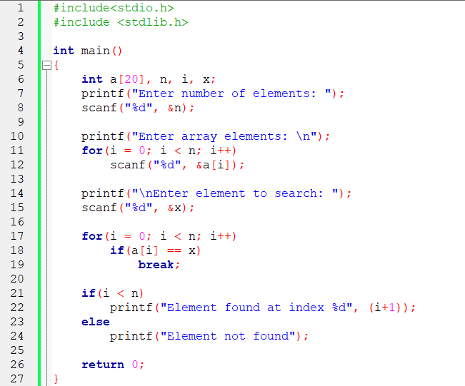
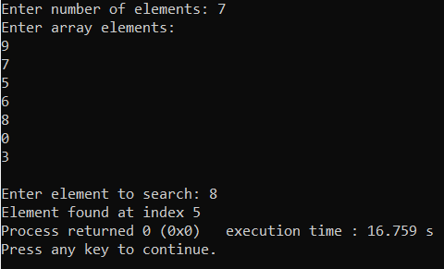

Code and output screenshots for Binary search:
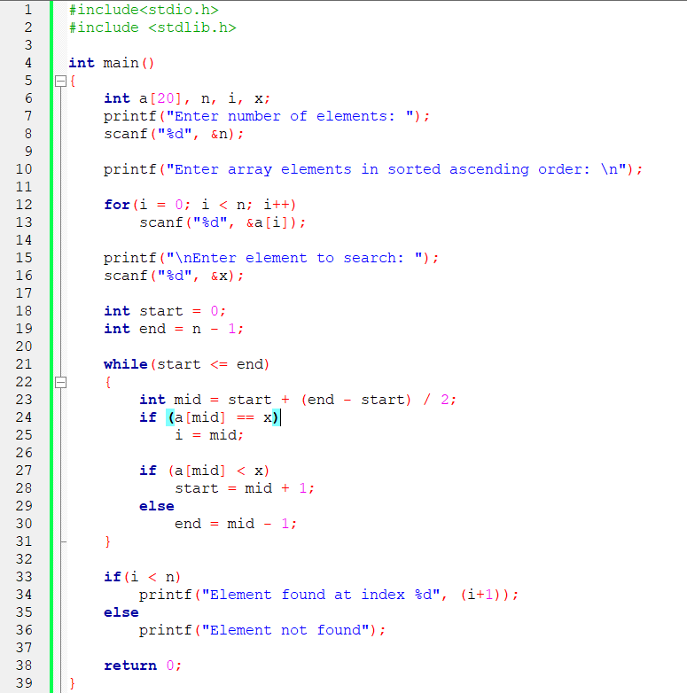
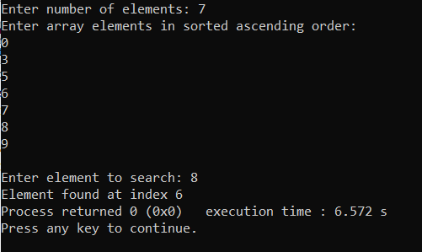
Code and output screenshots for Hash search:
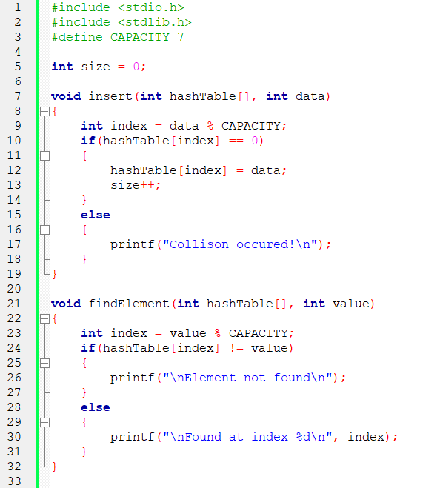
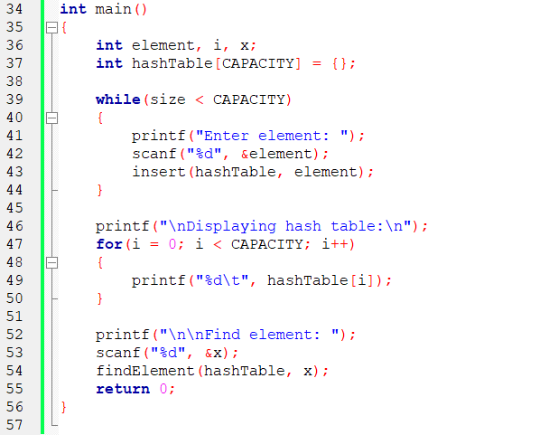
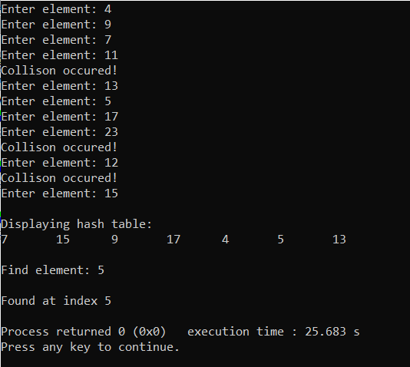

Conclusion:
Various searching algorithms like linear search, binary search and hash search was understood and implemented successfully.

Post Lab Questions:
- Compare and contrast various collision handling methods.
In Open Hashing each cell in the array points to a list containing the collisions. The hashing has produced the same index for all items in the linked list.

In Closed Hashing you use only one array for everything. You store the collisions in the same array. The trick is to use some smart way to jump from collision to collision until you find what you want. And do this in a reproducible / deterministic way.

 | Linear Probing | Quadratic Probing | Double Hashing
Primary Clustering | Yes | No | No
Secondary Clustering | Yes | Yes | No
Number of Probe sequence (m = size of table) | m | m | m^2
Cache Performance | Best | Lies between the two | Poor

- Compare linear search and binary search

Linear Search | Binary Search
The linear search starts searching from the first element and compares each element with a searched element till the element is not found | It finds the position of the searched element by finding the middle element of the array.
In a linear search, the elements don't need to be arranged in sorted order. | The pre-condition for the binary search is that the elements must be arranged in a sorted order.
The linear search can be implemented on any linear data structure such as an array, linked list, etc. | The implementation of binary search is limited as it can be implemented only on those data structures that have two-way traversal.
It is based on the sequential approach. | It is based on the divide and conquer approach.
It is preferable for small-sized data sets. | It is preferable for the large-size data sets.

- Store the given numbers in bucket of size 16, resolve the collisions if any with
  - Linear probing
  - Quadratic hashing
  - Chaining
20, 33, 65, 23, 11, 32, 78, 64, 3, 87, 10, 7

Linear probing:
0 | 32 | 20 = 1*16 + 4  1 probe.  33 = 2*16 + 1  1 probe.  65 = 4*16 + 1  2 probes.  23 = 1*16 + 7  1 probe.  11 = 0*16 + 11  1 probe.  32 = 2*16 + 0  1 probe.  78 = 4*16+14  1 probe.  64 = 4*16+0  4 probes.  3 = 0*16+3  3 probes.  87 = 5*16+7  2 probes.  10 = 0*16+10  1 probe.  7 = 0*16+7  3 probes.
1 | 33
2 | 65
3 | 64
4 | 20
5 | 3
6
7 | 23
8 | 87
9 | 7
10 | 10
11 | 11
12
13
14 | 78
15

Quadratic hashing:
0 | 32 | 20 = 1*16 + 4  4  1 probe.  33 = 2*16 + 1  1  1 probe.  65 = 4*16 + 1  1 2  2 probes.  23 = 1*16 + 7  7  1 probe.  11 = 0*16 + 11  11  1 probe.  32 = 2*16 + 0  0  1 probe.  78 = 4*16+14  14  1 probe.  64 = 4*16+0  0 1 4 9  4 probes.  3 = 0*16+3  3  3 probes.  87 = 5*16+7  7 8  2 probes.  10 = 0*16+10  10  1 probe.  7 = 0*16+7  7 8 11 0 7 0 11 8 7 8 11 0 7 0 11 8  3 probes.
1 | 33
2 | 65
3 | 3
4 | 20
5
6
7 | 23
8 | 87
9 | 64
10 | 10
11 | 11
12
13
14 | 78
15

Chaining:
0 | 32 64 | 20 = 1*16 + 4  33 = 2*16 + 1  65 = 4*16 + 1  23 = 1*16 + 7  11 = 0*16 + 11  32 = 2*16 + 0  78 = 4*16+14  64 = 4*16+0  3 = 0*16+3.  87 = 5*16+7  10 = 0*16+10  7 = 0*16+7
1 | 33 65
2
3 | 3
4 | 20
5
6
7 | 23 87 7
8
9
10 | 10
11 | 11
12
13
14 | 78
15

