Batch: B2 Roll. No.: 16010122158
Experiment: 9
Grade: AA / AB / BB / BC / CC / CD /DD

Title: Implementation of Hashing Concept

Objective: To understand various hashing methods

Expected Outcome of Experiment:

CO | Outcome
CO4 | Demonstrate sorting and searching methods.

Websites/books referred:
- https://www3.ntu.edu.sg/home/ehchua/programming/cpp/DataStructureAlgorithm.html
_____________________________________________________________________
Abstract: -
Related Theory: (Explain stable sort, in place sort, number of passes in a sorting algo)
Stable sort: A stable sorting algorithm maintains the relative order of the items with equal sort keys. An unstable sorting algorithm does not. In other words, when a collection is sorted with a stable sorting algorithm, items with the same sort keys preserve their order after the collection is sorted.
In place sort: A sort algorithm in which the sorted items occupy the same storage as the original ones. These algorithms may use o(n) additional memory for bookkeeping, but at most a constant number of items are kept in auxiliary memory at any time. Also known as sort in place.
Number of passes: ‘Pass’ is the iteration of outer loop, while counting iterations of inner loops.
Bubble Sort Algorithm:
- BEGIN
- for all array elements
- if arr[i] > arr[i+1]
- swap(arr[i], arr[i+1])
- end if
- end for
- END

Insertion Sort Algorithm:
- BEGIN
- If it is the first element, it is already sorted. return 1;
- Pick next element
- Compare with all elements in the sorted sub-list
- Shift all the elements in the sorted sub-list that is greater than the value to be sorted
- Insert the value
- Repeat until list is sorted
- END

Count Sort Algorithm:
- Iterate through the input array to find the highest value.
- Declare a new array with the value 0 and a size of max+1.
- Count each element in the array and increment its value in the auxiliary array generated at the corresponding index.
- Add current and previous frequency to the auxiliary array to find the cumulative sum.
- The cumulative value now represents the element's actual position in the sorted input array.
- Begin iterating through the auxiliary array from 0 to max.
- Put 0 at the corresponding index and reduce the count by 1, which will indicate the element's second position in the input array if it exists.
- Now put the array you got in the previous step into the actual input array.

Code and output screenshots:
Bubble Sort:
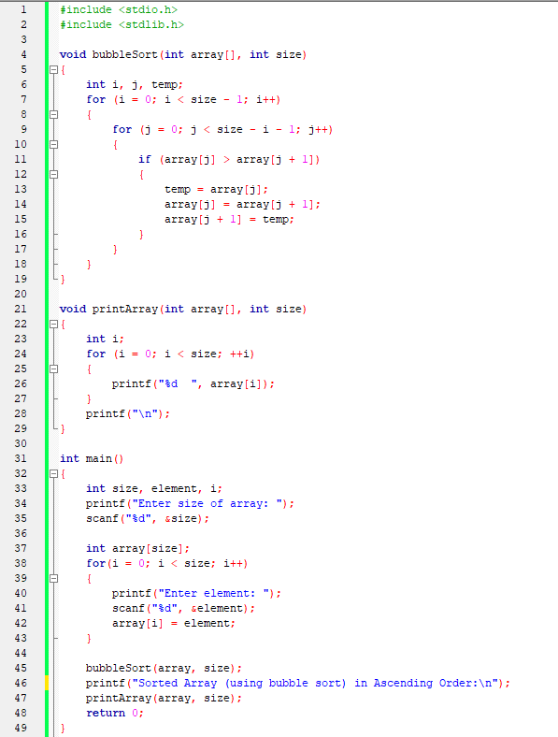
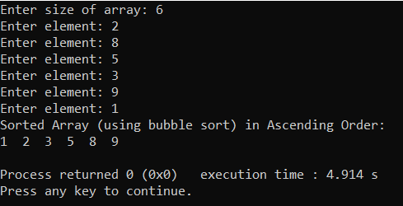
Insertion Sort:
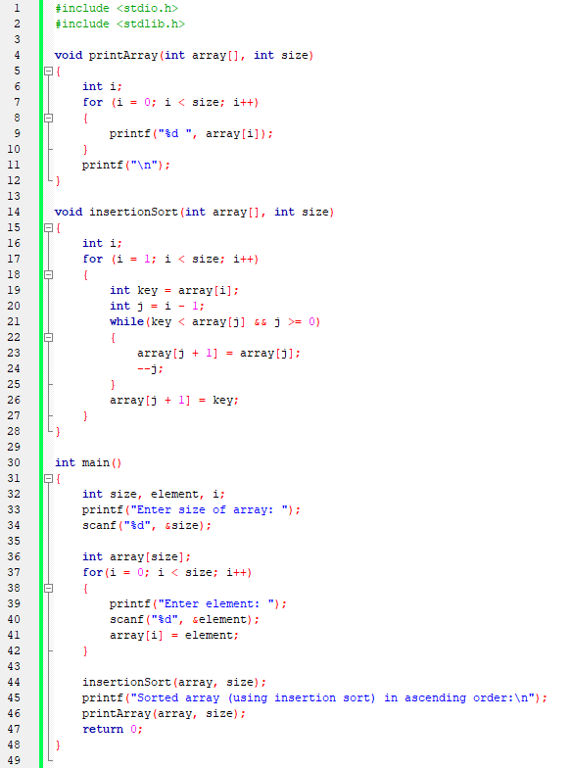
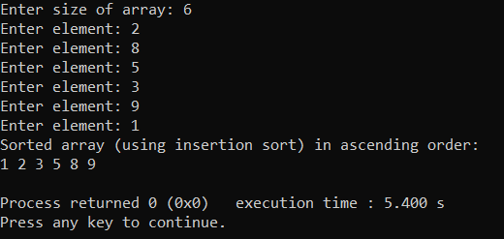

Conclusion:
The aim of the experiment is verified and we learnt and successfully implemented the various methods for sorting.
Post lab questions-
- Compare and contrast various sorting algorithms.

Sorting Algorithm | Time Complexity |  |  | Space Complexity | Stable Sort?
 | Best case | Average case | Worst case | Worst case
Bubble sort | O(n) | O(n²) | O(n²) | O(1) | Yes
Insertion sort | O(n) | O(n²) | O(n²) | O(1) | Yes
Counting sort | O(n+k) | O(n+k) | O(n+k) | O(k) | No

- Comment on the input (sorted in ascending order/descending order/random) and time required for execution of sorting algorithm.

In certain sorting problems, if the data is already sorted the complexity of the sorting algorithm changes. That is it can be said that the time complexity depends on the order of a given input.
The sorting algorithms in which the order of elements affects the time complexity of the sorting algorithm is known as an adaptive sorting algorithm.
In adaptive sorting, if the data is already sorted, the algorithm will not reorder the elements. As a result, it reduces the number of iterations and improves execution speed.
Eg: Insertion sort, bubble sort
The sorting algorithms in which the order of elements of the data doesn’t affect the time complexity of the sorting algorithms are known as non-adaptive sorting algorithms.
In a non-adaptive algorithm, the time complexity remains the same for any order of the array. A non-adaptive sorting algorithm tries to force all the items into sorted order.
Eg: Selection sort, merge sort

