Batch: H2-1 Roll No.: 16010122158

Experiment No. 1

Title : Exploring R for Data Science

Aim: To understand basics of R - Operators, built-in functions, Data types,
Data manipulation in R, R packages for Data Science

Expected Outcome of Experiment:
CO1: Develop an understanding of data science and business analytics.
CO2: Implementation of basic statistical modeling and analysis using R Programming.

Books/ Journals/ Websites referred:
1. https://cran.r-project.org/doc/manuals/r-release/R-intro.html

What is R?
- R is a scripting/programming language and environment for statistical computing, data science and graphics.
- R is a successor of the proprietary statistical computing programming language S.
- It is an important tool for computational statistics, visualization and data science.

Why R?

It provides techniques for various statistical analyses like classical tests and classification, time-series analysis, clustering, linear and non-linear modelling and graphical operations.

It has superior support for graphics.

Reasons for learning R:
- Free, Open source
- Great visualization
- Cross-platform compatibility
- Advanced statistics
- Integration with other programming languages
- Supportive open source community
- Easy extensibility via packages

- Exploring the atomic datatypes supported by R-Logical, Numeric-integer, Character, Double, Complex, Raw

There are six primary types of atomic vectors: logical, integer, double, character (which contains strings), complex, and raw.

Data Types | Values | Examples
Numeric | Set of all real numbers | "numeric_value <- 3.14"
Integer | Set of all integers, Z | "integer_value <- 42L"
Logical | TRUE and FALSE | "logical_value <- TRUE"
Complex | Set of complex numbers | "complex_value <- 1 + 2i"
Character | “a”, “b”, “c”, …, “@”, “#”, “$”, …., “1”, “2”, …etc | "character_value <- "Hello Geeks"
raw | as.raw() | "single_raw <- as.raw(255)"

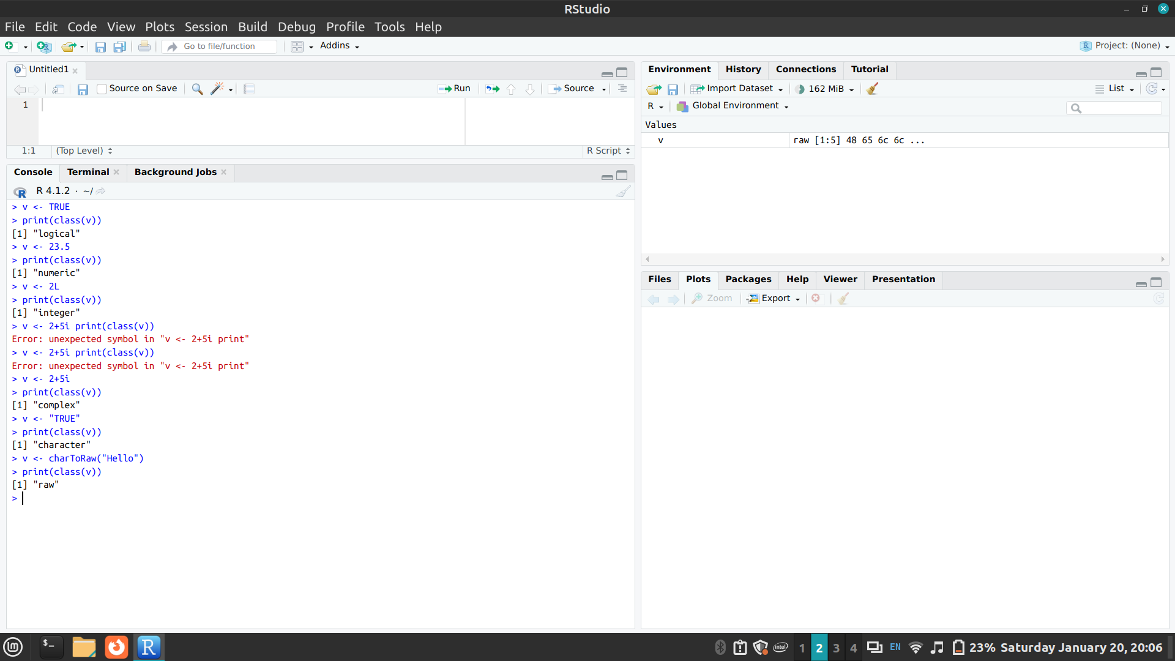

- Exploring data manipulation of different data objects of R- Vectors- Matrices, Factors, List, Array, Data Frames
Vectors are one-dimensional arrays that can hold numeric, character, or logical data.
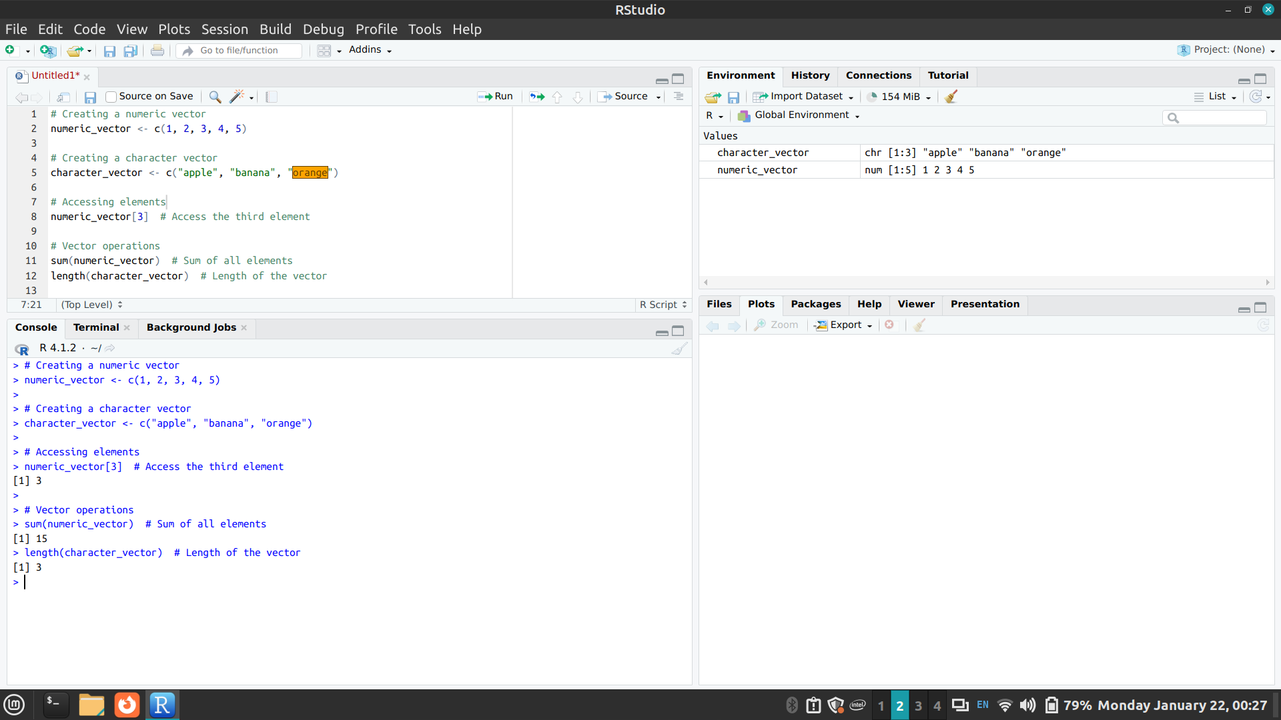

Matrices are two-dimensional arrays with rows and columns.
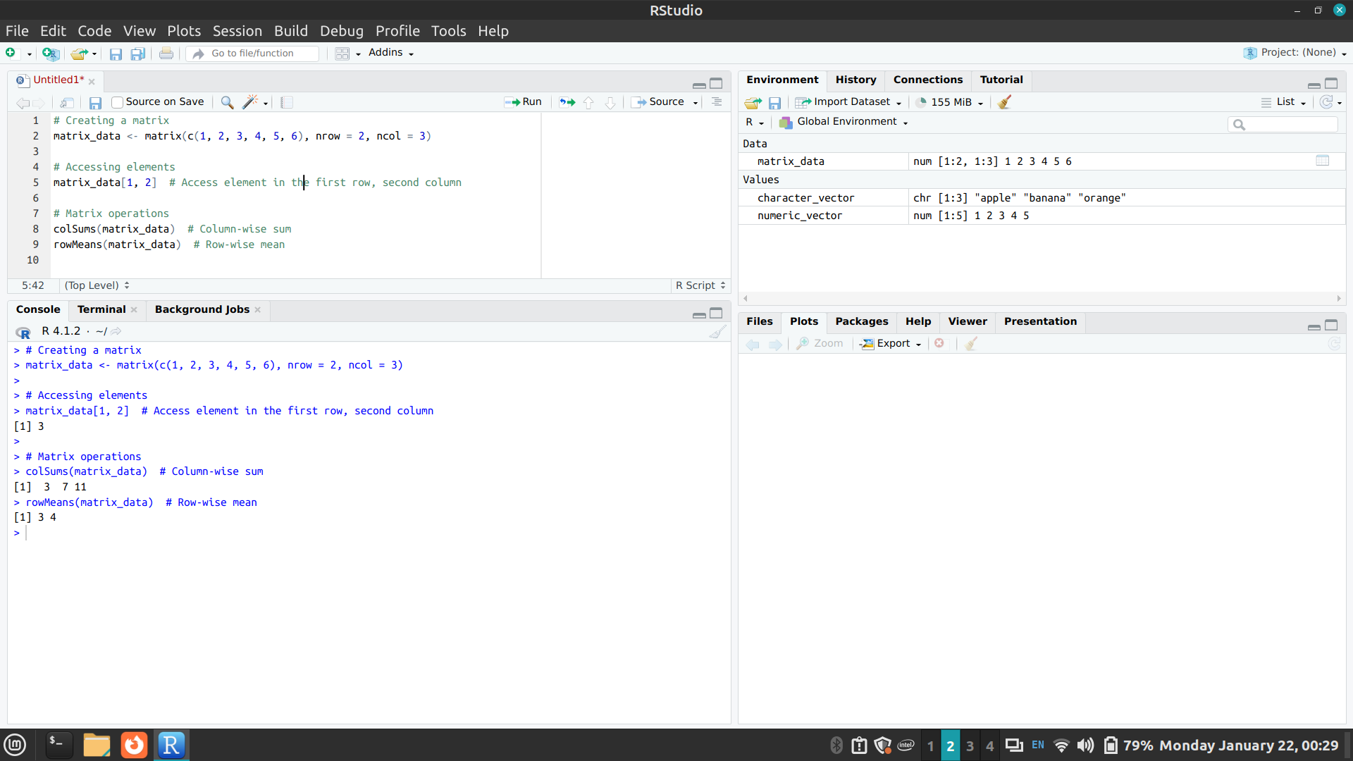
Factors are used to represent categorical data.
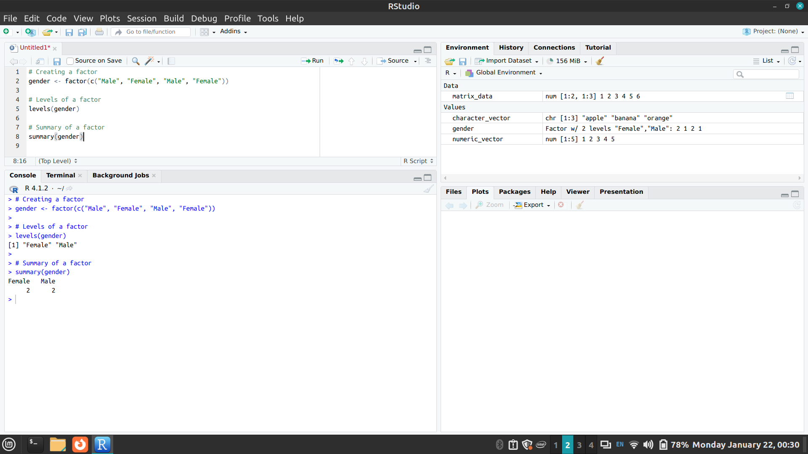6
Lists can contain elements of different data types, including other lists.
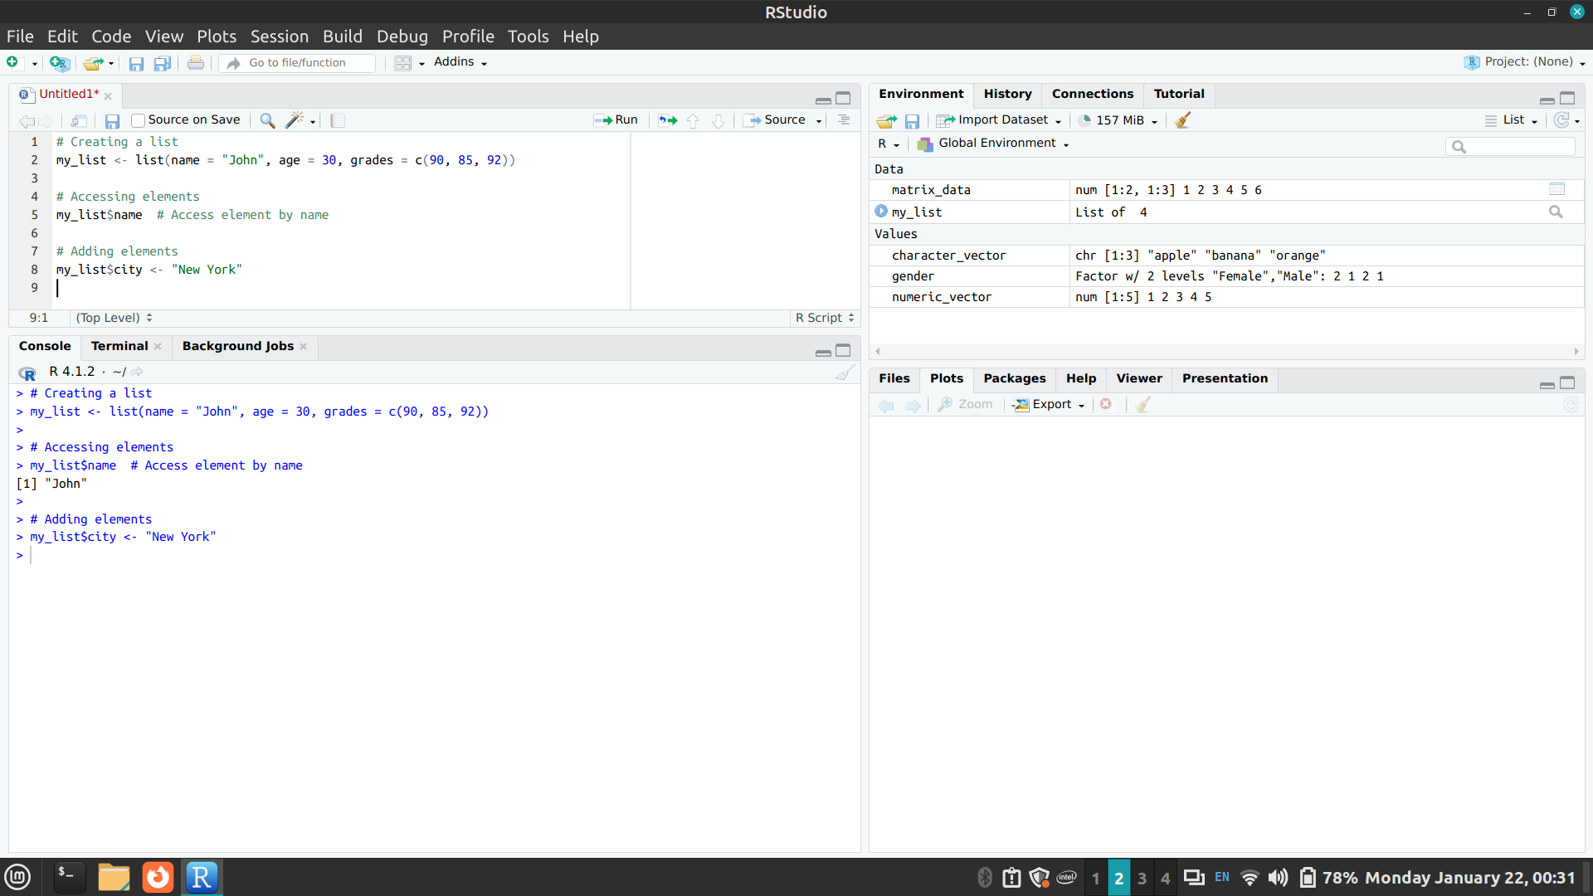
Arrays are multi-dimensional extensions of matrices.
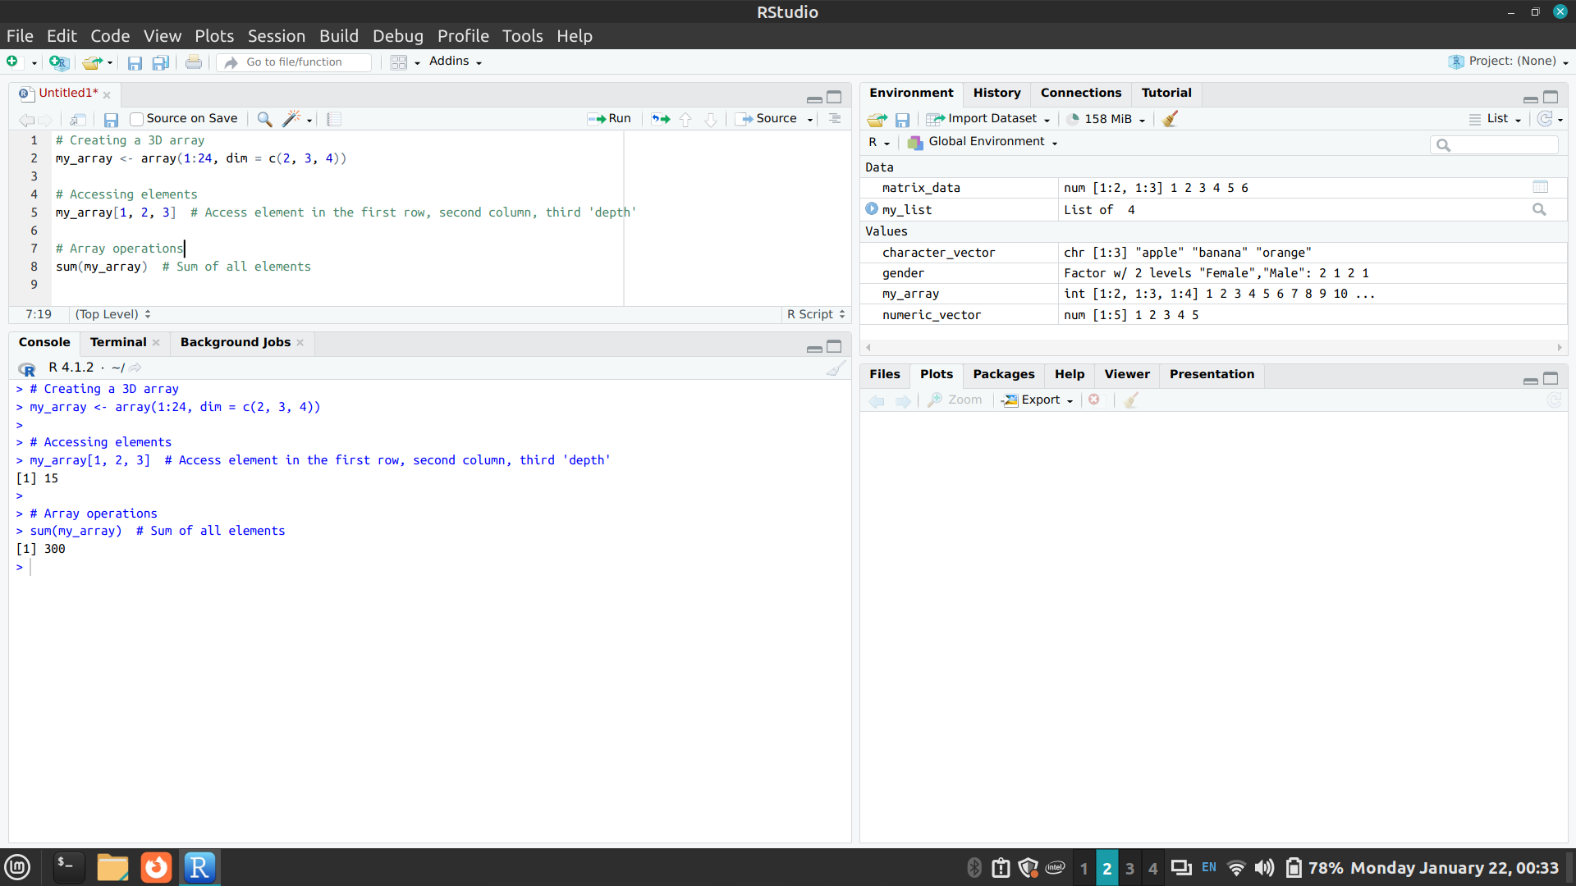
Data frames are similar to matrices but can store different data types in different columns.
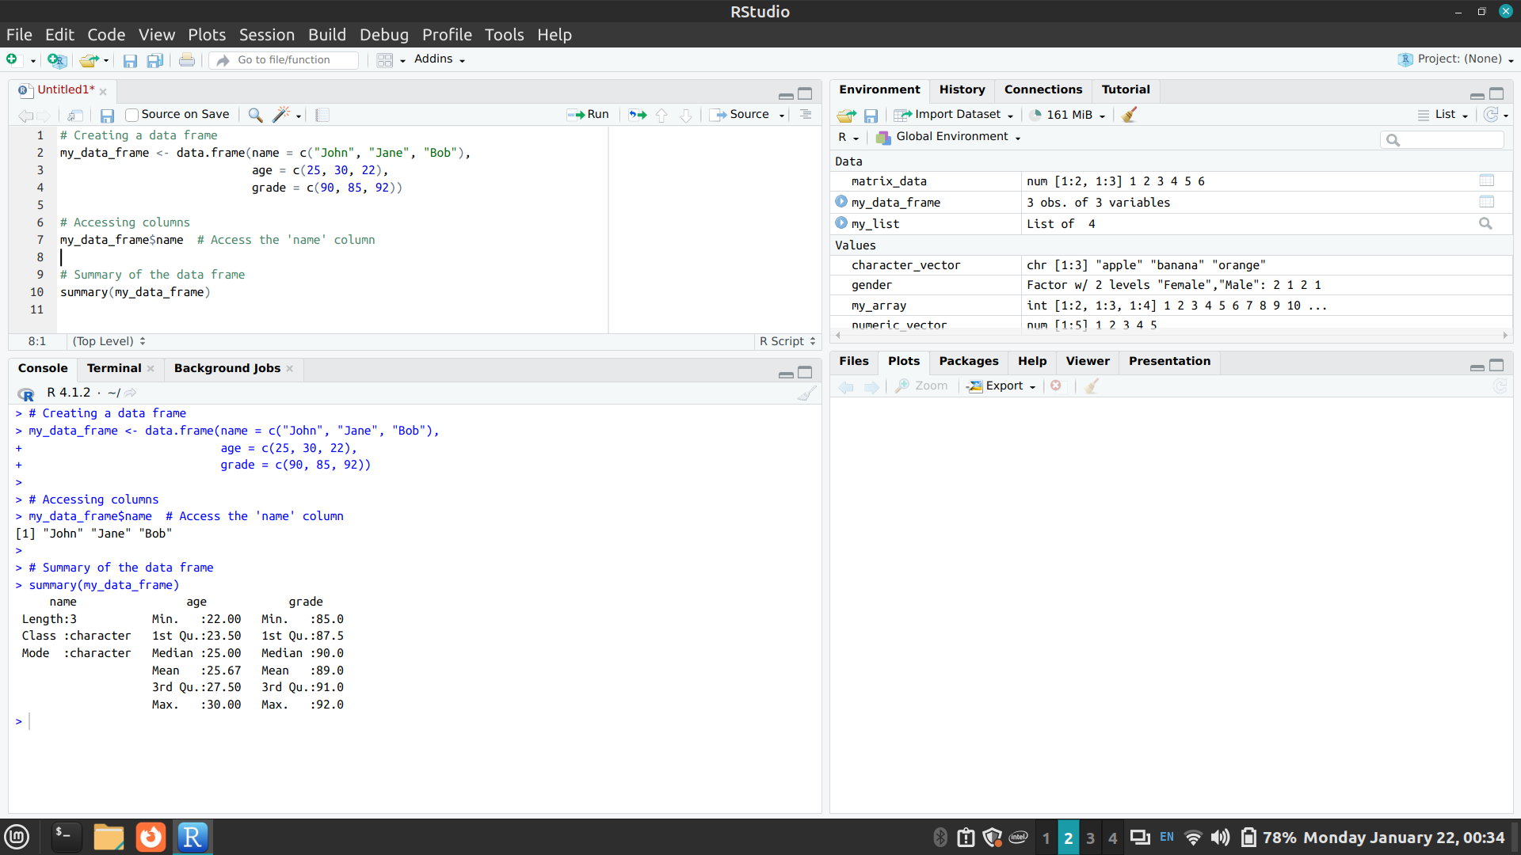

3. Exploring Operators and built-in functions and writing user-defined functions in R

OPERATORS

Arithmetic Operators

Operator | Description
+ | This operator is used to add two vectors in R.
- | This operator is used to divide a vector from another one.
* | This operator is used to multiply two vectors with each other.
/ | This operator divides the vector from another one.
%% | This operator is used to find the remainder of the first vector with the second vector.
%/% | This operator is used to find the division of the first vector with the second(quotient).
^ | This operator raised the first vector to the exponent of the second vector.

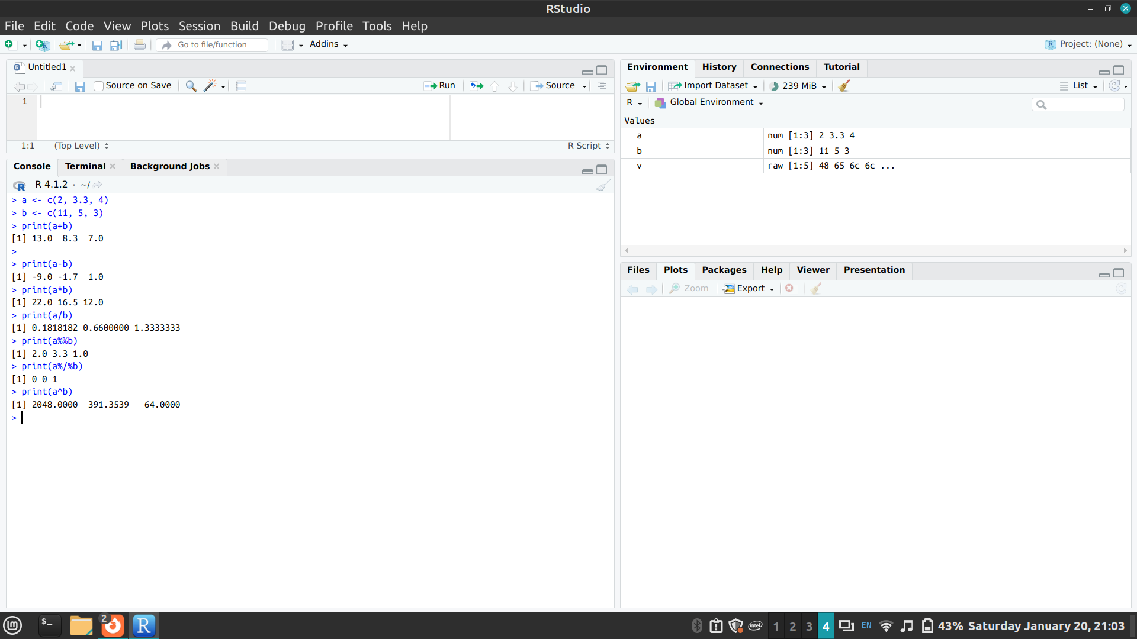
Relational Operators

Operator | Description
> | This operator will return TRUE when every element in the first vector is greater than the corresponding element of the second vector.
< | This operator will return TRUE when every element in the first vector is less than the corresponding element of the second vector.
<= | This operator will return TRUE when every element in the first vector is less than or equal to the corresponding element of another vector.
>= | This operator will return TRUE when every element in the first vector is greater than or equal to the corresponding element of another vector.
== | This operator will return TRUE when every element in the first vector is equal to the corresponding element of the second vector.
!= | This operator will return TRUE when every element in the first vector is not equal to the corresponding element of the second vector.

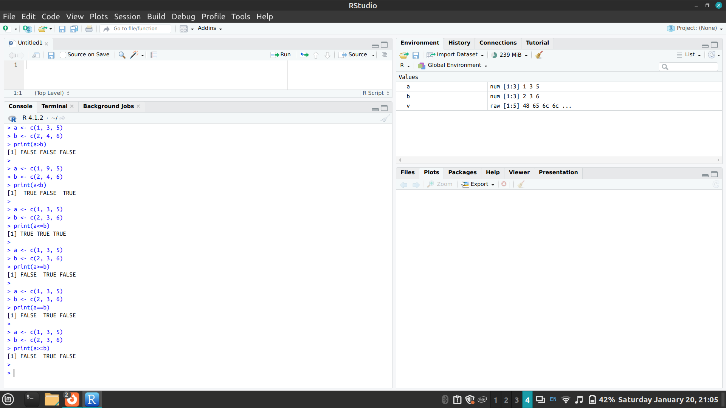
Logical Operators

Operator | Description
& | This operator is known as the Logical AND operator. This operator takes the first element of both the vector and returns TRUE if both the elements are TRUE.
| | This operator is called the Logical OR operator. This operator takes the first element of both the vector and returns TRUE if one of them is TRUE.
! | This operator is known as Logical NOT operator. This operator takes the first element of the vector and gives the opposite logical value as a result.
&& | This operator takes the first element of both the vector and gives TRUE as a result, only if both are TRUE.
|| | This operator takes the first element of both the vector and gives the result TRUE, if one of them is true.

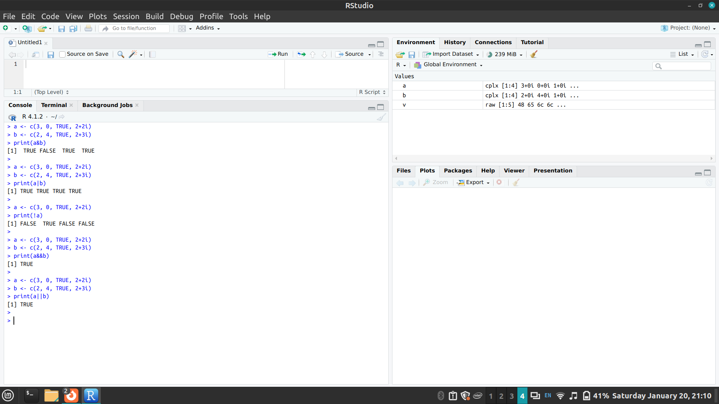

Assignment Operators

Operator | Description
<- or = or <<- | These operators are known as left assignment operators.
-> or ->> | These operators are known as right assignment operators.
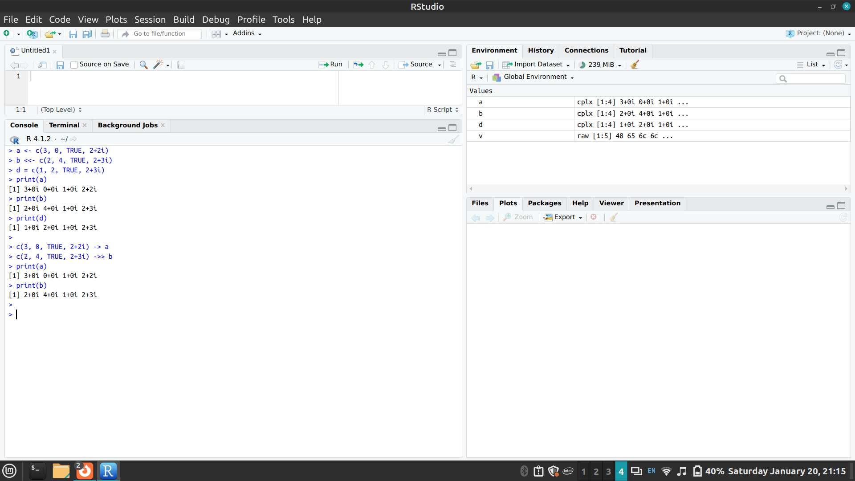

Miscellaneous Operators

Operator | Description
: | The colon operator is used to create the series of numbers in sequence for a vector.
%in% | This is used when we want to identify if an element belongs to a vector.
%*% | It is used to multiply a matrix with its transpose.
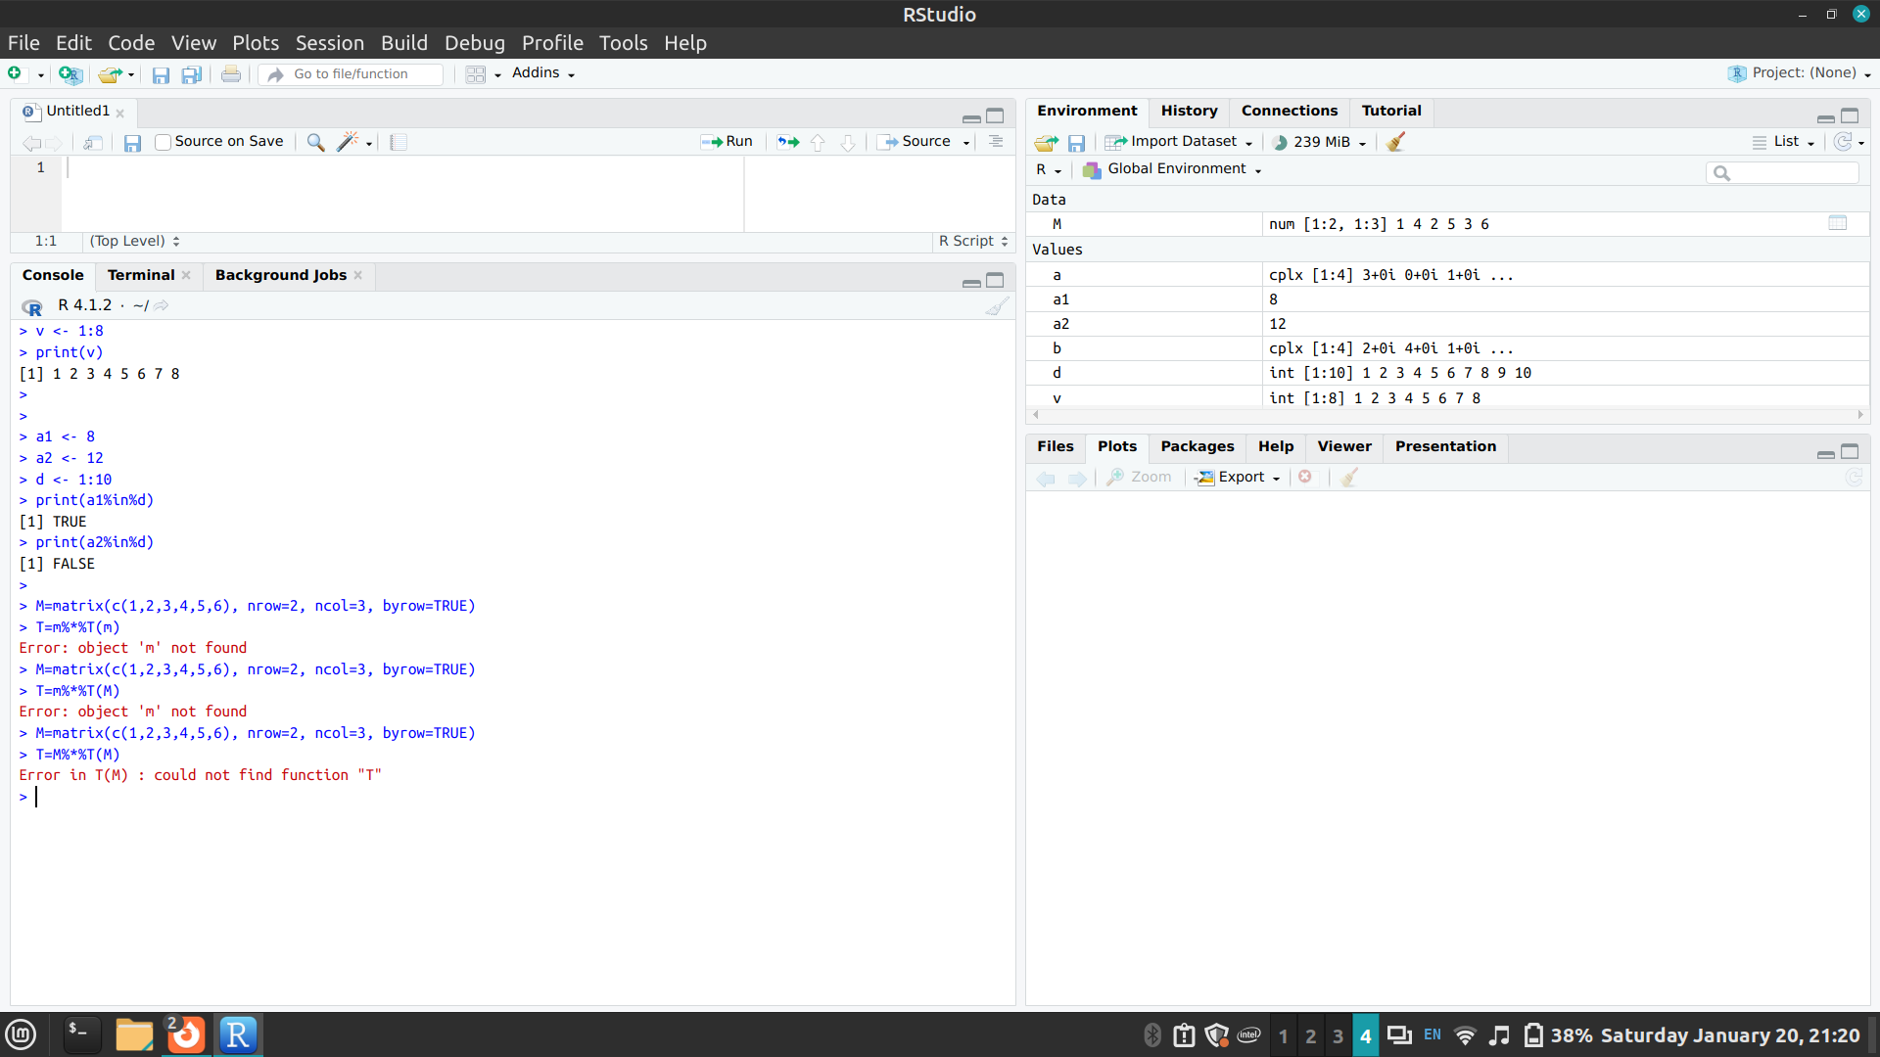
4. Using Looping constructs in R

For loop
Syntax :
for (value in vector) {
statements }

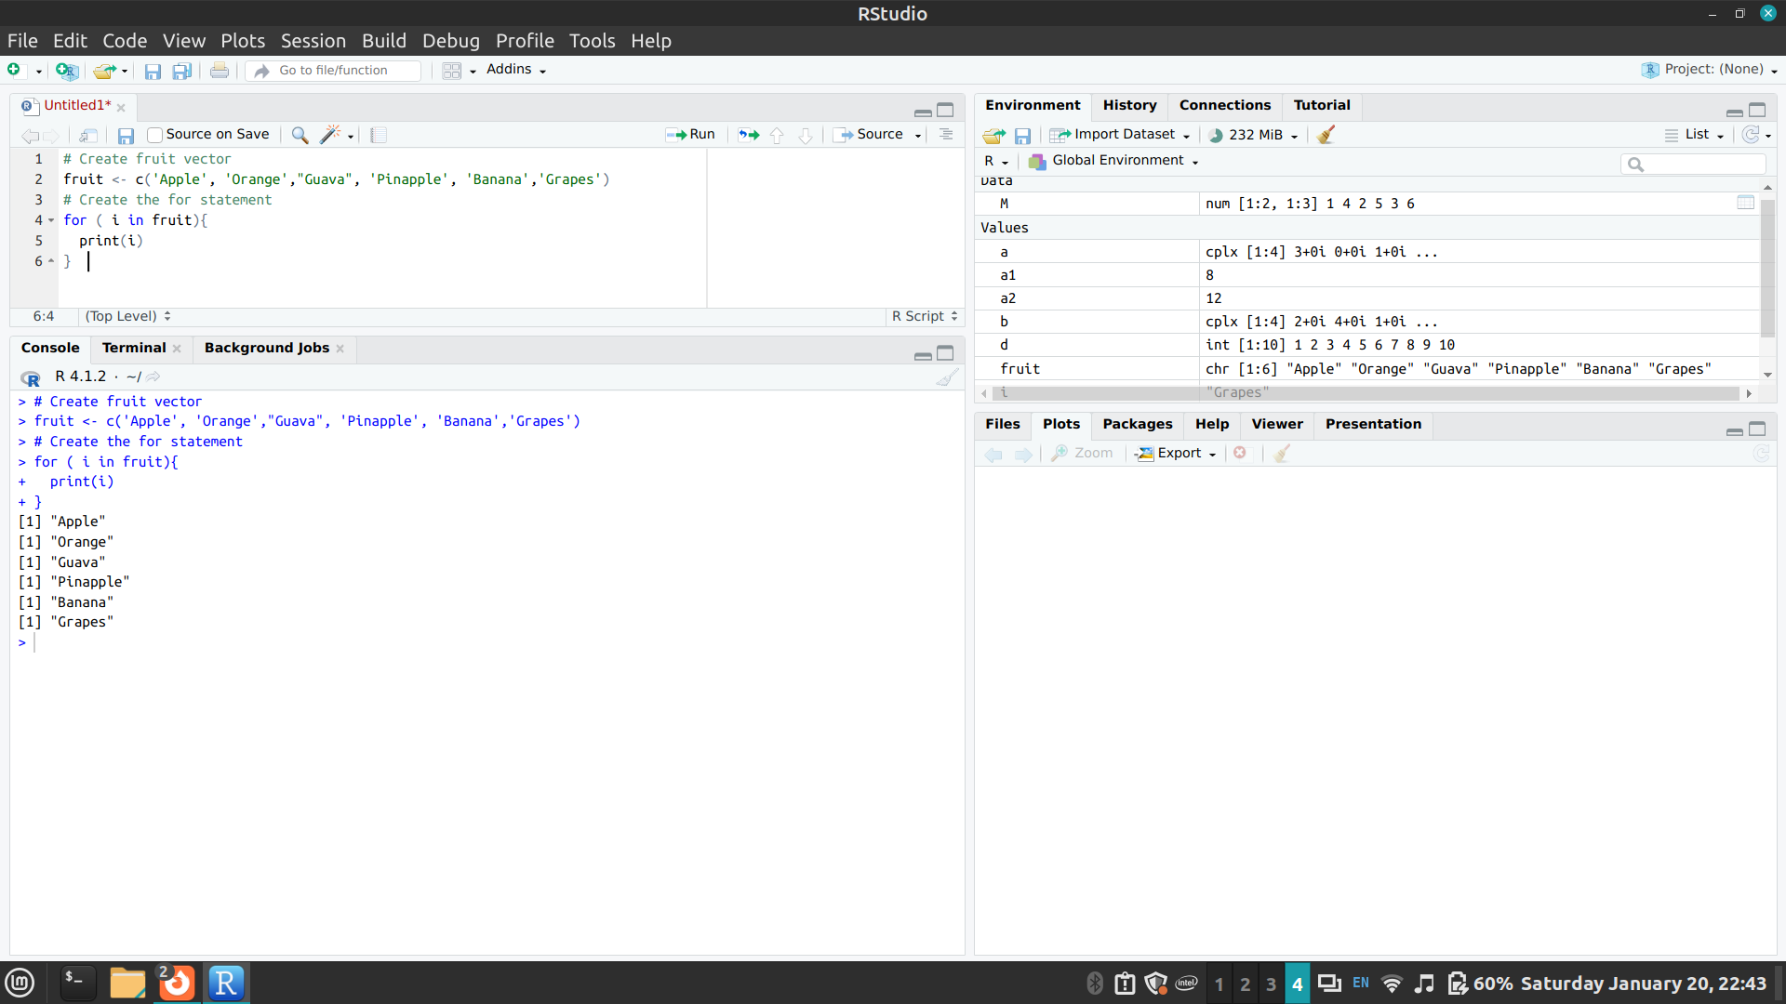

Repeat loop
Syntax:
repeat {
commands
if(condition) {
break } }
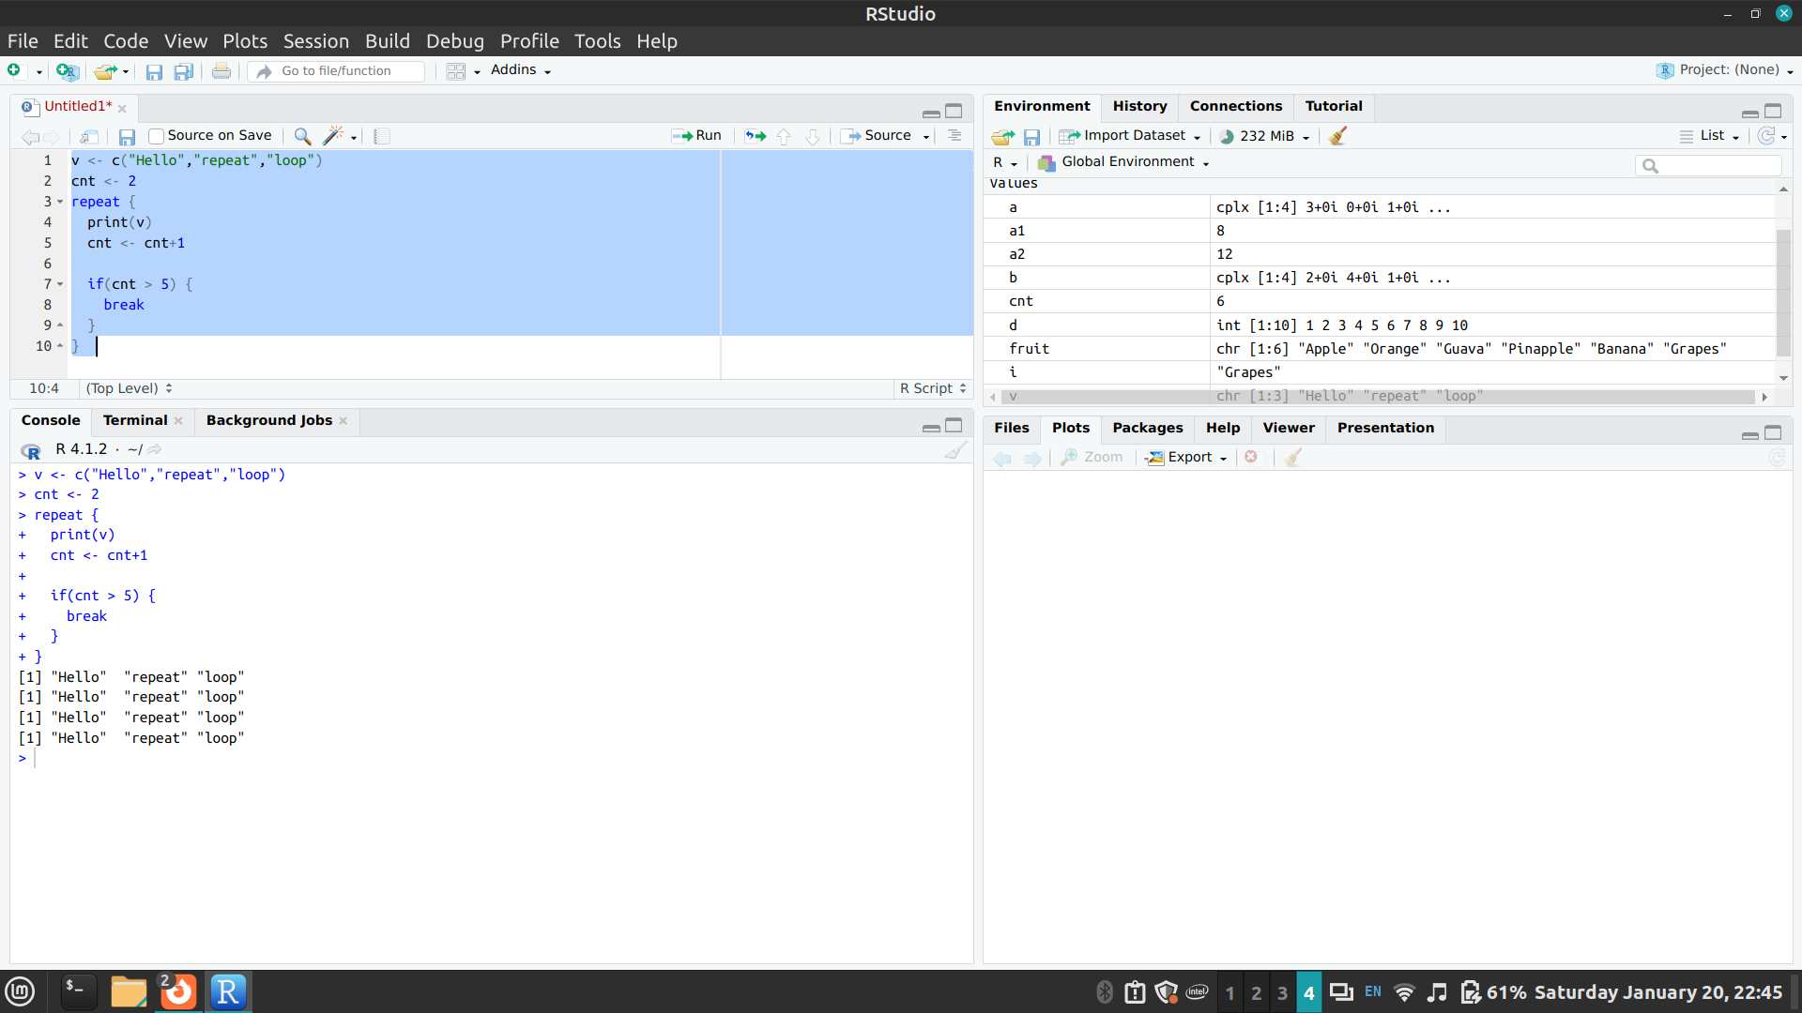

While loop
Syntax:
while (test_expression) {
statement
}
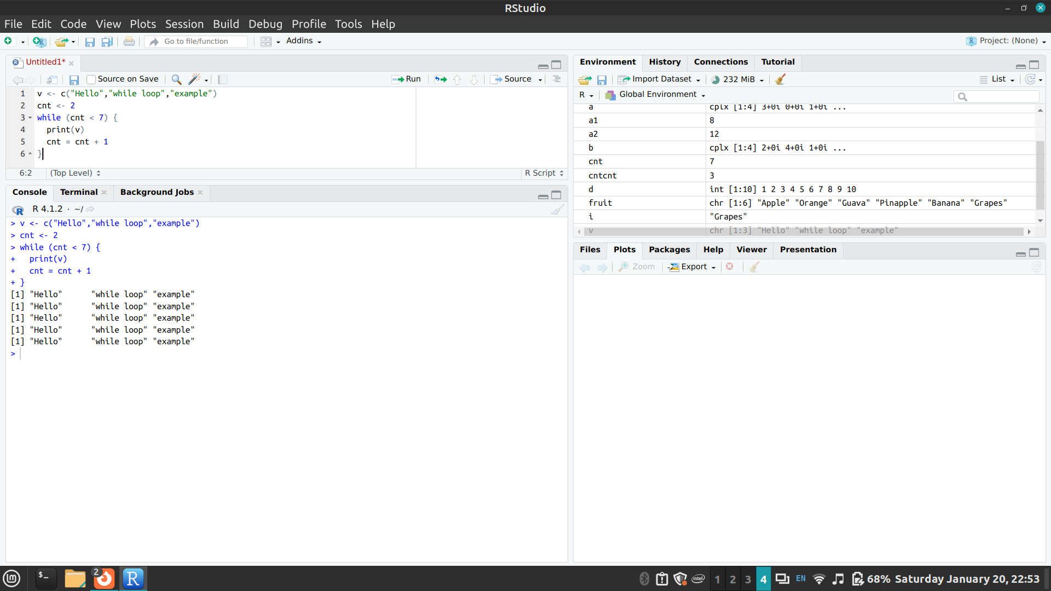

5. Exploring any Packages in R (any graphic package)

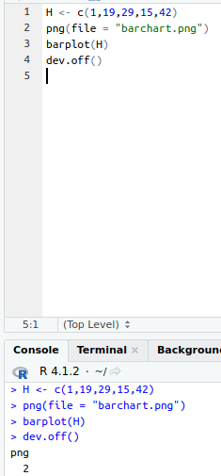

Output FIle:
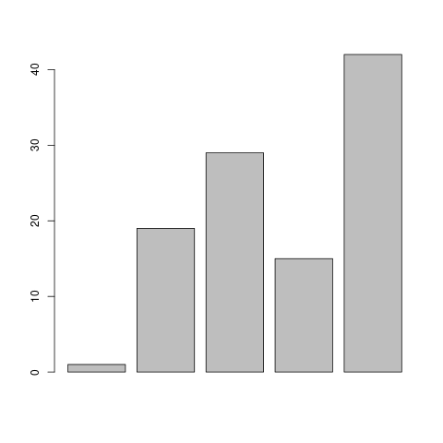

Conclusion:

This experiment has allowed me to get used to using R Studio. It has also helped me get a clearer understanding of the basics of R by going through the documentation of R.

