Batch: B3 Roll No.: 16010122158

Experiment No. 10

Title : Virtual lab on text processing (word analysis)

Aim: To implement text processing (Word analysis)

Expected Outcome of Experiment:
CO4 : Understand the basic concept and techniques of Machine Learning clustering.

Books/ Journals/ Websites referred:
- https://nlp-iiith.vlabs.ac.in/exp/word-analysis/index.html

Introduction

A word can be simple or complex. For example, the word 'cat' is simple because one cannot further decompose the word into smaller part. On the other hand, the word 'cats' is complex, because the word is made up of two parts: root 'cat' and plural suffix '-s'
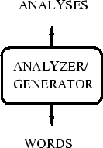

Procedure

STEP 1: Select the language.
OUTPUT: Drop down for selecting words will appear.
STEP 2: Select the word.
OUTPUT: Drop down for selecting features will appear.
STEP 3: Select the features.
STEP 4: Click "Check" button to check your answer.
OUTPUT: Right features are marked by tick and wrong features are marked by cross.
Simulation:

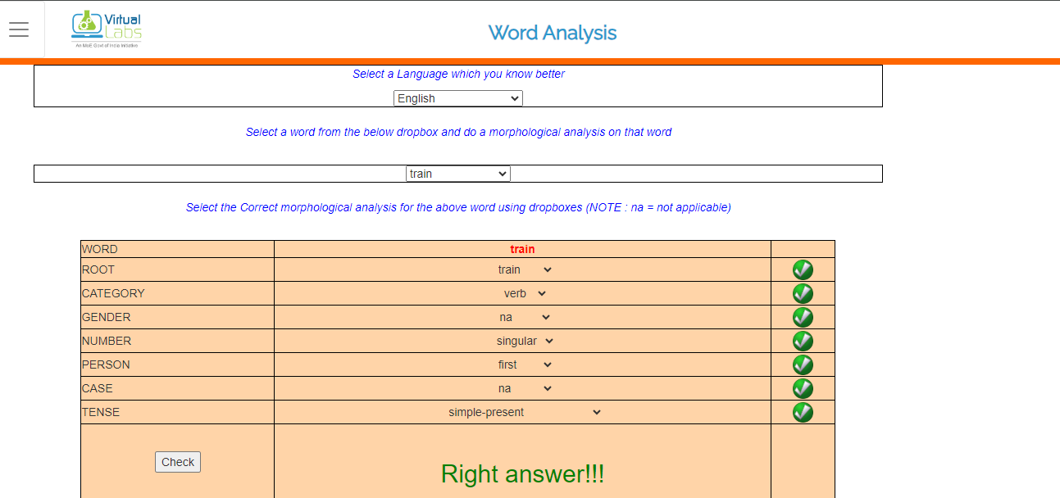
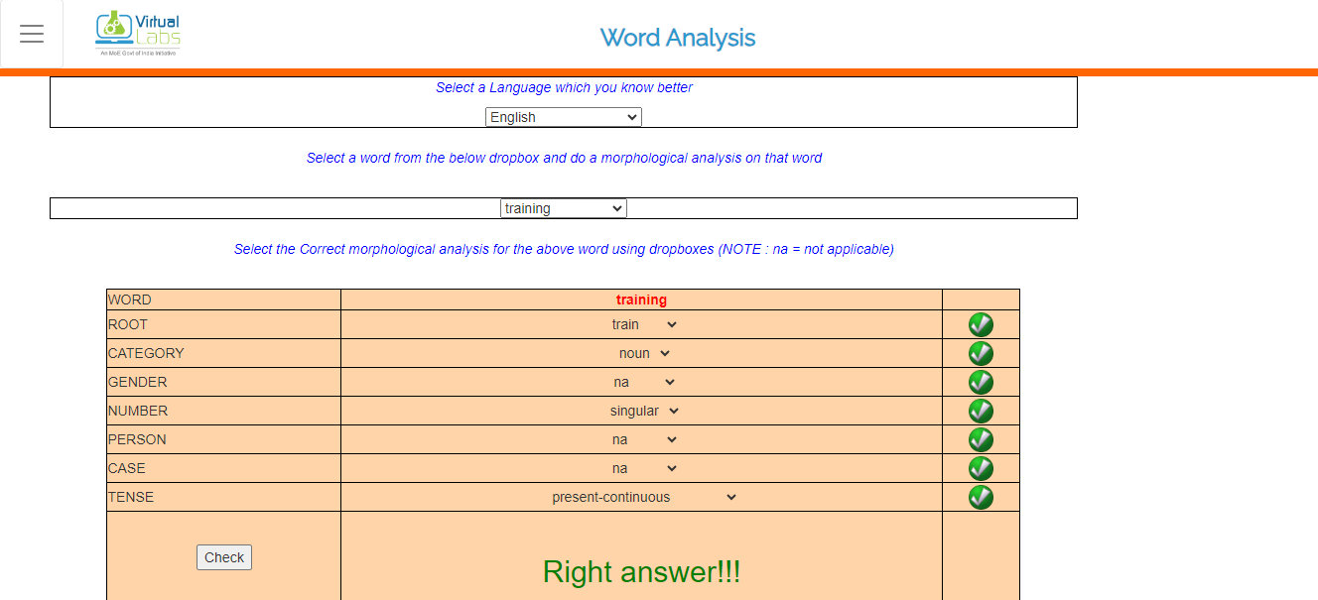
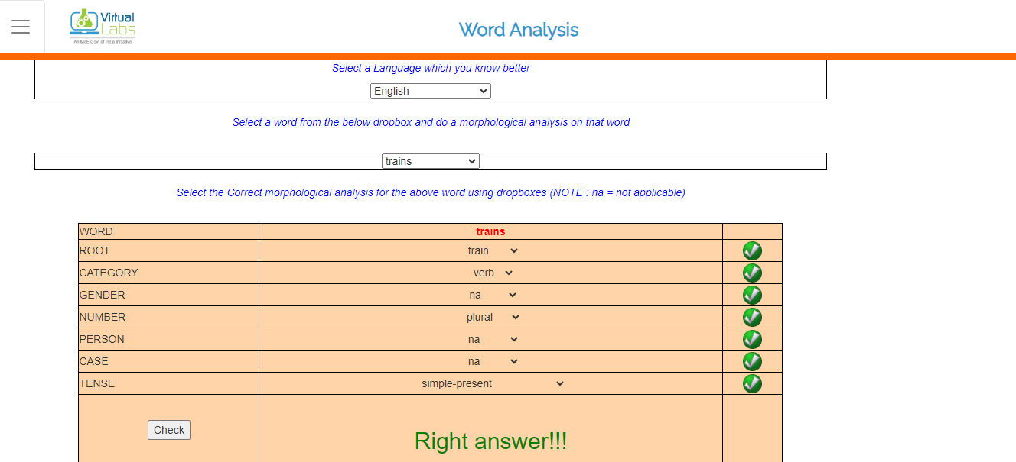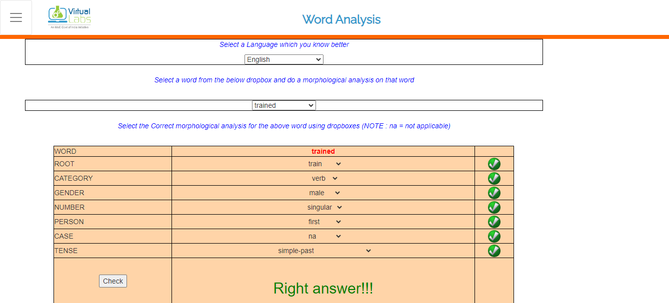

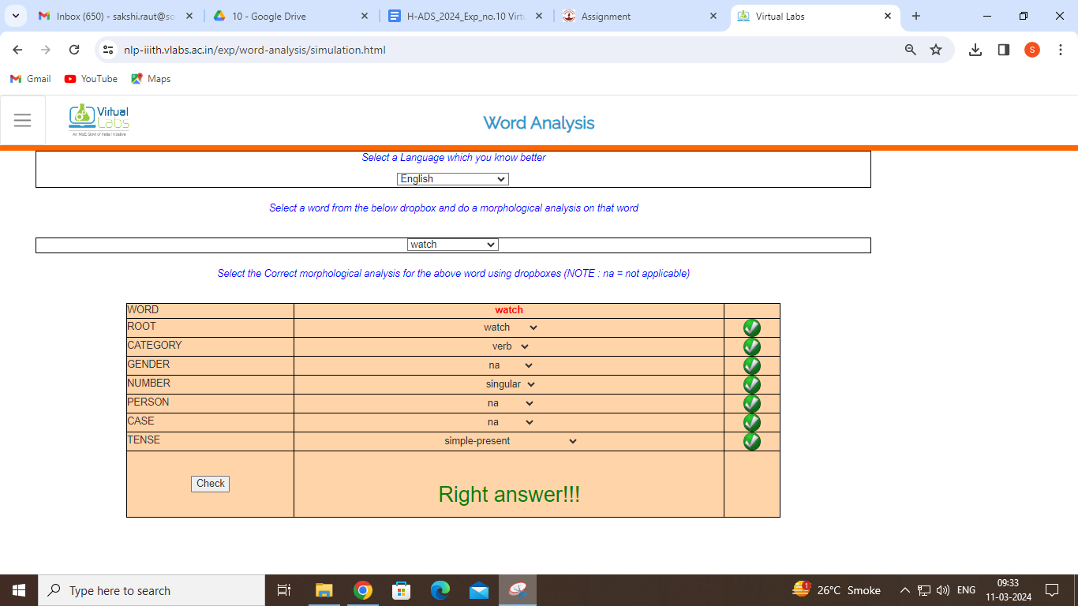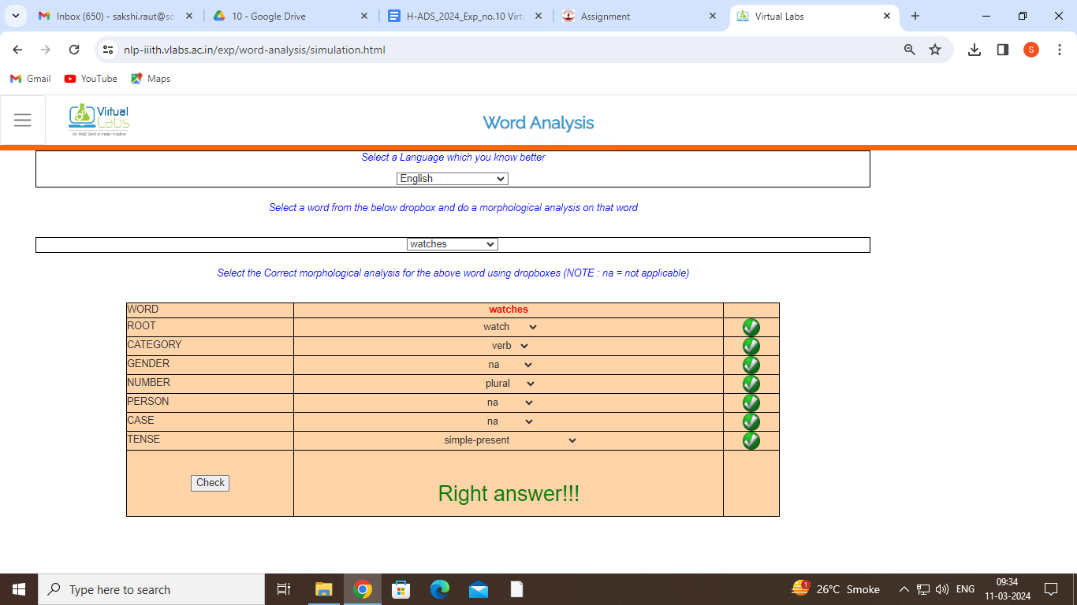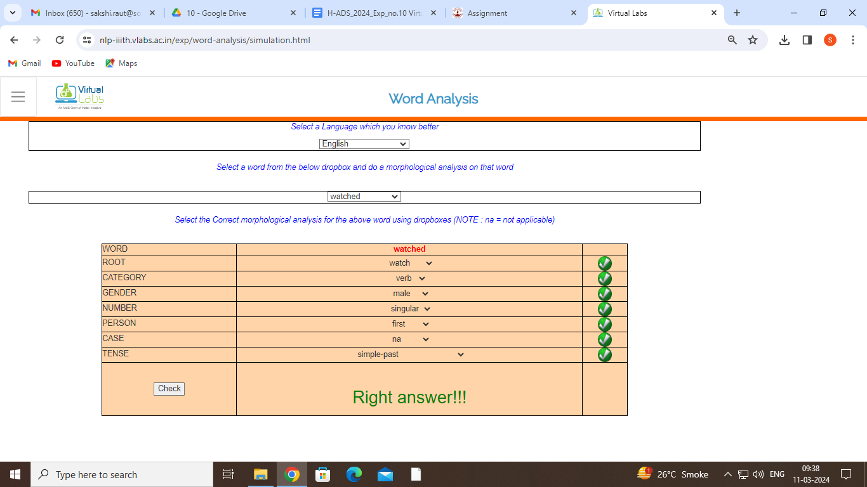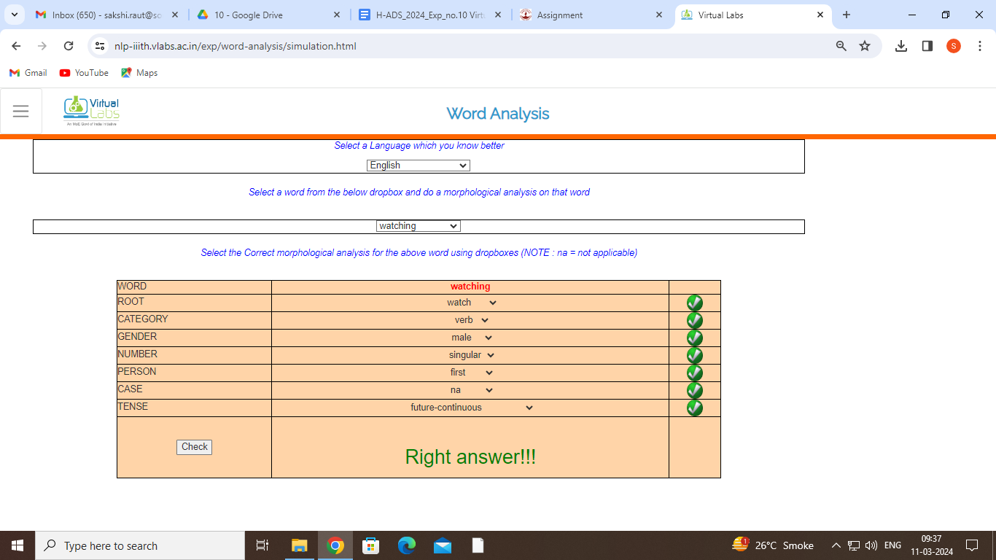
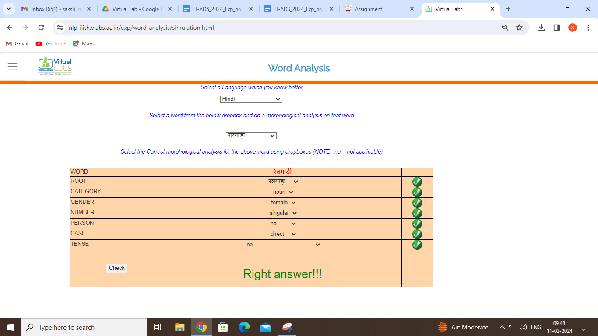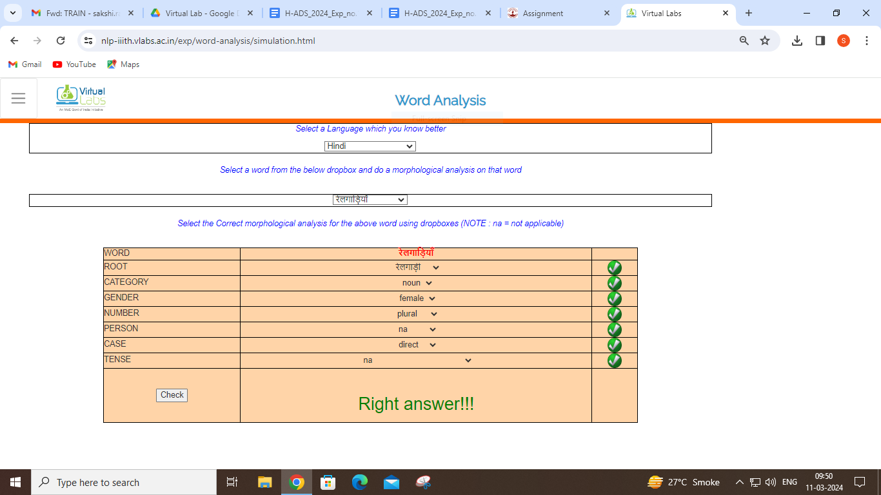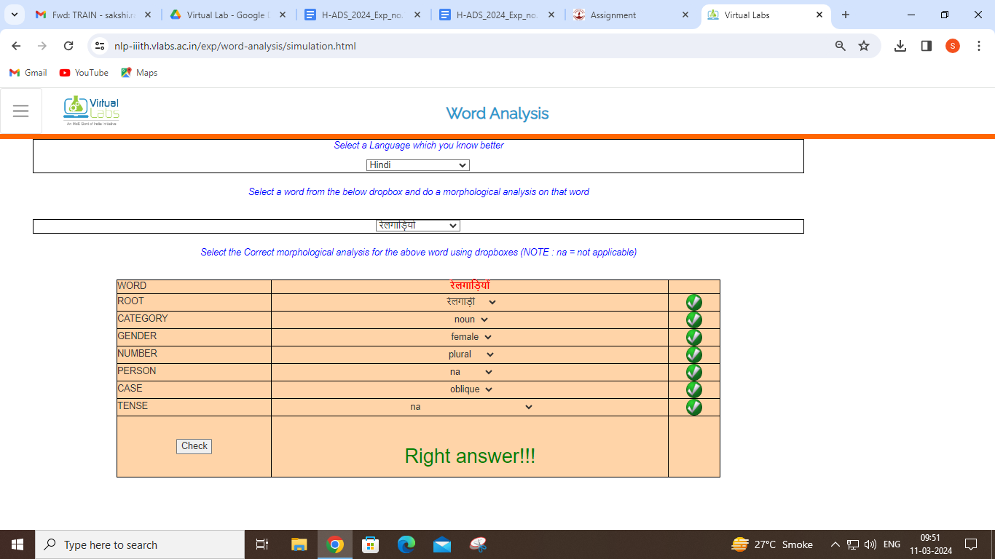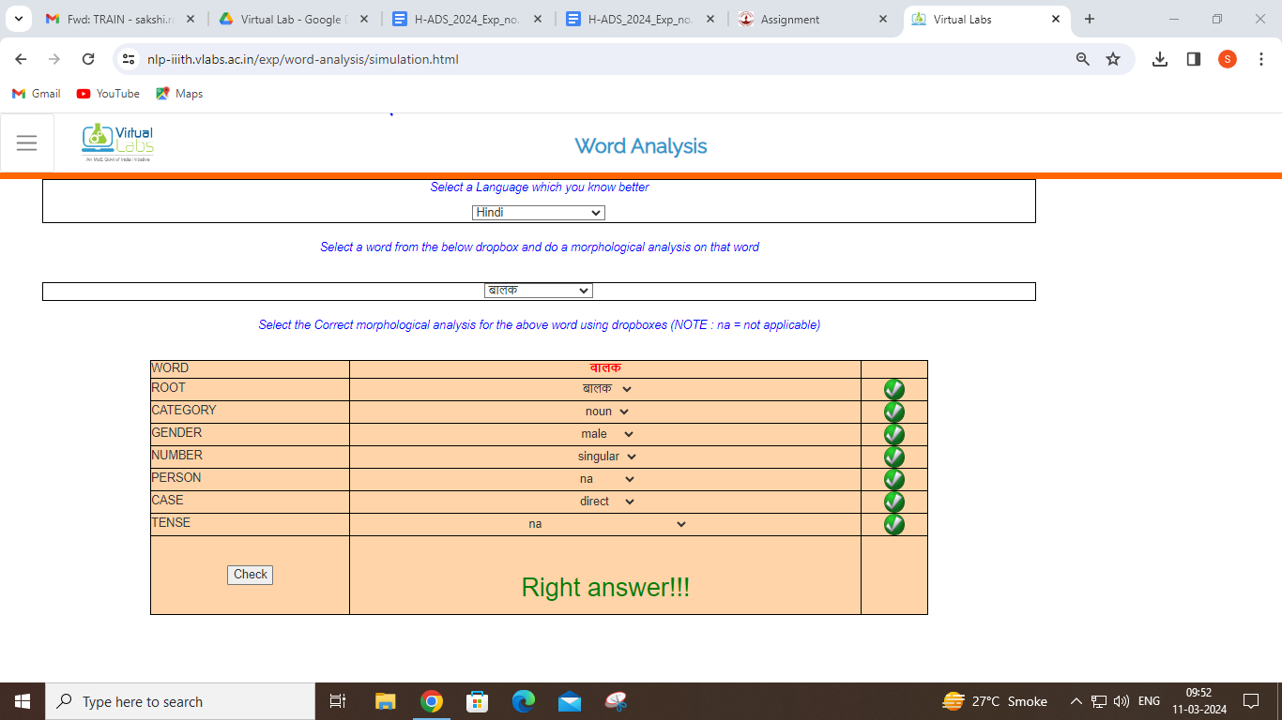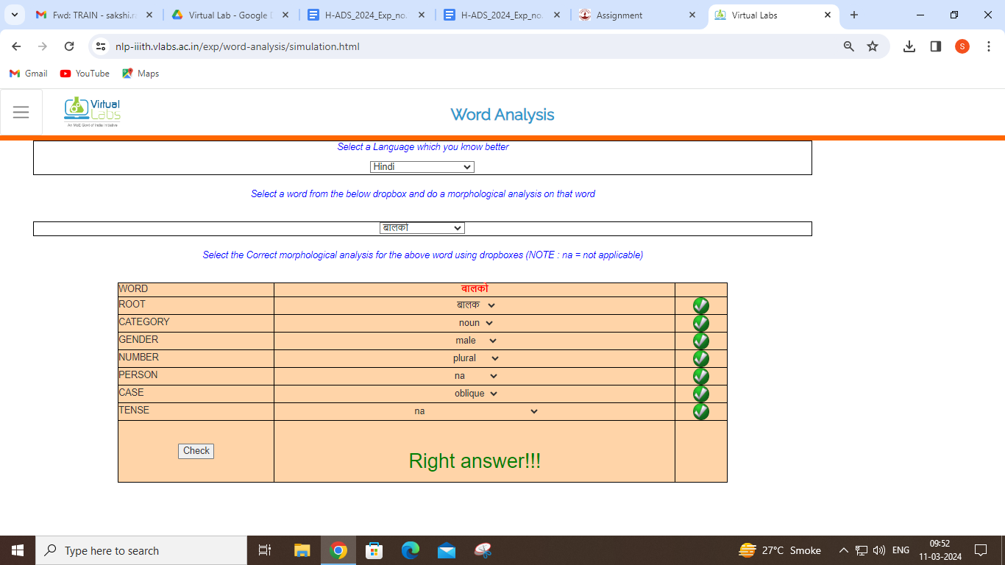
Assignment
1. Choose a typical masculine noun, ending in 'A', from your language. Write down its various forms along with various features and their values associated with them.
2. English has a suffix -en whose use is illustrated in the following lists:
List A | List B
Red | Redden
Mad | Madden
Soft | Soften
Wide | Widen
Sharp | Sharpen

In regard to these data, answer the following questions:
A. What part of speech does the suffix -en attach to? That is, what is the part of speech of the words in list A?
Answer:
The words in list A are adjectives
B. When the suffix -en is attached to a word, what part of speech is the resulting word? Give some specific morphological properties of one of the words in list B, in order to justify your answer.
Answer:
The resulting words are verbs.
Some specific morphological properties of "soften" include:
- Addition of the suffix -en to the base adjective.
- Change in grammatical category from adjective to verb.
- Retention of the meaning of the base word (for eg. soft), but with a change indicating a process of making something soft.
3. Take one verb from your mother tongue, gloss it (i.e., give the Engish meaning) and conjugate it in all tenses and aspects and persons.
Answer:
Hindi verb "खाना" (khaana), which means "to eat" in English.
Present Indefinite:
- मैं खाता हूँ (main khaata hoon) - I eat
- तू खाता है (tu khaata hai) - You eat (informal singular)
- वह खाता है (vah khaata hai) - He eats
- वह खाती है (vah khaati hai) - She eats
- हम खाते हैं (ham khaate hain) - We eat
- तुम खाते हो (tum khaate ho) - You eat (informal plural)
- वे खाते हैं (ve khaate hain) - They eat

Past Indefinite:
- मैंने खाया (maine khaaya) - I ate
- तूने खाया (tune khaaya) - You ate (informal singular)
- उसने खाया (usne khaaya) - He ate
- उसने खायी (usne khaayi) - She ate
- हमने खाया (hamne khaaya) - We ate
- तुमने खाया (tumne khaaya) - You ate (informal plural)
- उन्होंने खाया (unhone khaaya) - They ate

Future Indefinite:
- मैं खाऊँगा (main khaaunga) - I will eat
- तू खाएगा (tu khaayega) - You will eat (informal singular)
- वह खाएगा (vah khaayega) - He will eat
- वह खाएगी (vah khaayegi) - She will eat
- हम खाएँगे (ham khaayenge) - We will eat
- तुम खाओगे (tum khoge) - You will eat (informal plural)
- वे खाएँगे (ve khaayenge) - They will eat

Present Continuous:
- मैं खा रहा हूँ (main kha raha hoon) - I am eating
- तू खा रहा है (tu kha raha hai) - You are eating (informal singular)
- वह खा रहा है (vah kha raha hai) - He is eating
- वह खा रही है (vah kha rahi hai) - She is eating
- हम खा रहे हैं (ham kha rahe hain) - We are eating
- तुम खा रहे हो (tum kha rahe ho) - You are eating (informal plural)
- वे खा रहे हैं (ve kha rahe hain) - They are eating

Past Continuous:
- मैं खा रहा था (main kha raha tha) - I was eating
- तू खा रहा था (tu kha raha tha) - You were eating (informal singular)
- वह खा रहा था (vah kha raha tha) - He was eating
- वह खा रही थी (vah kha rahi thi) - She was eating
- हम खा रहे थे (ham kha rahe the) - We were eating
- तुम खा रहे थे (tum kha rahe the) - You were eating (informal plural)
- वे खा रहे थे (ve kha rahe the) - They were eating

Future Continuous:
- मैं खा रहा होऊँगा (main kha raha hounga) - I will be eating
- तू खा रहा होगा (tu kha raha hoga) - You will be eating (informal singular)
- वह खा रहा होगा (vah kha raha hoga) - He will be eating
- वह खा रही होगी (vah kha rahi hogi) - She will be eating
- हम खा रहे होऊँगे (ham kha rahe houngay) - We will be eating
- तुम खा रहे होगे (tum kha rahe hoge) - You will be eating (informal plural)
- वे खा रहे होऊँगे (ve kha rahe houngay) - They will be eating

Present Perfect:
- मैंने खा लिया है (maine kha liya hai) - I have eaten
- तूने खा लिया है (tune kha liya hai) - You have eaten (informal singular)
- उसने खा लिया है (usne kha liya hai) - He has eaten
- उसने खा लिया है (usne kha liya hai) - She has eaten
- हमने खा लिया है (hamne kha liya hai) - We have eaten
- तुमने खा लिया है (tumne kha liya hai) - You have eaten (informal plural)
- उन्होंने खा लिया है (unhone kha liya hai) - They have eaten

Past Perfect:
- मैंने खा लिया था (maine kha liya tha) - I had eaten
- तूने खा लिया था (tune kha liya tha) - You had eaten (informal singular)
- उसने खा लिया था (usne kha liya tha) - He had eaten
- उसने खा लियी थी (usne kha liyi thi) - She had eaten
- हमने खा लिया था (hamne kha liya tha) - We had eaten
- तुमने खा लिया था (tumne kha liya tha) - You had eaten (informal plural)
- उन्होंने खा लिया था (unhone kha liya tha) - They had eaten

Future Perfect:
- मैंने खा लिया होगा (maine kha liya hoga) - I will have eaten
- तूने खा लिया होगा (tune kha liya hoga) - You will have eaten (informal singular)
- उसने खा लिया होगा (usne kha liya hoga) - He will have eaten
- उसने खा लियी होगी (usne kha liyi hogi) - She will have eaten
- हमने खा लिया होगा (hamne kha liya hoga) - We will have eaten
- तुमने खा लिया होगा (tumne kha liya hoga) - You will have eaten (informal plural)
- उन्होंने खा लिया होगा (unhone kha liya hoga) - They will have eaten

These conjugations cover all tenses, aspects, and persons for the Hindi verb "खाना" (khaana), which means "to eat" in English.

4. Refer to the following data and answer the question below:
List 1: taller, shorter, higher, lower, smarter
List 2: mower, teacher, sailor, caller, operator
List 3: never, cover, finger, river

Are the words ending with 'er'/'or' have some common features?
Answer:
The words ending with 'er'/'or' do have some common features. These suffixes typically denote the agent of an action or someone who performs a particular function or role. In List 1, for example, "taller" refers to someone or something that is more tall, "smarter" refers to someone who is more smart, and so on. In List 2, "mower" is someone who mows, "teacher" is someone who teaches, and so forth. The '-er' and '-or' suffixes are commonly used to form agent nouns or comparative adjectives in English.

5. Identify root and suffix in the following words:
kissed
stronger
goodness
teacher
achievement

Answer:
kissed: root = kiss, suffix = ed
stronger: root = strong, suffix = er
goodness: root = good, suffix = ness
teacher: root = teach, suffix = er
achievement: root = achieve, suffix = ment

Post Lab questions

Q.1 List any two real-time applications of NLP?
Ans:
NLP is used in Large Language Models and can also be used in models that perform translations.

Q.2 What are stop words?
Ans:
Stop words are words that are used so much that they do not hold any important meaning or information for the NLP model to decipher what is going on.

Q.3 List the components of Natural Language Processing.
Ans:
The components of Natural Language Processing are as follows:
- Machine Learning
- Deep Learning
- Morphological and Lexical Analysis
- Syntactic Analysis
- Semantic Analysis
- Discourse Integration
- Pragmatic Analysis

Conclusion:

This Experiment helped us learn about morphological features of a word by analysing it.
Furthermore it helped us get an introduction to natural language processing.

