Batch: H2-1 Roll No.: 16010122158

Experiment No. 2

Title : To apply the descriptive statistics techniques

Aim:To apply various descriptive statistics techniques, such as measures of central tendency, variability, and distribution, to analyze and summarize the key features of a dataset.

Expected Outcome of Experiment:
CO1 : Develop an understanding of data science and business analytics.
Books/ Journals/ Websites referred:
1. https://cran.r-project.org/doc/manuals/r-release/R-intro.html

Select a built-in R dataset
You can see a list of all the built-in datasets using the data() function.
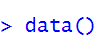
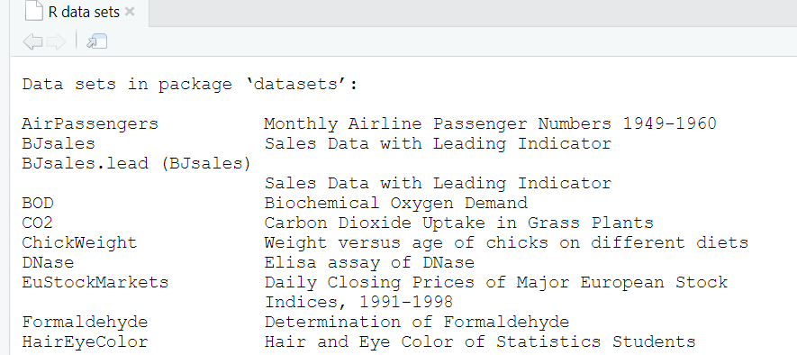
Here, we’ll use the built-in R data set named iris. Every student in the batch has to choose a unique dataset.
Check your data
You can inspect your data using the functions head() and tails(), which will display the first and the last part of the data, respectively.
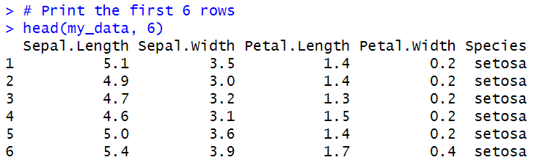
To find number or row in data
>nrow(my_data)
What will be output of
>ncol(my_data)
R functions for computing descriptive statistics
Description | R function
Mean | mean()
Standard deviation | sd()
Variance | var()
Minimum | min()
Maximum | maximum()
Median | median()
Range of values (minimum and maximum) | range()
Sample quantiles | quantile()
Generic function | summary()
Interquartile range | IQR()
Descriptive statistics for a single group
Measure of central tendency: mean, median, mode
Mean is nothing but the average of the given set of values.
Median The median of a set of data is the middlemost number or centre value in the set. The median is also the number that is halfway into the set. To find the median, the data should be arranged first in order of least to greatest or greatest to the least value.
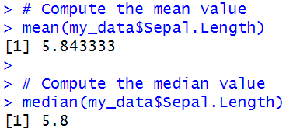

The mode is the value that appears most often in a set of data. The mode of a discrete probability distribution is the value x at which its probability mass function takes its maximum value. In other words, it is the value that is most likely to be sampled.
The function mfv() [in the modeest R package] can be used to compute the mo
de of a variable.
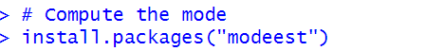
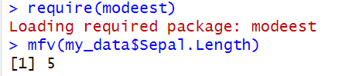
Measure of variability
Range: minimum & maximum
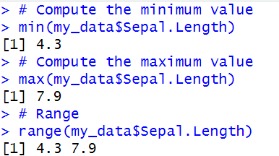
Quantiles
A quantile is a particular part of a data set that determines how many values in a distribution are above or below a certain limit. Quantiles are cut points that divide the range of a probability distribution into continuous intervals with equal probabilities, or divide the observations in a sample in the same way. The word "quantile" comes from the word quantity, and it refers to dividing a sample or a probability distribution into equal-sized, adjacent subgroups.
So given data set is arranged in the ascending order. Assume there are 100 samples; then, 25% means THE value of 25th sample; in other words the value below which 25% of the samples lie.
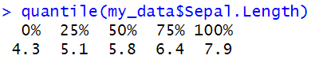
By default, the function returns the minimum, the maximum and three quartiles (the 0.25, 0.50 and 0.75 quantiles).
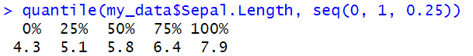
To compute deciles (0.1, 0.2, 0.3, …., 0.9), use this:
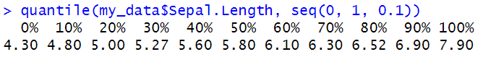
Interquartile range
The difference between the upper and lower quartile is known as the interquartile range.
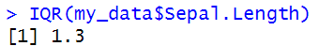
Variance and standard deviation
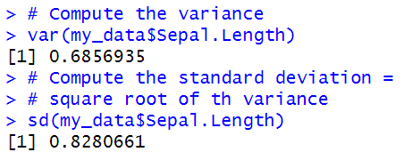
Median absolute deviation
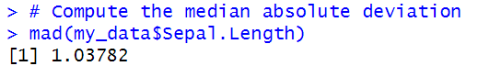
Computing an overall summary of a variable and an entire data frame
summary() function
Summary of a single variable. Five values are returned: the mean, median, 25th and 75th quartiles, min and max in one single line call:
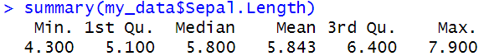
Summary of a data frame. In this case, the function summary() is automatically applied to each column. The format of the result depends on the type of the data contained in the column. For example:
- If the column is a numeric variable, mean, median, min, max and quartiles are returned.
- If the column is a factor variable, the number of observations in each group is returned.
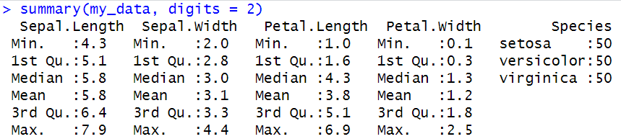
sapply() function
It’s also possible to use the function sapply() to apply a particular function over a list or vector. For instance, we can use it to compute for each column in a data frame, the mean, sd, var, min, quantile, …
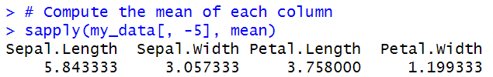
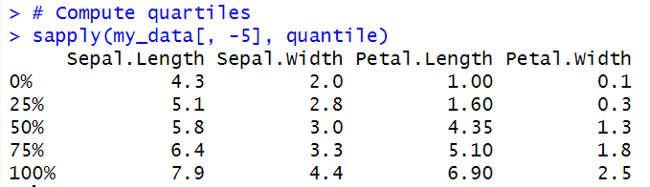
Graphical display of distributions
The R package ggpubr will be used to create graphs.
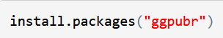
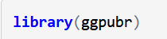
Box Plot
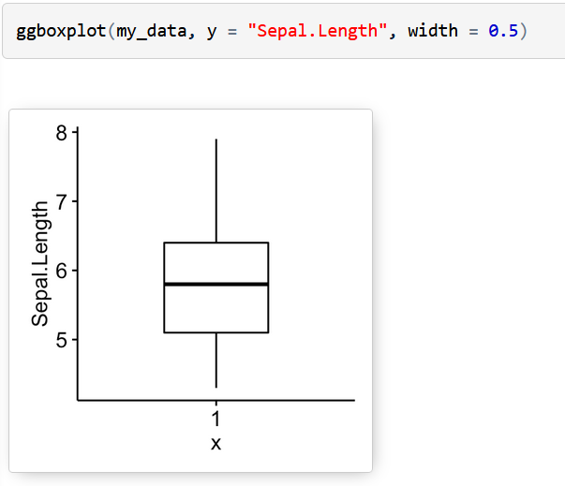
Histogram with mean line
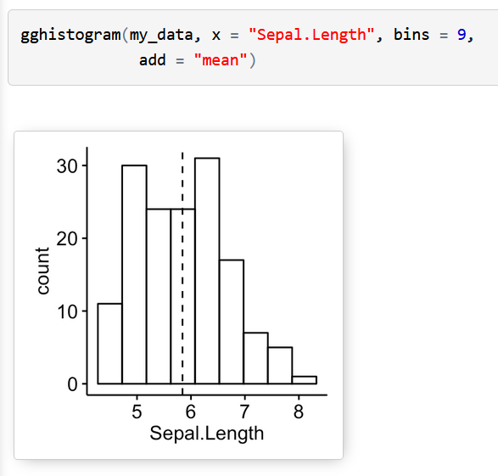
Empirical cumulative distribution function (ECDF)
ECDF is the fraction of data smaller than or equal to x.
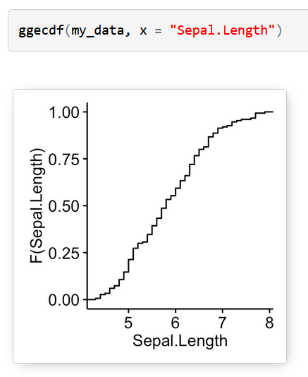
QQ plots are used to check whether the data is normally distributed.
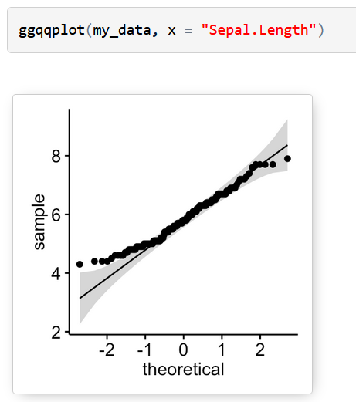
Descriptive statistics by groups
To compute summary statistics by groups, the functions group_by() and summarise() [in dplyr package] can be used.
- We want to group the data by Species and then:
  - compute the number of element in each group. R function: n()
  - compute the mean. R function mean()
  - and the standard deviation. R function sd()
Install dplyr as follow:
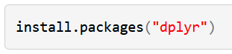
Descriptive statistics by groups:
To compute summary statistics by groups, the functions group_by() and summarise() [in dplyr package] can be used.
- We want to group the data by Species and then:
  - compute the number of element in each group. R function: n()
  - compute the mean. R function mean()
  - and the standard deviation. R function sd()
%>% is used to chain the operations.
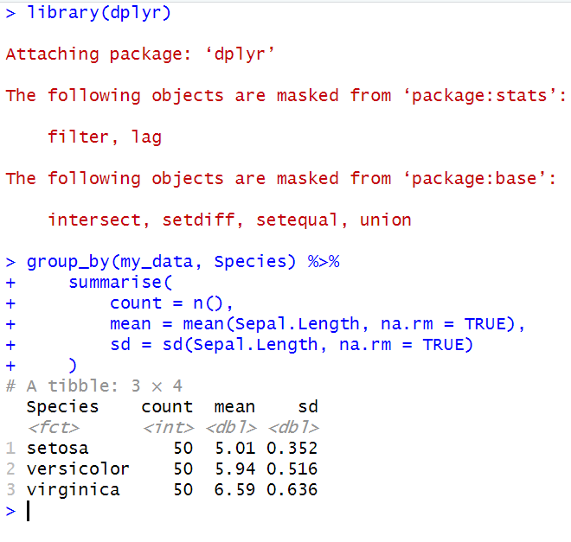
Graphics for grouped data:
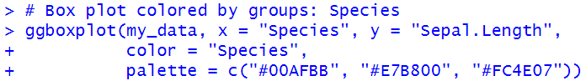

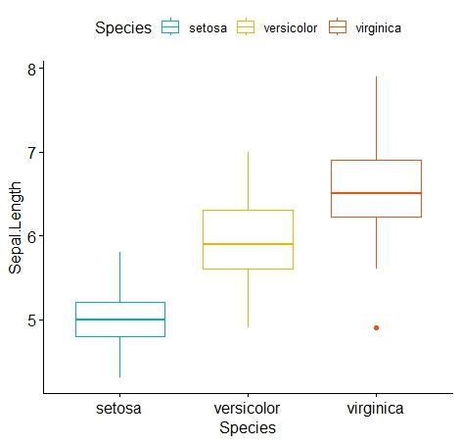
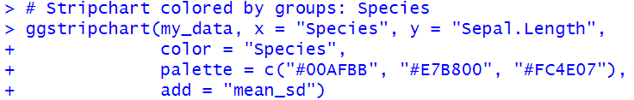
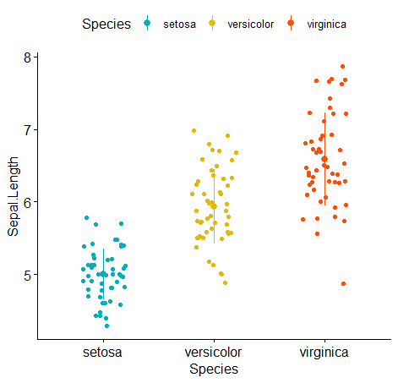
Frequency tables
A frequency table (or contingency table) is used to describe categorical variables. It contains the counts at each combination of factor levels.
R function to generate tables: table()
For this section we will use the built-in R dataset that contains the distribution of hair and eye color by sex of 592 students:
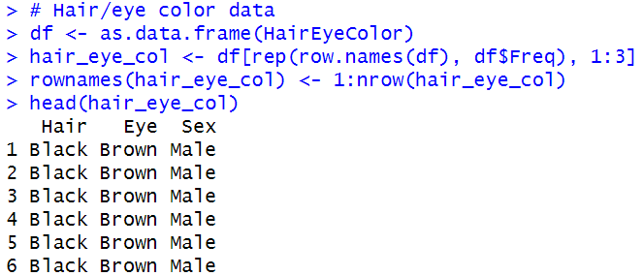
Simple frequency distribution: one categorical variable
Table of counts
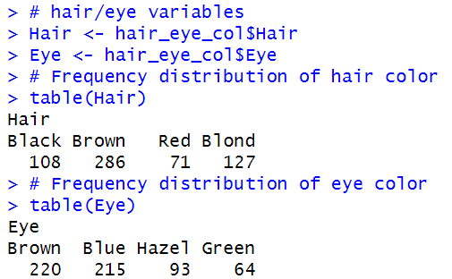
Visualization:
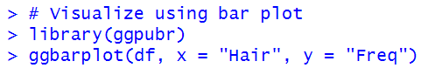
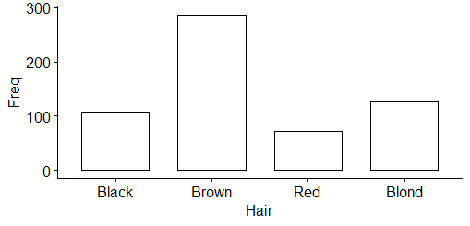
Two-way contingency table: Two categorical variables
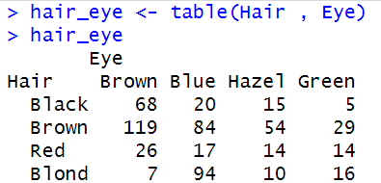
Multiway tables: More than two categorical variables
- Hair and Eye color distributions by sex using xtabs():
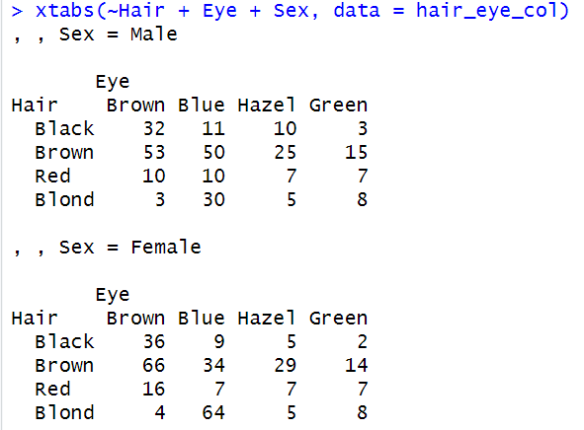
You can also use the function ftable() [for flat contingency tables]. It returns a cleaner looking output compared to xtabs() when you have more than two variables:
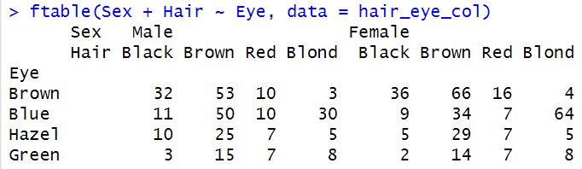
Compute table margins and relative frequency
Table margins correspond to the sums of counts along rows or columns of the table.
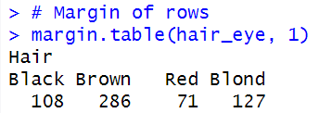
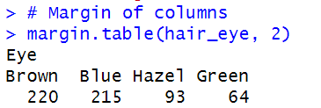
Relative frequencies express table entries as proportions of table margins (i.e., row or column totals).
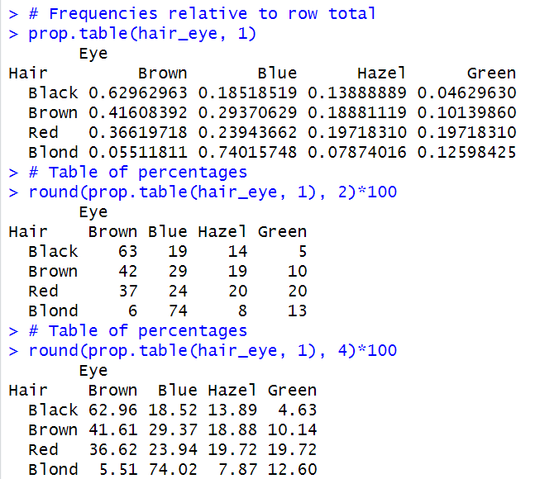
Students have to perform ALL the operations shown above on the dataset of their choice and add their screenshots here.
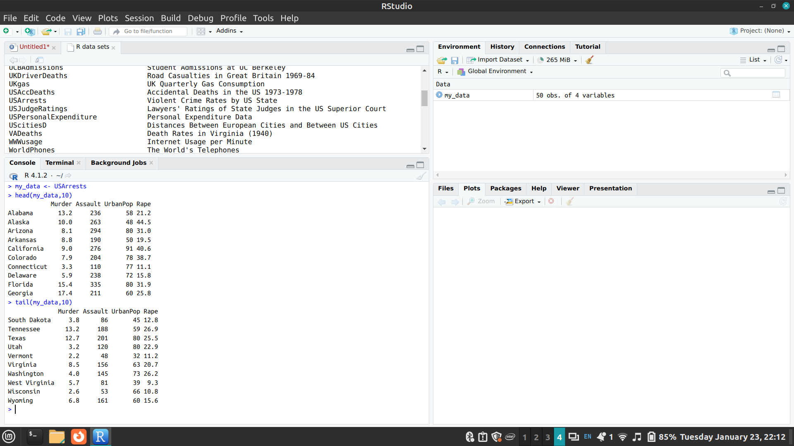
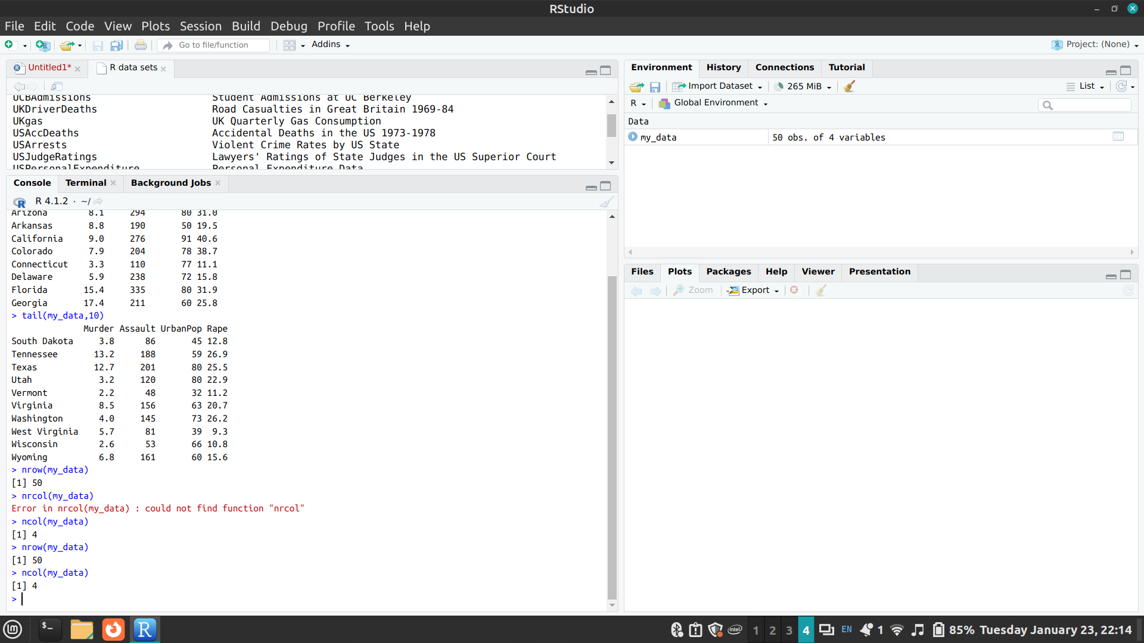
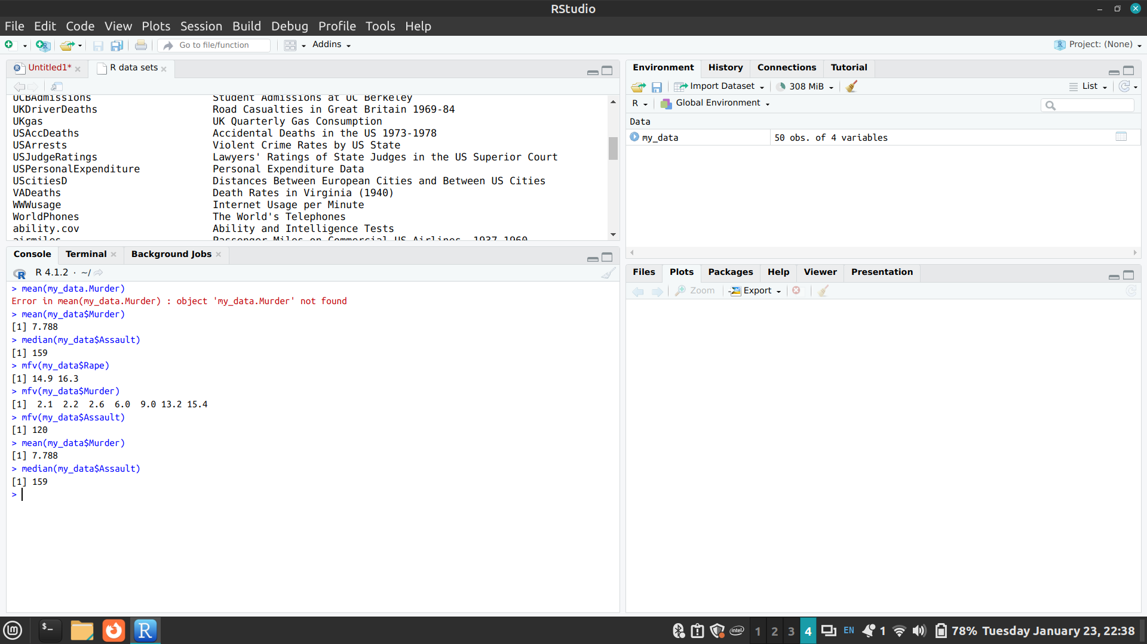
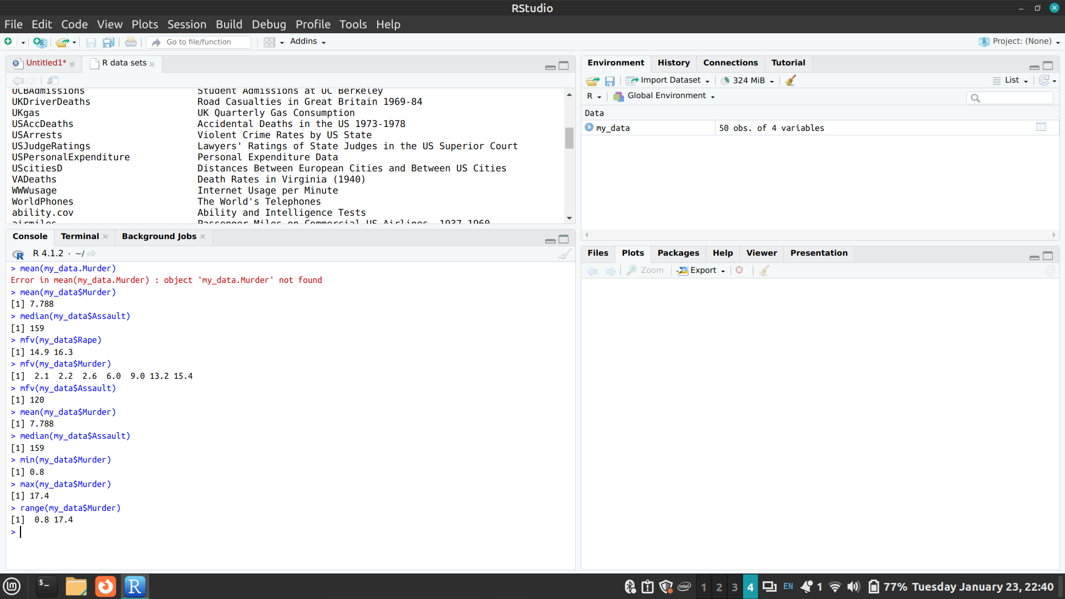
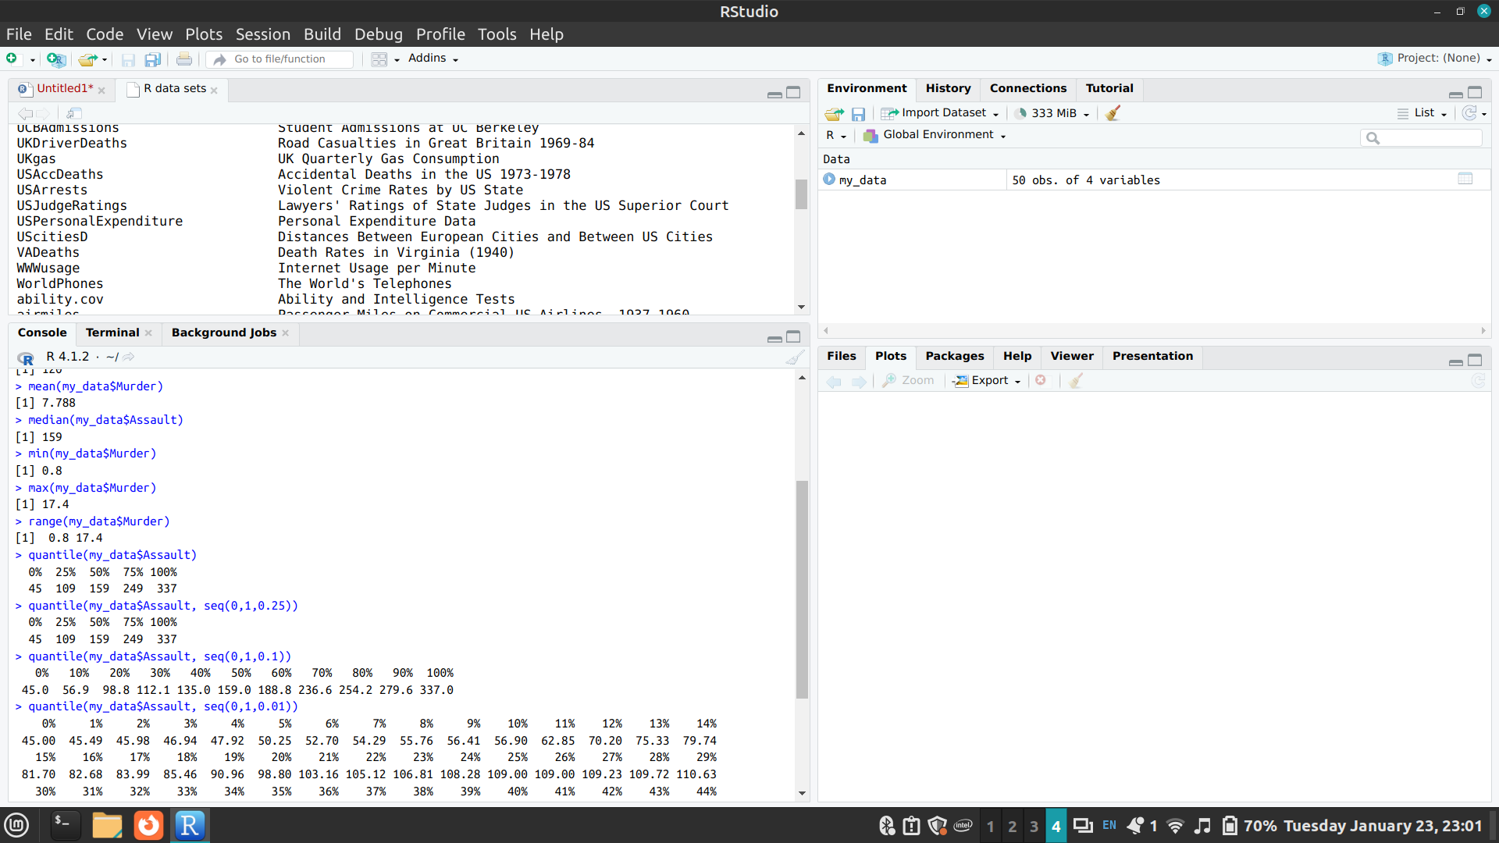
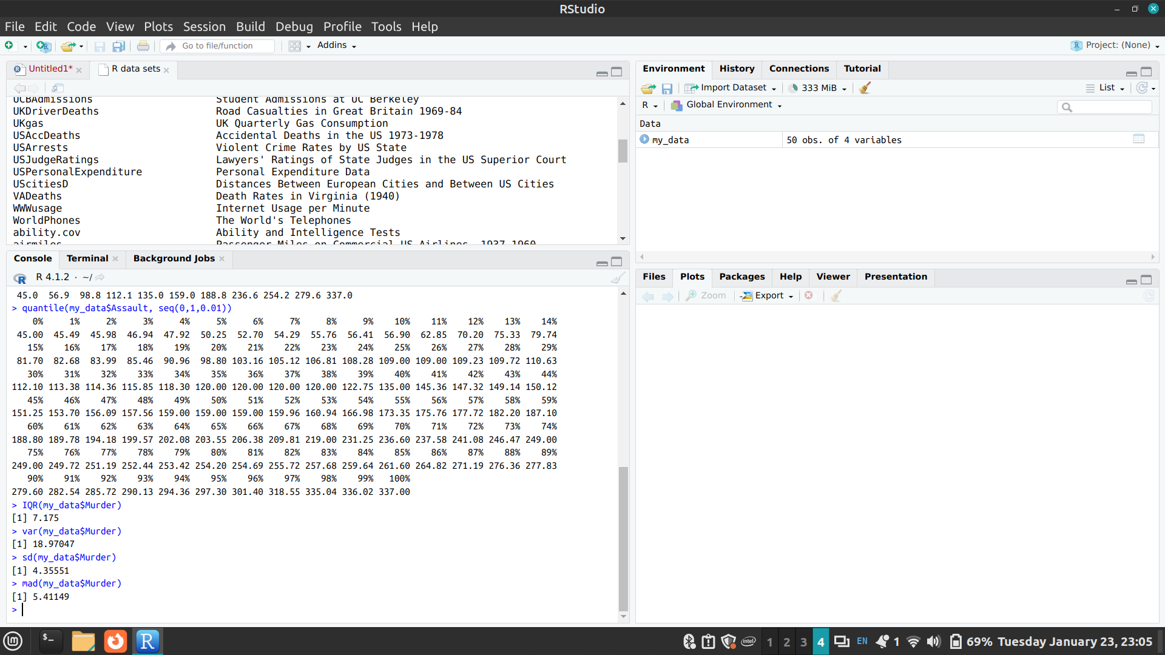
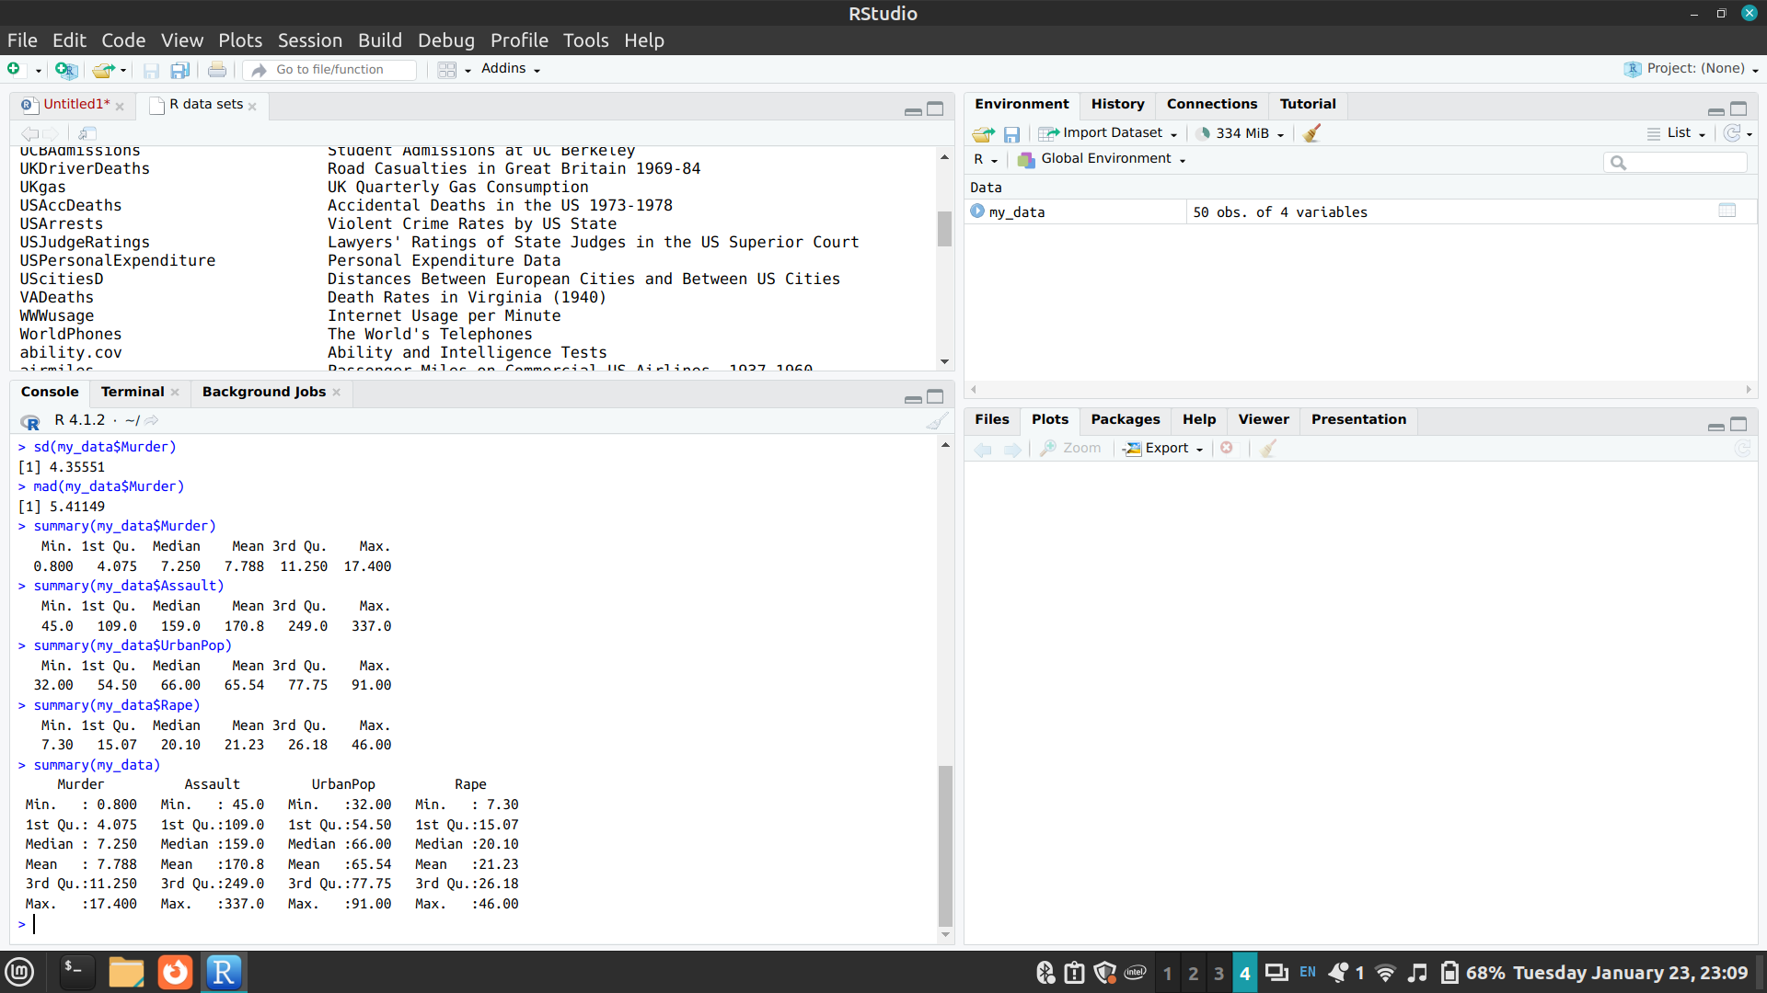
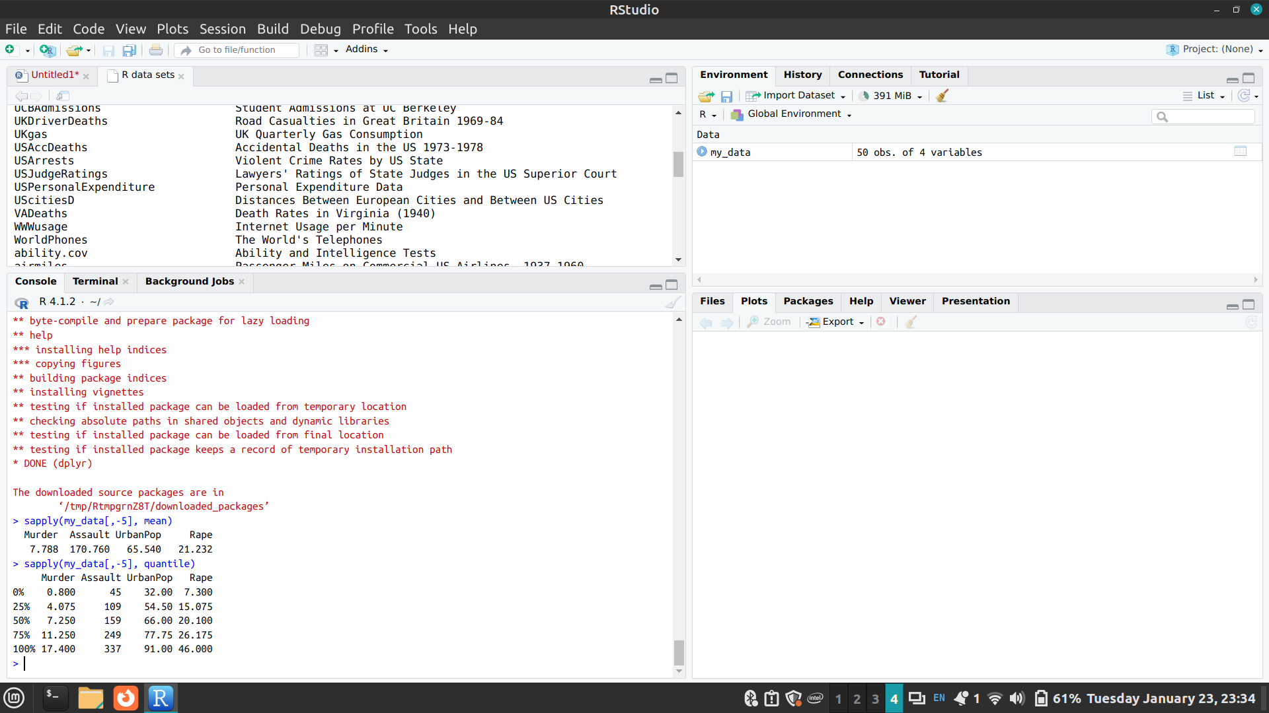
> ggboxplot(my_data, y="Murder", width=0.5)
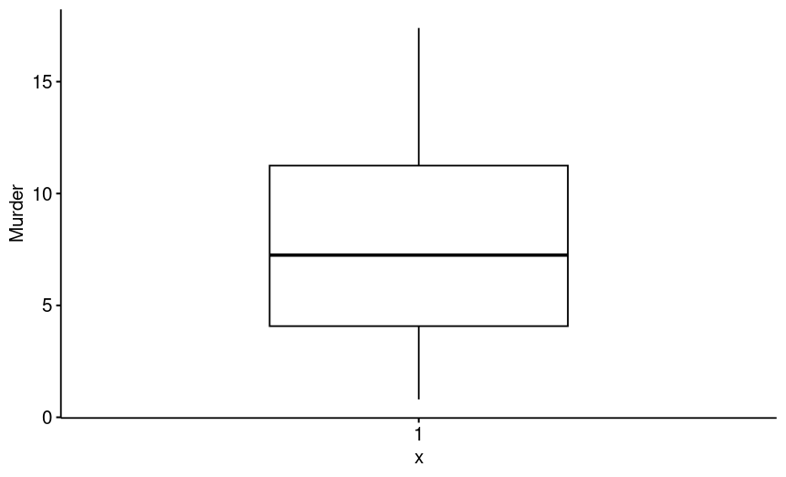
> gghistogram(my_data, x="Assault", bins=10, add="mean")
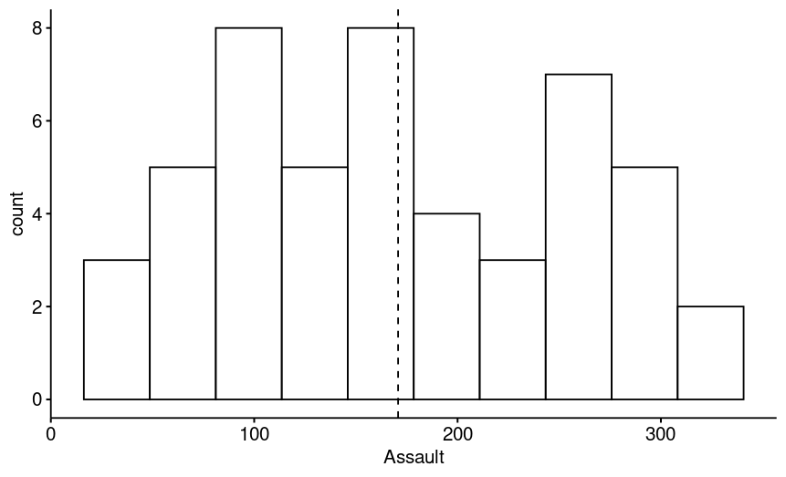
> ggecdf(my_data, x="Rape")
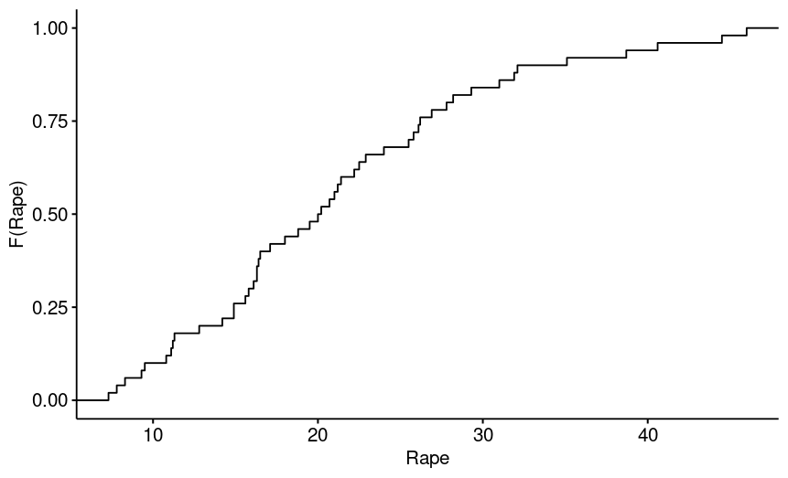

> ggqqplot(my_data, x="Rape")
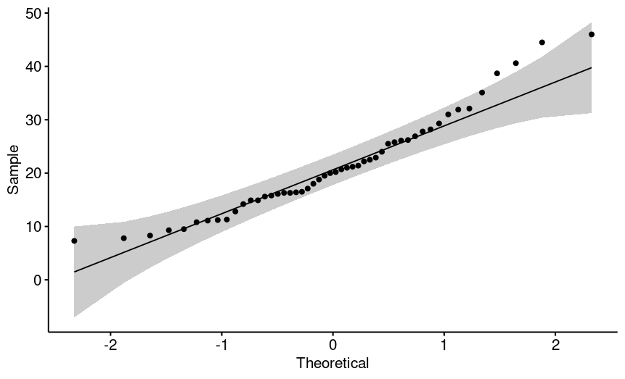
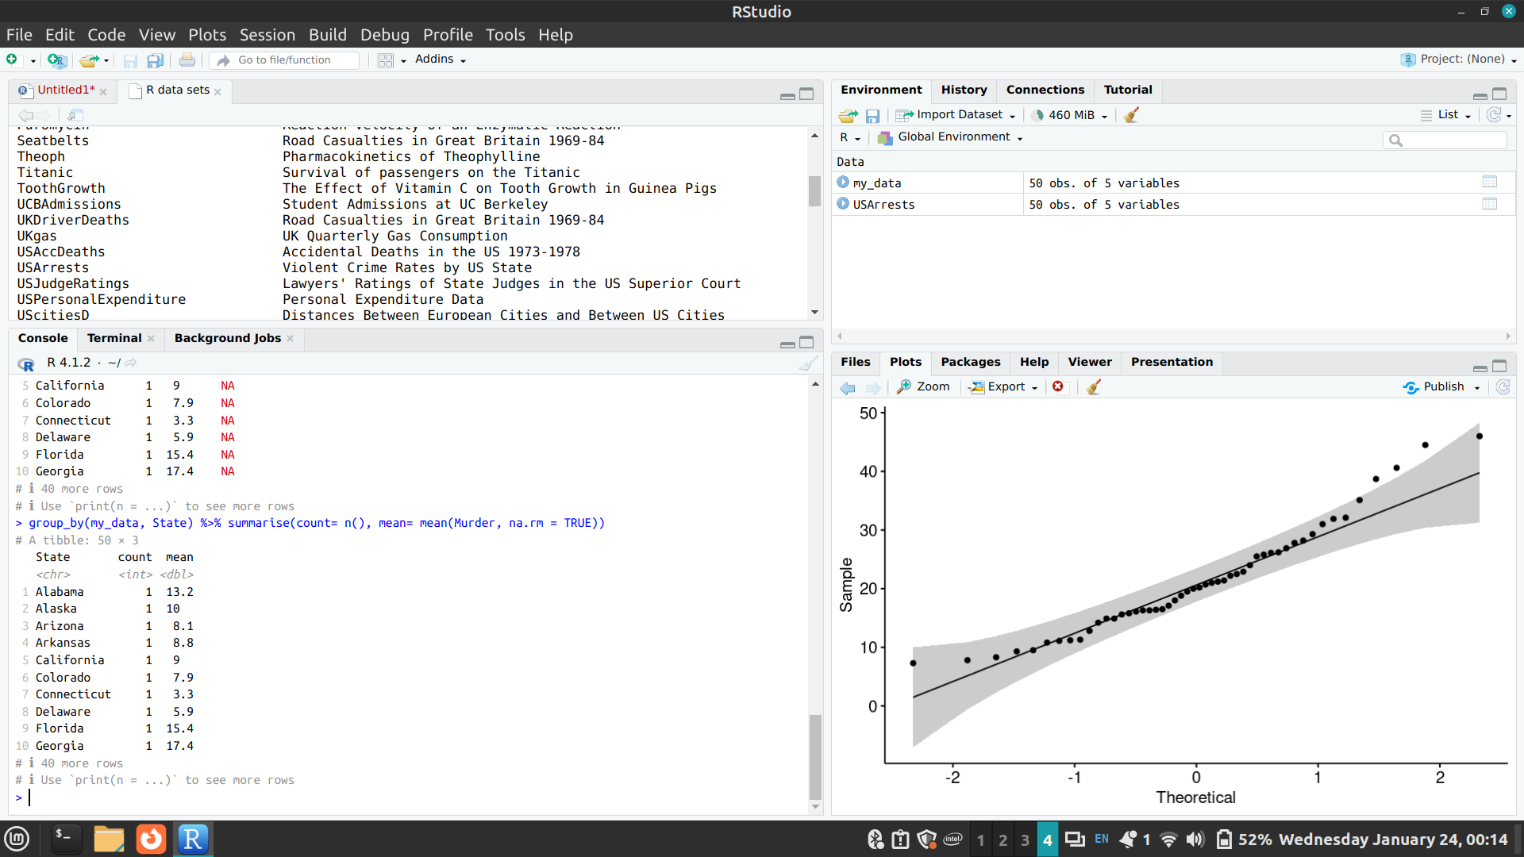
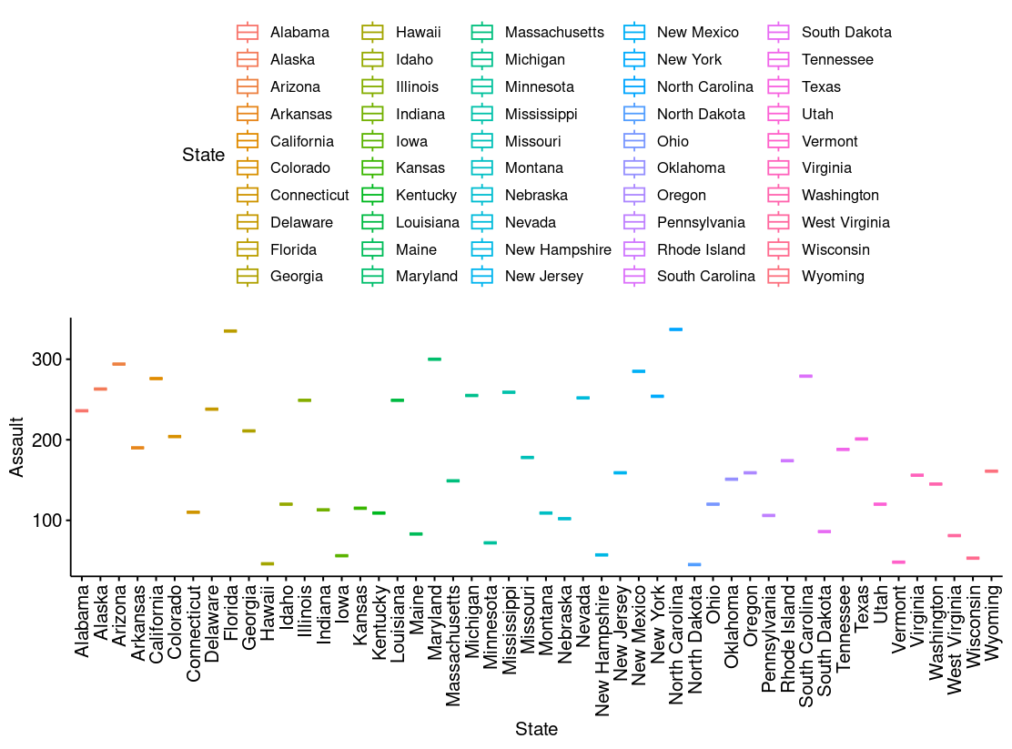
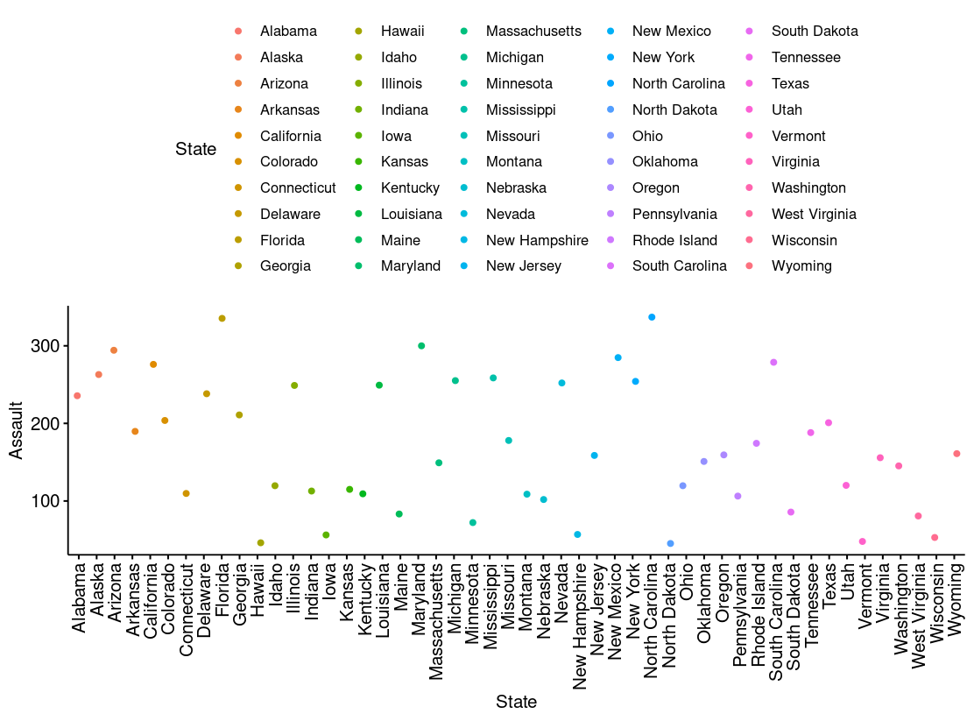

ggboxplot(my_data[1:3,], x="States", y="Assault", color="States", add = "mean_sd")
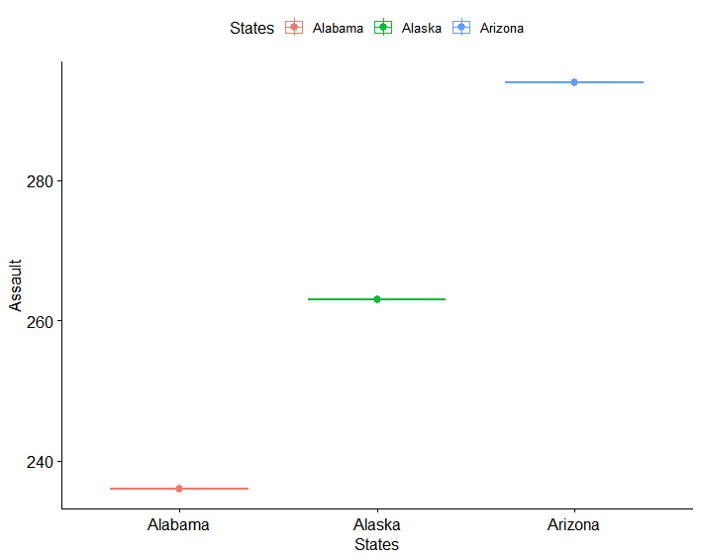
ggstripchart(my_data[1:3,], x="States", y="Assault", color="States", add = "mean_sd")
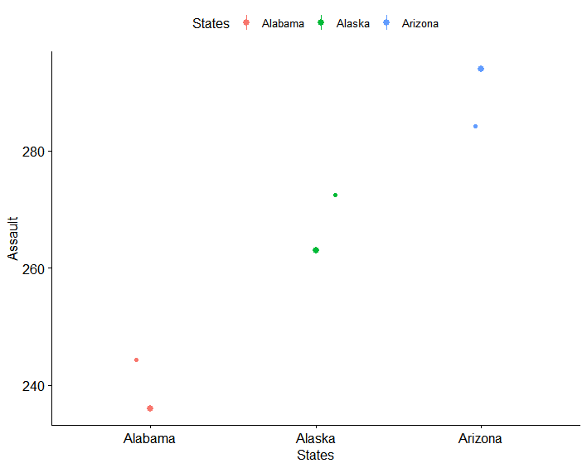
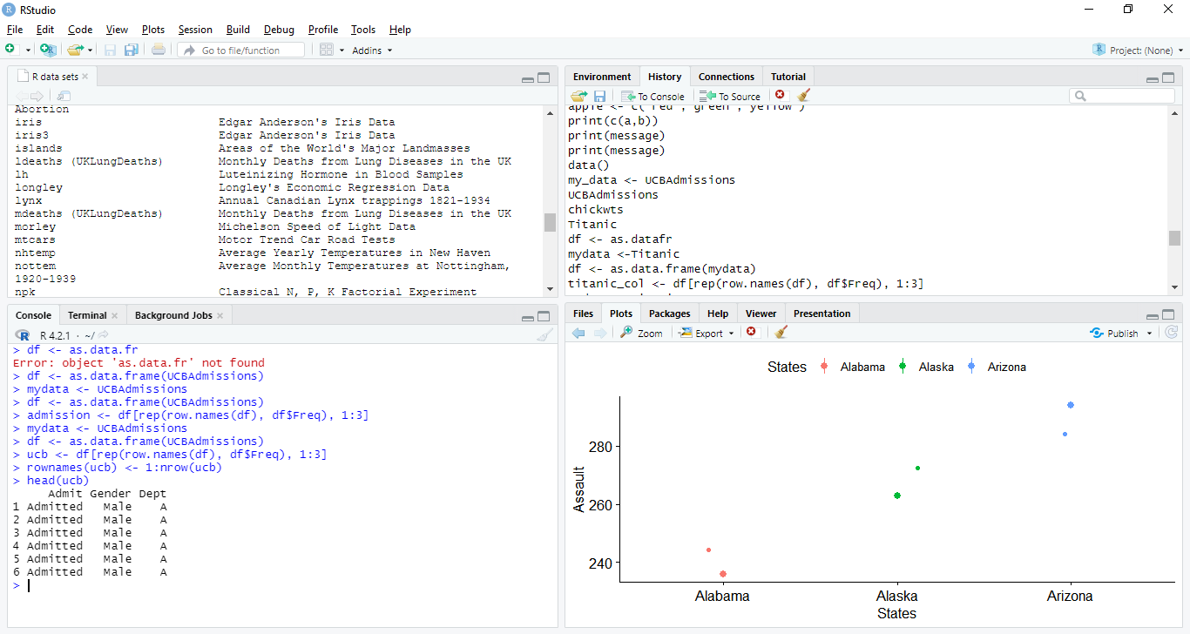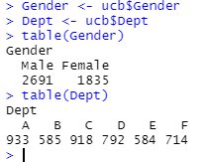
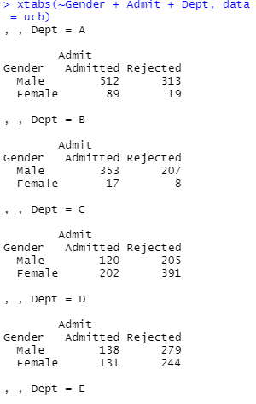
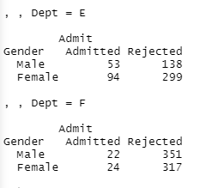
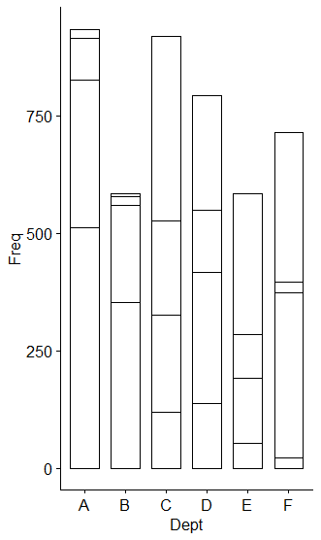

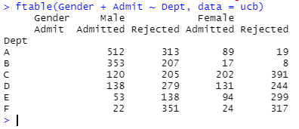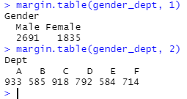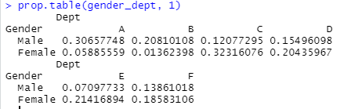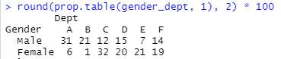
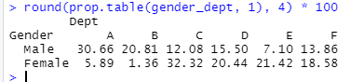

Post Lab questions

- Critically assess the limitations of using only measures of central tendency in data analysis.

- The mean is particularly sensitive to extreme values or outliers in the dataset. A few extreme observations can significantly skew the mean, leading to a distorted representation of the central tendency. In such cases, the median may be a more robust measure.

- Central tendency measures do not provide information about the distribution of data. Two datasets with the same mean can have entirely different patterns of distribution. Understanding the spread or dispersion of data is crucial for a comprehensive analysis.

- Using only measures of central tendency can lead to a loss of information about the shape of the distribution, variability, and any patterns or trends in the data. Researchers might overlook important nuances and characteristics by focusing solely on the central tendency.

- Measures of central tendency assume a normal distribution, and their interpretation may be misleading in the presence of skewed or non-normally distributed data. In such cases, alternative measures like the median or percentiles may be more appropriate.

- Measures of central tendency are primarily designed for quantitative data and may not be suitable for categorical or ordinal data. Mode can be used for categorical data, but it may not provide a complete picture of the data.

- Compare and contrast the different measures of variability, with the focus on when one measure might be more informative than the other.

Sensitivity to Outliers: Range is highly sensitive to outliers, as it depends solely on the extremes of the dataset. Variance is sensitive to outliers due to the squared differences in its calculation. Standard deviation is less sensitive to outliers compared to variance because it involves taking the square root.
Interpretability: Range is easy to interpret but does not provide a detailed picture of the distribution. Variance, while comprehensive, is in squared units, making it less intuitive. Standard deviation is more interpretable as it is in the same units as the original data.
Application to Normal Distribution: For data that approximately follows a normal distribution, standard deviation is often preferred due to its compatibility with the normal curve. Range and variance may be less informative for normally distributed data.

- Imagine you are presented with a dataset from a research study. Discuss how applying descriptive statistics techniques could aid in understanding the key features and trends in the data. Take any real life examples to aid your analysis.

Descriptive statistics play a crucial role in unraveling key features and trends within a dataset.
For instance, in a health study examining blood pressure levels, mean and standard deviation provide a central tendency and dispersion measure.
Histograms reveal the distribution of blood pressure values, aiding in identifying common ranges or anomalies.
Additionally, measures like skewness and kurtosis unveil the data's shape, aiding in understanding its symmetry and outliers.
These techniques collectively provide a comprehensive snapshot, enabling researchers to discern patterns, central tendencies, and potential outliers, fostering a deeper understanding of the dataset's inherent characteristics.

Conclusion:

This ADS experiment has helped me understand how to apply the descriptive statistics techniques in R.
Through this, we gained insights into the typical values, while measures of variability allowed us to assess the data's spread and dispersion.
The examination of distribution through histograms and other graphical representations provided a visual interpretation of the dataset's patterns.
This hands-on experience solidifies our foundational knowledge and enhances our capability to draw meaningful insights from diverse datasets.

