Batch: B3 Roll No.: 16010122158

Experiment No. 3

Title : To implement probability based statistical modelling

Aim:To implement probability based statistical modelling such as Binomial Distribution, Poisson Distribution and Normal/Gaussian distribution.

Expected Outcome of Experiment:
CO1 : Develop an understanding of data science and business analytics.

Books/ Journals/ Websites referred:
1.https://www.r-project.org/other-docs.html

- Binomial distribution
The “binomial” in binomial distribution means two terms—the number of successes and the number of attempts. Each is useless without the other. Binomial distribution is a common discrete distribution used in statistics, as opposed to a continuous distribution, such as normal distribution. This is because binomial distribution only counts two states, typically represented as 1 (for a success) or 0 (for a failure), given a number of trials in the data. Binomial distribution thus represents the probability for x successes in n trials, given a success probability p for each trial.
The binomial distribution function is calculated as:
P_{( x : n , p )} = ^{n} C _{x} p ^{x} ( 1 - p ) ^{n - x}
Where:
- n is the number of trials (occurrences)
- x is the number of successful trials
- p is the probability of success in a single trial
- ^{n} C _{x} is the combination of n and x. A combination is the number of ways to choose a sample of x elements from a set of n distinct objects where order does not matter, and replacements are not allowed. Note that _{n}C_{x} = n! / r! ( n − r ) ! ), where ! is factorial (so, 4! = 4 × 3 × 2 × 1).
Program:
# Setting the parameters for the binomial distribution
n_trials <- 10 # Number of trials
prob_success <- 0.3 # Probability of success

# Generate a random sample from a binomial distribution
random_sample <- rbinom(n = 1, size = n_trials, prob = prob_success)
cat("Random sample:", random_sample, "\n")

# Calculate the probability mass function (PMF) at specific values
values <- c(0, 1, 2, 3)
pmf_values <- dbinom(x = values, size = n_trials, prob = prob_success)
cat("PMF at", values, ":", pmf_values, "\n")

# Calculate the cumulative distribution function (CDF) at specific values
cdf_values <- pbinom(q = values, size = n_trials, prob = prob_success)
cat("CDF at", values, ":", cdf_values, "\n")

# Find quantiles given probabilities
quantiles <- qbinom(p = c(0.1, 0.5, 0.9), size = n_trials, prob = prob_success)
cat("Quantiles at probabilities 0.1, 0.5, 0.9:", quantiles, "\n")

OUTPUT:
Random sample: 3
PMF at 0 1 2 3 : 0.02824752 0.1210608 0.2334744 0.2668279
CDF at 0 1 2 3 : 0.02824752 0.1493083 0.3827828 0.6496107
Quantiles at probabilities 0.1, 0.5, 0.9: 1 3 5

- Poisson Distribution
In statistics, a Poisson distribution is a probability distribution that is used to show how many times an event is likely to occur over a specified period. In other words, it is a count distribution. Poisson distributions are often used to understand independent events that occur at a constant rate within a given interval of time. It was named after French mathematician Siméon Denis Poisson.

$f\left(x\right)=\frac{λ^{x}}{x!}e^{-λ}$

Where:
- e is Euler's number (e = 2.71828...)
- x is the number of occurrences
- x! is the factorial of x
- λ is equal to the expected value (EV) of x when that is also equal to its variance
Program:
# Setting the parameter for the Poisson distribution
lambda <- 3 # Average number of events per unit of time or space
# Generate a random sample from a Poisson distribution
random_sample <- rpois(n = 10, lambda = lambda)
cat("Random sample:", random_sample, "\n")
# Calculate the probability mass function (PMF) at specific values
values <- c(0, 1, 2, 3)
pmf_values <- dpois(x = values, lambda = lambda)
cat("PMF at", values, ":", pmf_values, "\n")
# Calculate the cumulative distribution function (CDF) at specific values
cdf_values <- ppois(q = values, lambda = lambda)
cat("CDF at", values, ":", cdf_values, "\n")
# Find quantiles given probabilities
quantiles <- qpois(p = c(0.1, 0.5, 0.9), lambda = lambda)
cat("Quantiles at probabilities 0.1, 0.5, 0.9:", quantiles, "\n")

OUTPUT:
Random sample: 2 4 1 2 3 3 4 2 2 3
PMF at 0 1 2 3 : 0.04978707 0.1493612 0.2240418 0.2240418
CDF at 0 1 2 3 : 0.04978707 0.1991483 0.4231901 0.6472319
Quantiles at probabilities 0.1, 0.5, 0.9: 1 3 5
- Normal Distribution
Normal distribution, also known as the Gaussian distribution, is a probability distribution that is symmetric about the mean, showing that data near the mean are more frequent in occurrence than data far from the mean.In graphical form, the normal distribution appears as a "bell curve". The standard normal distribution has two parameters: the mean and the standard deviation. In a normal distribution the mean is zero and the standard deviation is 1. It has zero skew and a kurtosis of 3.
The normal distribution follows the following formula. Note that only the values of the mean (μ ) and standard deviation (σ) are necessary
Normal Distribution Formula.
$f\left(x\right)=\frac{1}{σ\sqrt{2π}}e^{\frac{-1}{2}({\frac{x-μ}{σ})}^{2}}$
where:
- x = value of the variable or data being examined and f(x) the probability function
- μ = the mean
- σ = the standard deviation
Program:
# Setting the parameters for the normal distribution
mean_value <- 0 # Mean of the distribution
sd_value <- 1 # Standard deviation of the distribution
# Generate a random sample from a normal distribution
random_sample <- rnorm(n = 10, mean = mean_value, sd = sd_value)
cat("Random sample:", random_sample, "\n")
# Calculate the probability density function (PDF) at specific values
values <- c(-2, -1, 0, 1, 2)
pdf_values <- dnorm(x = values, mean = mean_value, sd = sd_value)
cat("PDF at", values, ":", pdf_values, "\n")
# Calculate the cumulative distribution function (CDF) at specific values
cdf_values <- pnorm(q = values, mean = mean_value, sd = sd_value)
cat("CDF at", values, ":", cdf_values, "\n")
# Find quantiles given probabilities
quantiles <- qnorm(p = c(0.1, 0.5, 0.9), mean = mean_value, sd = sd_value)
cat("Quantiles at probabilities 0.1, 0.5, 0.9:", quantiles, "\n")
OUTPUT:
Random sample: -2.450496 0.3155664 0.469913 -0.656226 -0.6094917 -1.41421 -0.124466 -1.610715 -0.4915843 -0.3460785
PDF at -2 -1 0 1 2 : 0.05399097 0.2419707 0.3989423 0.2419707 0.05399097
CDF at -2 -1 0 1 2 : 0.02275013 0.1586553 0.5 0.8413447 0.9772499
Quantiles at probabilities 0.1, 0.5, 0.9: -1.281552 0 1.281552

Students have to perform ALL the operations shown above and add their screenshots here.
Code and output to generate a random sample:
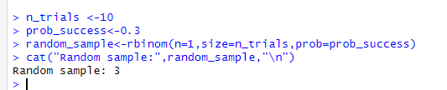

Code and Output for Binomial distribution:
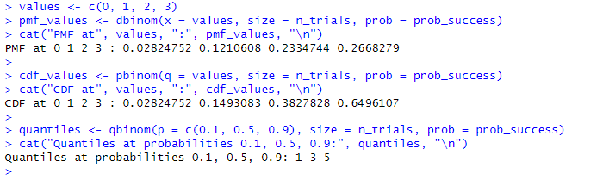

Code and Output for Poisson distribution:
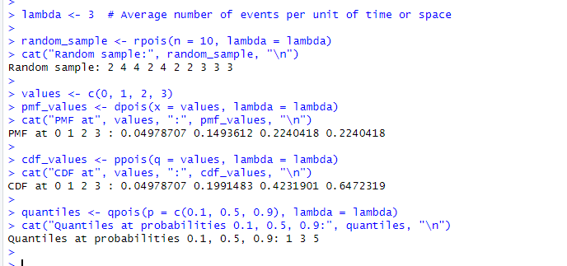
Code and Output for Normal Distribution:
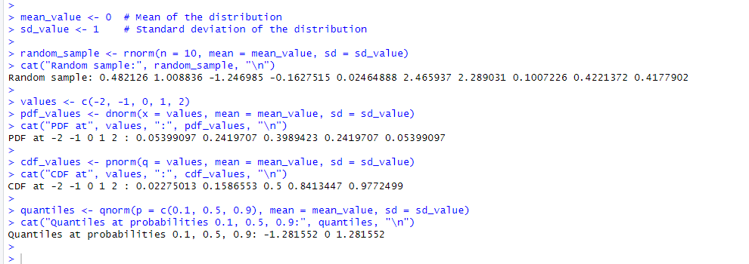

Post Lab questions

Q.1 You are managing a quality control process for a production line where each item produced can be classified as either defective or non-defective. The probability of producing a defective item is 0.05.

- Define the binomial distribution and explain the key components involved.
- How does the binomial distribution differ from other probability distributions?
- Discuss the conditions that must be satisfied for a random variable to follow a binomial distribution.
Answer:
a) The binomial distribution is a discrete probability distribution that describes the number of successes in a fixed number of independent Bernoulli trials, where each trial has only two possible outcomes (success or failure) and the probability of success remains constant for each trial.
Key components involved in the binomial distribution include:
The number of trials, denoted by n.
The probability of success on each trial, denoted by p.
The number of successes, denoted by k.
b) The binomial distribution differs from other probability distributions in several ways:
- It describes the number of successes in a fixed number of independent trials with only two possible outcomes (success or failure).
- It assumes a constant probability of success for each trial.
- It is discrete, meaning it deals with countable outcomes.
- It is a special case of the more general probability distribution known as the Bernoulli distribution, which describes a single trial.
c) For a random variable to follow a binomial distribution, the following conditions must be satisfied:
- Each trial must result in one of two possible outcomes (success or failure).
- The trials must be independent of each other.
- The probability of success (p) remains constant for each trial.
- The number of trials (n) is fixed in advance.

Q.2 Provide an example scenario from a real-world application where the binomial distribution and Poisson distribution is applicable. Explain why it fits the respective models.

Answer:
Binomial Distribution

Example Scenario - Quality Control in Manufacturing:
Consider a scenario where a manufacturing plant produces light bulbs, and the quality control team inspects a random sample of 50 bulbs for defects. Each bulb can be classified as either defective or non-defective. The probability of producing a defective bulb is known to be 0.05.

In this case:

Number of Trials (n): The fixed number of trials is 50 bulbs.
Probability of Success (p): The probability of producing a defective bulb is 0.05.
Probability of Failure (q): The probability of producing a non-defective bulb is 1 - 0.05 = 0.95.
Random Variable (X): The number of defective bulbs in the sample.
This scenario fits the binomial distribution because each bulb's inspection is an independent trial with two possible outcomes (defective or non-defective). The fixed number of trials and constant probability of producing a defective bulb make it suitable for modeling using the binomial distribution.

Poisson Distribution:

Example Scenario - Call Center Incoming Calls:
Suppose you manage a call center, and you observe the number of incoming calls per minute during a particular period. The average rate of incoming calls is known to be 4 calls per minute.

In this case:

Rate of Events (λ): The average rate of incoming calls is 4 calls per minute.
Time Interval (t): The time interval for observation, such as 1 minute.
Random Variable (X): The number of incoming calls during the observed time interval.
This scenario fits the Poisson distribution because:

The number of incoming calls in a fixed time interval is being observed.
The events (incoming calls) are assumed to be rare and independent.
The average rate of incoming calls per minute remains constant.
The Poisson distribution is appropriate for modeling rare events occurring in fixed intervals of time or space, making it suitable for scenarios like call center arrivals, where events are infrequent, and the average rate is known.

Q.3 The normal distribution is a fundamental concept in statistics and probability. Provide a comprehensive description of the normal distribution, covering the following aspects:

a. Define the normal distribution and explain its key characteristics.

b. Discuss the standard normal distribution and the role of the z-score in standardizing values.

c. Describe situations or phenomena in the real world where the normal distribution is commonly observed. Discuss why the normal distribution is a suitable model for these scenarios.

Answer:
a)
Normal Distribution: The normal distribution, also known as the Gaussian distribution, is a continuous probability distribution that is symmetric, bell-shaped, and characterized by two parameters: the mean (μ) and the standard deviation (σ). It is defined by the probability density function (PDF):

Key characteristics of the normal distribution include:
- Symmetry: The distribution is symmetric around its mean.
- Bell-shaped curve: The majority of the data cluster around the mean, with progressively fewer observations towards the tails.
- Location and scale parameters: The mean (μ) determines the central tendency of the distribution, while the standard deviation (σ) measures the spread or dispersion of the data.
- Inflection points: The points of inflection occur at μ - σ and μ + σ, where the curvature of the distribution changes.

b)
Standard Normal Distribution and Z-score: The standard normal distribution is a special case of the normal distribution with a mean of 0 and a standard deviation of 1. A random variable following the standard normal distribution is denoted by Z.

The Z-score represents the number of standard deviations a data point is from the mean. It allows for the comparison of values from different normal distributions by standardizing them onto a common scale. Positive Z-scores indicate values above the mean, while negative Z-scores indicate values below the mean.

c)
Real-world Applications:

- Height and Weight: Human heights and weights often follow a normal distribution. For example, the heights of adult males in a population tend to cluster around a central value (the mean), with progressively fewer individuals at taller or shorter heights. Similarly, weights of a population also tend to follow a normal distribution.
- Test Scores: Scores on standardized tests, such as IQ tests or SAT exams, are often normally distributed. This is because these tests are designed to measure skills or abilities that are normally distributed within a population.

- Measurement Errors: Measurement errors in scientific experiments or industrial processes often follow a normal distribution due to the combined effect of many small, random factors.

The normal distribution is suitable for these scenarios because of the central limit theorem, which states that the sampling distribution of the sample mean approaches a normal distribution as the sample size increases, regardless of the shape of the population distribution. Additionally, many natural phenomena and human characteristics tend to follow a normal distribution due to the influence of multiple independent factors contributing to the observed outcome.

Conclusion:

Successfully used R to implement probability based statistical modelling and its uses in Data Science and the real world.

