Batch: H1-2 Roll No.: 16010122034

Experiment 05

Title: To implement Predictive Modeling using linear regression

AIM: Prediction using linear regression model, model assessment and improving the model
________________________________________________________________
Expected Outcome of Experiment:
Simple and Multiple Linear Regression
________________________________________________________________
Books/ Journals/ Websites referred:
- http://r-statistics.co/Linear-Regression.html
- https://en.wikipedia.org/wiki/Linear_regression
- https://machinelearningmastery.com/linear-regression-for-machine-learning/
- https://www.kaggle.com/datasets/nikhil7280/student-performance-multiple-linear-regression
- https://www.kaggle.com/datasets/raphaelmanayon/temperature-and-ice-cream-sales
____________________________________________________________

Implementation:

SIMPLE LINEAR REGRESSION

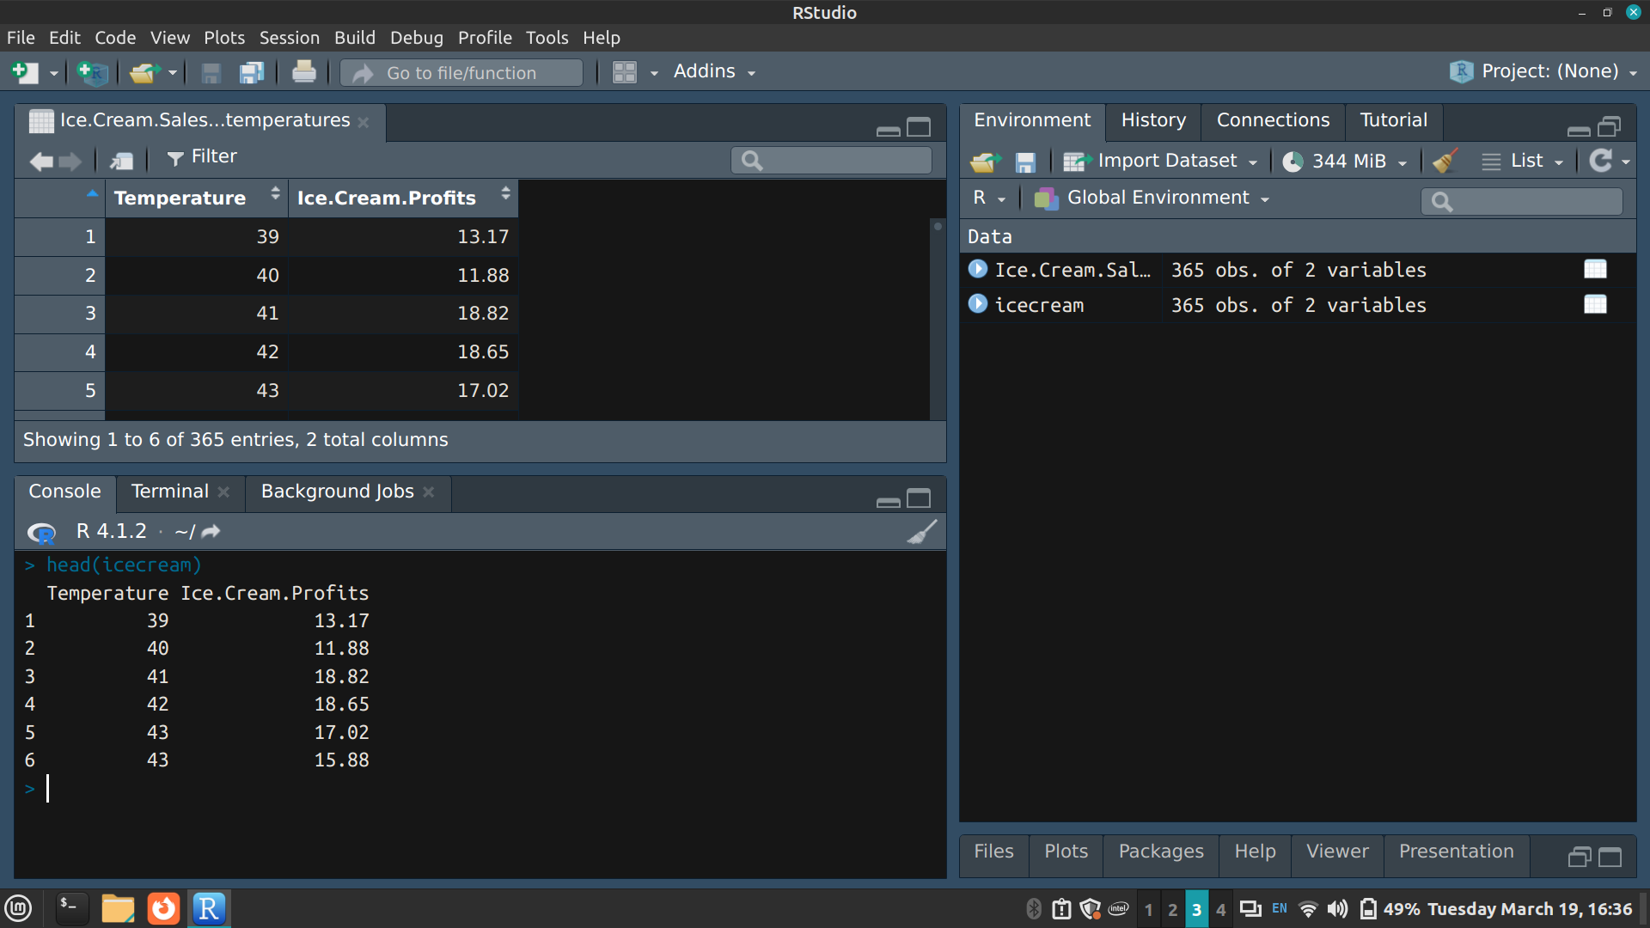
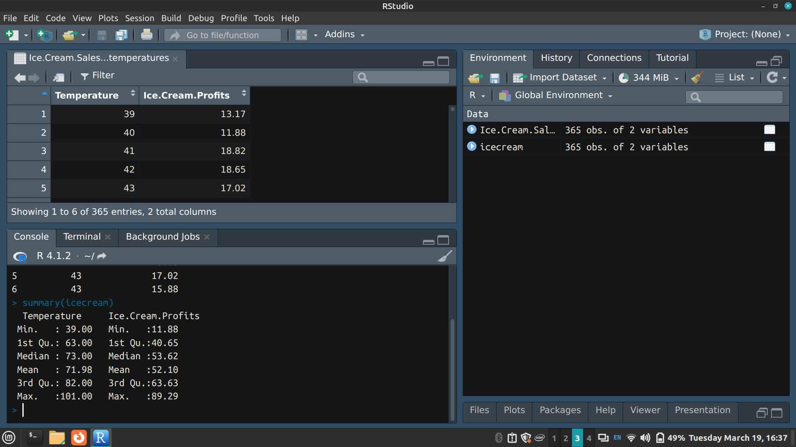

Renaming variables
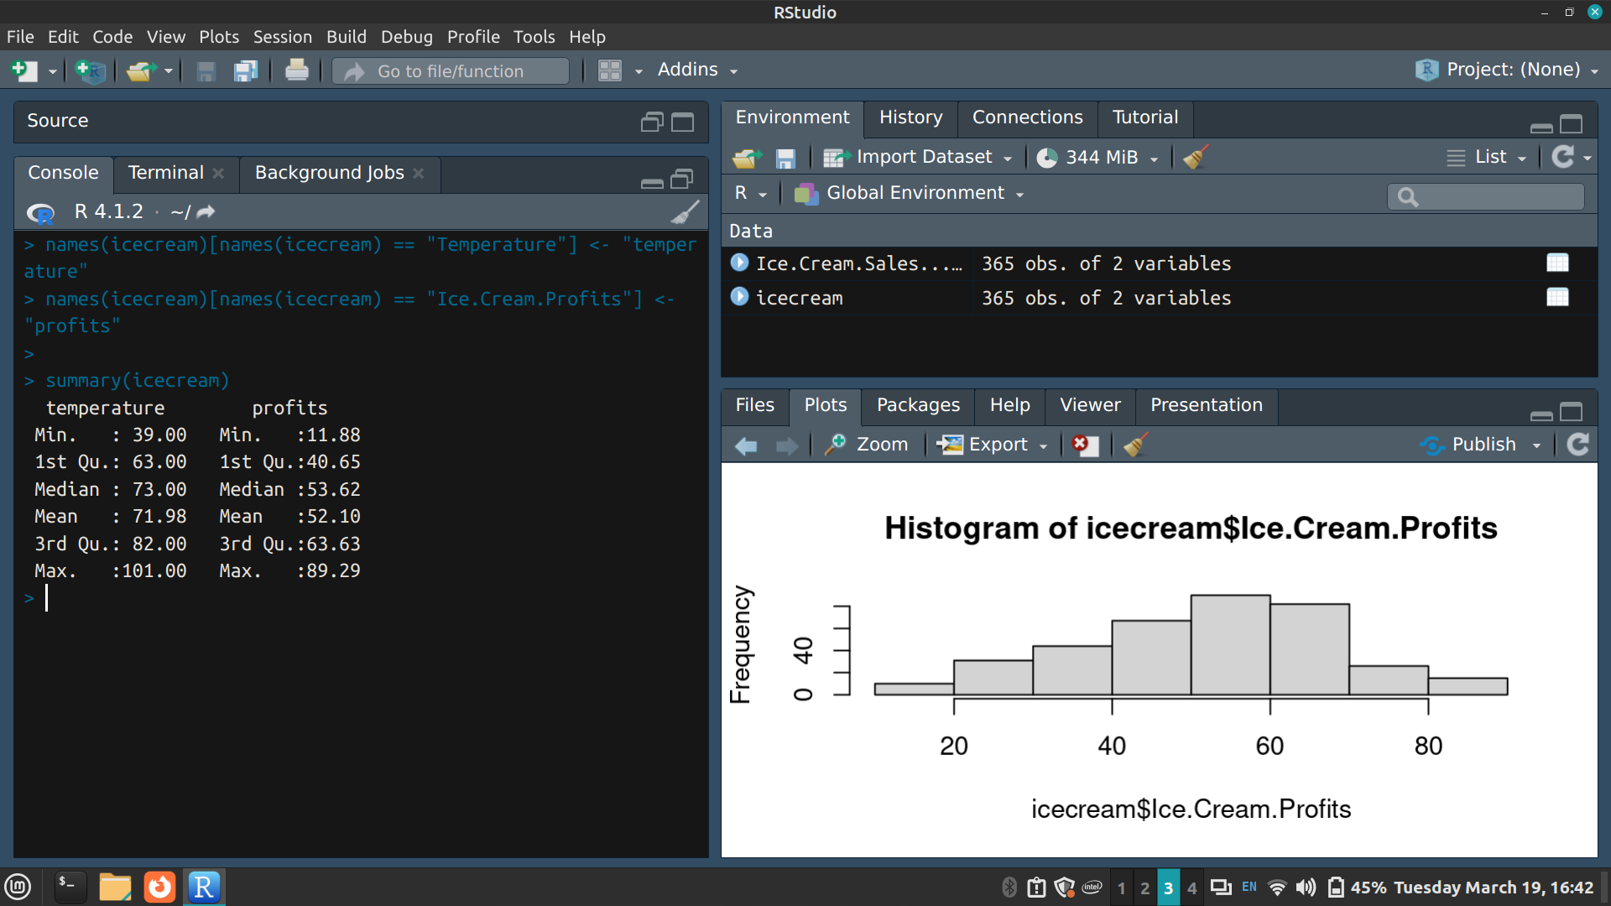

> hist(icecream$profits)
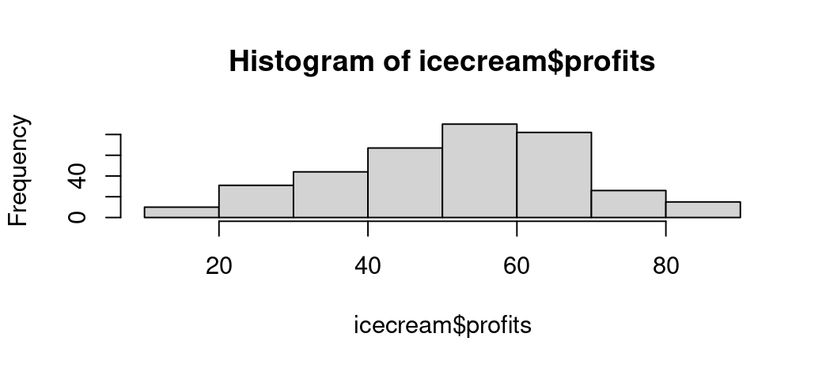
The ice cream profits roughly follow a normal distribution as it is bell-shaped

> plot(profits ~ temperature, data = icecream)
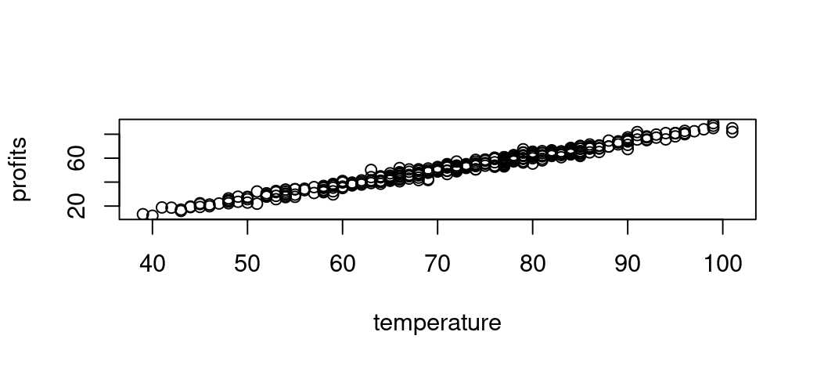
The relationship between profits and temperature looks roughly linear

> temperature.profits.lm <- lm(profits ~ temperature, data = icecream)
> summary(temperature.profits.lm)
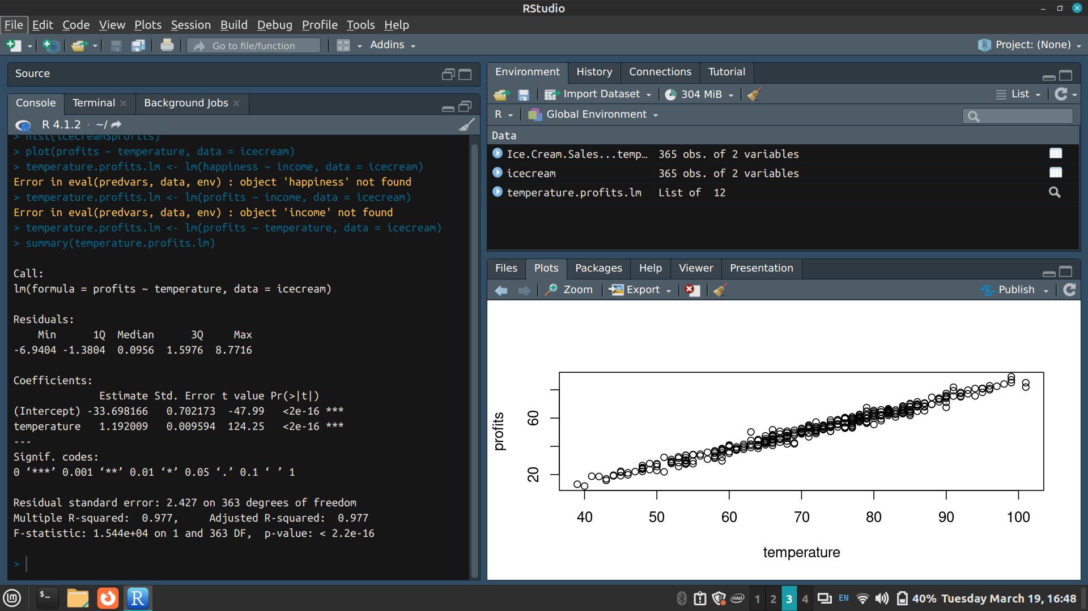
p-value: < 2.2e-16
Hence the model fits the data well

And there is a significant positive relationship between temperature and ice cream profits with a 1.192009 increase in profits for every unit increase in temperature

> plot(temperature.profits.lm)
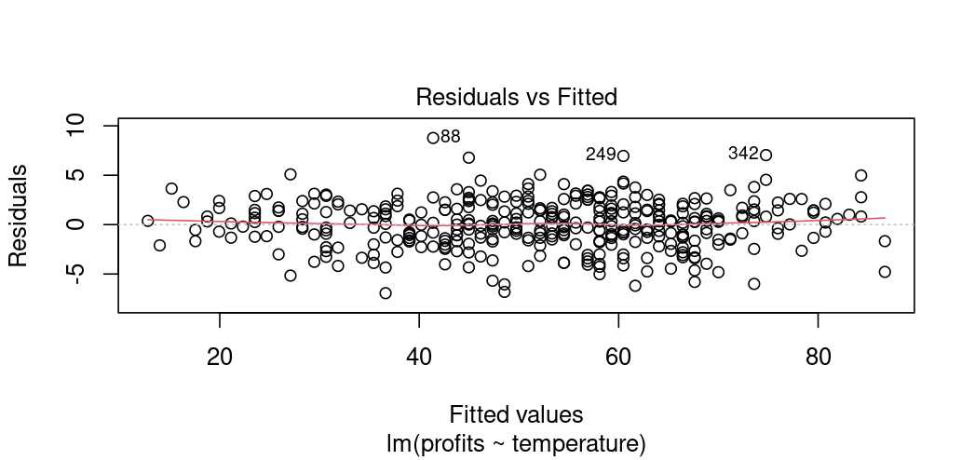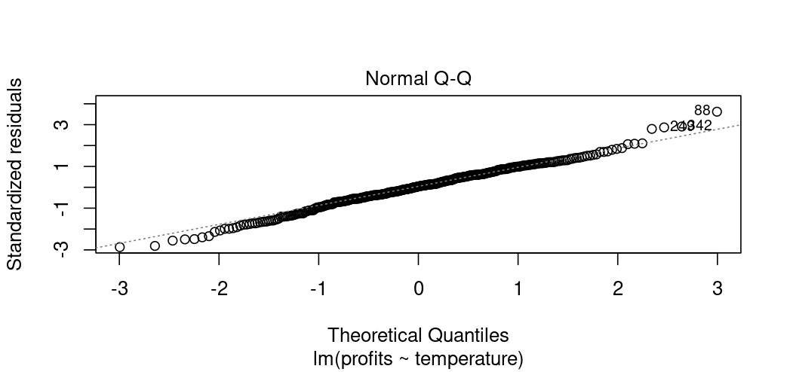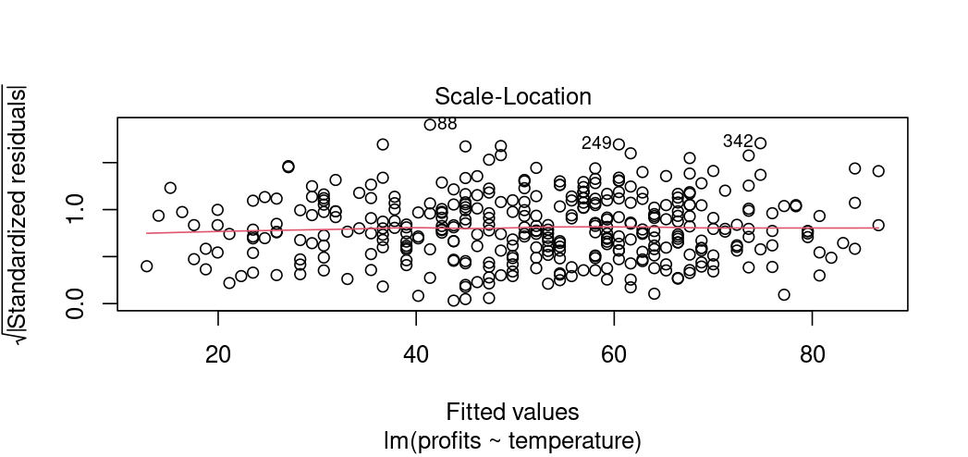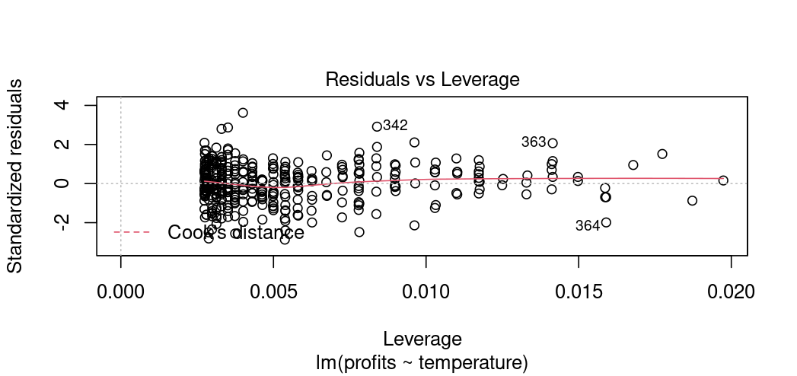
The normal Q-Q plot forms an almost perfectly one to one line with the theoretical residuals from a perfect model
Hence, our model meets the assumption of homoscedasticity

> icecream.graph <- ggplot(icecream, aes(x=temperature, y=profits)) + geom_point()
> icecream.graph
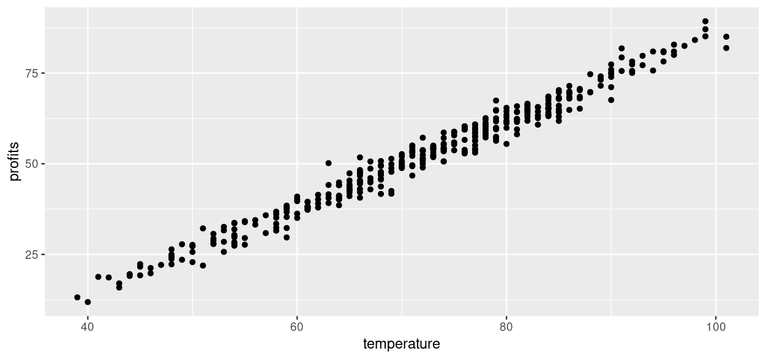

> icecream.graph <- icecream.graph + geom_smooth(method="lm", col="black")
> icecream.graph
`geom_smooth()` using formula = 'y ~ x'
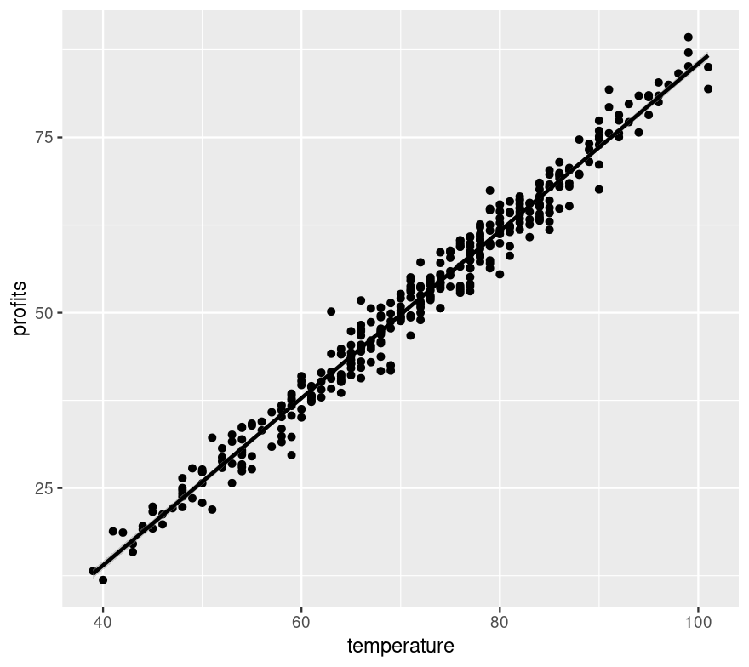

> icecream.graph<-ggplot(data = icecream, aes(x = temperature, y = profits)) +
+ stat_poly_line() +
+ stat_poly_eq(use_label(c("eq", "R2"))) +
+ geom_point()
> icecream.graph
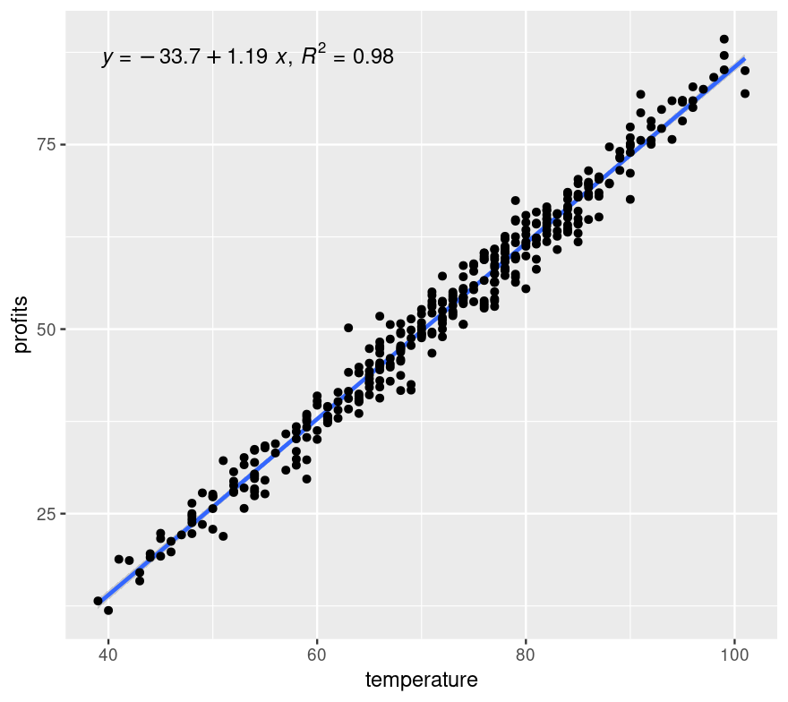

> icecream.graph <- icecream.graph + theme_light() + labs(title = "ice cream profits as a function of temperature")
> icecream.graph
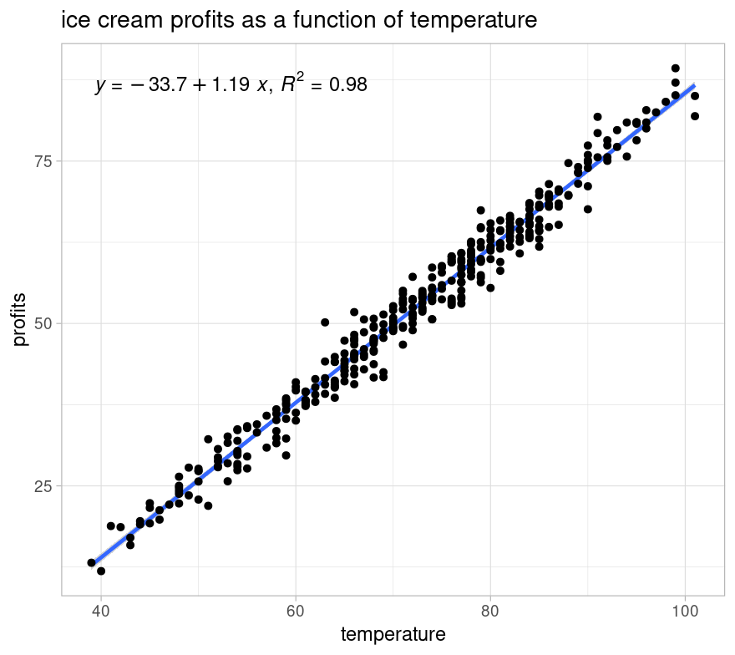

MULTIPLE LINEAR REGRESSION

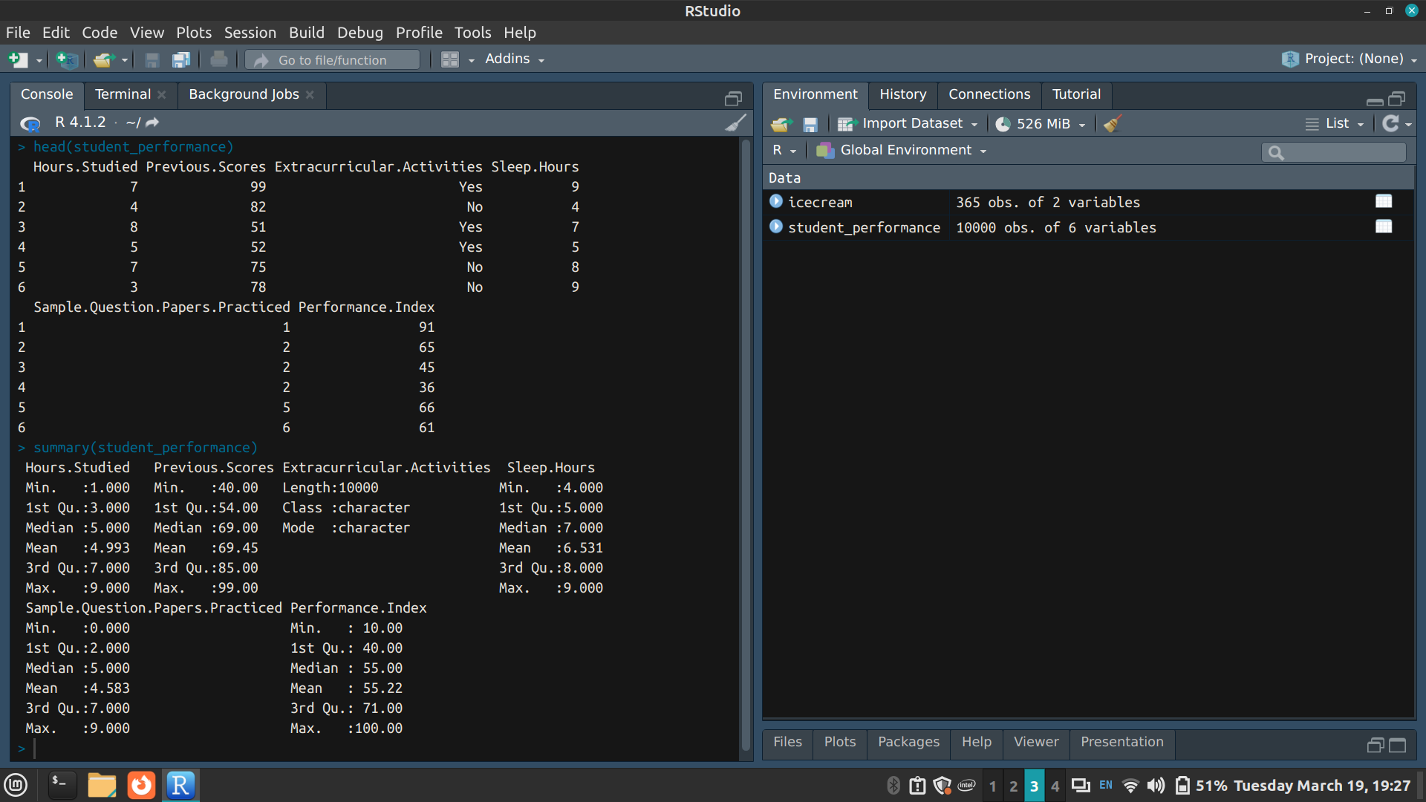

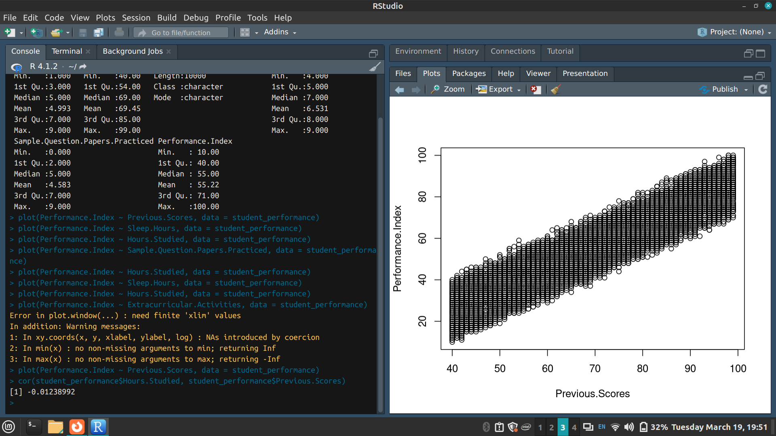
There is no autocorrelation between the 2 independent variables

> hist(student_performance$Performance.Index)
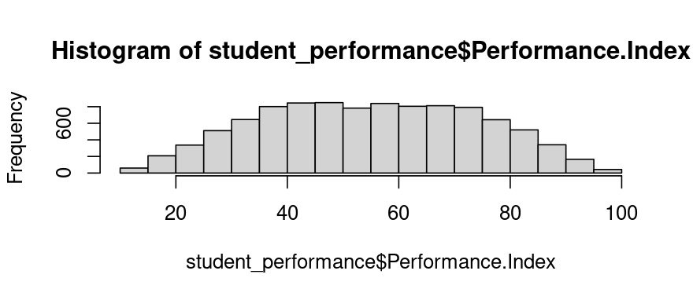
The performance index of students roughly follow a normal distribution as it is bell-shaped

> plot(Performance.Index ~ Previous.Scores, data = student_performance)
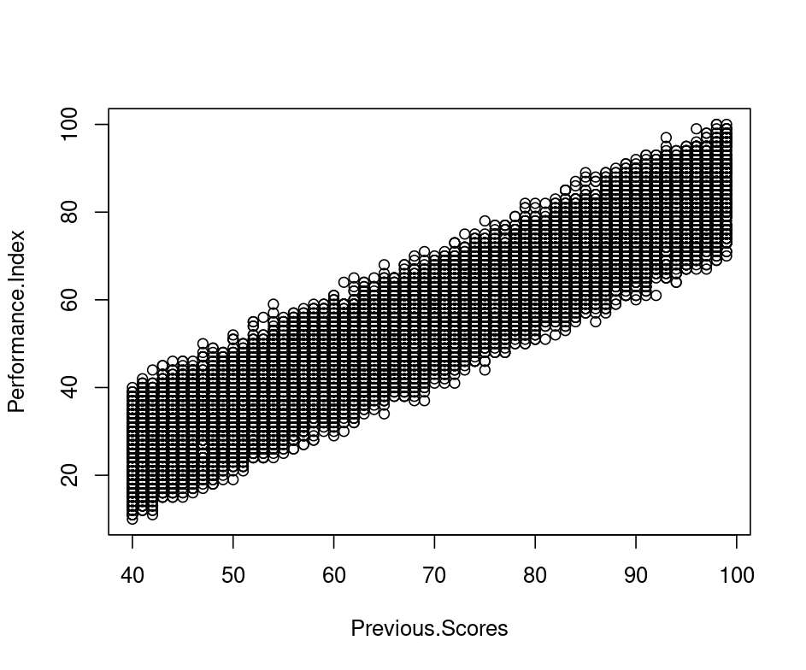

> plot(Performance.Index ~ Hours.Studied, data = student_performance)
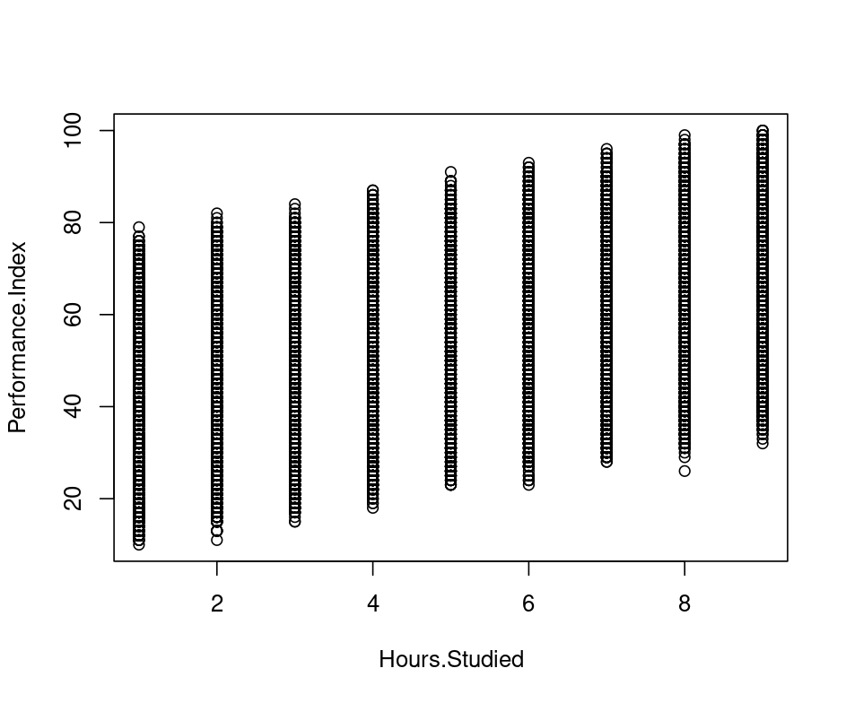

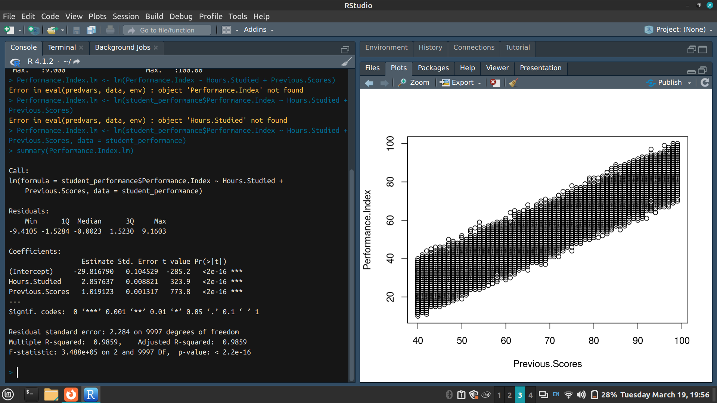
The estimated effect of previous scores on the performance index is 1.019123
And the estimated effect of the number of hours studied on the performance index is 2.857637

p-value: < 2.2e-16
Hence the model fits the data well

> plot(Performance.Index.lm)
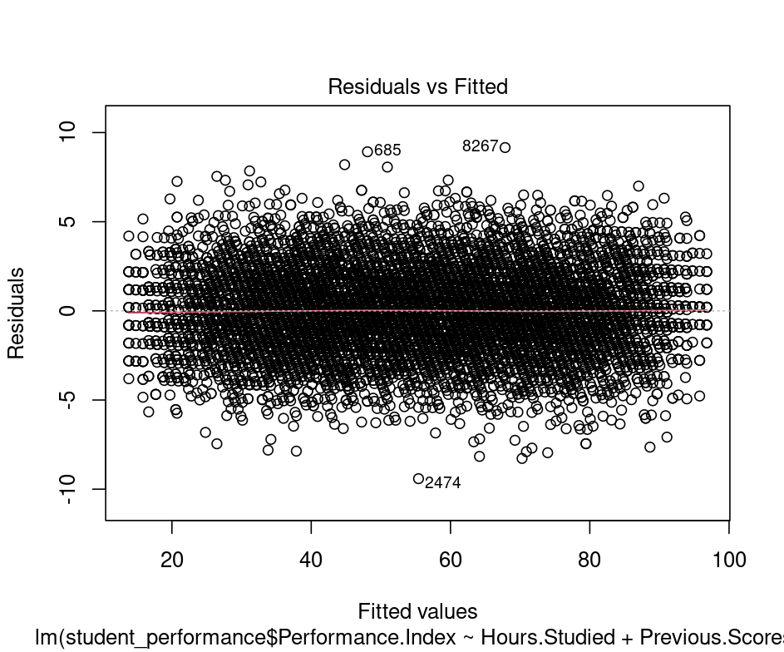
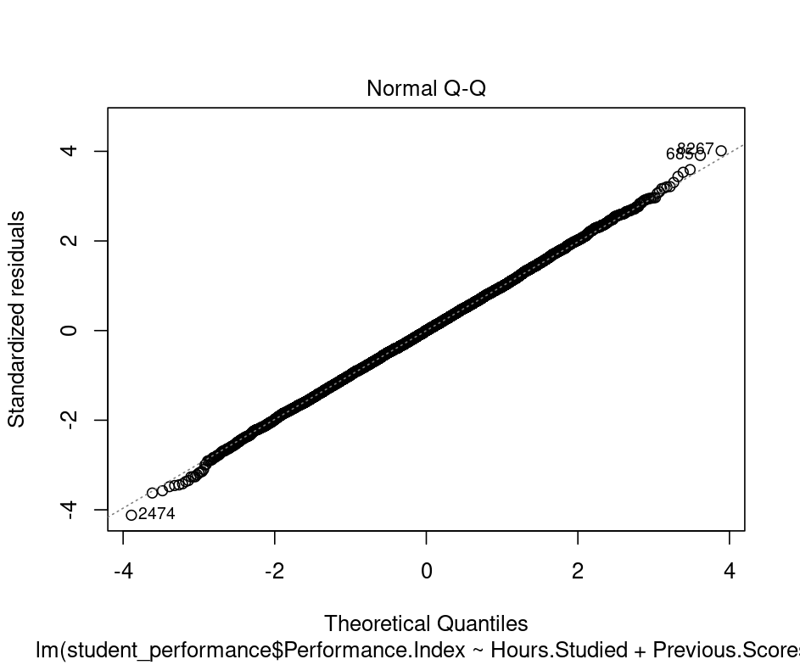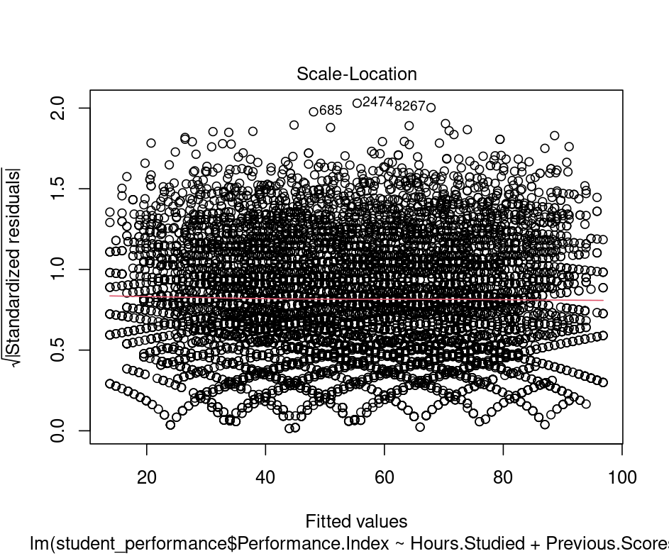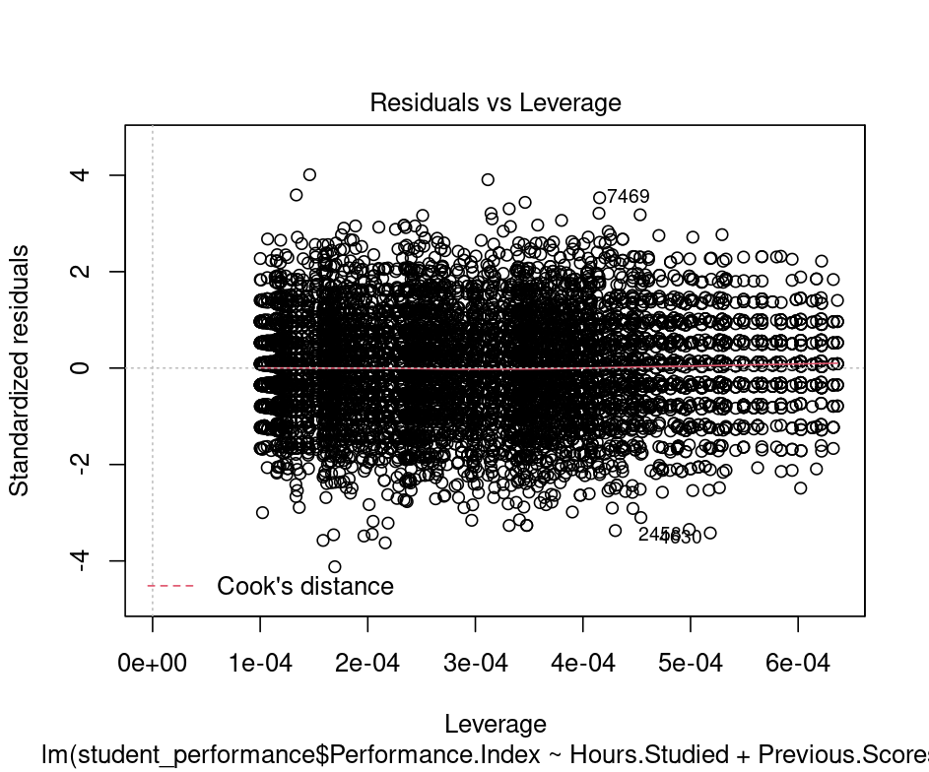
The normal Q-Q plot forms an almost perfectly one to one line with the theoretical residuals from a perfect model
Hence, our model meets the assumption of homoscedasticity

> predicted <- predict(Performance.Index.lm)
> plot(student_performance$Performance.Index ~ predicted, col="blue", pch=16, xlab="Predicted Performance.Index", ylab="Observed Performance.Index")
> abline(lm(student_performance$Performance.Index ~ predicted), col="red")
> legend("topleft", legend=c("Observed", "Predicted"), col=c("blue", "red"), pch=c(16, NA), lty=c(NA, 1))
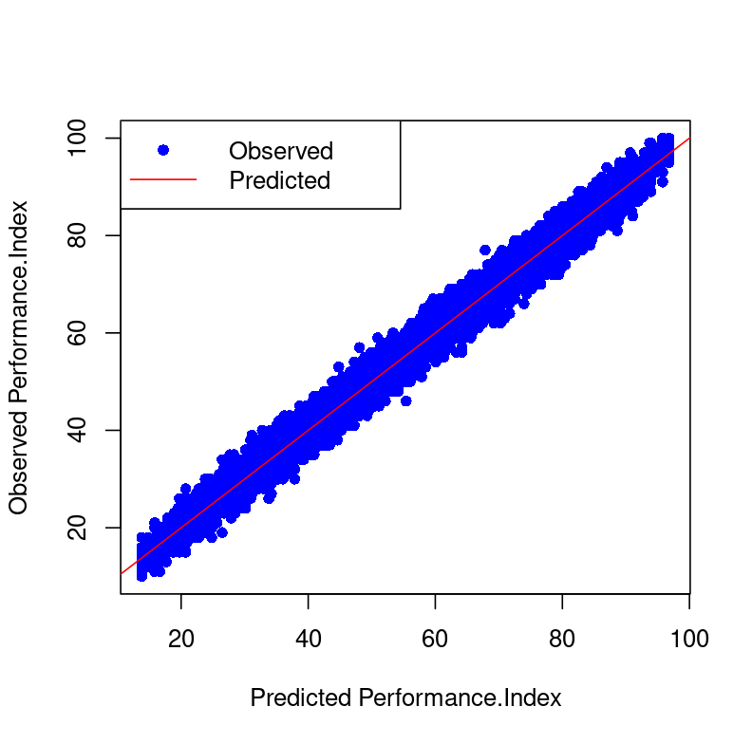

Description of the dataset used in the implementation (Data Dictionary)

The Student Performance Dataset is a dataset designed to examine the factors influencing academic student performance. The dataset consists of 10,000 student records, with each record containing information about various predictors and a performance index.

Variables:
- Hours Studied: The total number of hours spent studying by each student.
- Previous Scores: The scores obtained by students in previous tests.
- Extracurricular Activities: Whether the student participates in extracurricular activities (Yes or No).
- Sleep Hours: The average number of hours of sleep the student had per day.
- Sample Question Papers Practiced: The number of sample question papers the student practiced.
Target Variable:
- Performance Index: A measure of the overall performance of each student. The performance index represents the student's academic performance and has been rounded to the nearest integer. The index ranges from 10 to 100, with higher values indicating better performance.

The Temperature and Ice Cream Sales Dataset has 2 variables
Temperature in Fahrenheit
Profits in USD

Identify the suitable attributes and perform the following steps for simple and multiple linear regression. Explain your implementation and output screenshots

- Select and load the dataset
- Find and remove the outliers.
- Build the linear model
- Checking the quality of the model by performing the linear regression analysis.
- Find predicted values and plot the regression lines
- Refine the model if necessary

Conclusion:
Successfully performed simple linear regression on the Temperature and Ice Cream Sales dataset and multiple linear regression on the Student Performance Dataset.
Post lab:

- Based on the image given below, a model was built with an objective to predict the salary of an individual based on the years of experience. From the given output, what does the p-value indicate with respect to hypothesis testing?

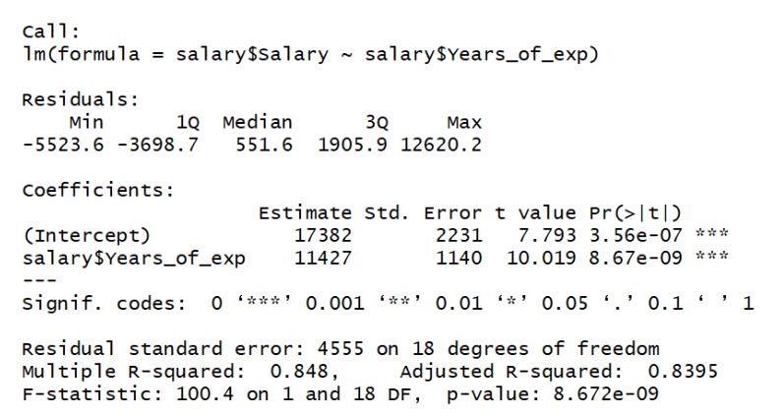

Select ones which are appropriate
- The model failed to reject the null hypothesis
- There is a strong evidence of a relationship between salary and years of experience
- There is a strong evidence that there is no relationship between salary and years of experience
- The null hypothesis can be rejected

Read the dataset auto.csv and answer the questions 2 to 4 based on the same. The dataset contains the weight and fuel consumption details of different cars.
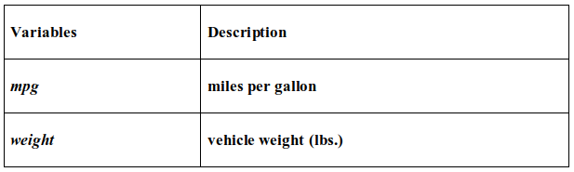

The objective of the problem is to predict mpg (miles per gallon) using weight of the vehicle.

2. The adjusted R² for the linear model is ___
- 0.87
- 0.77
- 0.97
- None of the above

3. The third quartile residual value for the linear model built is ___
- -1.91
- -7.21
- -0.08
- 1.73

4. The t value corresponding to the coefficient of weight is ___
- 62.77
- -31.71
- 40.56
- None of the above
5. Standardised residuals have:
- binomial distribution with n degrees of freedom
- t distribution with n-2 degrees of freedom
- log-normal distribution with n-2 degrees of freedom
- chi-square distribution with n degrees of freedom

6. The higher the value of R for a model, the observations are more closely grouped around:
- the origin
- the best fit line
- average values of the predicted variable
- the intercept

7) Which of the following metrics can be used for evaluating regression models?
- R Squared
- Adjusted R Squared
- F Statistics
- RMSE / MSE / MAE
a) All
b) None
c) I, IV
d) I, II, III

