Batch: H2-1 Roll No.: 16010122158

Experiment No. 9

Title : To implement data scraping using Selenium/ ScraPy

Aim: To perform testing using web scrapers in Python

Expected Outcome of Experiment:
CO2: Application of Exploratory data analysis (EDA) on Real world problems.

Books/ Journals/ Websites referred:
1. https://realpython.com/python-web-scraping-practical-introduction/

Web Scraping:
Web scraping is the process of collecting and parsing raw data from the Web.
Web scraping is an automated method used to extract large amounts of data from websites. The data on the websites are unstructured.
Web scraping helps collect these unstructured data and store it in a structured form. There are different ways to scrape websites such as online Services, APIs or writing your own code.
Why is Web Scraping Used?
• Price Comparison: Services such as ParseHub use web scraping to collect data from online shopping websites and use it to compare the prices of products.
• Email address gathering: Many companies that use email as a medium for marketing, use web scraping to collect email ID and then send bulk emails.
• Social Media Scraping: Web scraping is used to collect data from Social Media websites such as Twitter to find out what’s trending.
• Research and Development: Web scraping is used to collect a large set of data (Statistics, General Information, Temperature, etc.) from websites, which are analyzed and used to carry out Surveys or for R&D.
• Job listings: Details regarding job openings, interviews are collected from different websites and then listed in one place so that it is easily accessible to the user.
Why is Python Good for Web Scraping?
• Here is the list of features of Python which makes it more suitable for web scraping.
• Ease of Use: Python is simple to code. You do not have to add semi-colons “;” or curly-braces “{}” anywhere. This makes it less messy and easy to use.
• Large Collection of Libraries: Python has a huge collection of libraries such as Numpy, Matlplotlib, Pandas etc., which provides methods and services for various purposes. Hence, it is suitable for web scraping and for further manipulation of extracted data.
• Dynamically typed: In Python, you don’t have to define data types for variables, you can directly use the variables wherever required. This saves time and makes your job faster.
How Do You Scrape Data From A Website?
• When you run the code for web scraping, a request is sent to the URL that you have mentioned. As a response to the request, the server sends the data and allows you to read the HTML or XML page. The code then parses the HTML or XML page, finds the data and extracts it.
• To extract data using web scraping with python, you need to follow these basic steps:
- Find the URL that you want to scrape
- Inspecting the Page
- Find the data you want to extract
- Write the code
- Run the code and extract the data
- Store the data in the required format
Libraries used for Web Scraping
- Selenium: Selenium is a web testing library. It is used to automate browser activities.
- BeautifulSoup: Beautiful Soup is a Python package for parsing HTML and XML documents. It creates parse trees that is helpful to extract the data easily.
- Pandas: Pandas is a library used for data manipulation and analysis. It is used to extract the data and store it in the desired format.

Scraping Implementation 1:
import bs4
from bs4 import BeautifulSoup as bs import requests

link='https://www.flipkart.com/search?q=tv&as=on&as- show=on&otracker=AS_Query_TrendingAutoSuggest_8_0_na_na_na&otracker 1=AS_Query_TrendingAutoSuggest_8_0_na_na_na&as-pos=8&as- type=TRENDING&suggestionId=tv&requestId=9c9fa553-b7e5-454b-a65b- bbb7a9c74a29'

page=requests.get(link)
page.content

soup=bs(page.content, 'html.parser')
# print(soup.prettify())

#extract name of product
name=soup.find('div',class_="_4rR01T")
print(name.text)

#extract rating of product
rating=soup.find('div',class_="_3LWZlK")
print(rating.text)

#extracting other details
details=soup.find('div',class_="fMghEO")
print(details.text)

#to get all details seperately
for each in details:
spec=each.find_all('li',class_='rgWa7D')
print(spec[0].text)
print(spec[1].text)
print(spec[2].text)
print(spec[4].text)
print(spec[5].text)
print(spec[7].text)

#extract price of the product
price=soup.find('div',class_='_30jeq3 _1_WHN1')
print(price.text)

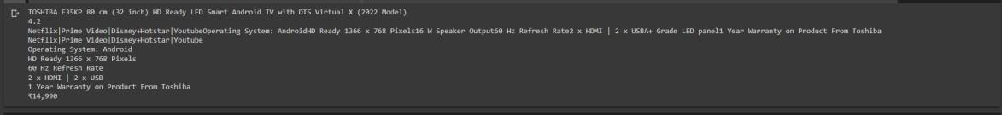

import bs4
from bs4 import BeautifulSoup as bs
import requests
import pandas as pd
link='https://www.flipkart.com/search?q=tv&as=on&as-show=on&otracker=AS_Query_TrendingAutoSuggest_8_0_na_na_na&otracker
1=AS_Query_TrendingAutoSuggest_8_0_na_na_na&as-pos=8&as-type=TRENDING&suggestionId=tv&requestId=9c9fa553-b7e5-454b-a65b-bbb7a9c74a29'
page=requests.get(link)
page.content
soup=bs(page.content, 'html.parser')
# print(soup.prettify())
products=[] #List to store the name of the product
prices=[] #List to store price of the product
ratings=[] #List to store rating of the product
apps = [] #List to store supported apps

os = [] #List to store operating system
hd = [] #List to store resolution
sound = [] #List to store sound output
for data in soup.findAll('div',class_='_3pLy-c row'):
names=data.find('div', attrs={'class':'_4rR01T'})
price=data.find('div', attrs={'class':'_30jeq3 _1_WHN1'})
rating=data.find('div', attrs={'class':'_3LWZlK'})
specification = data.find('div', attrs={'class':'fMghEO'})

for each in specification:
col=each.find_all('li', attrs={'class':'rgWa7D'})
app =col[0].text
os_ = col[1].text
hd_ = col[2].text
sound_ = col[3].text
products.append(names.text) # Add product name to list
prices.append(price.text) # Add price to list
apps.append(app)# Add supported apps specifications to list
os.append(os_) # Add operating system specifications to list
hd.append(hd_) # Add resolution specifications to list
sound.append(sound_) # Add sound specifications to list
ratings.append(rating.text) #Add rating specifications tolist
#printing the length of list
print(len(products))
print(len(ratings))
print(len(prices))
print(len(apps))
print(len(sound))
print(len(os))
print(len(hd))
df=pd.DataFrame({'Product Name':products,'Supported_apps':apps,'sound_system':sound,'OS':os,"Resolution":hd,'Price':prices,'Rating':ratings})
df.head(10)

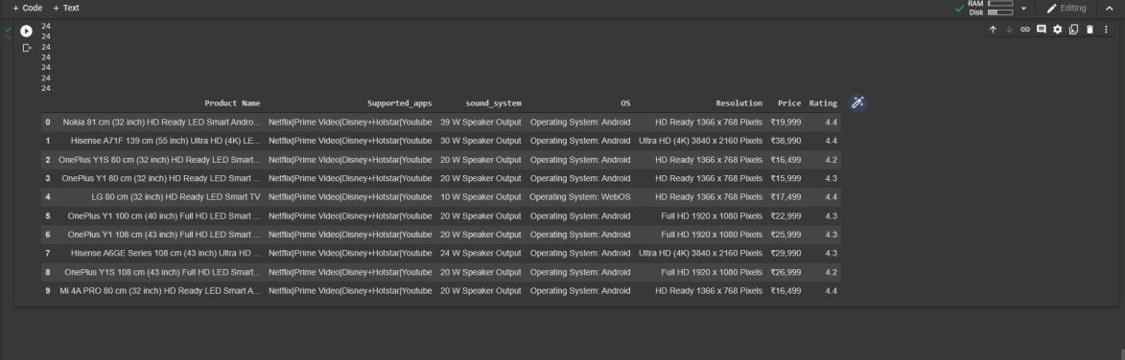

Scraping Implementation 2

Web Scraping Code

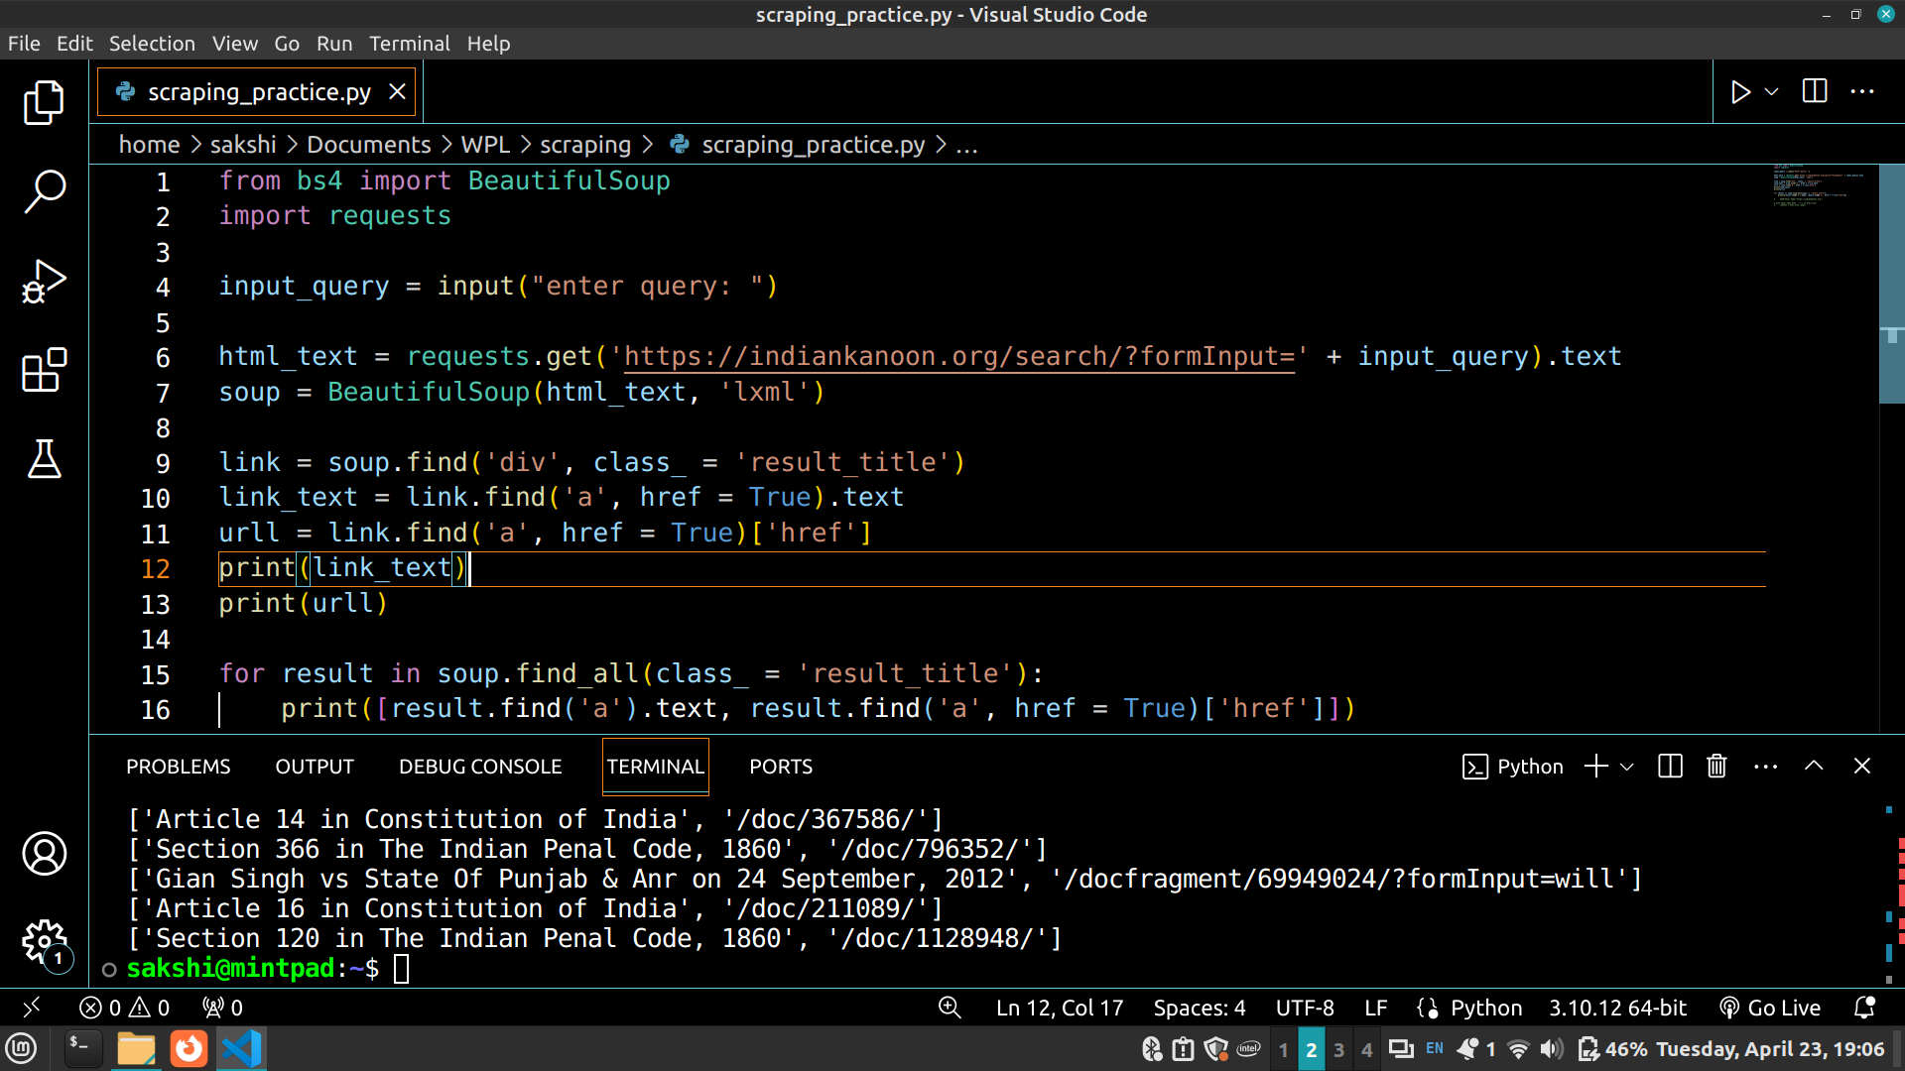
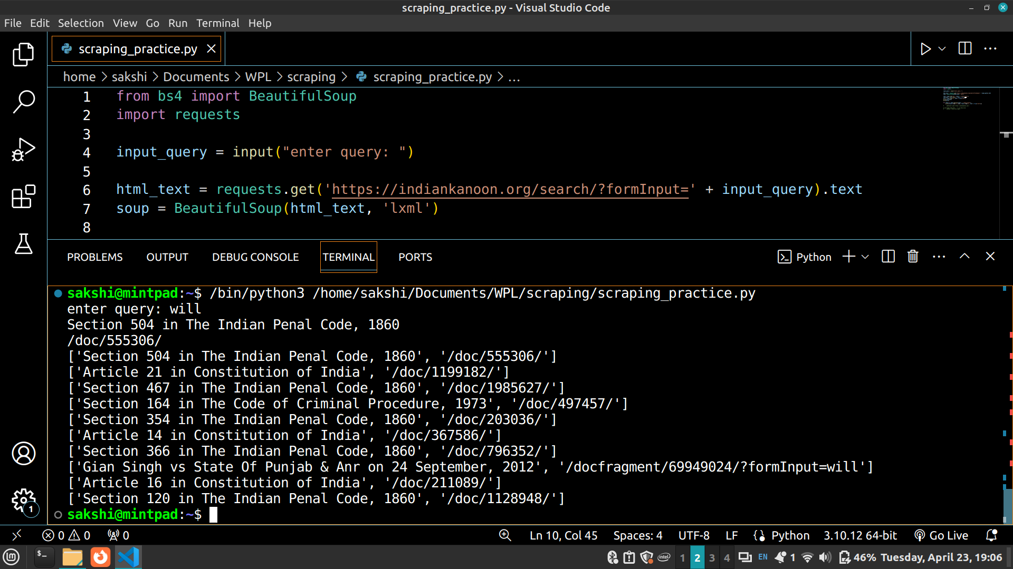
Output Screenshot

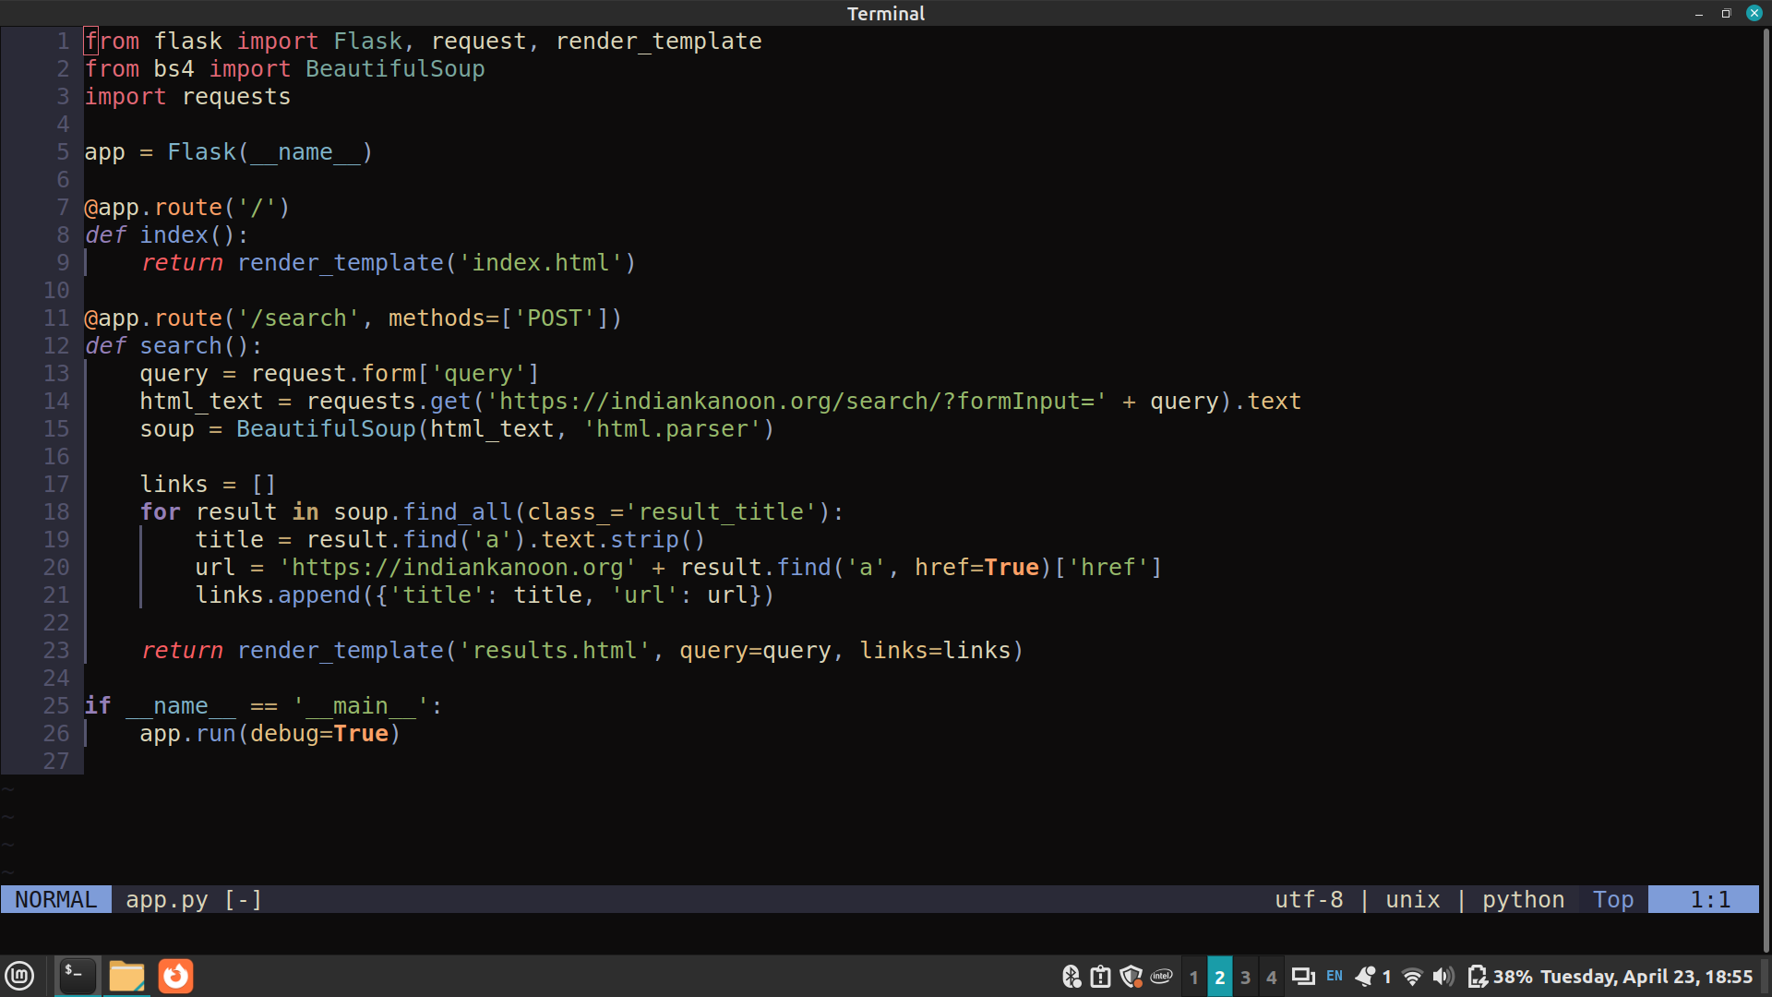
Using Flask as backend and Web Scraping

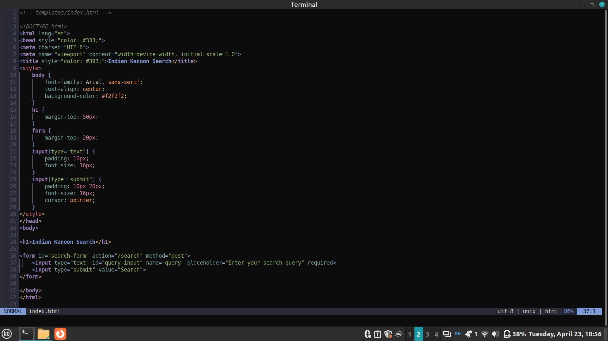
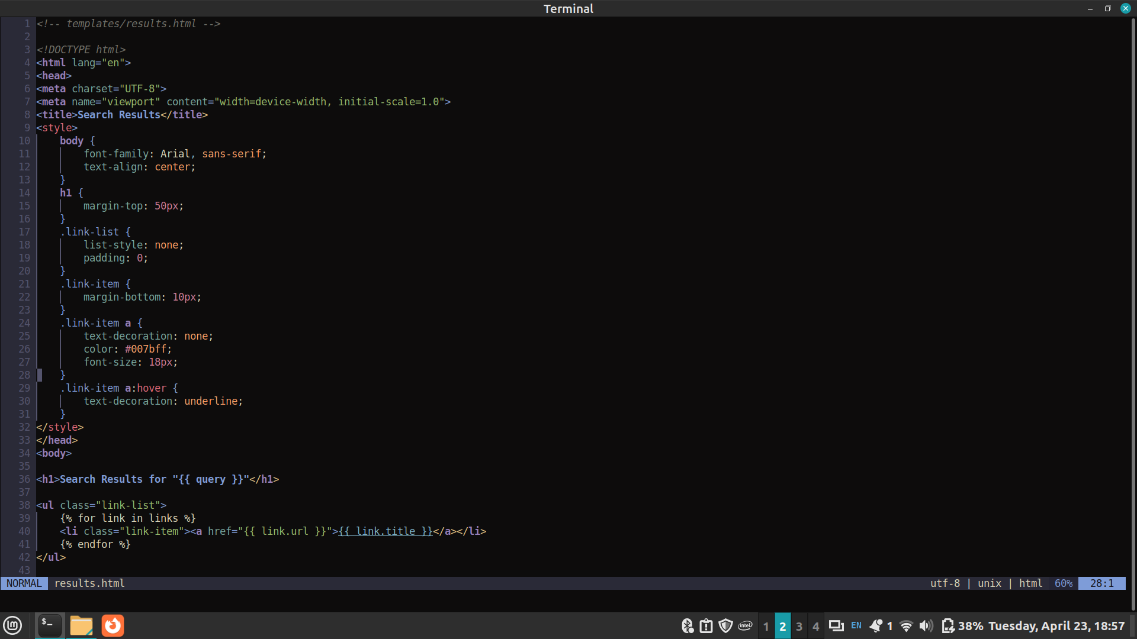
Frontend Code to view the results of scraping

Result Screenshots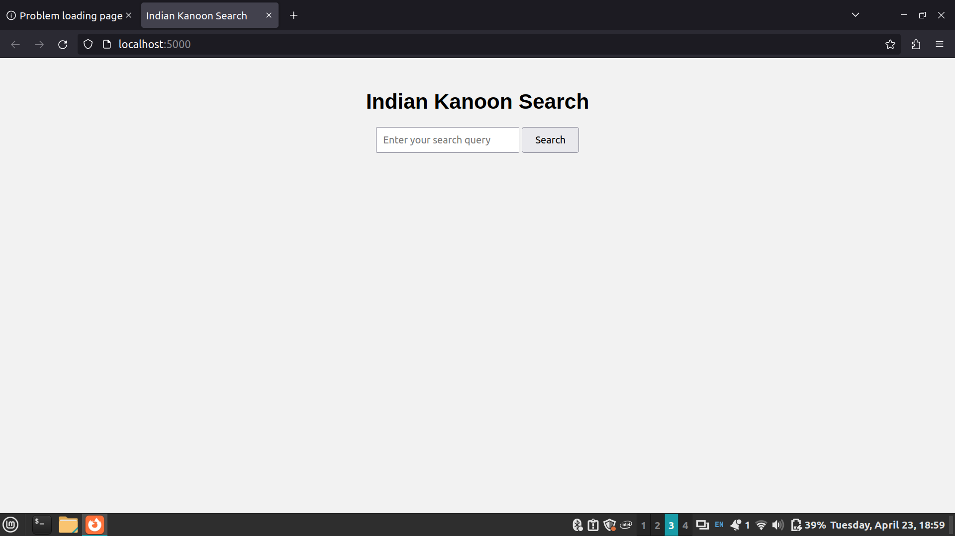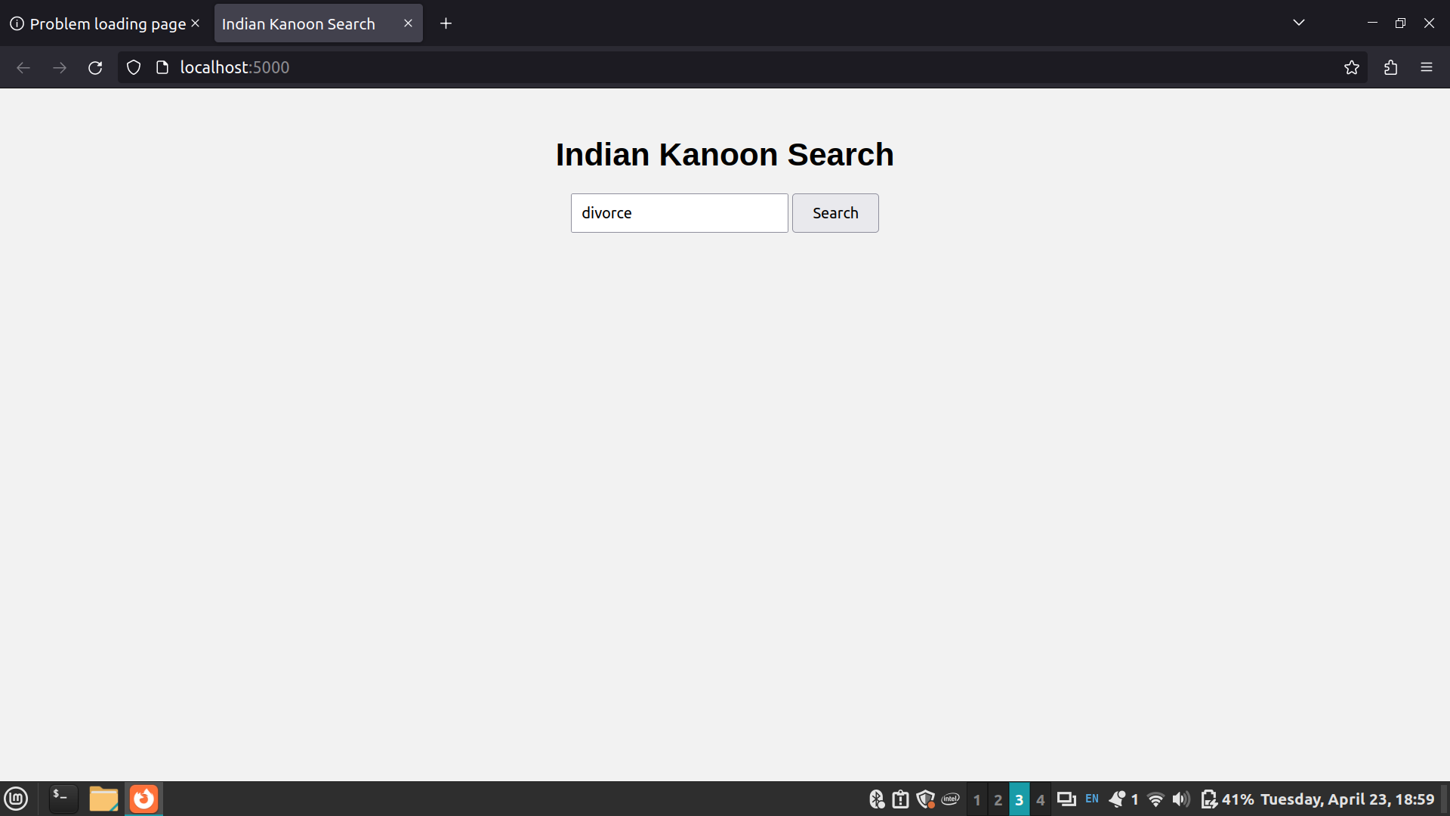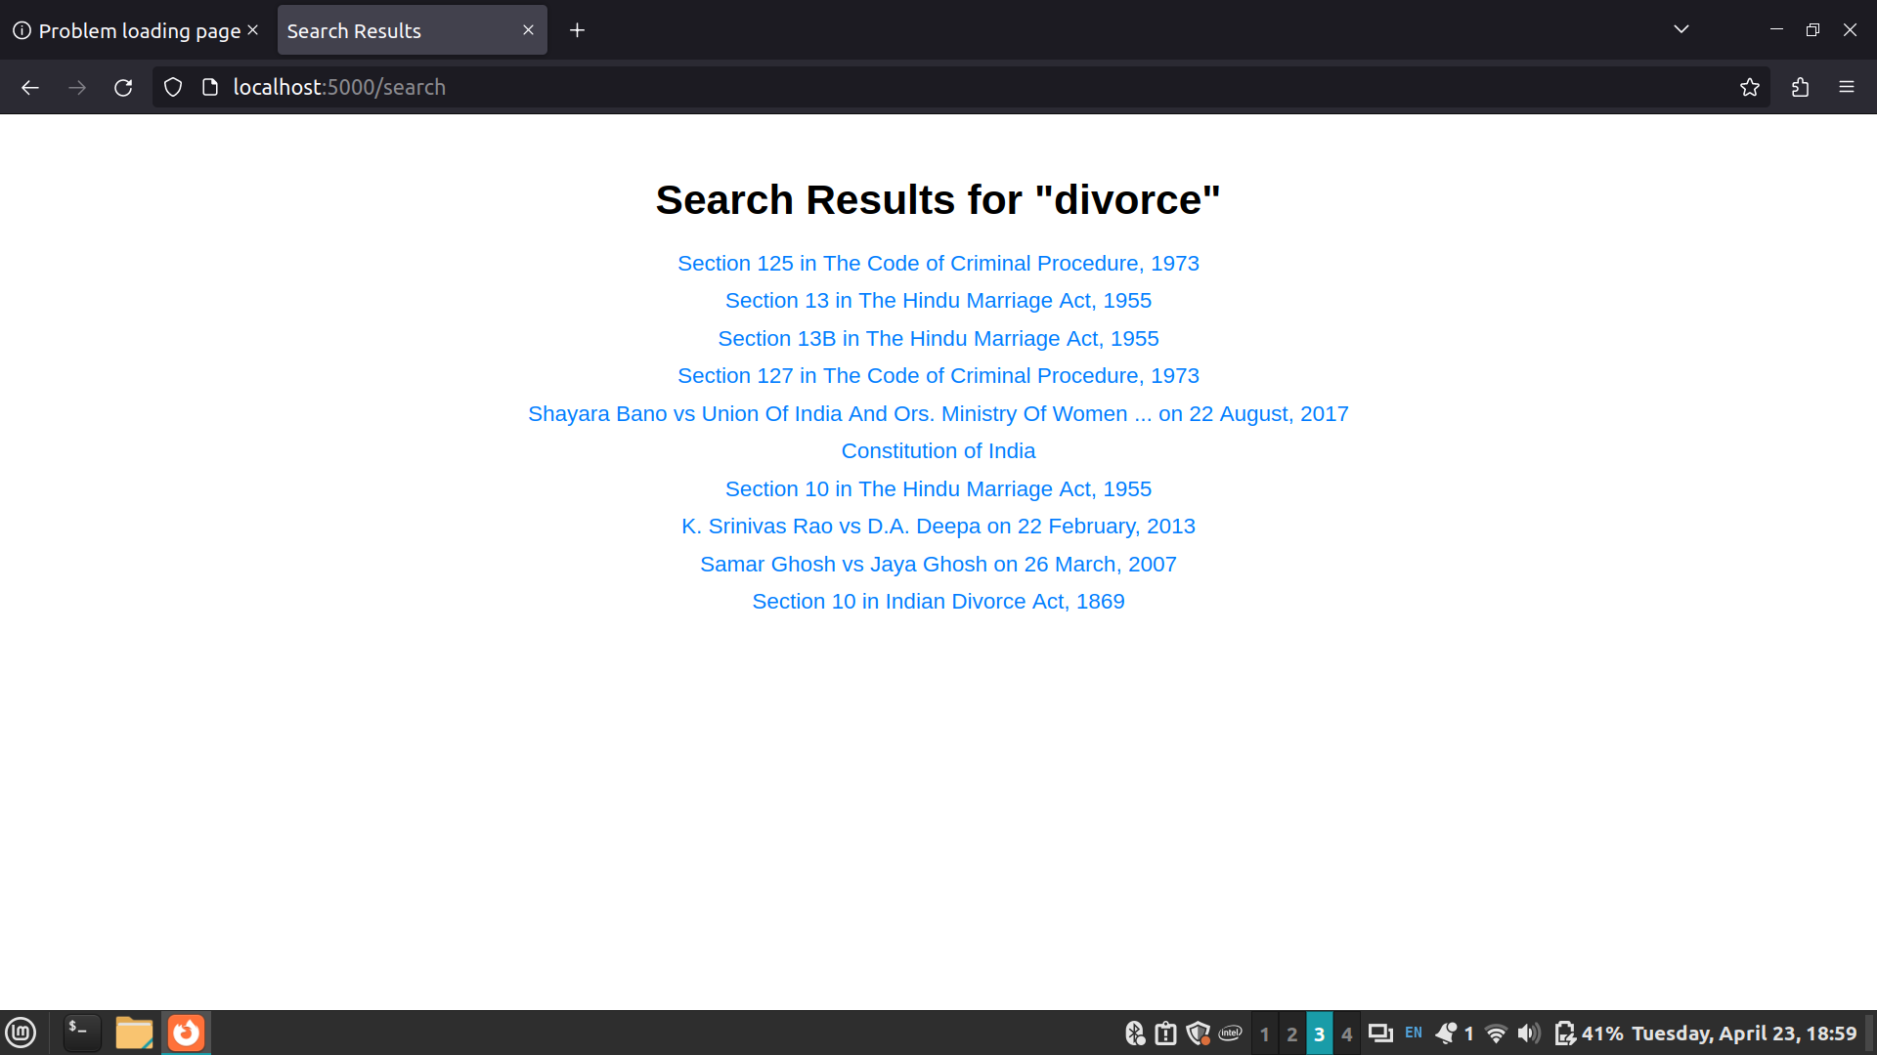

Conclusion:

That’s how we can scrape and store the data from the website. Here we have learned to scrape just one page, we can also perform the same on various pages and extract more data for comparison or analysis. The next step from here is to clean the data and perform analysis.

Post lab Questions:
- What are the different HTTP response status codes?
HTTP response status codes are standardized codes that indicate the outcome of an HTTP request. They are sent by a server in response to a client's request. Here are some of the most common HTTP response status codes:
- 1xx Informational:
- 100 Continue
- 101 Switching Protocols
- 102 Processing (WebDAV; RFC 2518)
- 2xx Success:
- 200 OK
- 201 Created
- 202 Accepted
- 204 No Content
- 206 Partial Content
- 3xx Redirection:
- 300 Multiple Choices
- 301 Moved Permanently
- 302 Found (previously "Moved Temporarily")
- 304 Not Modified
- 307 Temporary Redirect
- 308 Permanent Redirect
- 4xx Client Error:
- 400 Bad Request
- 401 Unauthorized
- 403 Forbidden
- 404 Not Found
- 405 Method Not Allowed
- 409 Conflict
- 410 Gone
- 429 Too Many Requests
- 5xx Server Error:
- 500 Internal Server Error
- 501 Not Implemented
- 502 Bad Gateway
- 503 Service Unavailable
- 504 Gateway Timeout
- 505 HTTP Version Not Supported

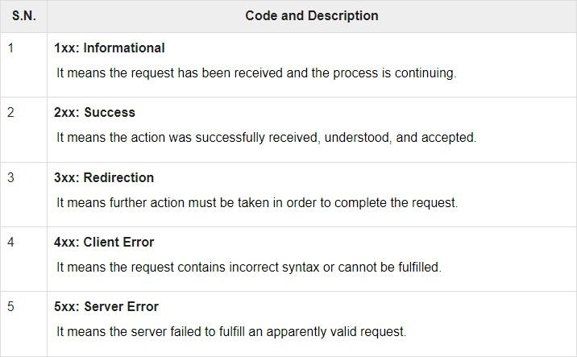
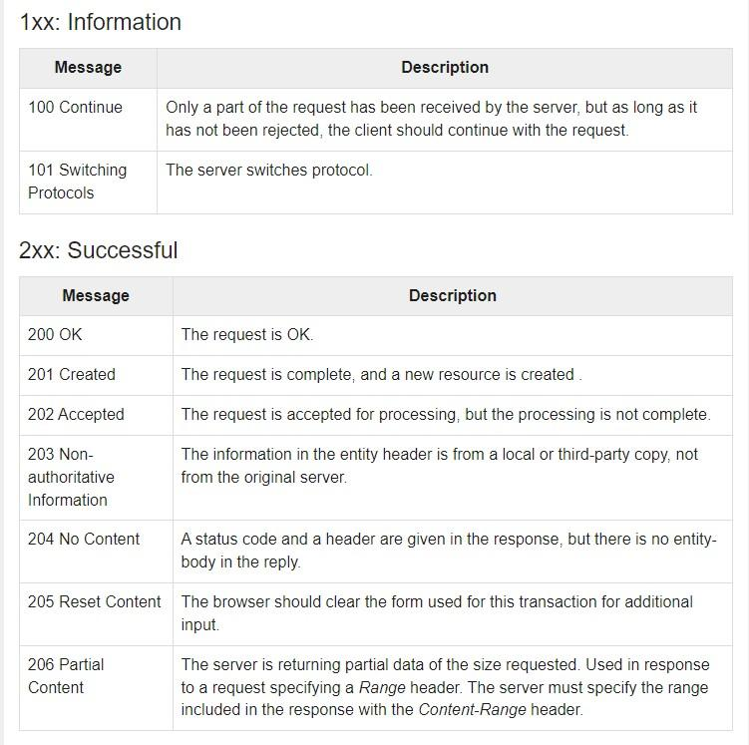
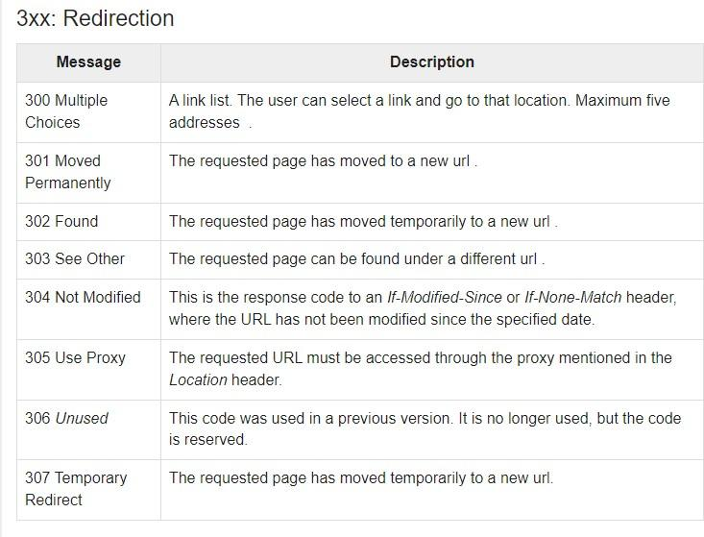
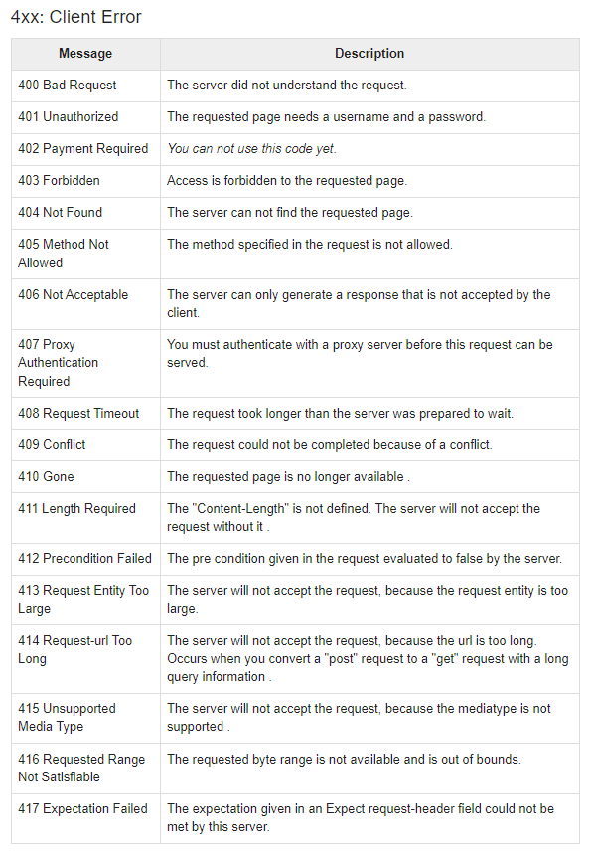

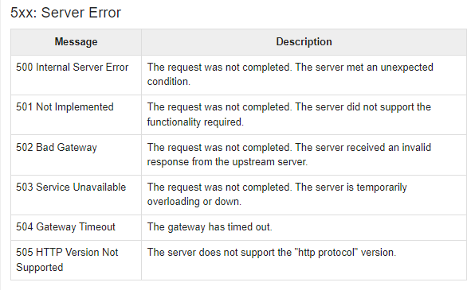
- How to get the Updated Daily News using Python
import requests
from bs4 import BeautifulSoup

url = 'https://www.bbc.com/news' response = requests.get(url)

soup = BeautifulSoup(response.text, 'html.parser') headlines = soup.find('body').find_all('h3')
unwanted = ['BBC World News TV', 'BBC World Service Radio', 'News daily newsletter', 'Mobile app', 'Get in touch']

for x in list(dict.fromkeys(headlines)): if x.text.strip() not in unwanted:
print(x.text.strip())

