Batch: A2 Roll No.: 16010122034

Experiment No. 6

Grade: AA / AB / BB / BC / CC / CD /DD

Signature of the Staff In-charge with date

Title: Implementation Matrix Chain Multiplication of Dynamic Programming

Objective: To learn Matrix chain multiplication using Dynamic Programming Approach
CO to be achieved:
CO 2 | Describe various algorithm design strategies to solve different problems and analyse Complexity.

Books/ Journals/ Websites referred:
- Ellis horowitz, Sarataj Sahni, S.Rajsekaran,” Fundamentals of computer algorithm”, University Press
- T.H.Cormen ,C.E.Leiserson,R.L.Rivest and C.Stein,” Introduction to algortihtms”,2nd Edition ,MIT press/McGraw Hill,2001
- http://www.lsi.upc.edu/~mjserna/docencia/algofib/P07/dynprog.pdf
- http://www.geeksforgeeks.org/travelling-salesman-problem-set-1/
- http://www.mafy.lut.fi/study/DiscreteOpt/tspdp.pdf
- https://class.coursera.org/algo2-2012-001/lecture/181
- http://www.quora.com/Algorithms/How-do-I-solve-the-travelling-salesman-problem-using-Dynamic-programming
- www.cse.hcmut.edu.vn/~dtanh/download/Appendix_B_2.ppt
- www.ms.unimelb.edu.au/~s620261/powerpoint/chapter9_4.ppt‎

Pre Lab/ Prior Concepts:
Data structures, Concepts of algorithm analysis

Historical Profile:
Dynamic Programming (DP) is used heavily in optimization problems (finding the maximum and the minimum of something). Applications range from financial models and operation research to biology and basic algorithm research. So the good news is that understanding DP is profitable. However, the bad news is that DP is not an algorithm or a data structure that you can memorize. It is a powerful algorithmic design technique.

New Concepts to be learned:
Application of algorithmic design strategy to any problem, dynamic Programming method of problem solving Vs other methods of problem solving, optimality of the solution, Optimal Binary Search Tree Problems and their applications

Theory:
Problem definition:
Given a sequence of N matrices, the matrix chain multiplication problem is to find the most efficient way to multiply these matrices by minimizing the number of computations involved during multiplications.

Optimal Substructure: parameterization/ select the subgroup of matrices that will result in least number of computations.
For multiplication of matrix series Ai to Aj, choose Ak such that multiplication of matrices through Ai..k and Ak+1…j will incur least number of computations for any k such that i<=k<j.
Recursive Formula:
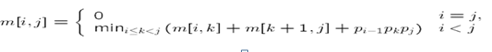
Algorithm:
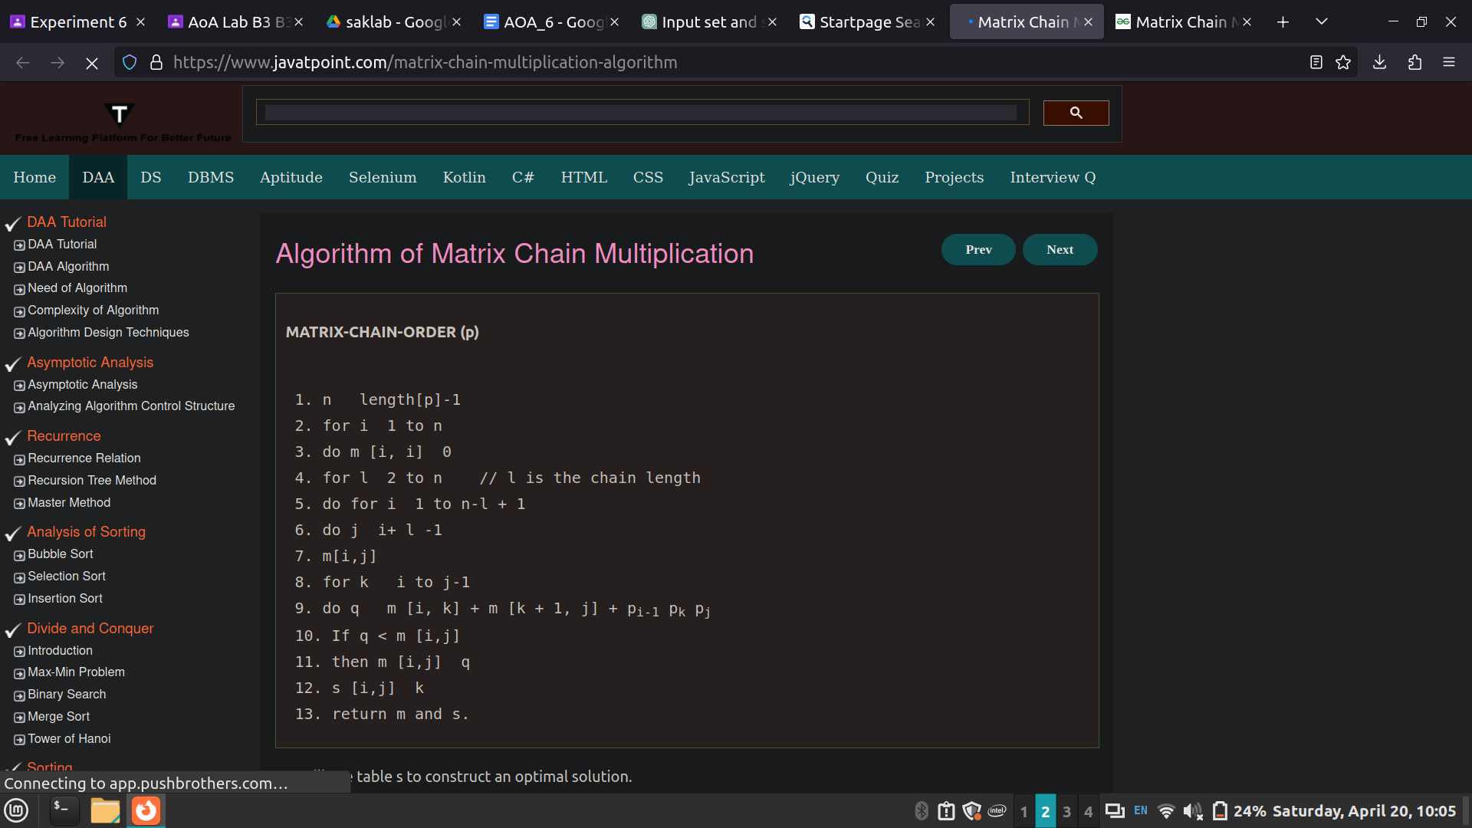
Example:
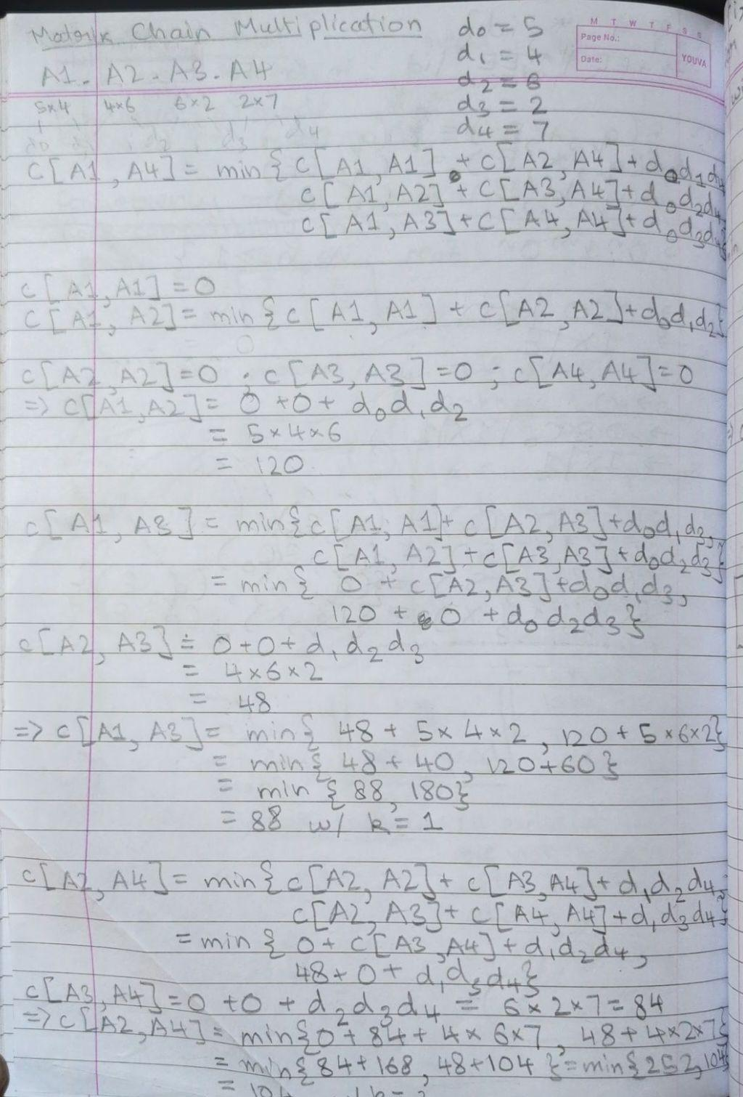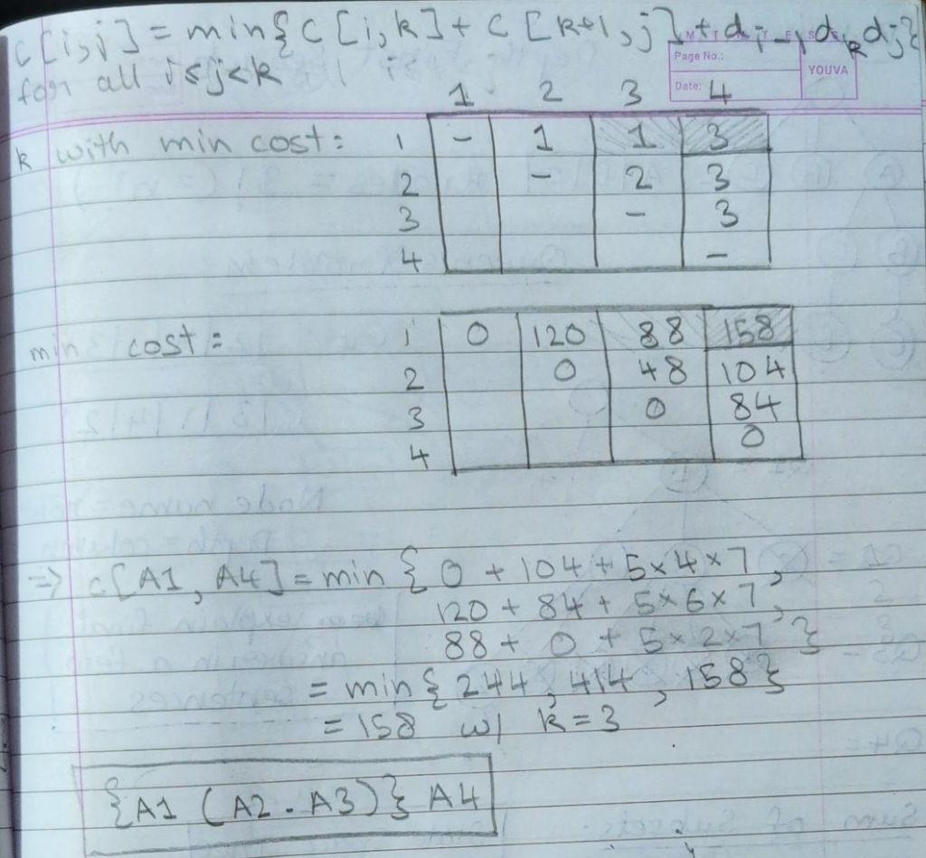

Code:

import sys

def MatrixChainOrder(p, i, j):
if i == j:
return 0

_min = sys.maxsize

for k in range(i, j):
count = (MatrixChainOrder(p, i, k)
+ MatrixChainOrder(p, k + 1, j)
+ p[i-1] * p[k] * p[j])

if count < _min:
_min = count

return _min

if __name__ == '__main__':
arr = list(map(int, input("Enter the dimensions of matrices separated by spaces: ").split()))
N = len(arr)

print("Minimum number of multiplications is ",
MatrixChainOrder(arr, 1, N-1))

Output:

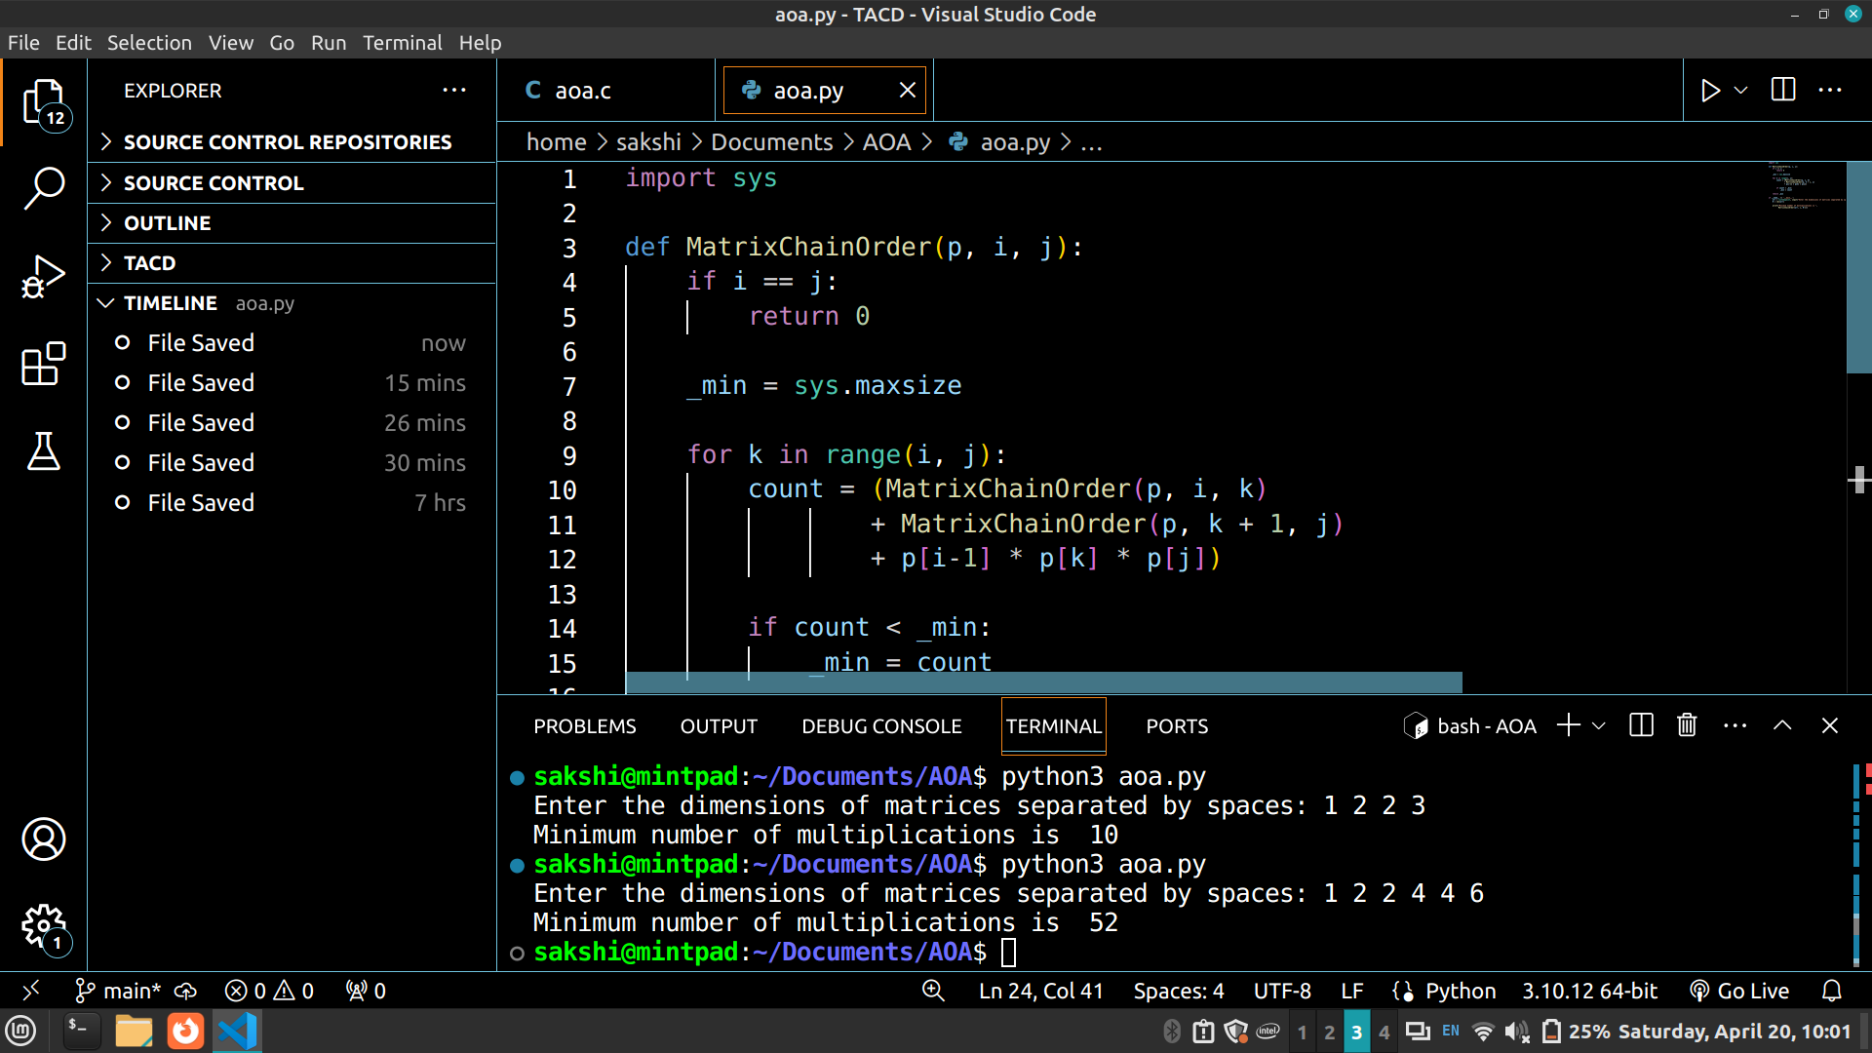


Analysis of algorithm:

Time Complexity: O(N³ )
Auxiliary Space: O(N²)

CONCLUSION:
The dynamic programming implementation efficiently solves the Matrix Chain Multiplication problem by minimizing the number of computations required for multiplying a sequence of matrices. Leveraging optimal substructure and recursive calculations, the algorithm determines the most efficient way to multiply matrices. With a time complexity of O(N^3) and auxiliary space complexity of O(N^2), it offers a polynomial-time solution suitable for a wide range of optimization problems. Understanding dynamic programming techniques is crucial for tackling various optimization challenges effectively.

