Batch: B2 Roll No.: 16010122158

Experiment No. 1

Grade: AA / AB / BB / BC / CC / CD /DD

Signature of the Staff In-charge with date

Title: Implementation of selection sort/ Insertion sort

Objective: To analyse performance of sorting methods

CO to be achieved:
CO 1 | Analyze the asymptotic running time and space complexity of algorithms.

Books/ Journals/ Websites referred:
- Ellis horowitz, Sarataj Sahni, S.Rajsekaran,” Fundamentals of computer algorithm”, University Press
- T.H.Cormen ,C.E.Leiserson,R.L.Rivest and C.Stein,” Introduction to algortihtms”,2nd Edition ,MIT press/McGraw Hill,2001
- http://en.wikipedia.org/wiki/Insertion_sort
- http://www.sorting-algorithms.com/insertion-sort
- http://www.princeton.edu/~achaney/tmve/wiki100k/docs/Insertion_sort.html
- http://www.personal.kent.edu/~rmuhamma/Algorithms/MyAlgorithms/Sorting/insertionSort.htm
- http://en.wikipedia.org/wiki/Selection_sort
- http://www.sorting-algorithms.com/selection-sort
- http://www.personal.kent.edu/~rmuhamma/Algorithms/MyAlgorithms/Sorting/selectionSort.htm
- http://courses.cs.vt.edu/~csonline/Algorithms/Lessons/SelectionCardSort/selectioncardsort.html

Pre Lab/ Prior Concepts:
Data structures, sorting techniques.

Historical Profile:
There are various methods to sort the given list. As the size of input changes, the performance of these strategies tends to differ from each other. In such case, the priori analysis can helps the engineer to choose the best algorithm.

New Concepts to be learned:
Space complexity, time complexity, size of input, order of growth.

Topic: Sorting Algorithms
Theory: Given a function to compute on n inputs the divide-and-conquer strategy suggests splitting the inputs into k distinct subsets, 1< k ≤n, yielding k sub problems. These sub problems must be solved and then a method must be found to combine sub solutions into a solution of the whole. If the sub problems are still relatively large, then the divide-and-conquer strategy can possibly be reapplied. Often the sub problems resulting from a divide-and-conquer design are the same type as the original problem. For those cases the reapplication of the divide-and- conquer principle is naturally expressed by a recursive algorithm. Now smaller and smaller sub problems of the same kind are generated until eventually sub problems that are small enough to be solved without splitting are produced.

Algorithm Insertion Sort
INSERTION_SORT (A,n)
//The algorithm takes as parameters an array A[1.. n] and the length n of the array.
//The array A is sorted in place: the numbers are rearranged within the array
// A[1..n] of eletype, n: integer
FOR j ← 2 TO length[A]
DO key ← A[j]
{Put A[j] into the sorted sequence A[1 . . j − 1]}
i ← j − 1
WHILE i > 0 and A[i] > key
DO A[i +1] ← A[i]
i ← i − 1
A[i + 1] ← key

Algorithm Selection Sort

SELECTION_SORT (A,n)
//The algorithm takes as parameters an array A[1.. n] and the length n of the array.
//The array A is sorted in place: the numbers are rearranged within the array
// A[1..n] of eletype, n: integer
FOR i ← 1 TO n-1 DO
min j ← i;
min x ← A[i]
FOR j ← i + 1 to n do
IF A[j] < min x then
min j ← j
min x ← A[j]
A[min j] ← A [i]
A[i] ← min x

1. Insertion Sort Space Complexity (O(n)): Insertion sort uses a constant amount of additional memory for variables, making it an in-place sorting algorithm with space complexity O(n), where n is the size of the input array.

2. Selection Sort Space Complexity (O(n)): Similar to insertion sort, selection sort is an in-place algorithm with a space complexity of O(n), meaning it uses a constant amount of extra memory proportional to the size of the input array.

3. Insertion Sort Time Complexity (O(n^2)): Insertion sort has a quadratic time complexity of O(n^2) in the worst and average cases, as it involves nested loops that iterate over the elements, making it less efficient for large datasets.

4. Selection Sort Time Complexity (O(n^2)): Selection sort also exhibits a quadratic time
complexity of O(n^2) in the worst and average cases, as it repeatedly selects the minimum element in the unsorted portion and swaps it with the first unsorted element.

Graphs for varying input sizes: (Insertion Sort & Selection sort)

The average time complexity of all algorithms is O(n^2) but as the size of input data
increases, insertion sort performs slightly better than selection sort.

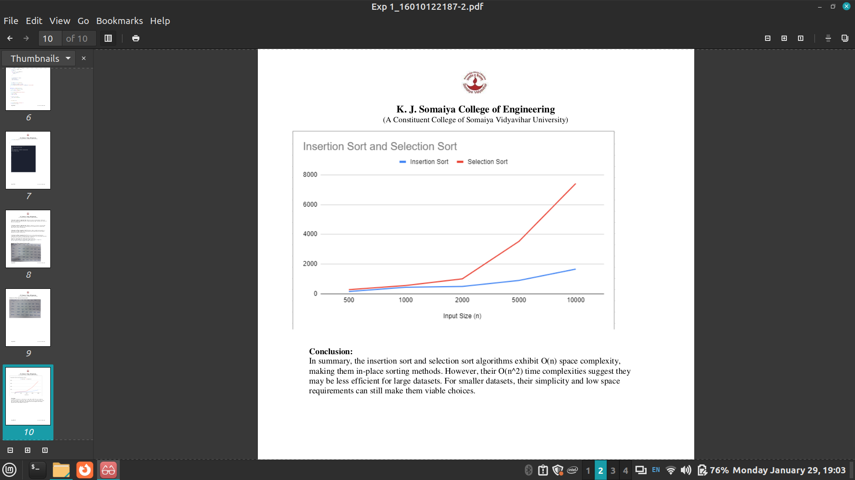

Selection Sort

import java.util.*;

class Main {
static void selectionSort(int[] A, int n) {
long startTime = System.nanoTime();

for (int i = 0; i < A.length - 1; i++) {
int index = i;
for (int j = i + 1; j < A.length; j++) {
if (A[j] < A[index]) {
index = j;
}
}

int smallerNumber = A[index];
A[index] = A[i];
A[i] = smallerNumber;
}

long endTime = System.nanoTime();
long timeElapsed = endTime - startTime;
System.out.println("Time Complexity: " + timeElapsed + " nanoseconds");
}

public static void main(String[] args) {
Scanner sc = new Scanner(System.in);
Random rand = new Random();

System.out.println("Enter the size of array:");
int n = sc.nextInt();
int A[] = new int[n];

for (int i = 0; i < n; i++) {
A[i] = rand.nextInt(10000);
}

selectionSort(A, n);

System.out.println("The sorted array:\n");

for (int i = 0; i < n; i++) {
System.out.println(A[i]);
}
}
}

Insertion Sort

import java.util.*;

class Main {
static void insertionSort(int A[], int n) {
int key, j;
long startTime = System.nanoTime();

for (int i = 1; i <= n - 1; i++) {
key = A[i];
j = i - 1;
while (j >= 0 && A[j] > key) {
A[j + 1] = A[j];
j--;
}
A[j + 1] = key;
}

long endTime = System.nanoTime();
long timeElapsed = endTime - startTime;
System.out.println("Time Complexity: " + timeElapsed + " nanoseconds");
}

public static void main(String[] args) {
Scanner sc = new Scanner(System.in);
Random rand = new Random();

System.out.println("Enter the size of array:");
int n = sc.nextInt();
int A[] = new int[n];

for (int i = 0; i < n; i++) {
A[i] = rand.nextInt(10000);
}

insertionSort(A, n);

System.out.println("The sorted array:\n");
for (int i = 0; i < n; i++) {
System.out.println(A[i]);
}
}
}

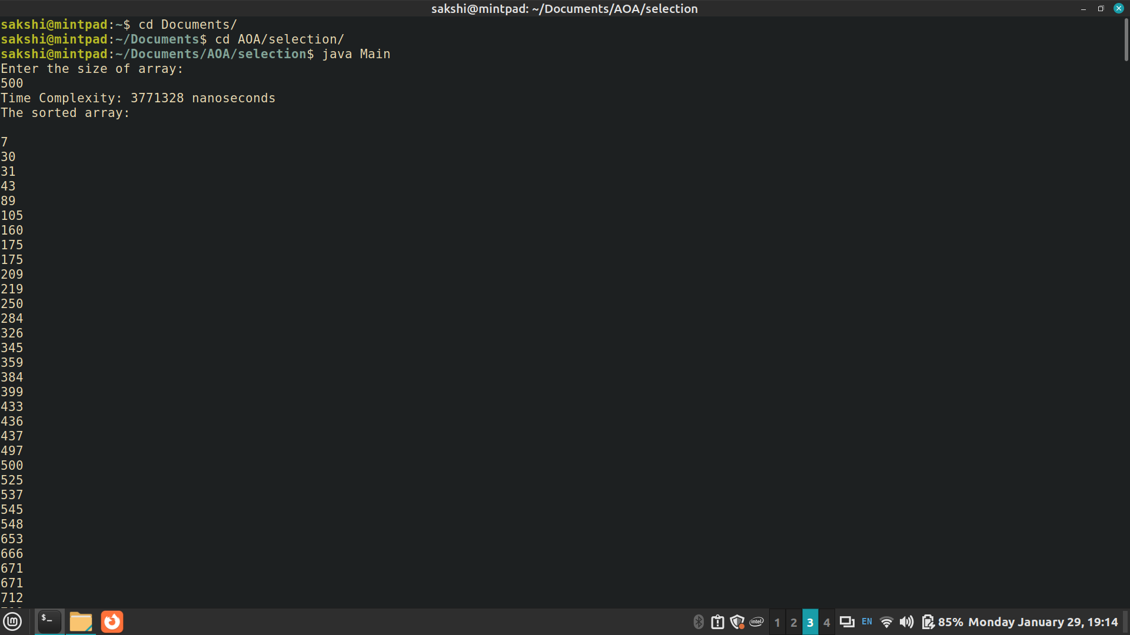
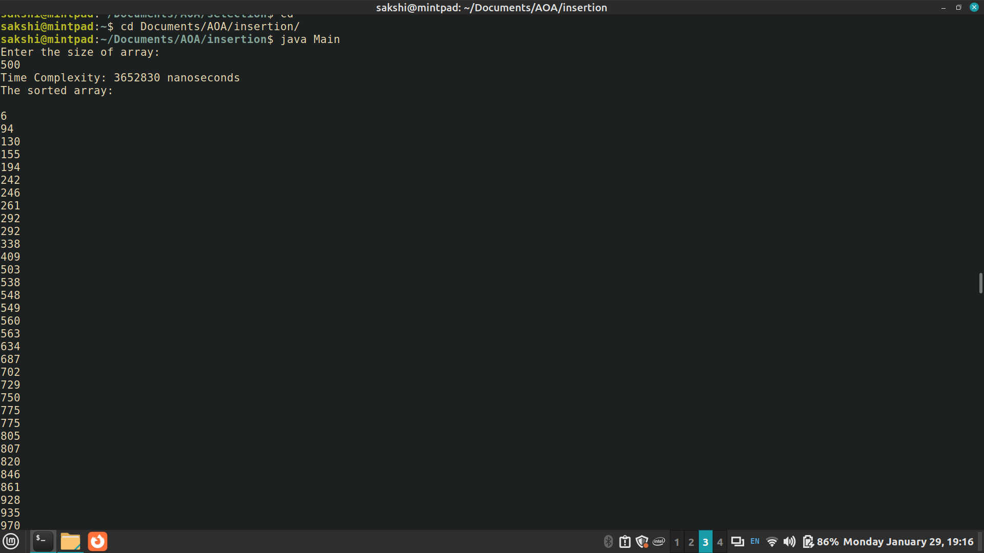

Insertion Sort (Time measured in nanoseconds)

Input Size | t1 | t2 | t3 | t4 | t5 | Average
100 | 183079 | 194792 | 186092 | 157682 | 172019 | 178733
200 | 785209 | 680037 | 634776 | 668916 | 706426 | 695072
300 | 1385484 | 1470348 | 1306988 | 1503446 | 1380679 | 1409389
400 | 2377156 | 2854113 | 2601100 | 2607564 | 2383421 | 2564671
500 | 3965324 | 3145115 | 3358962 | 3212467 | 3921309 | 3520635

Selection Sort (Time measured in nanoseconds)

Input Size | t1 | t2 | t3 | t4 | t5 | Average
100 | 257970 | 282256 | 281582 | 268983 | 282625 | 274683
200 | 1055994 | 1071072 | 1056850 | 1052987 | 1083592 | 1064099
300 | 2332903 | 2301096 | 2280584 | 2359781 | 2357904 | 2326454
400 | 4030058 | 4026392 | 4086916 | 3975096 | 4149397 | 4053572
500 | 4613648 | 4402022 | 4543976 | 4656919 | 4608182 | 4564949

CONCLUSION:

In summary, the insertion sort and selection sort algorithms exhibit O(n) space complexity,
making them in-place sorting methods. However, their O(n^2) time complexities suggest they
may be less efficient for large datasets. For smaller datasets, their simplicity and low space
requirements can still make them viable choices.

