Batch: A2 Roll No.: 16010122034

Experiment No. 10

Grade: AA / AB / BB / BC / CC / CD /DD

Signature of the Staff In-charge with date

Title: Implementation of Longest Common Subsequence String Matching Algorithm

Objective: To compute longest common subsequence for the given two strings.
CO to be achieved:
CO 2 | Analyze and solve problems for divide and conquer strategy, greedy method, dynamic programming approach and backtracking and branch & bound policies.
CO 3 | Analyze and solve problems for different string matching algorithms.

Books/ Journals/ Websites referred:
- Ellis horowitz, Sarataj Sahni, S.Rajsekaran,” Fundamentals of computer algorithm”, University Press
- T.H.Cormen ,C.E.Leiserson,R.L.Rivest and C.Stein,” Introduction to algortihtms”,2nd Edition ,MIT press/McGraw Hill,2001
- http://www.math.utah.edu/~alfeld/queens/queens.

Pre Lab/ Prior Concepts:
Data structures, Concepts of algorithm analysis

Historical Profile:
Given 2 sequences, X = x1 , ..., xm and Y = y1 , ... , yn , find a subsequence common to both whose length is longest. A subsequence doesn’t have to be consecutive, but it has to be in order.
New Concepts to be learned:
String matching algorithm, Dynamic programming approach for LCS, Applications of LCS.

Recursive Formulation:
Define c[i, j ] = length of LCS of Xi and Y j .
Final answer will be computed with c[m, n].

c[i, j]= 0
if i=0 or j=0.
c[i, j]= c[i − 1, j − 1] + 1
if i,j>0 and xi=yj

c[i, j]= max(c[i − 1, j ], c[i, j − 1])
if i, j > 0 and x_{i} <> y_{j}

Algorithm: Longest Common Subsequence

Compute length of optimal solution-
LCS-LENGTH ( X , Y, m, n)
for i ← 1 to m
do c[i, 0] ← 0
for j ← 0 to n
do c[0, j ] ← 0
for i ← 1 to m
do for j ← 1 to n
do if xi = y j
then c[i, j ] ← c[i − 1, j − 1] + 1
b[i, j ] ← “≈”
else if c[i − 1, j ] ≥ c[i, j − 1]
then c[i, j ] ← c[i − 1, j ]
b[i, j ] ← “↑”
else c[i, j ] ← c[i, j − 1]
b[i, j ] ← “←”
return c and b

Print the solution-
PRINT-LCS(b, X , i, j )
if i = 0 or j = 0
then return
if b[i, j ] = “≈”
then PRINT-LCS(b, X , i − 1, j − 1)
print xi
elseif b[i, j ] = “↑”
then PRINT-LCS(b, X , i − 1, j )
else PRINT-LCS(b, X , i, j − 1)

Initial call is PRINT-LCS(b, X , m, n).
b[i, j ] points to table entry whose subproblem we used in solving LCS of Xi
and Y j.
When b[i, j ] = ≈, we have extended LCS by one character. So longest com- mon subsequence = entries with ≈ in them.

Example: LCS computation
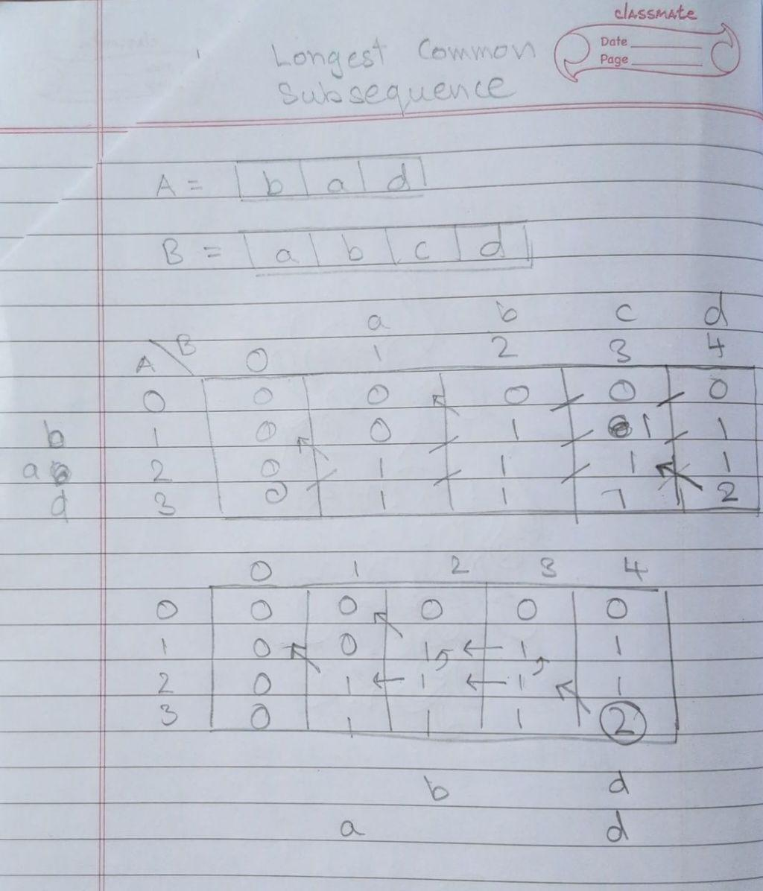
a,d and b,d are the Longest Common Subsequence
Code:

#include <stdio.h>
#include <string.h>

#define MAX_LENGTH 50

void lcsAlgo(char S1[], char S2[]) {
int m = strlen(S1);
int n = strlen(S2);

// Initialize the LCS_table with zeros
int LCS_table[MAX_LENGTH + 1][MAX_LENGTH + 1] = {0};

// Building the matrix in bottom-up way
for (int i = 1; i <= m; i++) {
for (int j = 1; j <= n; j++) {
if (S1[i - 1] == S2[j - 1])
LCS_table[i][j] = LCS_table[i - 1][j - 1] + 1;
else
LCS_table[i][j] = (LCS_table[i - 1][j] > LCS_table[i][j - 1]) ? LCS_table[i - 1][j] : LCS_table[i][j - 1];
}
}

// code written by me
// for (int i = 1; i <= m; i++)
// {
// for (int j = 1; j <=n; j++)
// {
// if (string1[i - 1] == string2[j-1])
// {
// table[i][j] = table[i-1][j-1] + 1;
// }

// else
// {
// if (table[i-1][j] > table[i][j-1])
// {table[i][j] = table[i-1][j];}

// else
// {table[i][j] = table[i][j-1];}
// }
// }
// }

// Calculate length of LCS
int index = LCS_table[m][n];

// Allocate memory for LCS string
// +1 adjusts for the \0 we add
char lcsAlgo[MAX_LENGTH + 1];
lcsAlgo[index] = '\0';
//

// Backtrack to find LCS
int i = m, j = n;
while (i > 0 && j > 0) {
if (S1[i - 1] == S2[j - 1]) {
lcsAlgo[--index] = S1[i - 1];
i--;
j--;
} else if (LCS_table[i - 1][j] > LCS_table[i][j - 1])
i--;
else
j--;
}
// didnt understand!!!??? properly
// --index
// can u simplify

// Print the result
printf("S1 : %s \nS2 : %s \n", S1, S2);
printf("LCS: %s\n", lcsAlgo);
printf("Length of LCS: %ld\n", strlen(lcsAlgo));

}

int main() {
char S1[MAX_LENGTH + 1], S2[MAX_LENGTH + 1];

printf("Enter first string: ");
scanf("%s", S1);
printf("Enter second string: ");
scanf("%s", S2);

lcsAlgo(S1, S2);

return 0;
}

Analysis of LCS computation
The optimal time complexity of the longest common subsequence (LCS) algorithm is O(m * n), where m and n are the lengths of the input strings. This is typically implemented using dynamic programming, where we create a matrix of size (m+1) x (n+1) to store the prefix lengths and fill the matrix iteratively, requiring examining each cell, which takes constant time. Another way to achieve this time complexity is using recursion with memoization, where we ensure no duplicate computations are made when visiting each node in the recursive tree. As a result, the overall time complexity is determined by the number of cells in the matrix or nodes in the recursive tree.
Output:
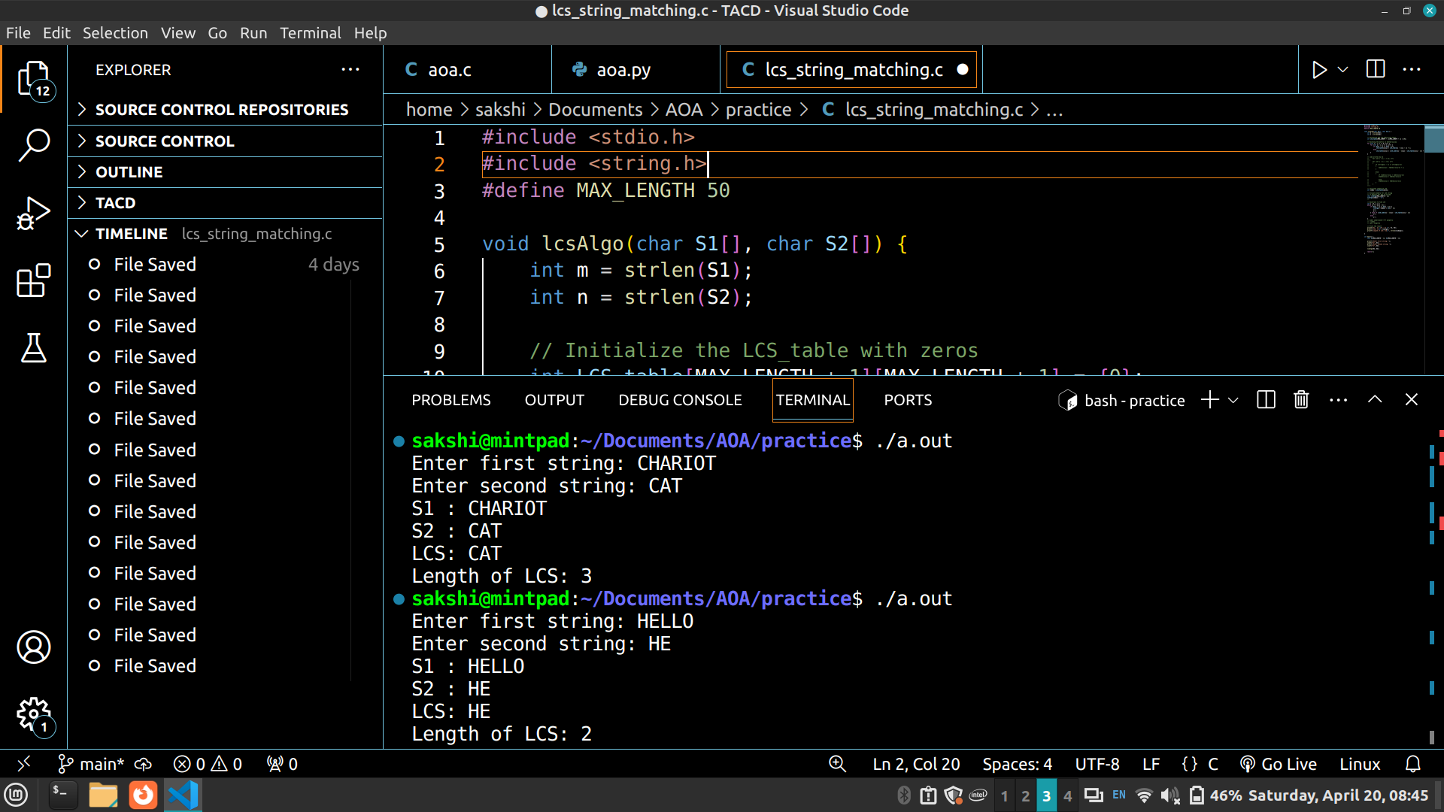

CONCLUSION:

The Longest Common Subsequence (LCS) algorithm efficiently finds the longest subsequence that is present in both given strings. Through dynamic programming, it achieves an optimal time complexity of O(m * n), where m and n are the lengths of the input strings. This algorithm constructs a matrix to store the lengths of the common subsequences, iteratively filling it by comparing characters of the input strings.

