Batch: B3 Roll No.: 16010122158

Experiment No. 02

Grade: AA / AB / BB / BC / CC / CD /DD

Signature of the Staff In-charge with date

Title: Implementation of Binary search/Max-Min algorithm

Objective: To learn the divide and conquer strategy of solving the problems of different types

CO to be achieved:
CO 2 | Describe various algorithm design strategies to solve different problems and analyse Complexity.

Books/ Journals/ Websites referred:
- Ellis horowitz, Sarataj Sahni, S.Rajsekaran,” Fundamentals of computer algorithm”, University Press
- T.H.Cormen ,C.E.Leiserson,R.L.Rivest and C.Stein,” Introduction to algortihtms”,2nd Edition ,MIT press/McGraw Hill,2001
- http://en.wikipedia.org/wiki/Binary_search_algorithm
- https://www.princeton.edu/~achaney/tmve/wiki100k/docs/Binary_search_algorithm.html
- http://video.franklin.edu/Franklin/Math/170/common/mod01/binarySearchAlg.html
- http://xlinux.nist.gov/dads/HTML/binarySearch.html
- https://www.cs.auckland.ac.nz/software/AlgAnim/searching.html

Pre Lab/ Prior Concepts:
Data structures

Historical Profile:

Finding maximum and minimum or Binary search are few problems those are solved with the divide-and-conquer technique. This is one the simplest strategies which basically works on dividing the problem to the smallest possible level.

Binary Search is an extremely well-known instance of divide-and-conquer paradigm. Given an ordered array of n elements, the basic idea of binary search is that for a given element , "probe" the middle element of the array. Then continue in either the lower or upper segment of the array, depending on the outcome of the probe until the required (given) element is reached.

New Concepts to be learned:
Number of comparisons, Application of algorithmic design strategy to any problem, Classical problem solving Vs Divide-and-Conquer problem solving.

Algorithm IterativeBinarySearch
int binary_search(int A[ ], int key, int imin, int imax)
//The algorithm takes as parameters an array A[1.. n] , the search key and lower-higher index pair of the array.
// Output- The algorithm returns index of the search key in the given array, if it’s present.
{
// continue searching while [imin, imax] is not empty
WHILE (imax >= imin)
{
// calculate the midpoint for roughly equal partition
int imid = midpoint(imin, imax);
IF(A[imid] == key)
// key found at index imid
return imid;
// determine which subarray to search
ELSE If (A[imid] < key)
// change min index to search upper subarray
imin = imid + 1;
ELSE
// change max index to search lower subarray
imax = imid - 1;
}
// key was not found
RETURN KEY_NOT_FOUND;
}

The space complexity of Iterative Binary Search: O(1)
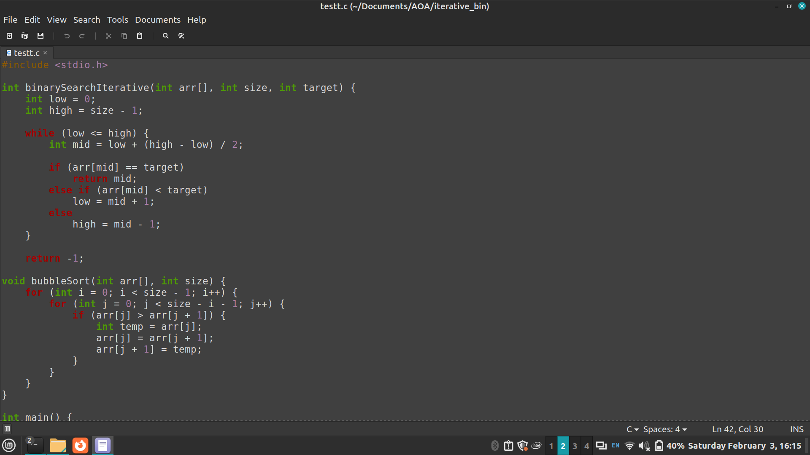
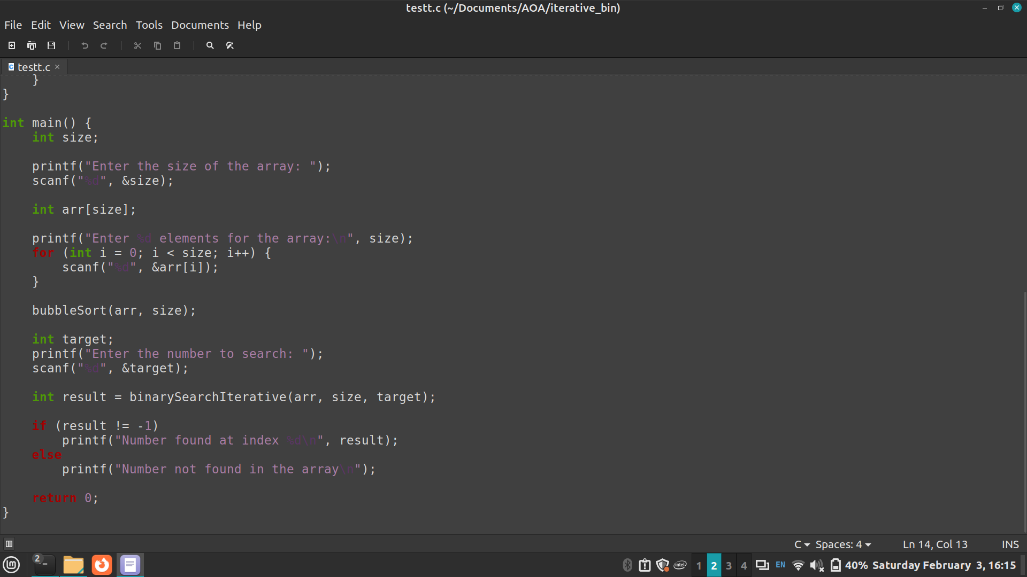

Algorithm Recursive Binary Search
int binary_search(int A[], int key, int imin, int imax)
//The algorithm takes as parameters an array A[1.. n] , the search key and lower-higher index pair of the array.
// Output- The algorithm returns index of the search key in the given array, if it’s present.
{
// test if array is empty
IF (imax < imin)
// set is empty, so return value showing not found
RETURN KEY_NOT_FOUND;
ELSE{
// calculate midpoint to cut set in half
int imid = midpoint(imin, imax);
// three-way comparison
IF (A[imid] > key)
// key is in 🡨 lower subset
RETURN binary_search(A, key, imin, imid-1);
ELSE IF (A[imid] < key)
// key is in 🡪 higher subset
RETURN binary_search(A, key, imid+1, imax);
ELSE
// key has been found
RETURN imid;
}
}
The space complexity of Recursive Binary Search: O(logN)
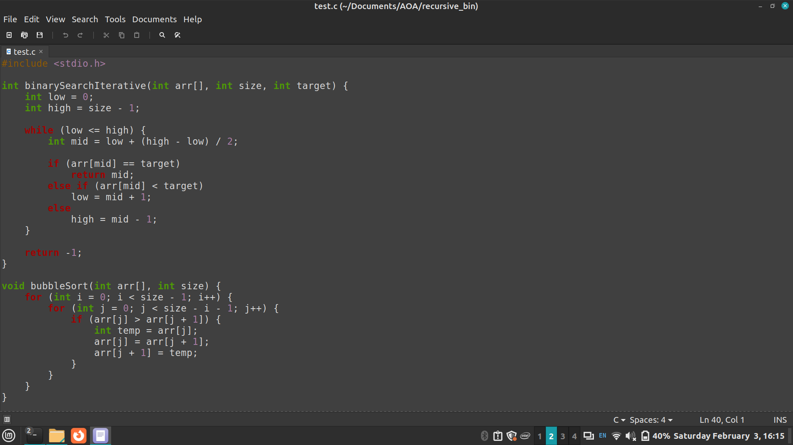
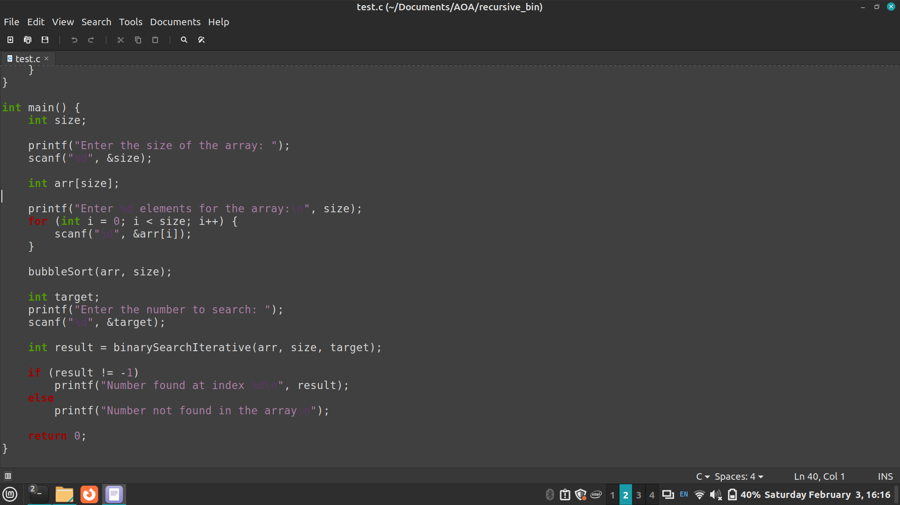
The Time complexity of Binary Search:
- Best Case: O(1)
- Average Case: O(log N)
- Worst Case: O(log N)

Algorithm StraightMaxMin:

VOID StraightMaxMin (Type a[], int n, Type& max, Type& min)
// Set max to the maximum and min to the minimum of a[1:n].
{ max = min = a[1];

FOR (int i=2; i<=n; i++)
{
IF (a[i]>max) then max = a[i];
IF (a[i]<min) min = a[i];
}
}

Algorithm: Recursive Max-Min

VOID MaxMin(int i, int j, Type& max, Type& min)
// A[1:n] is a global array. Parameters i and j are integers, 1 <= i <= j <= n.
//The effect is to set max and min to the largest and smallest values in a[i:j], respectively.
{
IF (i == j) max = min = a[i]; // Small(P)
ELSE IF (i == j-1) { // Another case of Small(P)
IF (a[i] < a[j])
max = a[j]; min = a[i];
ELSE { max = a[i]; min = a[j];
}
ELSE { Type max1, min1;

// If P is not small divide P into sub problems. Find where to split the set.

int mid=(i+j)/2;
// solve the sub problems.
MaxMin(i, mid, max, min);
MaxMin(mid+1, j, max1, min1);
// Combine the solutions.
IF (max < max1) max = max1;
IF (min > min1) min = min1;

}
}

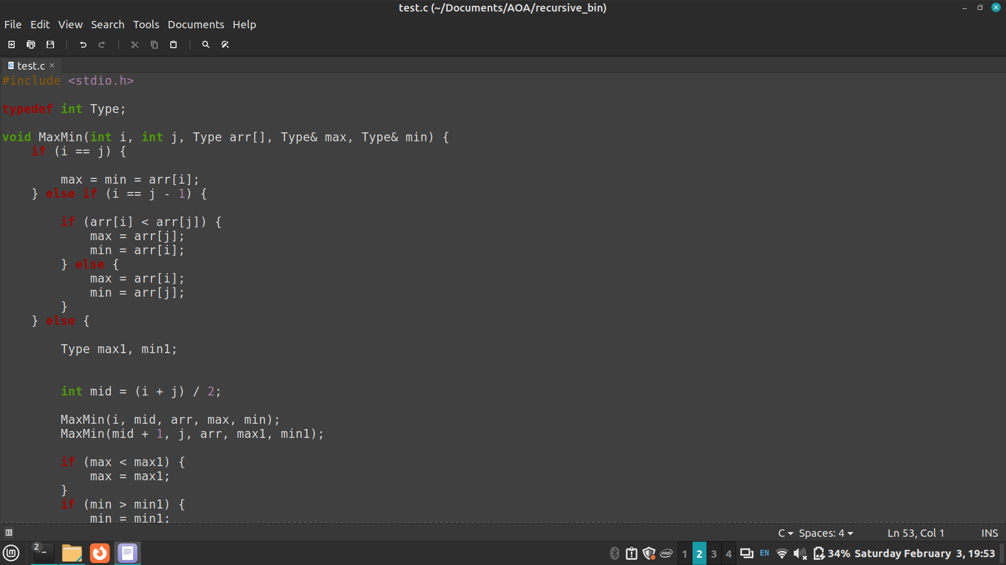
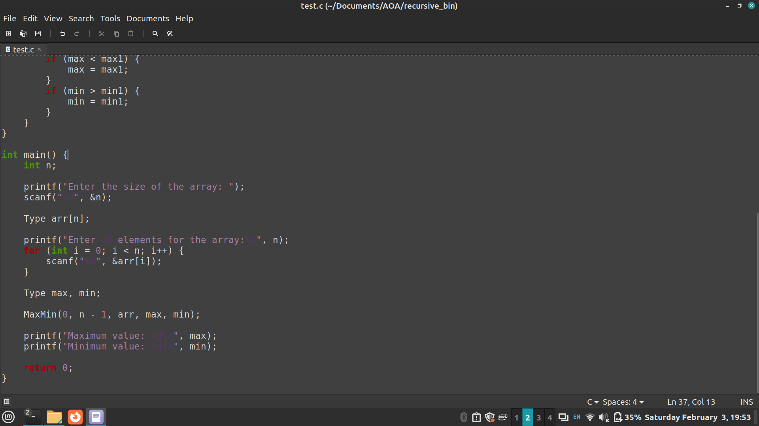

The space complexity of Max-Min: S(n)=S(2n​)+constant

Time complexity for Max-Min: T(n)=2T(2n​)+constant

CONCLUSION:

Successful implementation of Iterative and Recursive binary search algorithms and Max-Min algorithm

