Batch: B3 Roll No.: 16010122158

Experiment No. 5

Grade: AA / AB / BB / BC / CC / CD /DD

Signature of the Staff In-charge with date

Title: Implementation of Knapsack Problem using Greedy strategy

Objective: To learn the Greedy strategy of solving the problems for different types of problems
CO to be achieved:
CO 2 | Describe various algorithm design strategies to solve different problems and analyse Complexity.

Books/ Journals/ Websites referred:
- Ellis horowitz, Sarataj Sahni, S.Rajsekaran,” Fundamentals of computer algorithm”, University Press
- T.H.Cormen ,C.E.Leiserson,R.L.Rivest and C.Stein,” Introduction to algortihtms”,2nd Edition ,MIT press/McGraw Hill,2001
- http://lcm.csa.iisc.ernet.in/dsa/node184.htm
- http://students.ceid.upatras.gr/~papagel/project/kruskal.htm
- http://www.personal.kent.edu/~rmuhamma/Algorithms/MyAlgorithms/GraphAlgor/kruskalAlgor.html
- http://lcm.csa.iisc.ernet.in/dsa/node183.html
- http://students.ceid.upatras.gr/~papagel/project/prim.htm
- http://www.cse.ust.hk/~dekai/271/notes/L07/L07.pdf

Pre Lab/ Prior Concepts:
Data structures, Concepts of algorithm analysis

Historical Profile:

The knapsack problem represents constraint satisfaction optimization problems’ family. Based on nature of constraints, the knapsack problem can be solved with various problem saolving strategies. Typically, these problems represent resource optimization solution.

Given a set of n inputs. · Find a subset, called feasible solution, of the n inputs subject to some constraints, and satisfying a given objective function. · If the objective function is maximized or minimized, the feasible solution is optimal. · It is a locally optimal method.

New Concepts to be learned:
Application of algorithmic design strategy to any problem, Greedy method of problem solving Vs other methods of problem solving, optimality of the solution, knapsack problem and their applications

Knapsack Problem Algorithm
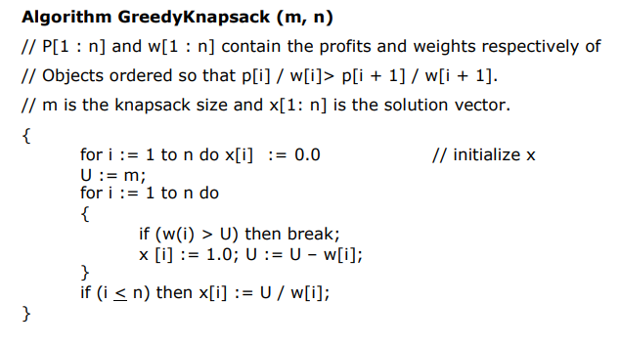
Example: Knapsack Problem
Consider the example: arr[] = {{100, 20}, {60, 10}, {120, 30}}, W = 50.

Code:

#include <bits/stdc++.h>
using namespace std;

struct Item {
int profit, weight;

Item(int profit, int weight)
{
this->profit = profit;
this->weight = weight;
}
};

static bool cmp(struct Item a, struct Item b)
{
double r1 = (double)a.profit / (double)a.weight;
double r2 = (double)b.profit / (double)b.weight;
return r1 > r2;
}

double fractionalKnapsack(int W, struct Item arr[], int N)
{
sort(arr, arr + N, cmp);

double finalvalue = 0.0;

for (int i = 0; i < N; i++) {

if (arr[i].weight <= W) {
W -= arr[i].weight;
finalvalue += arr[i].profit;
}

else {
finalvalue
+= arr[i].profit
* ((double)W / (double)arr[i].weight);
break;
}
}

return finalvalue;
}

int main()
{
int W = 50;
Item arr[] = { { 60, 10 }, { 100, 20 }, { 120, 30 } };
int N = sizeof(arr) / sizeof(arr[0]);

cout << fractionalKnapsack(W, arr, N);
return 0;
}

Output:
240

Analysis of Knapsack Problem algorithm:
Time Complexity: O(N * logN)
Auxiliary Space: O(N)

Conclusion:
Successfully solved the fractional Knapsack Problem

