Batch: A2 Roll No.: 16010122034

Experiment No. 7

Grade: AA / AB / BB / BC / CC / CD /DD

Signature of the Staff In-charge with date

Title: Implementation of All Pair Shortest Path using Dynamic Programming

Objective To learn the All-Pair Shortest Path using Floyd-Warshall’s algorithm
CO to be achieved:
CO 2 | Describe various algorithm design strategies to solve different problems and analyse Complexity.
Books/ Journals/ Websites referred:
- Ellis horowitz, Sarataj Sahni, S.Rajsekaran,” Fundamentals of computer algorithm”, University Press
- T.H.Cormen ,C.E.Leiserson,R.L.Rivest and C.Stein,” Introduction to algortihtms”,2nd Edition ,MIT press/McGraw Hill,2001
- http://users.cecs.anu.edu.au/~Alistair.Rendell/Teaching/apac_comp3600/module4/all_pairs_shortest_paths.xhtml
- https://www.geeksforgeeks.org/floyd-warshall-algorithm-dp-16/
- http://www.cs.bilkent.edu.tr/~atat/502/AllPairsSP.ppt
Theory:
It aims to figure out the shortest path from each vertex v to every other u.
- In all pair shortest path, when a weighted graph is represented by its weight matrix W then objective is to find the distance between every pair of nodes.
- Apply dynamic programming to solve the all pairs shortest path.
- In all pair shortest path algorithm, we first decomposed the given problem into sub problems.
- In this principle of optimally is used for solving the problem.
- It means any sub path of shortest path is a shortest path between the end nodes.

Algorithm:
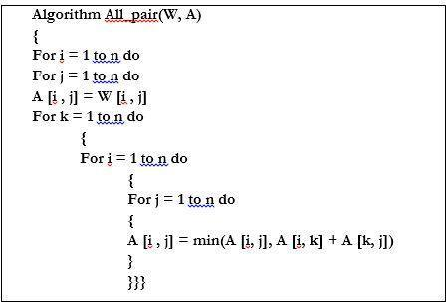
Example :
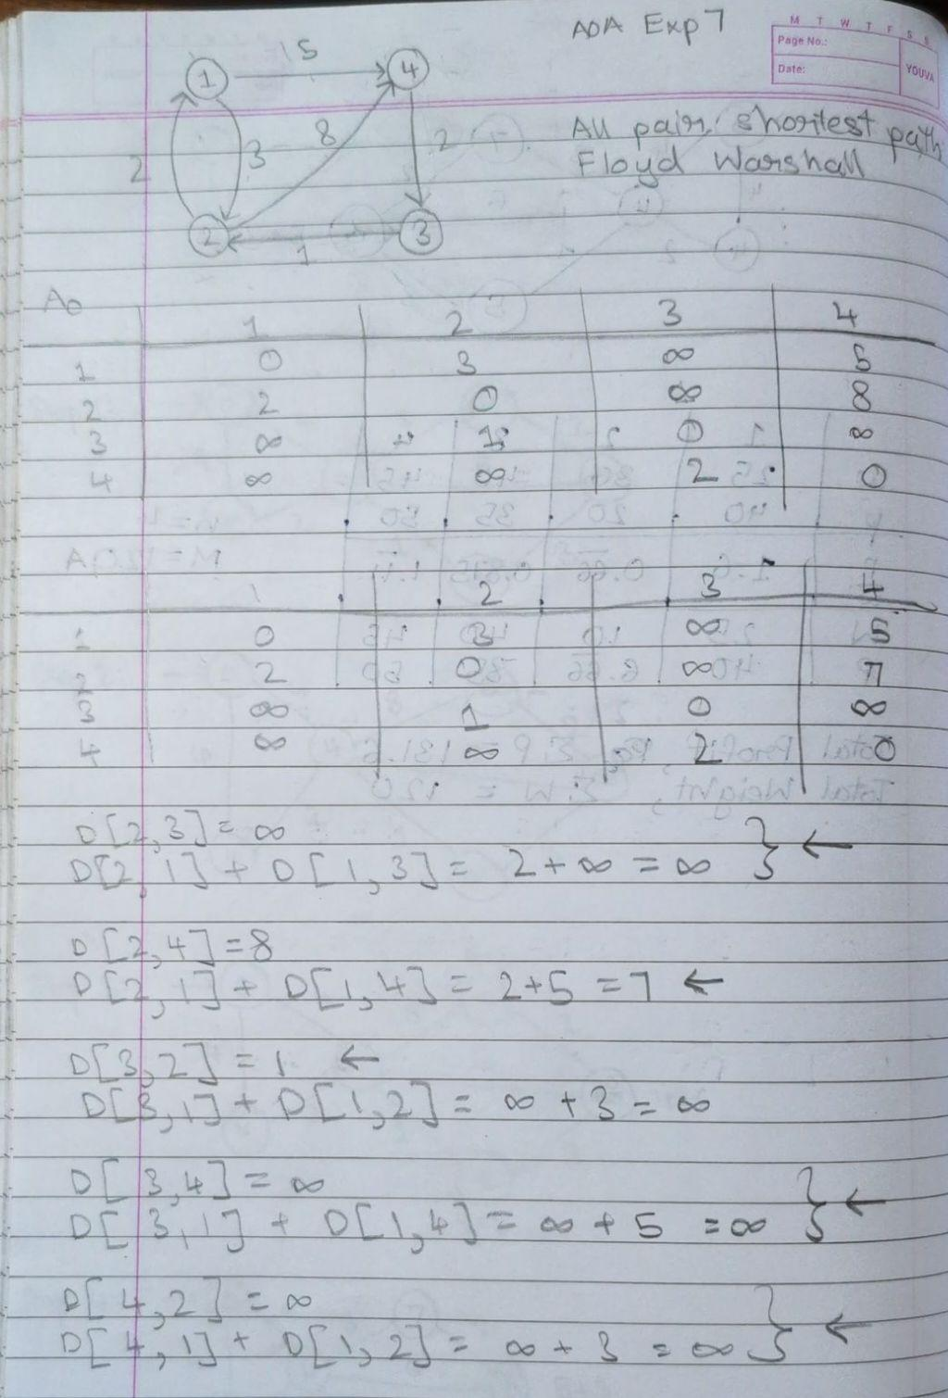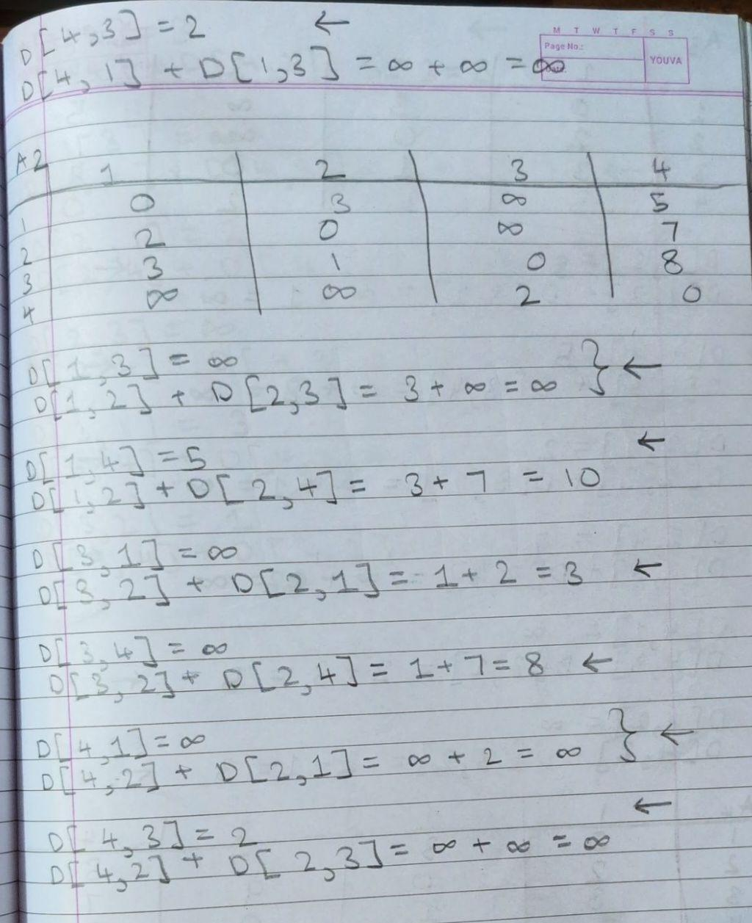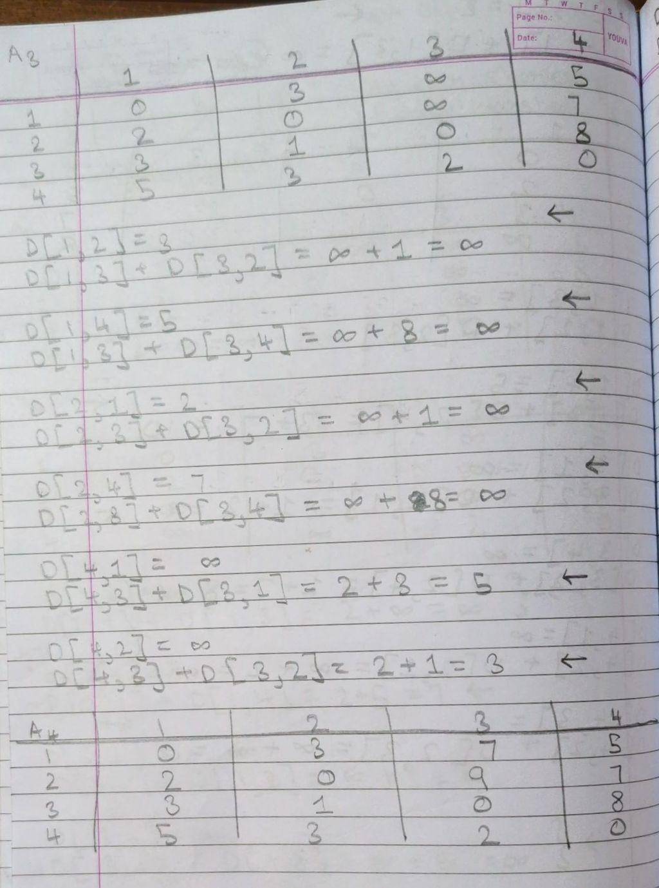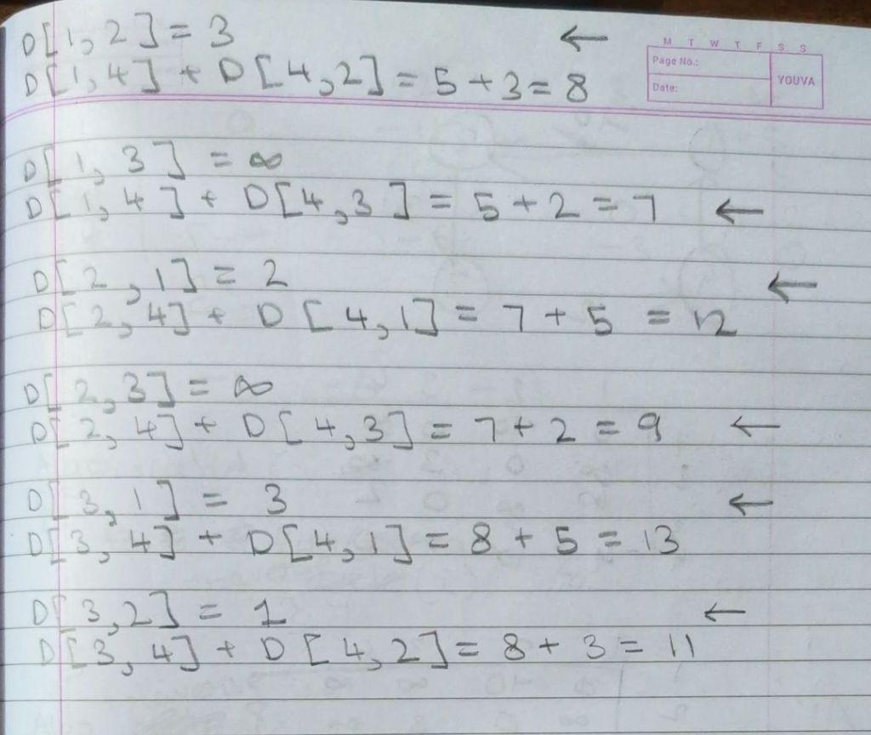

Code:

#include<stdio.h>
#include<stdlib.h>
#include<time.h>

void floydWarshall(int **graph,int n){
int i, j, k;
int inf=1000;
for (k = 0; k < n; k++){
for (i = 0; i < n; i++){
for (j = 0; j < n; j++){
if (graph[i][j] > graph[i][k] + graph[k][j])
graph[i][j] = graph[i][k] + graph[k][j];
}}}}
int main(void)
{
int n, i, j;
clock_t start_t, end_t; double total_t;
printf("Enter the number of vertices: ");
scanf("%d", &n);
int **graph = (int **)malloc((long unsigned) n * sizeof(int *));
for (i = 0; i < n; i++){
graph[i] = (int *)malloc((long unsigned) n * sizeof(int));
}
for (i = 0; i < n; i++){
for (j = 0; j < n; j++){
if (i == j) graph[i][j] = 0;
else
graph[i][j] = 100;
}
}
printf("Enter the edges (enter 1000 for no direct edge): \n");
for (i = 0; i < n; i++){
for (j = 0; j < n; j++){
printf("[%d][%d]: ", i, j);
scanf("%d", &graph[i][j]);
}
}
printf("The original graph is:\n");
for (i = 0; i < n; i++)
{
for (j = 0; j < n; j++)
{
printf("%d ", graph[i][j]);
}
printf("\n");
}
start_t = clock(); floydWarshall(graph, n); end_t = clock();
total_t = ((double)(end_t - start_t)) / CLOCKS_PER_SEC;

printf("The shortest path matrix is:\n"); for (i = 0; i < n; i++)
{
for (j = 0; j < n; j++)
{
printf("%d ", graph[i][j]);
}
printf("\n");

}
printf("\nexecution time is %f seconds \n", total_t); return 0;
}

Output Screenshots:
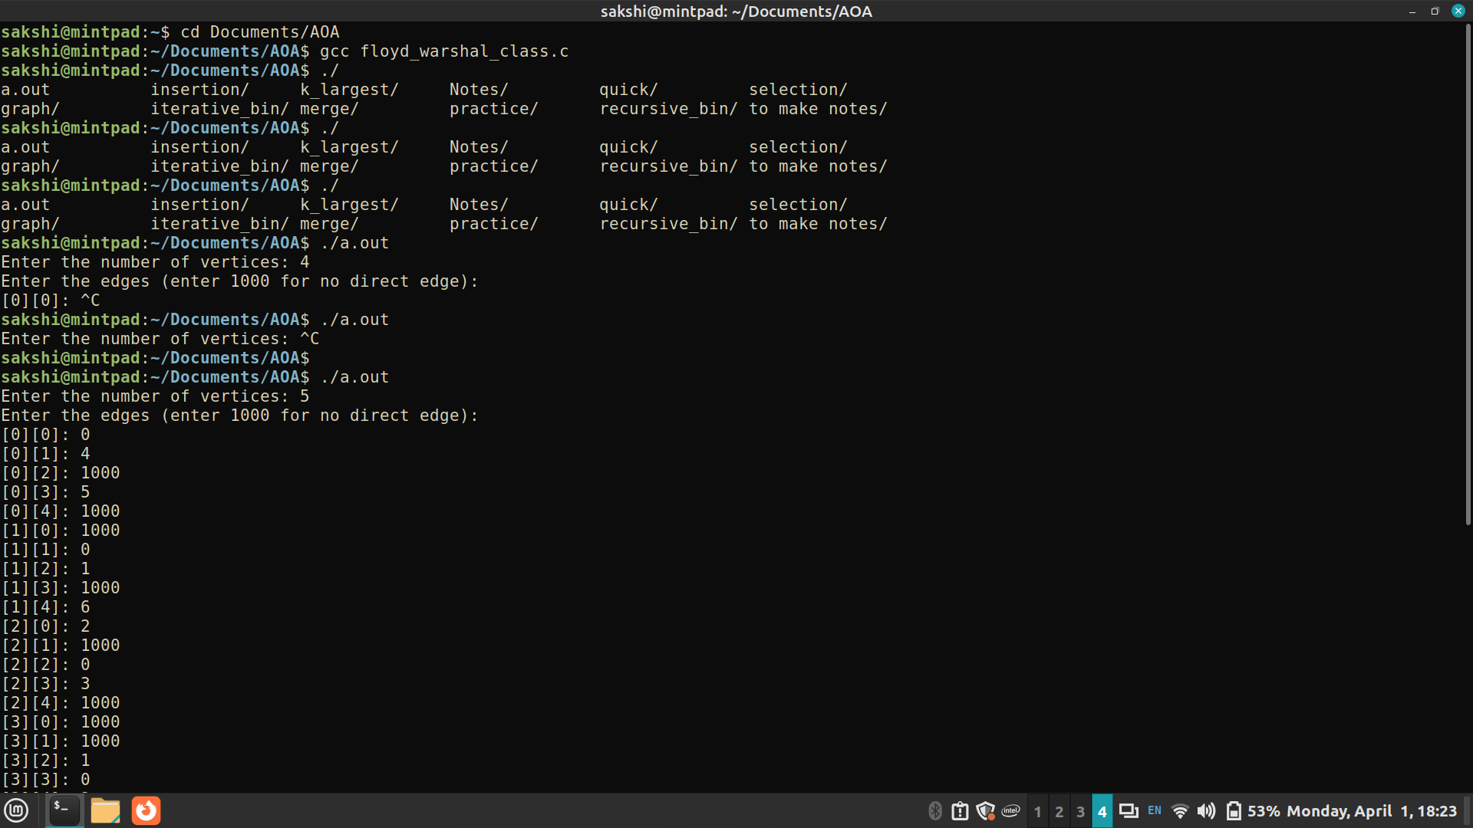
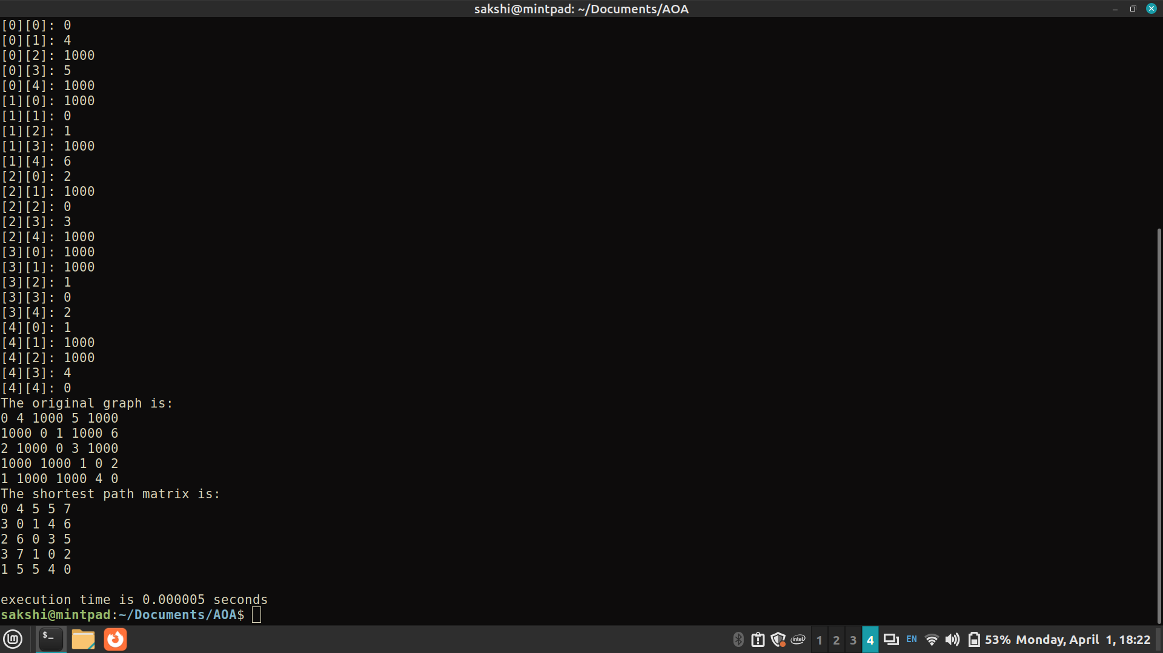

Analysis of algorithm:

Time Complexity: O(V³), where V is the number of vertices in the graph and we run three nested loops each of size V
Auxiliary Space: O(V²), to create a 2-D matrix in order to store the shortest distance for each pair of nodes.
CONCLUSION:

In summary, the Floyd-Warshall algorithm efficiently computes the shortest paths between all pairs of vertices in a graph. Its time complexity is O(V^3), where (V) is the number of vertices, and it requires O(V^2) auxiliary space. Overall, it provides a concise and effective solution to the All-Pair Shortest Path problem.

