Batch: A2 Roll No.: 16010122034

Experiment No. 8

Grade: AA / AB / BB / BC / CC / CD /DD

Signature of the Staff In-charge with date

Title: Implementation of sum of subset Algorithm

Objective: To learn the Backtracking strategy of problem solving for Sum of subset

CO to be achieved:
CO 2 | Analyze and solve problems for divide and conquer strategy, greedy method, dynamic programming approach and backtracking and branch & bound policies.

Books/ Journals/ Websites referred:
- Ellis horowitz, Sarataj Sahni, S.Rajsekaran,” Fundamentals of computer algorithm”, University Press
- T.H.Cormen ,C.E.Leiserson,R.L.Rivest and C.Stein,” Introduction to algortihtms”,2nd Edition ,MIT press/McGraw Hill,2001

Pre Lab/ Prior Concepts:
Data structures, Concepts of algorithm analysis

Historical Profile:
Subset sum problem is to find a subset of elements that are selected from a given set whose sum adds up to a given number K. We are considering the set containing non-negative values. It is assumed that the input set is unique (no duplicates are presented).
One way to find subsets that sum to K is to consider all possible subsets. A power set contains all those subsets generated from a given set. The size of such a power set is 2N.

Input:
A vector X={x1,x2… xn} for all n elements in the set where Xi=0 (element not added) or xi=1 (element added in the solution tuple).

Output:
Summation of the chosen numbers must be equal to given number M and one number can be used only once.

BACKTRACKING CONDITION
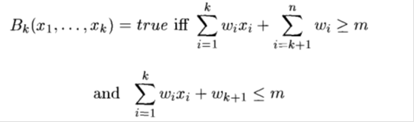

New Concepts to be learned:
Application of algorithmic design strategy to any problem, Backtracking method of problem solving Vs other methods of problem solving problem sum of subset and its applications.

Algorithm:

Algorithm sumOfSub(s, k, r)

{//It is assumed w[1]<=m and Sigma(i=1 to m)w[i]>=m

//generate the left child. Note: s+w(k)<=M since Bk-1 is true.

X{k]=1;

if (S+W[k]=m) then write(X[1:k]); //Subset found. there is no recursive call here
as W[j]>0,1<=j<=n.

else if (S+W[k]+W[k+1]<=m) then sumOfSub(S+W[k], k+1,r- W[k]); //moving to
next sub-problem.

Similarly, assume the array is presorted and we found one subset. We can generate
next node excluding the present node only when inclusion of next
node satisfies the constraints.

if ((S+ r- W[k]>=m)and (S+ W[k+1]<=m)) then//generate right {
//child and those satisfying 2 bounding functions

X{k]=0;

sumOfSub (S, k+1, r- W[k]);
}}

Implementation(Code):

flag = False

def print_subset_sum(i, n, _set, target_sum, subset):
global flag
if target_sum == 0:
flag = True
print("[", end=" ")
for element in subset:
print(element, end=" ")
print("]", end=" ")
return

if i == n:
return

print_subset_sum(i + 1, n, _set, target_sum, subset)

if _set[i] <= target_sum:
subset.append(_set[i])
print_subset_sum(i + 1, n, _set, target_sum - _set[i], subset)
subset.pop()

if __name__ == "__main__":
set_input = input("Enter the set elements separated by spaces: ")
target_sum_input = int(input("Enter the target sum: "))

_set = list(map(int, set_input.split()))
n = len(_set)
subset = []

print("Output:")
print_subset_sum(0, n, _set, target_sum_input, subset)
print()

if not flag:
print("There is no such subset")

Output:
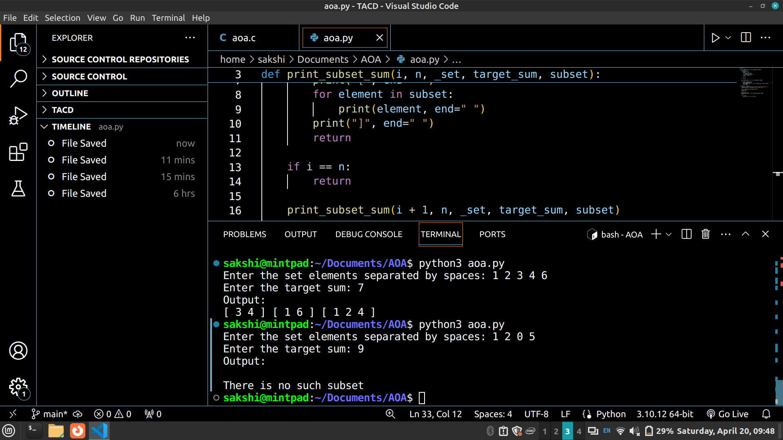


Example sum of subset Problem along with state space tree:
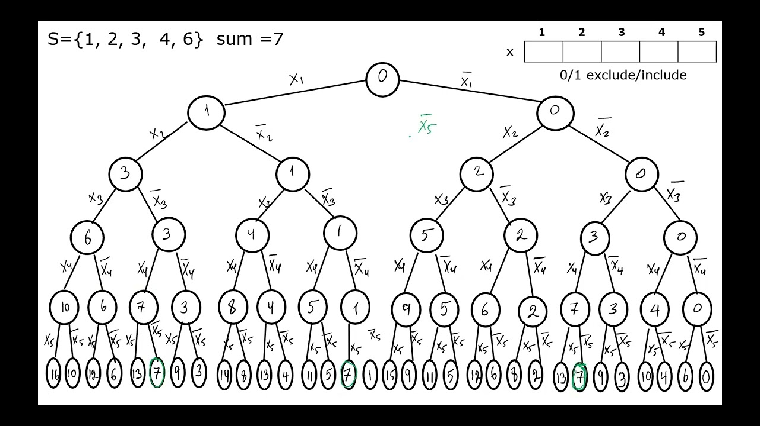

Analysis of Backtracking solution for sum of subset Problem:

Time Complexity: O(N*K) where N is the number of elements in the array and K is total sum.
Auxiliary Space: O(K), since K extra space has been taken.

Conclusion:

The backtracking algorithm provides a solution for the sum of subset problem, efficiently finding subsets of elements that sum up to a given target value. It recursively explores different combinations of elements, considering both inclusion and exclusion, and prunes branches that violate constraints. The time complexity is O(N * K), where N is the number of elements and K is the total sum. The auxiliary space complexity is O(K). This approach demonstrates the effectiveness of backtracking in solving combinatorial problems.

