Batch: A2 Roll No.: 1610122034

Experiment No. 9

Grade: AA / AB / BB / BC / CC / CD /DD

Signature of the Staff In-charge with date

Title: Implementation of N-Queen Problem using Backtracking Algorithm

Objective: To learn the Backtracking strategy of problem solving for 8-Queens problem
CO to be achieved:

Sr. No | Objective
CO 1 | Compare and demonstrate the efficiency of algorithms using asymptotic complexity notations.
CO 2 | Analyze and solve problems for divide and conquer strategy, greedy method, dynamic programming approach and backtracking and branch & bound policies.

Books/ Journals/ Websites referred:
- Ellis horowitz, Sarataj Sahni, S.Rajsekaran,” Fundamentals of computer algorithm”, University Press
- T.H.Cormen ,C.E.Leiserson,R.L.Rivest and C.Stein,” Introduction to algortihtms”,2nd Edition ,MIT press/McGraw Hill,2001
- http://www.math.utah.edu/~alfeld/queens/queens.html
- http://www-isl.ece.arizona.edu/ece175/assignments275/assignment4a/Solving%208%20queen%20problem.pdf
- http://www.slideshare.net/Tech_MX/8-queens-problem-using-back-tracking
- http://www.mathcs.emory.edu/~cheung/Courses/170.2010/Syllabus/Backtracking/8queens.html
- http://www.geeksforgeeks.org/backtracking-set-3-n-queen-problem/
- http://www.hbmeyer.de/backtrack/achtdamen/eight.htm

Pre Lab/ Prior Concepts:
Data structures, Concepts of algorithm analysis

Historical Profile:
The N-Queens puzzle is the problem of placing N queens on an N×N chessboard so that no two queens attack each other. Thus, a solution requires that no two queens share the same row, column, or diagonal.

New Concepts to be learned:
Application of algorithmic design strategy to any problem, Backtracking method of problem-solving Vs other methods of problem solving, 8- Queens problem and its applications.

Algorithm N Queens Problem: -

void NQueens(int k, int n)
// Using backtracking, this procedure prints all possible placements of n queens on an n X n chessboard so that they are nonattacking.
{ for (int i=1; i<=n; i++)
{
if (Place(k, i))
{
x[k] = i;
if (k==n)
for (int j=1;j<=n;j++) Print x[j] ;
else NQueens(k+1, n);
}
}
}

Boolean Place(int k, int i)
// Returns true if a queen can be placed in k^{th} row and i^{th} column. Otherwise it returns false.
// x[] is a global array whose first (k-1) values have been set. abs(r) returns absolute value of r.
{
for (int j=1; j < k; j++)

if ((x[j] == i) // Two in the same column

|| (abs(x[j]-i) == abs(j-k))) // or in the same diagonal
return(false);
return(true);

}

Example 8-Queens Problem:

The eight queens puzzle is the problem of placing eight chess queens on an 8×8 chessboard so that no two queens threaten each other i.e. no two queens share the same row, column, or diagonal.

Solution Using Backtracking Approach:

The idea is to place queens one by one in different columns, starting from the leftmost column. When we place a queen in a column, we check for clashes with already placed queens. In the current column, if we find a row for which there is no clash, we mark this row and column as part of the solution. If we do not find such a row due to clashes then we backtrack and return false.

State Space tree for N-Queens (Solution):

State Space tree 4 Queen problem

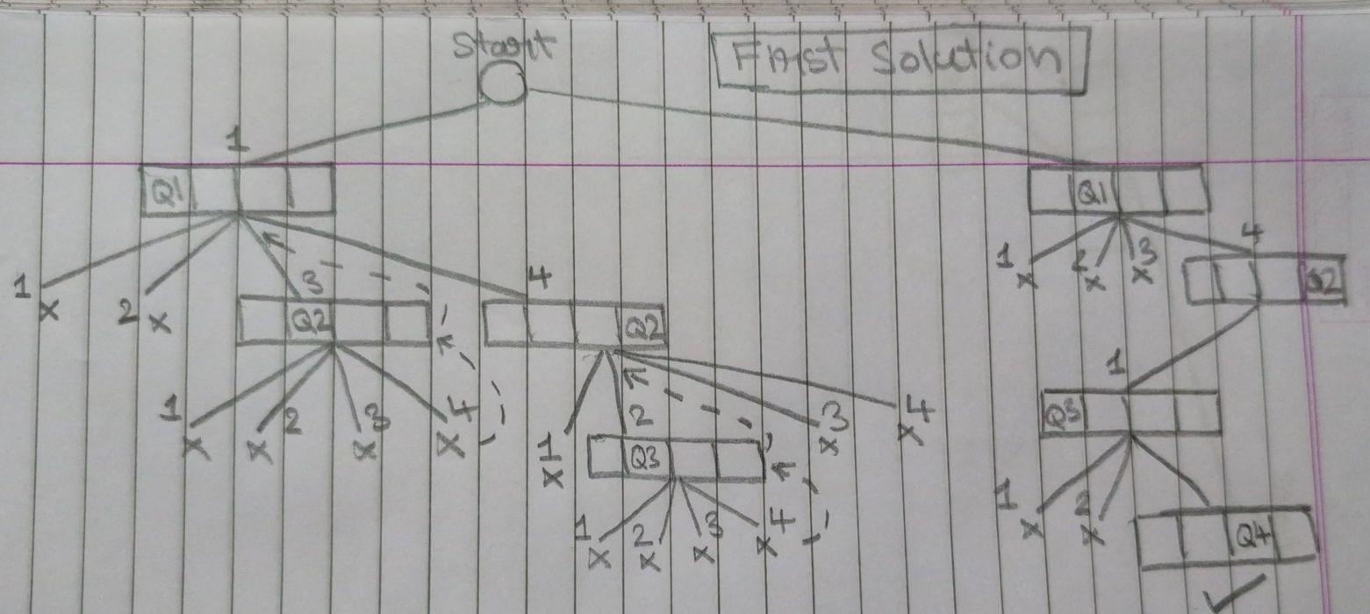

Implementation (Code):

# Define the size of the chessboard
N = 8

# Initialize the chessboard
board = [[0] * N for _ in range(N)]

# Function to print the solution
def print_solution(board):
for row in board:
print(' '.join('Q' if x else '.' for x in row))

# Function to check if a queen can be placed on board[row][col]
def is_safe(board, row, col):
# Check the column on the left
for i in range(col):
if board[row][i] == 1:
return False

# Check upper diagonal on the left
for i, j in zip(range(row, -1, -1), range(col, -1, -1)):
if board[i][j] == 1:
return False

# Check lower diagonal on the left
for i, j in zip(range(row, N, 1), range(col, -1, -1)):
if board[i][j] == 1:
return False

# The position is safe for placing a queen
return True

# Recursive utility function to solve N Queen problem
def solve_nq_util(board, col):
# Base case: If all queens are placed, return true
if col >= N:
return True

# Consider this column and try placing this queen in all rows one by one
for i in range(N):
# Check if the queen can be placed on board[i][col]
if is_safe(board, i, col):
# Place this queen in board[i][col]
board[i][col] = 1

# Recur to place the rest of the queens
if solve_nq_util(board, col + 1) == True:
return True

# If placing queen in board[i][col] doesn't lead to a solution, then backtrack
board[i][col] = 0

# If the queen cannot be placed in any row in this column, return false
return False

# Function to solve the N Queen problem using the backtracking approach
def solve_nq():
if not solve_nq_util(board, 0):
print("Solution does not exist")
return False

print_solution(board)
return True

# Execute the algorithm
solve_nq()

OUTPUT:

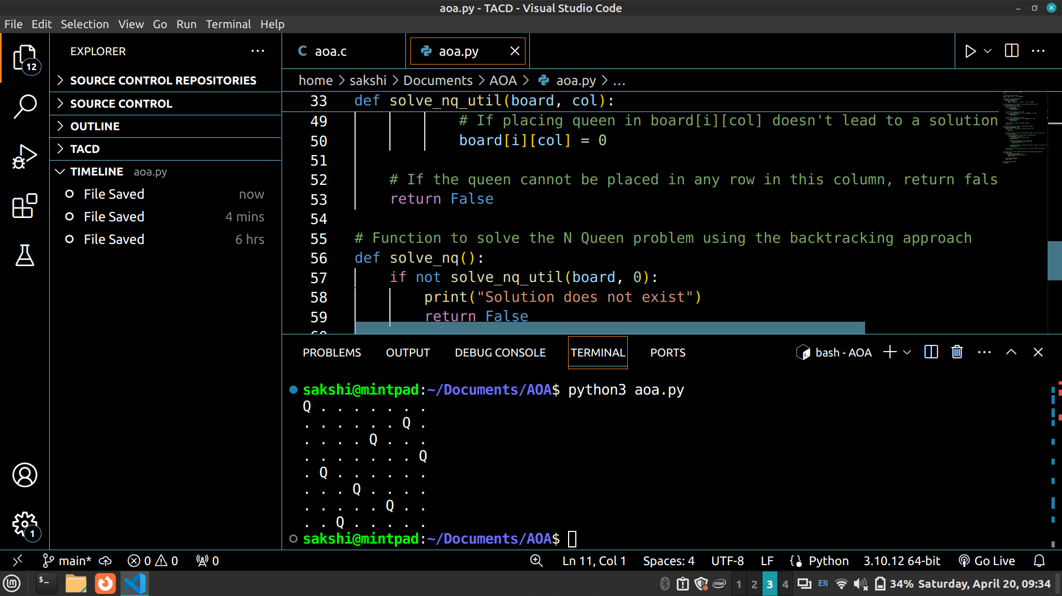

Analysis of Backtracking solution:

Time Complexity: O(N!)
Auxiliary Space: O(N²)

CONCLUSION:

The implementation of the N-Queens problem using the backtracking algorithm provides a solution for placing N queens on an N×N chessboard such that no two queens threaten each other. This problem is significant in demonstrating the backtracking strategy for problem-solving and analyzing the efficiency of algorithms.

