Tutorial Number 4

Name: SAKSHI RAUT
Batch: B3
Roll Number: 16010122158
Date: 06/03/2024

Question 1
If X is Binomial Distribution B(n,p) where n=40 p=0.25
Write R-program to evaluate and print
(i) P(X=35)
(ii) P(X≤24)
(iii) P(X≥37)

Code
a=dbinom(35,40,0.25)
b=pbinom(24,40,0.25)
c=1-pbinom(36,40,0.25)
cat("P(X=35)=",a)
cat("P(X≤24)=",b)
cat("P(X≥37)=",c)
cat("Name & Roll No","Sakshi Raut & 16010122158")

Output
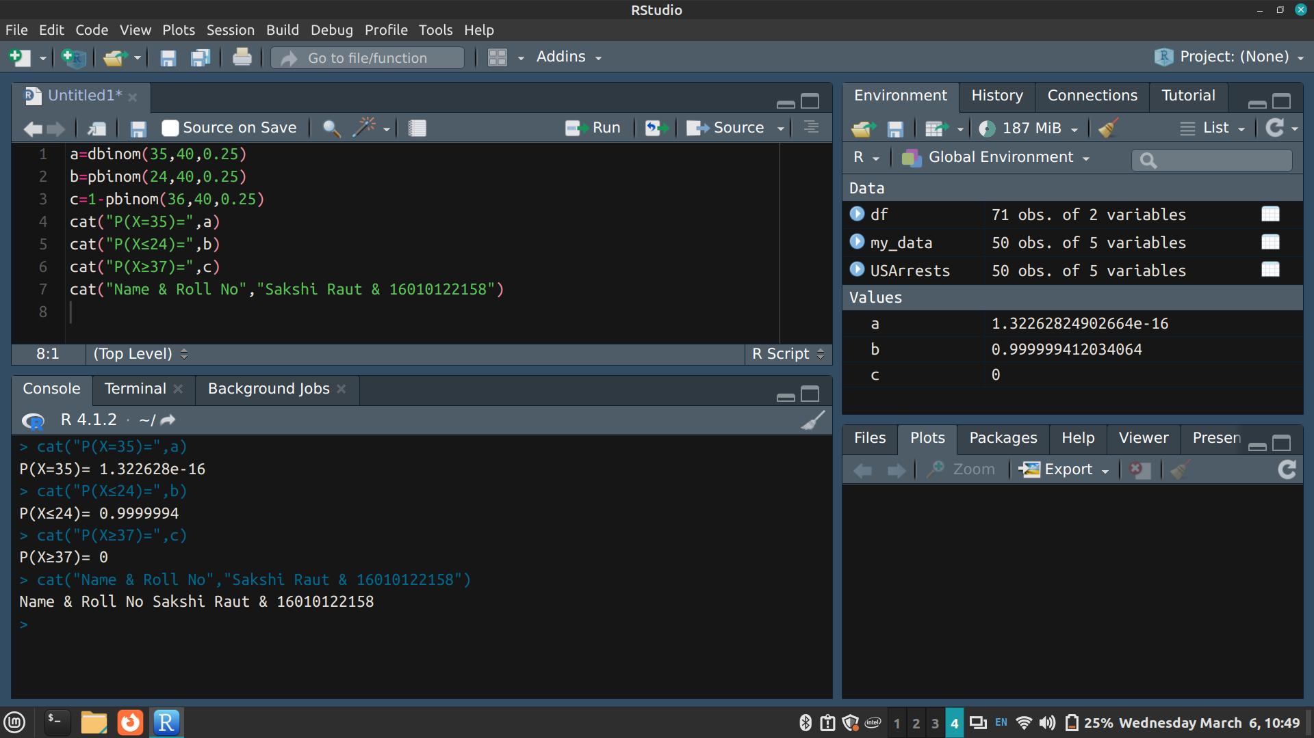

Question 2
If X is Poisson Distribution with mean 12
Write an R-program to evaluate and print
(i) P(X=5)
(ii) P(X≤8)
(iii) P(5≤X≤15)

Code
m=12
a=dpois(5,m)
b=ppois(8,m)
c=ppois(15,m)-ppois(5,m)
cat("P(X=5)=",a)
cat("P(X≤8)=",b)
cat("P(5≤X≤15)=",c)
cat("Name & Roll No","Sakshi Raut & 16010122158")

Output
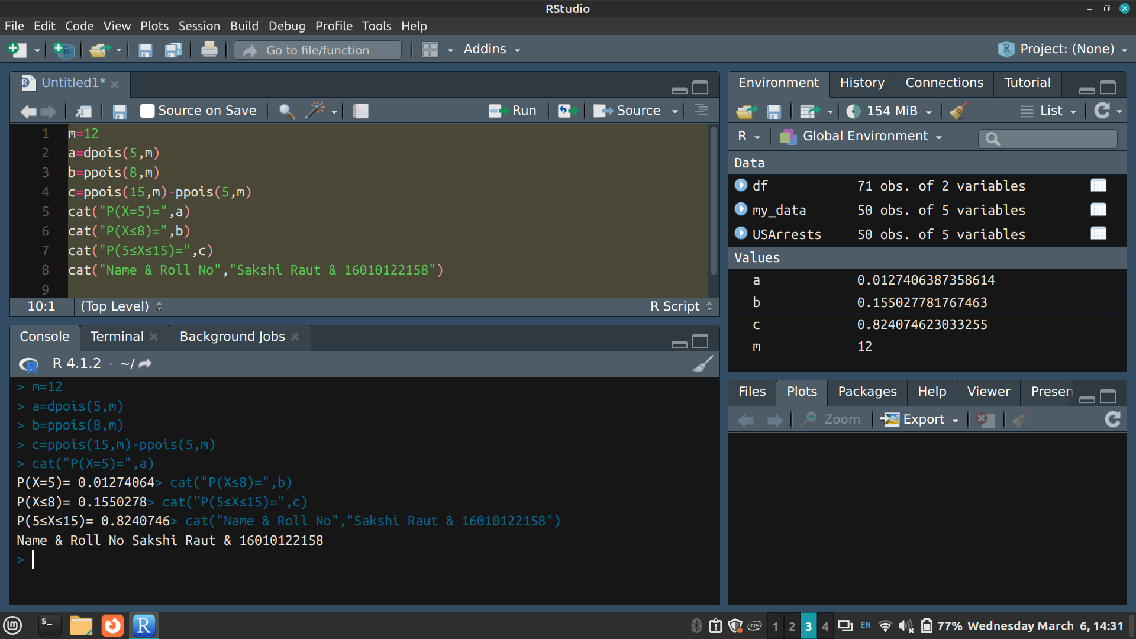

Question 3
If X is Uniform Distribution over the range (1,20). Write R-program to evaluate and print
(i) P(X<15.2)
(ii) P(X>12.9)
(iii) P(1.2<X<16.5)

Code
a=punif(15.2,1,20)
b=1-punif(12.9,1,20)
c=punif(1.2,1,20)-punif(16.5,1,20)
cat("P(X<15.2)=",a)
cat("P(X>12.9)=",b)
cat("P(1.2<X<16.5)=",c)
cat("Name & Roll No","Sakshi Raut & 16010122158")

Output
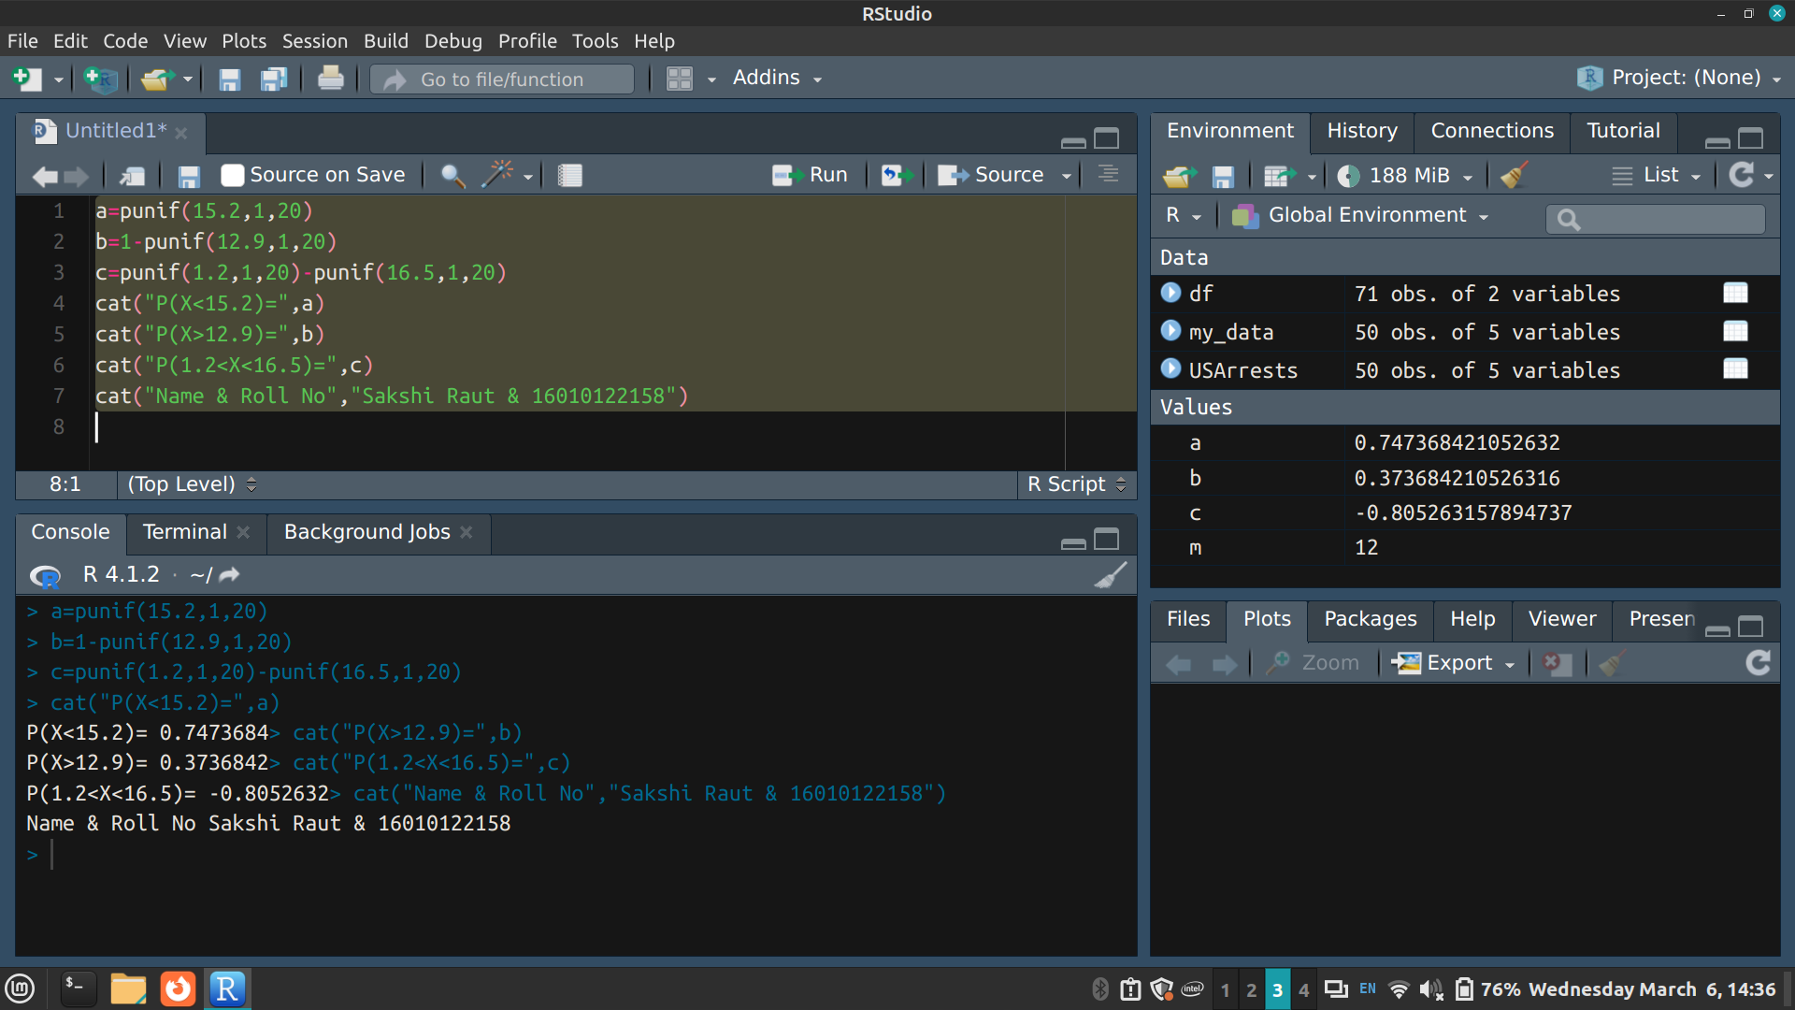

Question 4
If X is Exponential Distribution with mean 10. Write R-program to evaluate and print
(i) P(X<5)
(ii) P(X>3)
(iii) P(4<X<6)
Find value of k such that P(X<k) = 0.4

Code
pa=1/10
a=pexp(5, pa)
b=1-pexp(3, pa)
c=pexp(6, pa)-pexp(4, pa)
k=qexp(.4, pa)
cat("P(X<5)=", a)
cat("P(X>3)=", b)
cat("P(4<X<6).=", c)
cat("The value of k is ", k)
cat("Name & Roll No", "Sakshi Raut & 16010122158")

Output
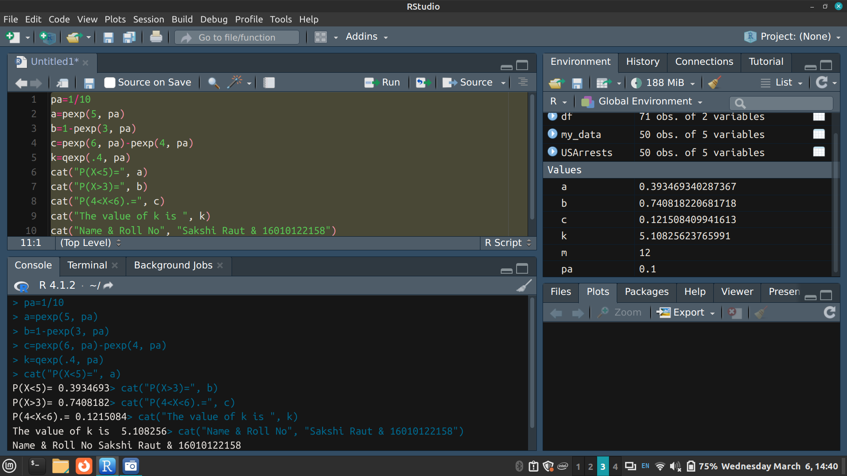

Question 5
If X is Normal Distribution with mean 6 and standard deviation 1.5.
Write an R-program to evaluate and print
(i) P(X<8)
(ii) P(X>3)
(iii) P(7< X<9).
Find the value of k1 such that P(X<k1) = 0.3.
Also find k2 such that P(X>k2) = 0.25

Code
a=pnorm(8,6,1.5)
b=1-pnorm(3,6,1.5)
c=pnorm(9,6,1.5)-pnorm(7,6,1.5)
k1=qnorm(.3,6,1.5)
k2=qnorm(.25,6,1.5)
cat("P(X<8) =", a)
cat("P(X>3) =", b)
cat("P(7<X<9)=", c)
cat("value of k1 such that P(X<k1) = 0.3 is ", k1)
cat("value of k2 such that P(X>k2) = 0.25 is", k2)
cat("Name & Roll No", "Sakshi Raut & 16010122158")

Output
