Tutorial 6
NAME: Sakshi Raut
BATCH: B3
ROLL NO.: 16010122158
DATE: 13/03/2024
Question 1
A study on the compressive strength of 12 concrete blocks resulted in the following values : 38, 40, 36, 41, 37, 38, 40, 39, 42, 38 and 41 MPa.
Investigate if the compressive strength of the concrete blocks can be assumed to be 39 MPa.
Code
pm = 39 # population mean
x <- c(38, 40, 36, 41, 37, 38, 40, 39, 42, 38, 41)
smean=mean(x) # sample mean
sdeviation=sd (x) # sample sd
n = 11 # size of sample
tcal = abs((smean-pm)/(sdeviation/sqrt(n-1)))
cat("absolute value of t-calculated is ",tcal)
cat("Name & Roll No","Sakshi Raut & 16010122158")

R Studio Screenshot
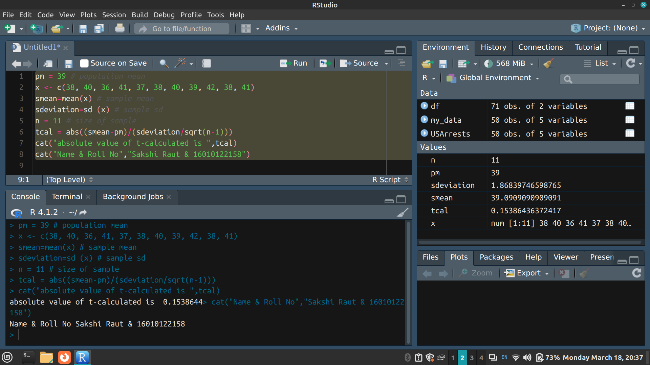

Answer
H₀: µ = 39.
H₁: µ ≠ 39 (Nature of the test is two-tailed)
LOS is 5% and dof = n - 1 = 11 - 1 = 10
Table value of t at 5% significance level for a two-tailed test with 11 degrees of freedom is approximately 2.228
t_{cal} ≈ 0.1538644
t_{cal} < t_{α}
H₀ is accepted
Thus we can conclude that the compressive strength of the concrete blocks can be assumed to be 39 MPa

Question 2
Test the significance of the difference between the means of two normal populations with the same standard deviation from the following data.

 | Size | Mean | St. Dev
Sample-1 | 50 | 125 | 26
Sample-2 | 60 | 130 | 28

Code
sm1 = 125 # mean for sample 1
sm2 = 130 # mean for sample 2
sd1 = 26 # standard deviation of sample1
sd2 = 28 # standard deviation of sample2
n1 = 50 # size of sample 1
n2 = 60 # size of sample 2
zcal = abs((sm1-sm2)/sqrt((sd1^2/n2)+(sd2^2/n1)))
cat("absolute value of z-calculated is ",zcal)
cat("Name & Roll No","Sakshi Raut & 16010122158")

R Studio Screenshot
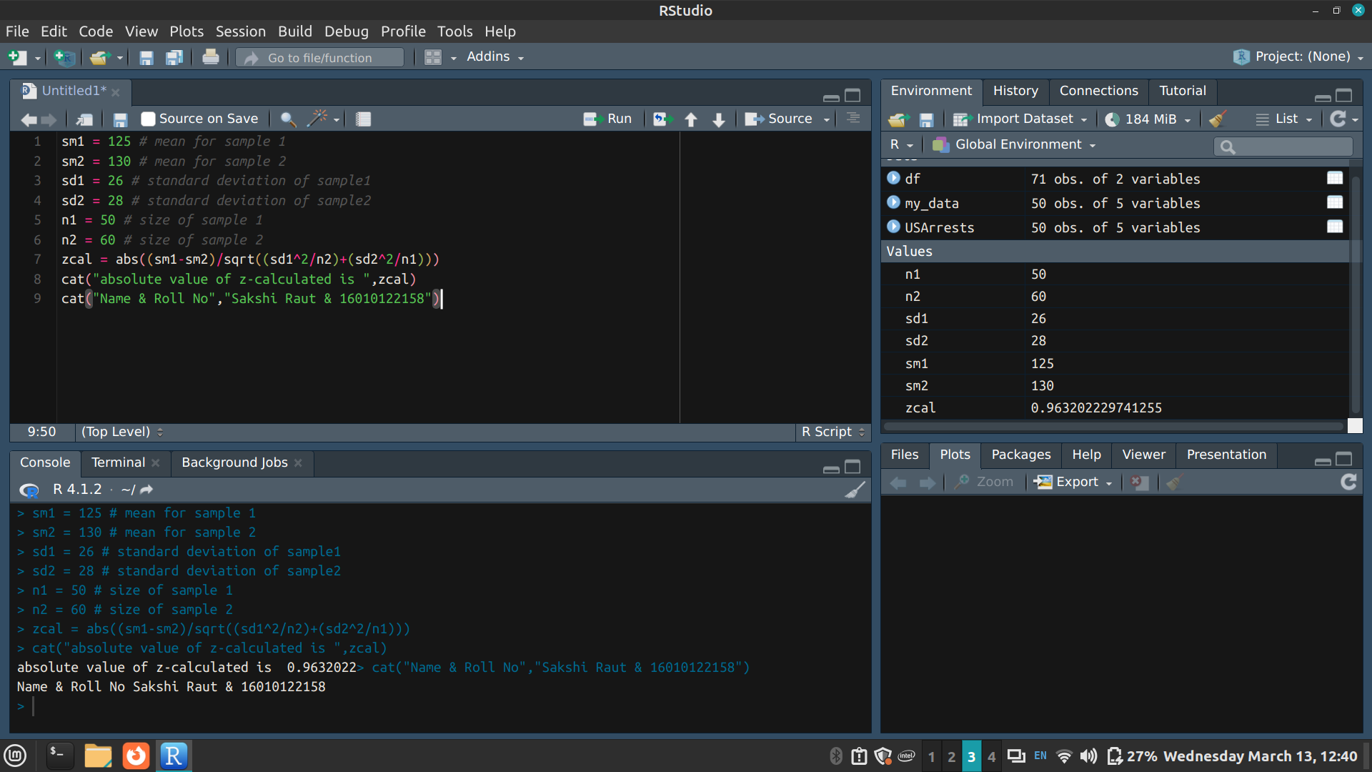

Answer
H₀: µ₁= µ₂
H₁ : µ₁ ≠ µ₂ (Nature of the test is two-tailed)
LOS is 5%
Table value of Z_{α} is 1.96
Calculated value of Z: Z_{cal}= 0.9632022
Z_{cal} < Z_{α} thus H₀ is accepted
We can say that the difference between the population means is not significant

Question 3
The GPAs of seven randomly selected students in a class are recorded: 3.2, 3.5, 3.7, 3.8, 3.9, 4.0, 4.1. The GPAs of twelve randomly selected graduates from a neighboring university are recorded: 3.0, 3.1, 3.2, 3.4, 3.6, 3.8, 3.9, 4.0, 4.1, 4.2, 4.3, 4.5. Can it be determined whether, on average, graduates have higher GPAs than students in the class?

Code
x1 <- c(3.2, 3.5, 3.7, 3.8, 3.9,4.0, 4.1)
x2 <- c(3.0, 3.1, 3.2, 3.4, 3.6, 3.8, 3.9, 4.0, 4.1, 4.2, 4.3, 4.5)
sm1 = mean (x1) # mean for sample 1
sm2 = mean (x2) # mean for sample 2
sd1 = sd(x1) # standard deviation of sample1
sd2 = sd(x2) # standard deviation of sample2
n1= 7 # size of sample 1
n2= 12 # size of sample 2
tcal= abs((sm1-sm2)/sqrt(((n1*sd1^2+n2*sd2^2)/(n1+n2-2))*((1/n1)+(1/n2))))
cat("absolute value of t-calculated is ", tcal)
cat("Name & Roll No","Sakshi Raut & 16010122158")

R Studio Screenshot
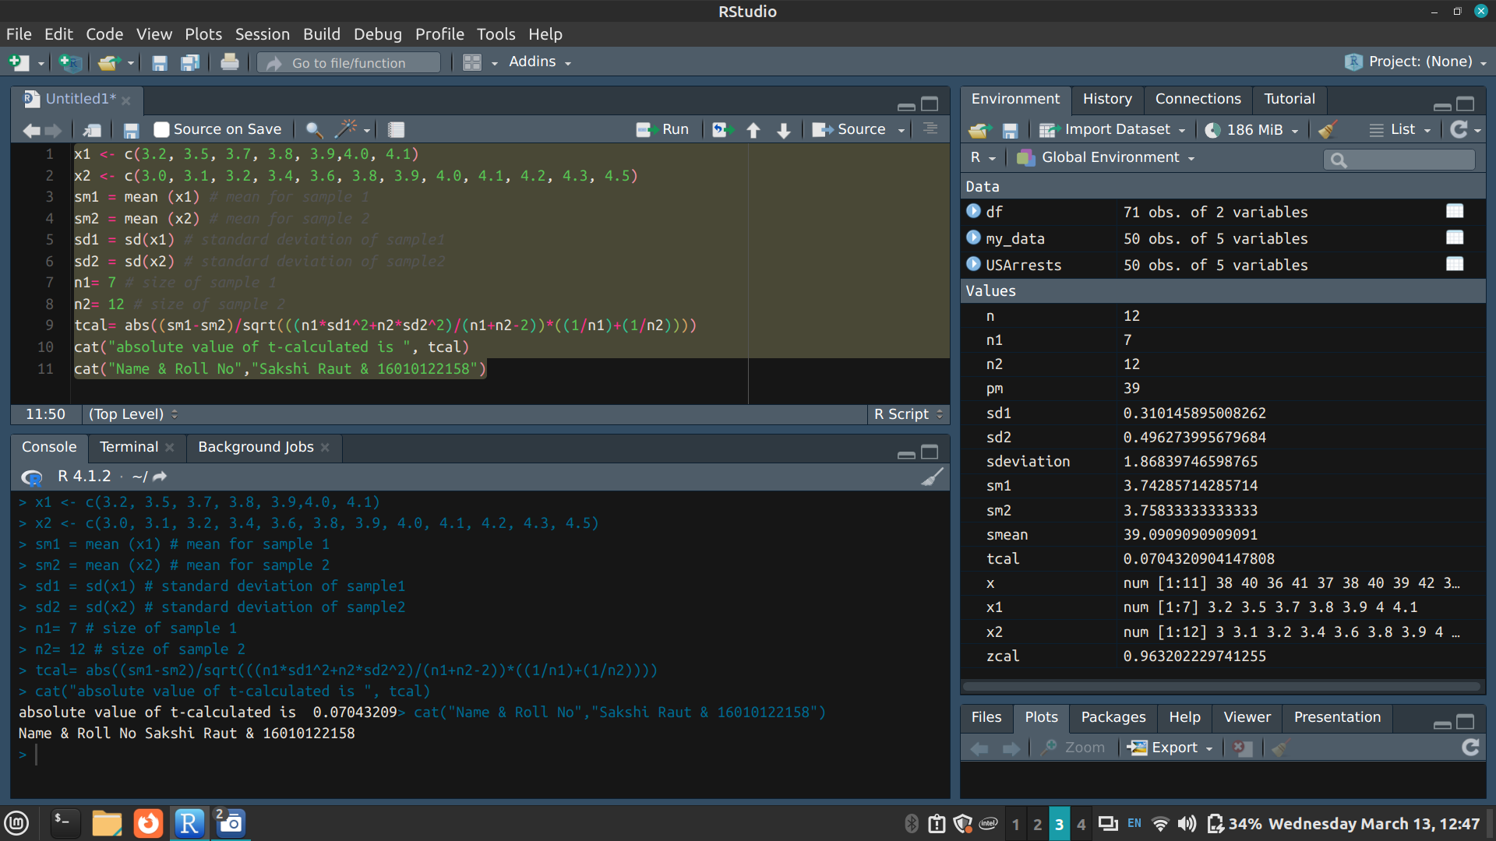

Answer
H₀: µ₁= µ₂
H₁ : µ₁ ≠ µ₂ (Nature of the test is one-tailed)
LOS is 5% dof = 7 + 12 - 2 = 17
Table value of t_{α} is 1.740
Calculated value of t: t_{cal} = 0.07043209
t_{cal} < t_{α}
H₀ is accepted
Thus on average, graduates do not have higher GPAs than students in the class

