Roll No: 16010122158 Batch: B3

Experiment No.01

Title: Problem Definition and Design of Extended-Entity-Relationship diagram

Objective: To define a Database Problem and Design an EER diagram for a business domain.

Expected Outcome of Experiment:
CO 1: Design entity-relationship diagrams to represent different database application scenarios.

Books/ Journals/ Websites referred:
- G. K. Gupta :”Database Management Systems”, McGraw – Hill
- Korth, Slberchatz, Sudarshan : “Database Systems Concept”, 6th Edition , McGraw Hill
- Elmasri and Navathe, “Fundamentals of Database Systems”, 5thEdition, PEARSON Education.

Dia Software: A software to Design ER Model

Dia is one of the convenient open source tool which runs on multiple platforms including Linux, Windows and MacOS. Dia has a number of "sheets" each of which includes diagram objects for different modeling tools, such as UML, ER diagrams, flowcharts, etc.
The ER tool has objects for entities, relationships, attributes (using the oval notation), edges, and so on. The properties boxes for each of these elements allow you to specify cardinality constraints, total participation, identifying relationship, etc.
It supports many common formats to store diagrams such as jpeg, png, eps, etc.

Pre Lab/ Prior Concepts:
The ER data model was developed to facilitate the database design by allowing specification of an enterprise schema that represents the overall logical structure of the database. The ER model is one of the several data models. The semantic aspect of the model lies in its representation of the meaning of the data. The ER model is very useful many database design tools drawn on concepts from the ER model. The ER model employs 3 basic notations: entity set, relationship set and attributes.

Symbols Used in ER Notation

Sr. No. | Diagram | Explanation
 | Entity | Entity set: An entity is a set of entities of the same type that share the properties or attributes.
 | Entity | Weak entity set: An entity set may not have sufficient attributes to form a primary key. Such an entity set is termed as weak entity set
 | R | Relationship Set: A relationship is an association among several entities. A relationship set is a set of relationship of the same type.
 | R | Identifying relationship set for weak entity set: The relationship associating the weak entity set with the
 | A | Primary key: The primary key is used to denote a candidate key that is chosen by the database designers as the principal means of identifying entities within an entity set.
 | R  1  N | One to Many Relationship
 | R  1  1 | One to One relationship
 | A | Attribute
 | A | Multi valued

Extended Entity Relationship Diagram:
The EER model includes all of the concepts introduced by the ER model. Additionally it includes the concepts of a subclass and superclass (Is-a), along with the concepts of specialization and generalization. Furthermore, it introduces the concept of a union type or category, which is used to represent a collection of objects that is the union of objects of different entity types. EER model also includes EER diagrams that are conceptual models that accurately represent the requirements of complex databases.

Example Case Study: List the data requirements for the database of the company which keeps track of the company employee, department and projects. The database designers provide the following description

  - The company is organized into departments. Each department has unique name, unique number, and particular employee to manage the department. We keep track of the start date and the employee begins managing the department. The department has several locations.
  - The department controls a number of projects each of which has a unique name, unique number and a single location.
  - We store each employee names social security number, address, salary, sex and dob. An employee is assigned one department but may work on several projects which are not necessarily controlled by the same department. We keep track of the department of each employee works on each project and for insurance purpose. We keep each dependents first name, gender, date of birth and relation.

Procedure for doing the ER diagram experiment

- Identifying the Entities (Strong and weak entities)

- Identify attributes of the Entity (keys, partial key, simple, composite, multivalued, derived)

- Identify relationship(recursive)

- Identify the structural constraints of the relationship (cardinality ratio, participation constraints)

Sample ER- Diagram for company Case Study Database:
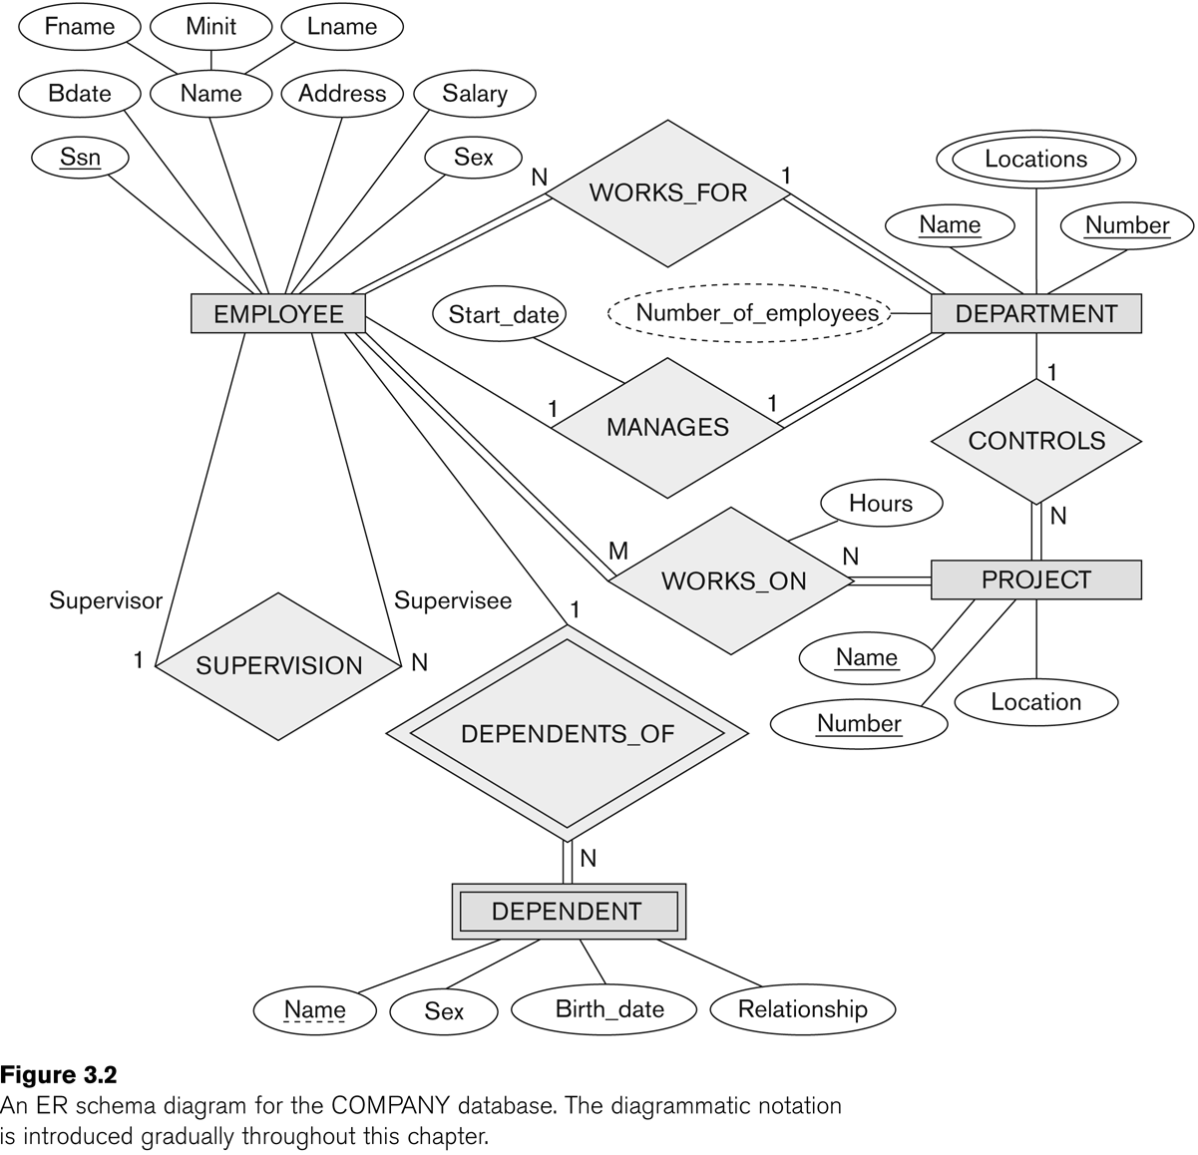
E R Diagram of Company Database

Problem Definition:
Design an EER diagram for a Hospital Management System.

Design of EER:
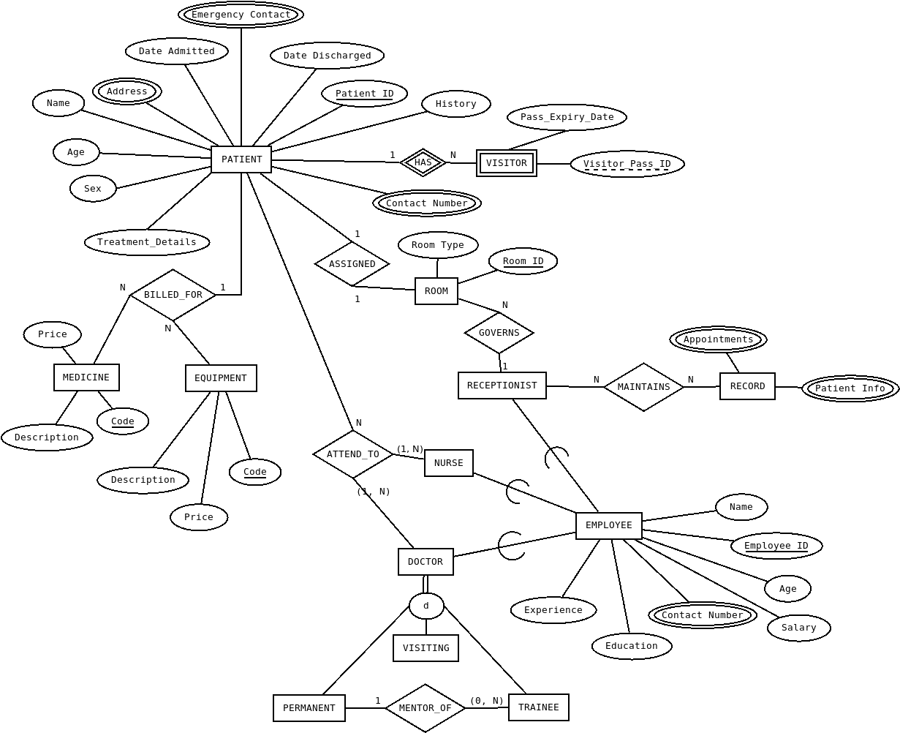

Post Lab Descriptive Questions:
- In the Academic database a Grade is issued to each STUDENT for each COURSE taken and stored in the STUDENT COURSE DETAIL entity. A STUDENT may decide to re-take a COURSE to better their GRADE. The administration would like to keep a record of the old/previous Grade as well as the new Grade. Show ER diagram to include historical Grades if the students should have them.
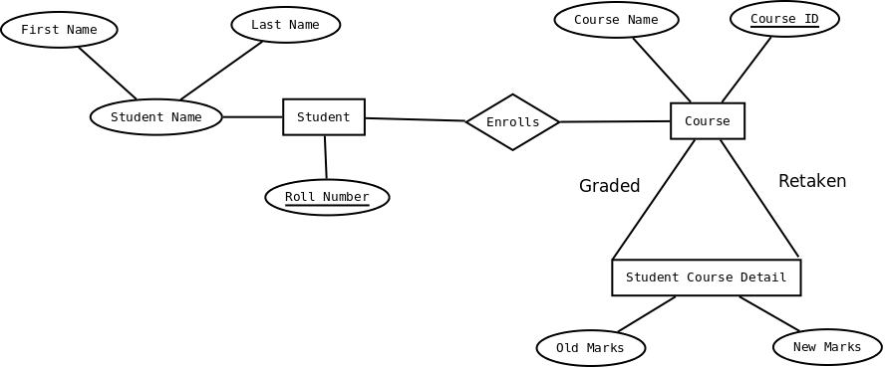

- Discuss the concept of aggregation. Give an example. How to represent aggregation in ER model (if aggregation is not supported in EER diagram).

Aggregation:

Aggregation is a concept used to represent a "whole-part" relationship between two objects. It is a form of association where one class represents a collection or container of another class. Aggregation implies a relationship where the child can exist independently of the parent.

Example of Aggregation:

Consider the relationship between a university and its departments. A university consists of various departments such as Computer Science, Physics, and Mathematics. Each department, however, can exist independently of the university. This relationship can be modeled using aggregation, where the university is the whole and the departments are parts.

In this example, the University class has an aggregation relationship with the Department class. The university is composed of multiple departments, but each department can exist on its own.

Aggregation in ER Model:

a. Use Standard Entities and Relationships:
Represent the "whole" and "part" entities separately.
Connect them with a relationship line, specifying the nature of the relationship.

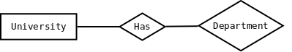

b. Cardinality Notation:
Use cardinality notation to indicate the number of instances of each entity that can be related.

In this example, "University" is connected to "Department" through a relationship labeled "Has," and the attributes {startDate, endDate} capture information about the aggregation. The cardinality notation indicates that a university can have zero or more departments, and each department belongs to exactly one university.

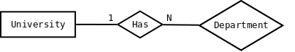

- Two separate banks which decide to merge. Both banks use same ER database schema(Assume the ER diagram). If the merged bank is to have a single database, there are several potential problems:
- The possibility that two original banks have branches with the same name
- The possibility that some customers are customers of both original banks
- The possibility that some loan or account numbers were used at both original banks

Discuss for each of these potential problems , why there is indeed potential difficulty in database based on ER model. Propose a solution to a problem. For your solution, explain any changes that would have to be made and describe what their effect would be on the ER database schema and the data.

a. Branches with the Same Name:
Potential Difficulty:
If both original banks have branches with the same name, it could lead to ambiguity and confusion in the merged database. Identifying and distinguishing between branches becomes challenging, potentially causing errors in transactions and reporting.

Solution:
One solution is to introduce a unique identifier for each branch, ensuring that even if branches have the same name, they have distinct identification numbers. This can be achieved by adding a branch ID attribute to the branch entity.

Effect on ER Database Schema:
The addition of a BranchID attribute to the Branch entity allows for unique identification of branches. This change ensures that even if two branches have the same name, they can be differentiated based on their unique identifiers.

b. Customers of Both Original Banks:

Potential Difficulty:
If some customers are customers of both original banks, merging the databases without addressing this could result in duplicate customer entries and data inconsistencies.

Solution:
To handle customers who are clients of both banks, merge their information into a single customer entry. Introduce a mapping table to establish a many-to-many relationship between customers and banks.

Effect on ER Database Schema:
The addition of the CustomerBankMapping table allows for a flexible representation of customers associated with multiple banks. It resolves the issue of duplicate entries and ensures accurate tracking of customer relationships with each bank.

c. Duplicate Loan or Account Numbers:

Potential Difficulty:
If loan or account numbers were used at both original banks, merging the databases without addressing this issue may lead to conflicts and difficulties in managing transactions.

Solution:
Introduce a unique identifier for each loan and account, ensuring that even if the same numbers were used in both banks, they become unique in the merged database.

Effect on ER Database Schema:
The addition of unique identifiers (LoanID and AccountID) to the Loan and Account entities ensures that each record is uniquely identified. This resolves conflicts arising from the use of the same loan or account numbers in both original banks.

CONCLUSION:
In this experiment, the objective was to define and solve a database problem by designing Enhanced Entity-Relationship (EER) diagrams using Dia software. The hands-on experience has let me skillfully represent a database application scenario, honing my proficiency in EER modeling for real-world business domains.

