Batch: B3 Roll No.: 16010122158

Experiment / assignment / tutorial No. 3

Grade: AA / AB / BB / BC / CC / CD /DD

Signature of the Staff In-charge with date

Title: : Implementation of Database in SQL -DDL

Objective: Define/modify database definitions with proper constraints
_____________________________________________________________
Expected Outcome of Experiment:
CO 2: Convert entity-relationship diagrams into relational tables, populate a relational
database and formulate SQL queries on the data Use SQL for creation and query the database.

CO 3: Define and apply integrity constraints and improve database design using normalization techniques.
_____________________________________________________________
Pre Lab/ Prior Concepts:

Pre Lab/ Prior Concepts:
Resources used: Postgresql

Theory: The set of relations in a database must be specified to the system by means of a data definition language (DDL). The SQL DDL allows specification of not only a set of relations but also specific information about the relation including,
- The schema for each relation
- The domain of values associated with each attribute
- The integrity constraints
- The set of indices to be maintained for each relation
- The security and authorization information for each relation
- The physical storage structure of each relation on disk

Syntax Create Table:
create table employee(
ssn,
fname varchar(10),
mname varchar(10),
lname varchar(10),
desg varchar(20),
gender varchar(5),
addr varchar(20),
bdate datetime,
sal float,
primary key(ssn)
);

create table manages(
ssn int,
dept_code int,
start_dt datetime,
foreign key(ssn) references employee,
foreign key(dept_code) references department,
key(ssn,dept_code)
) on delete set null; primary

Data Constraints
Business managers of the organization determine a set of rules that must be applied before the data is stored in the database. The application of such rules on raw data ensures data integrity.
Eg:- An employee belonging to the Sales department cannot have a salary higher than Rs. 1000.
An employee has an unique identification number.
Applying Data Constraints
Oracle permits data constraints to be attached to table columns using SQL syntax. Constraints can be attached to table columns using
Alter table
Unique Constraint
Unique Constraint- At column level Syntax
<ColumnName><Datatype>(<size>)
UNIQUE Unique Constraint- At table level
CREATE TABLE<TableName>(

<ColumnName><Datatype>(<size>)

<ColumnName><Datatype>(<size>)

<Columnname><Datatype>(<size>) UNIQUE(<ColumnName1>,<ColumnName2>);
SCREENSHOT OF CODE AND TABLE
CODE, SELECT, TABLE
Implementation Details (Problem Statement, Query and Screenshots of Results):
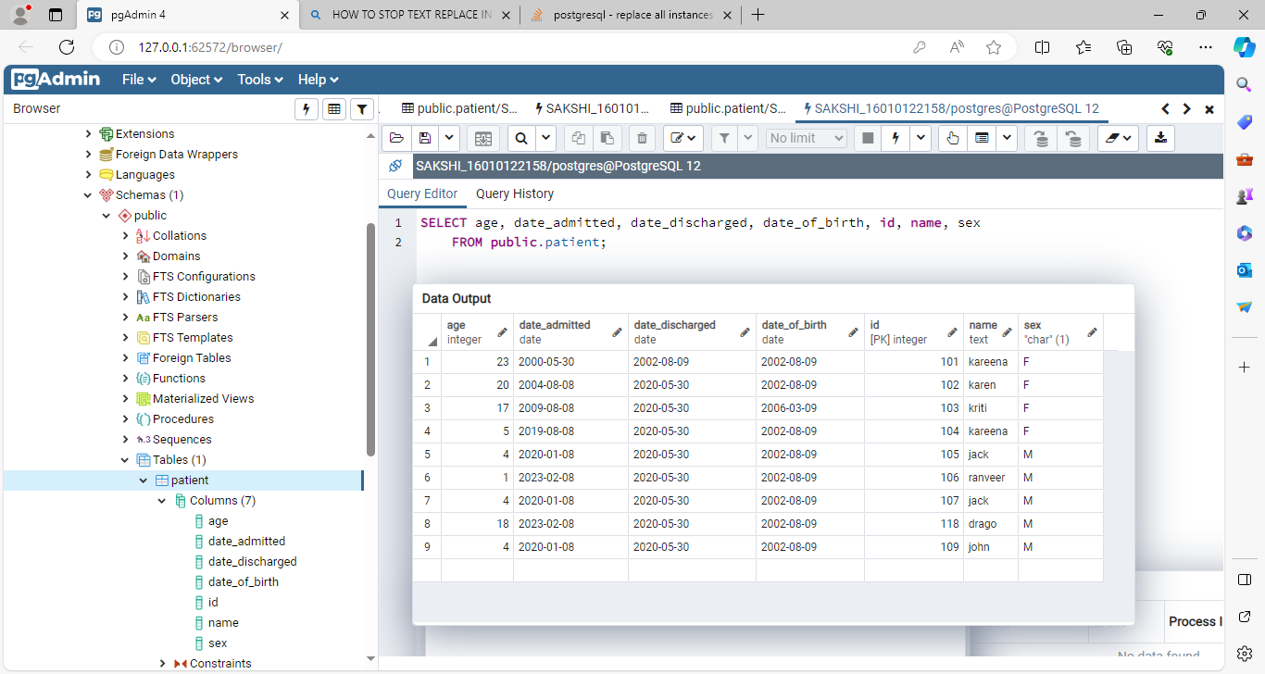

SCREENSHOTS
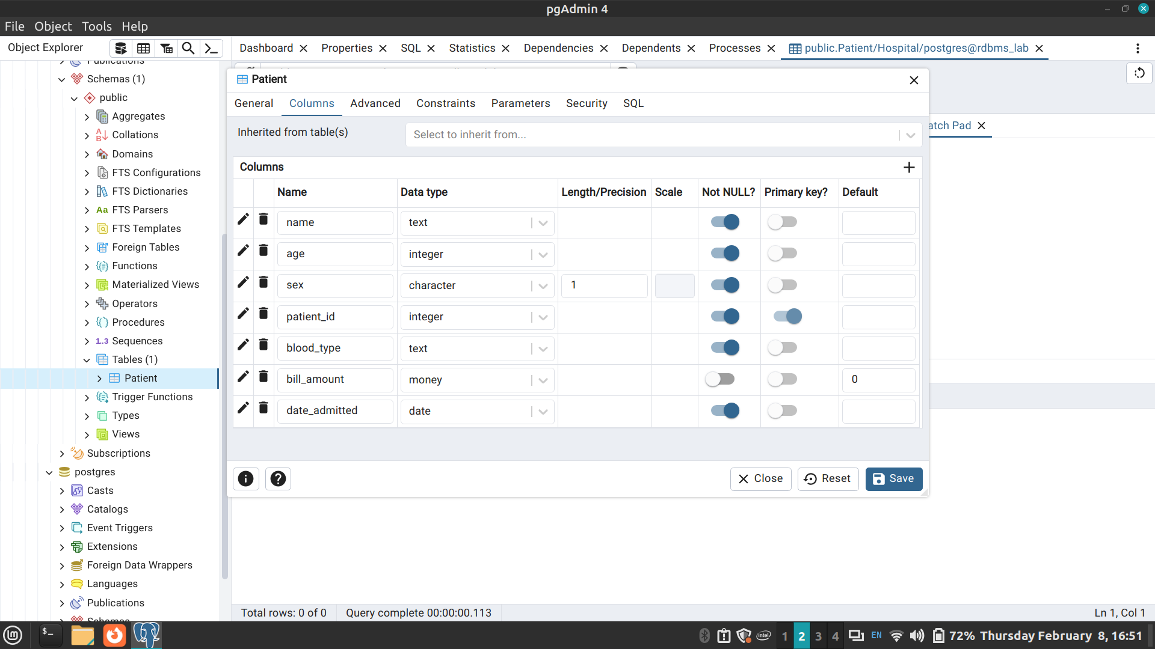
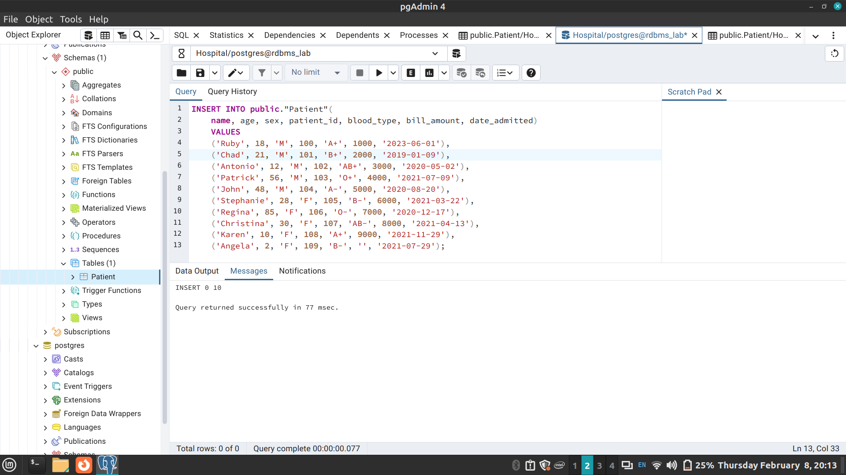
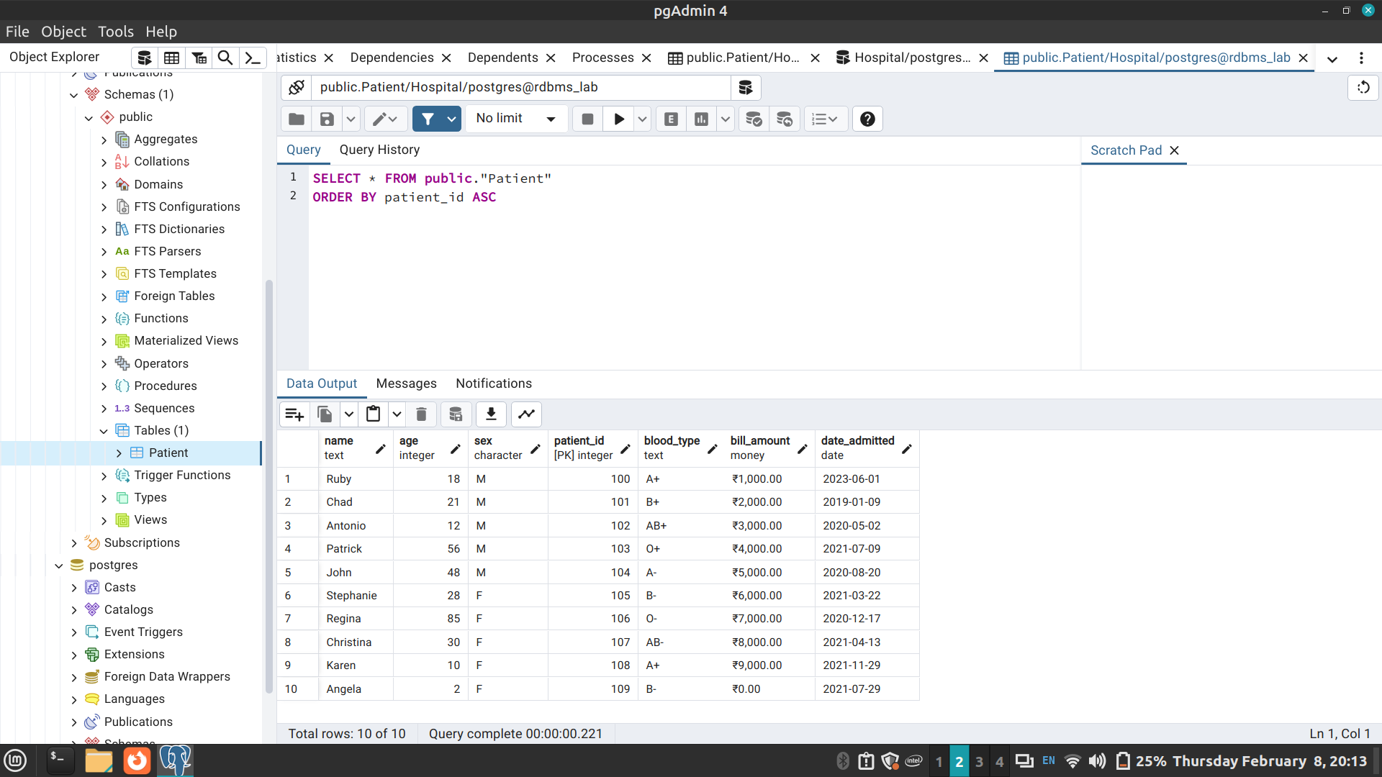
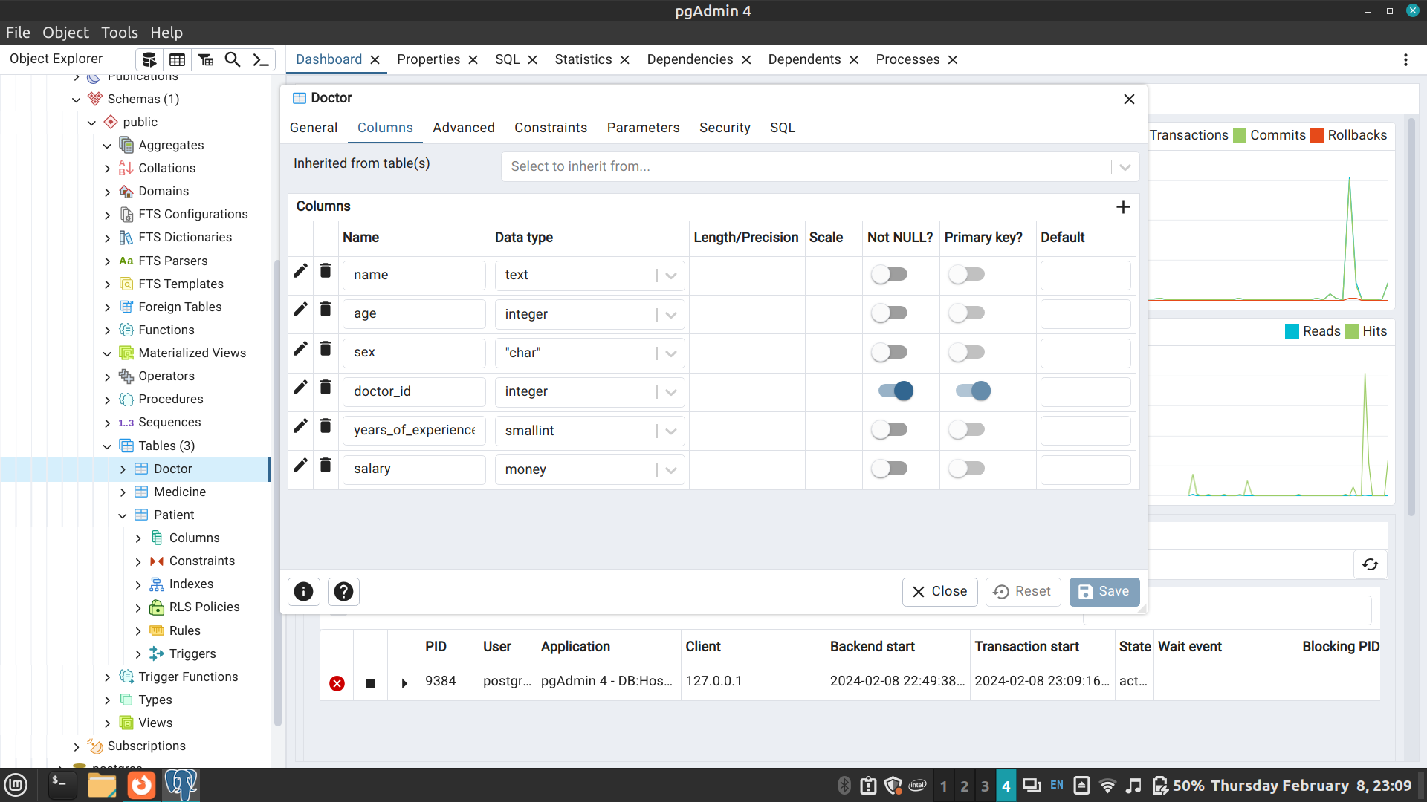
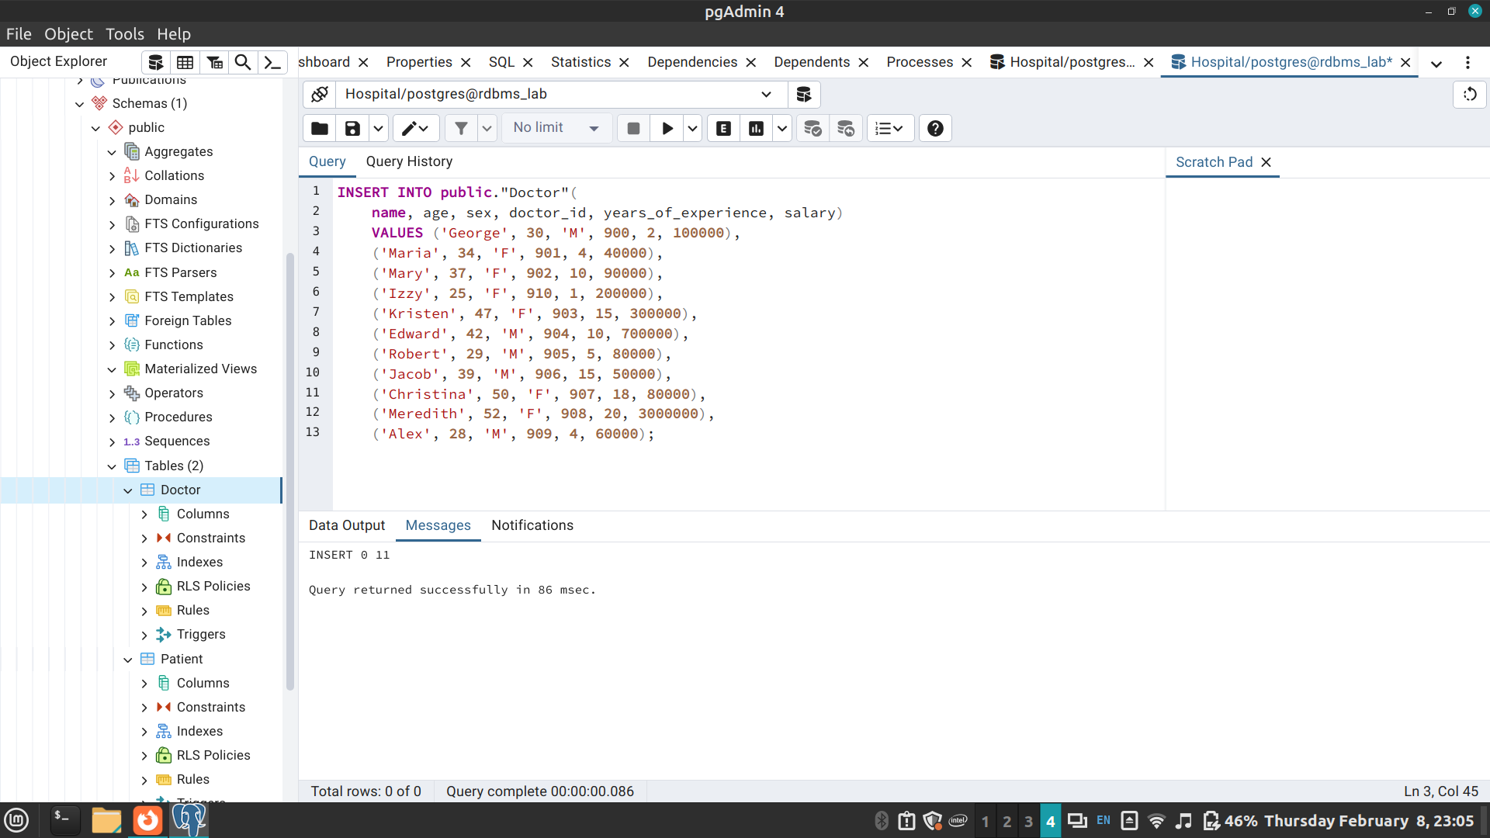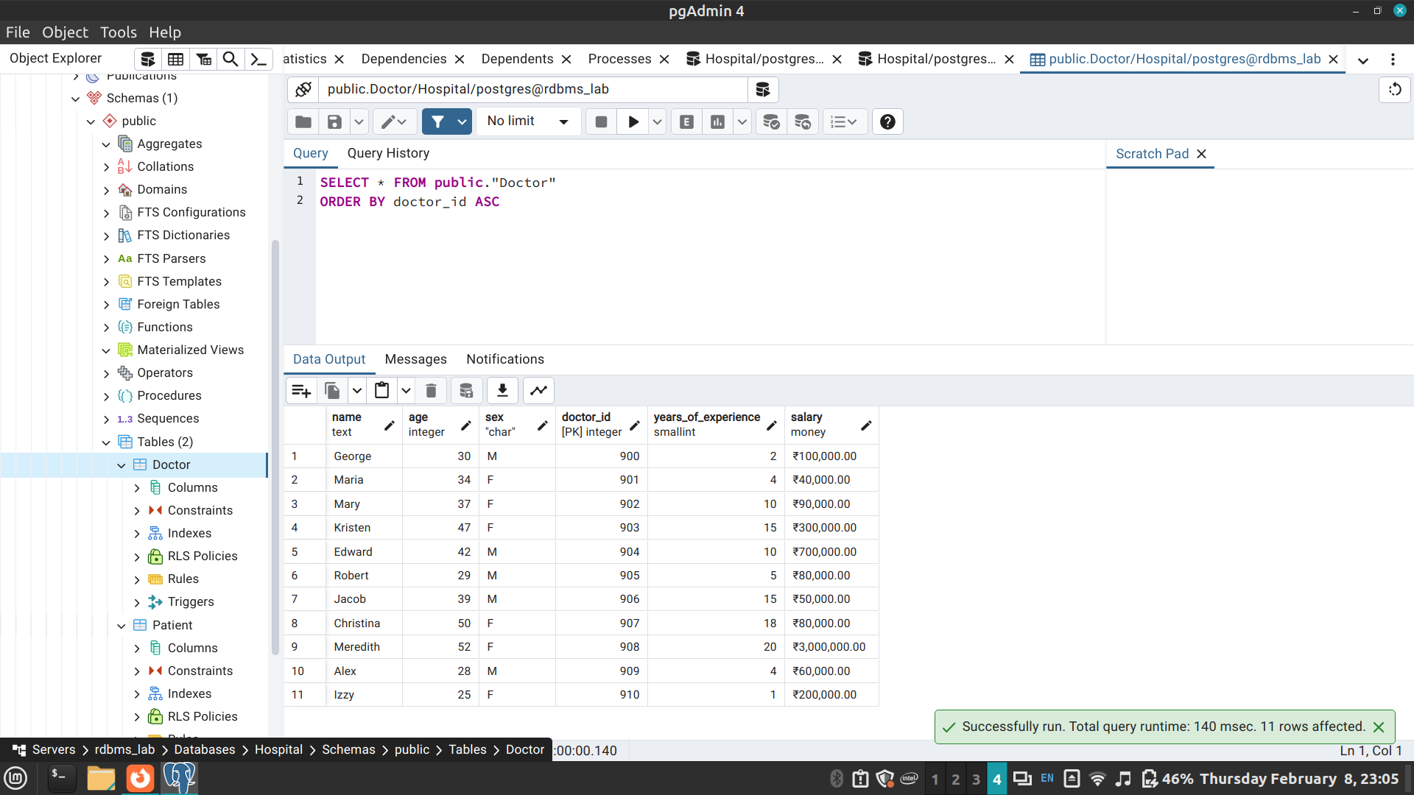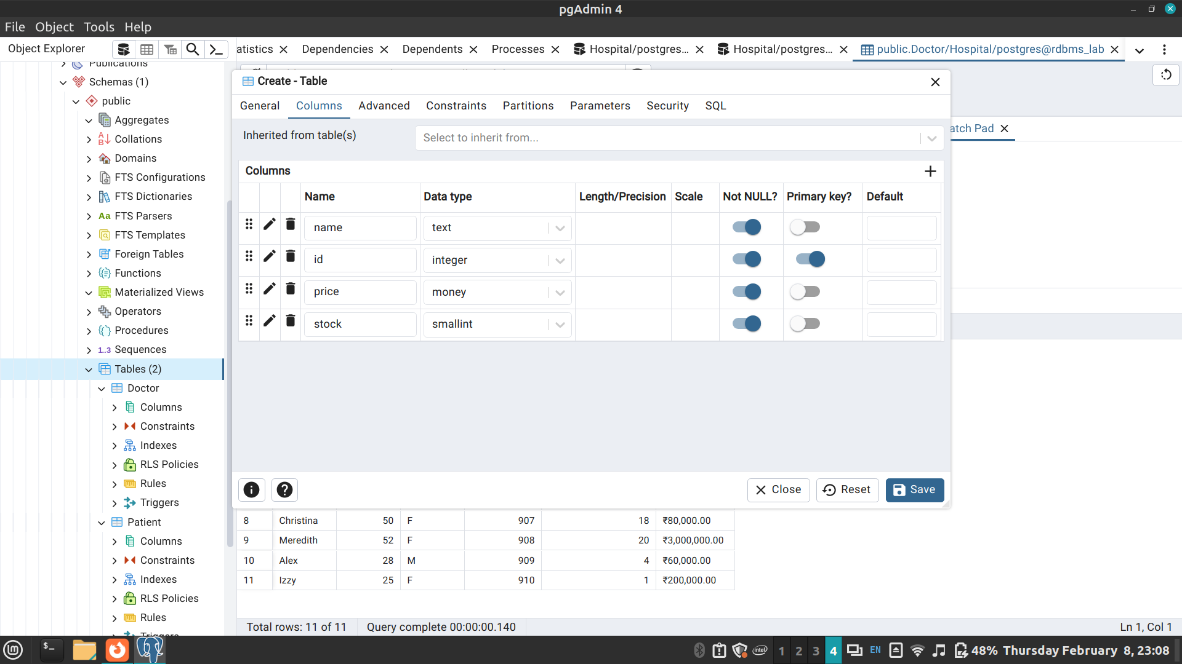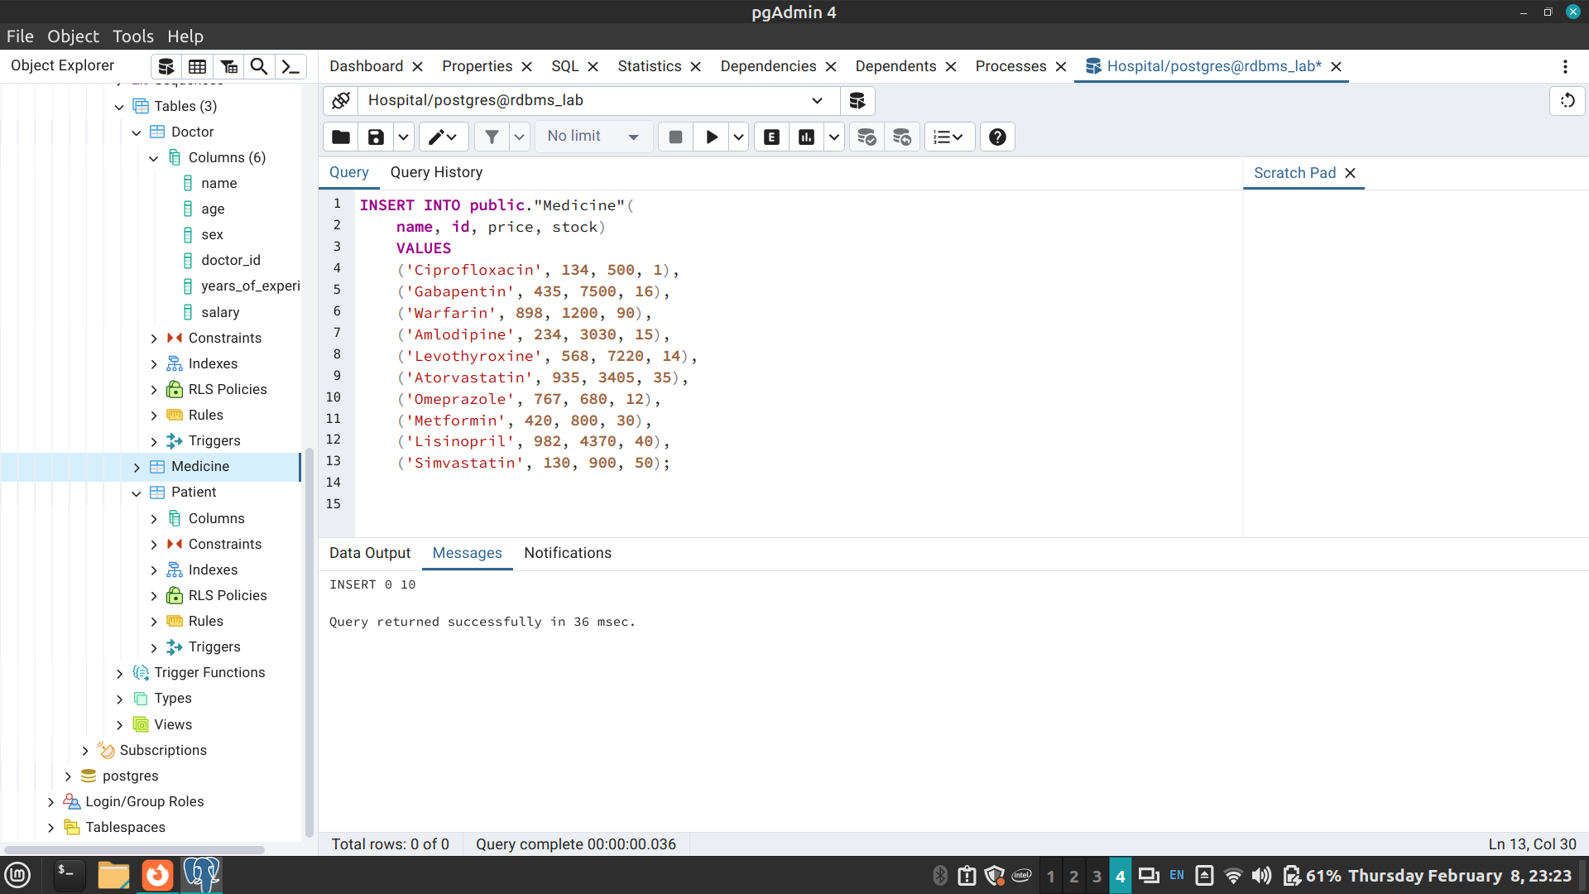
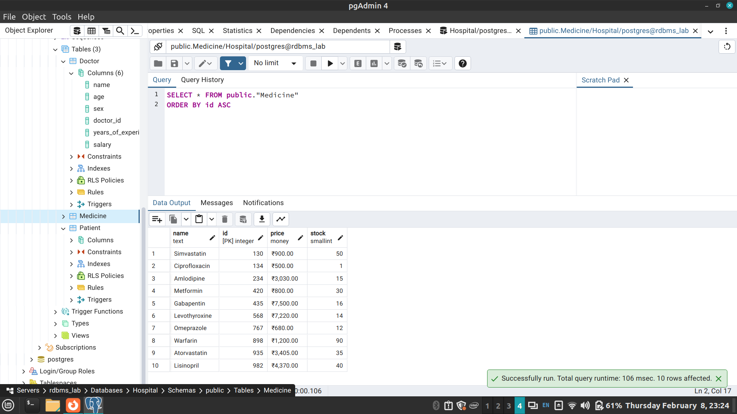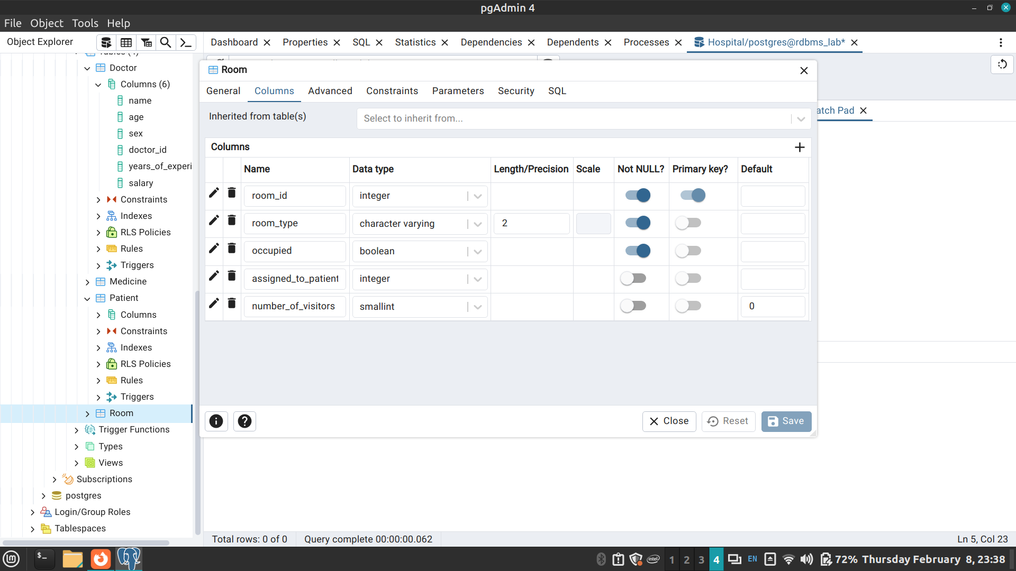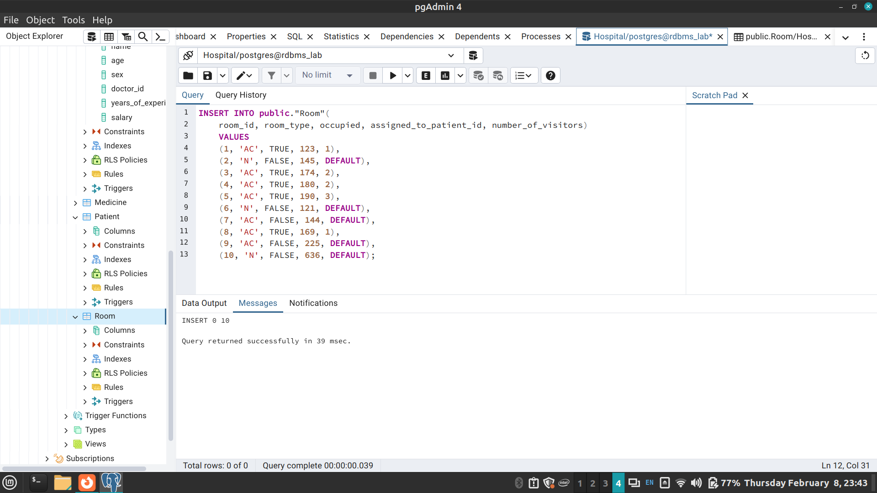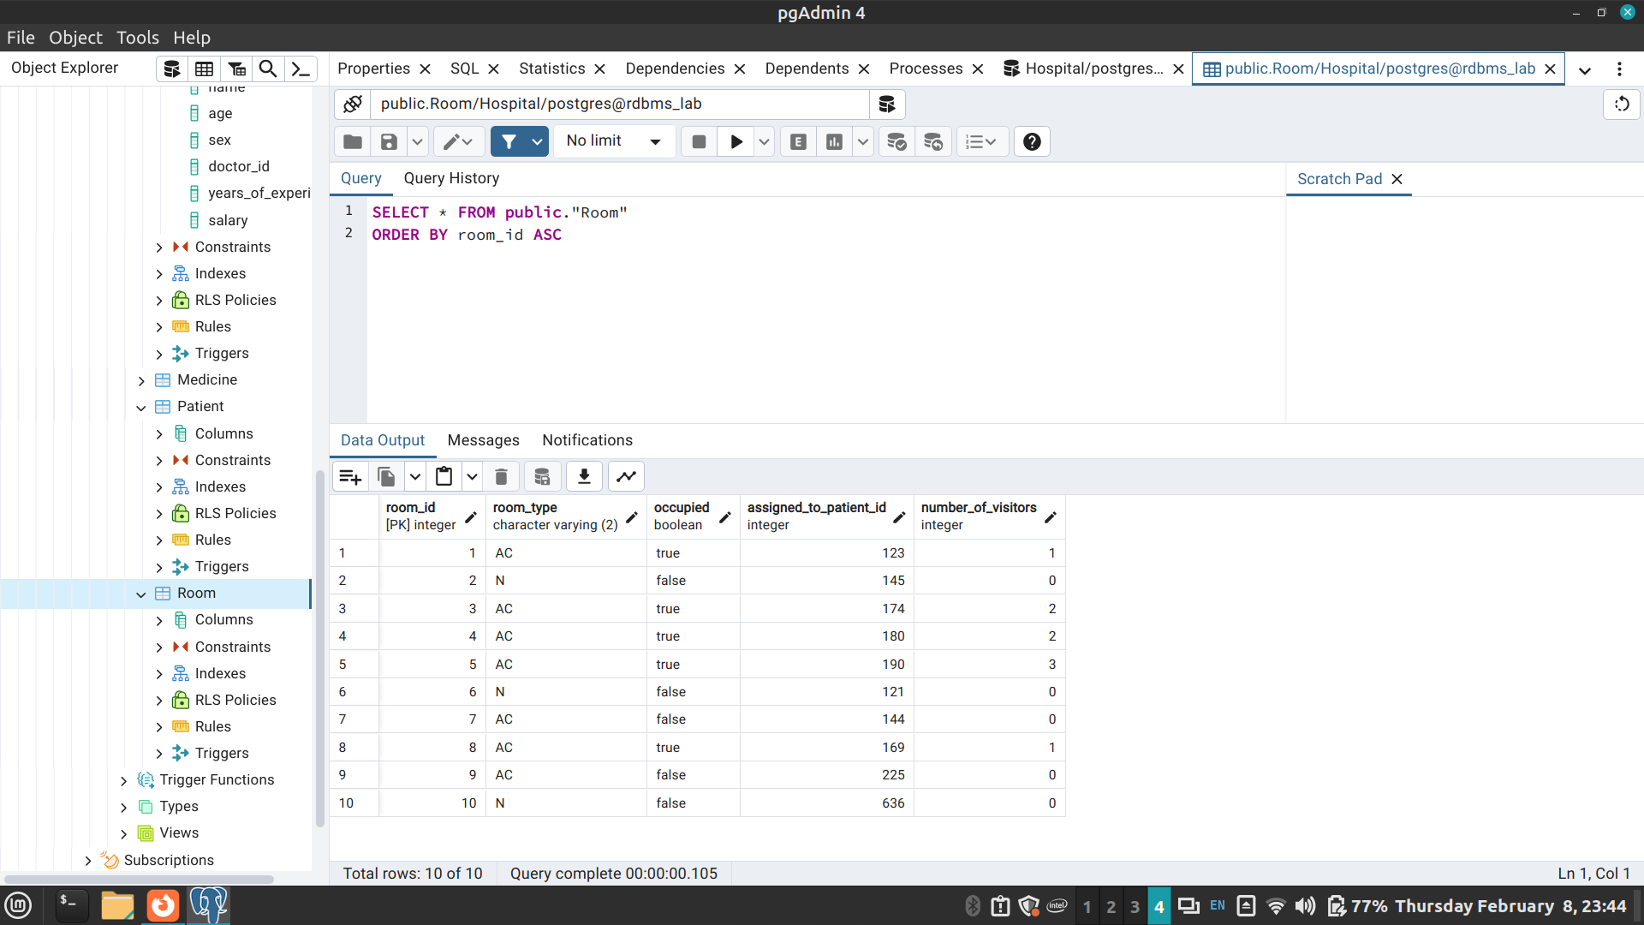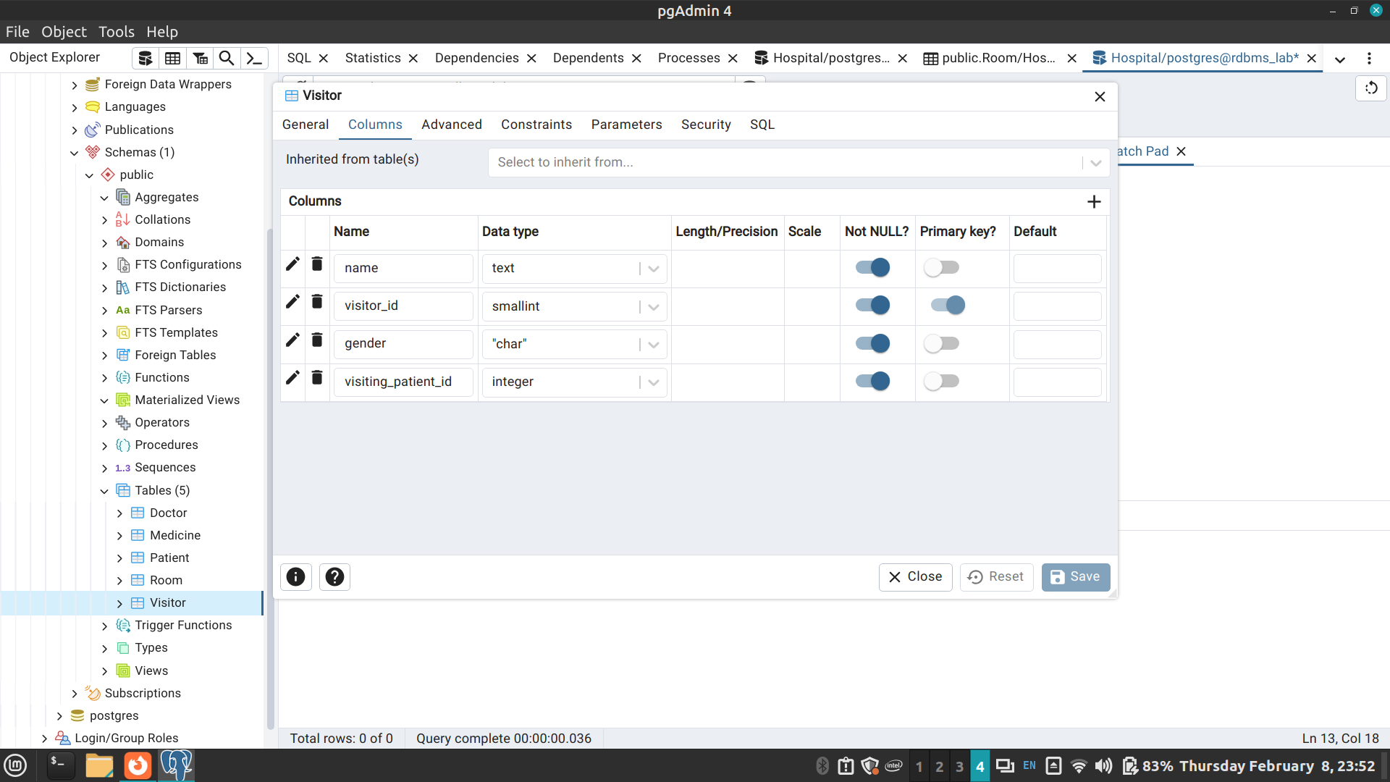
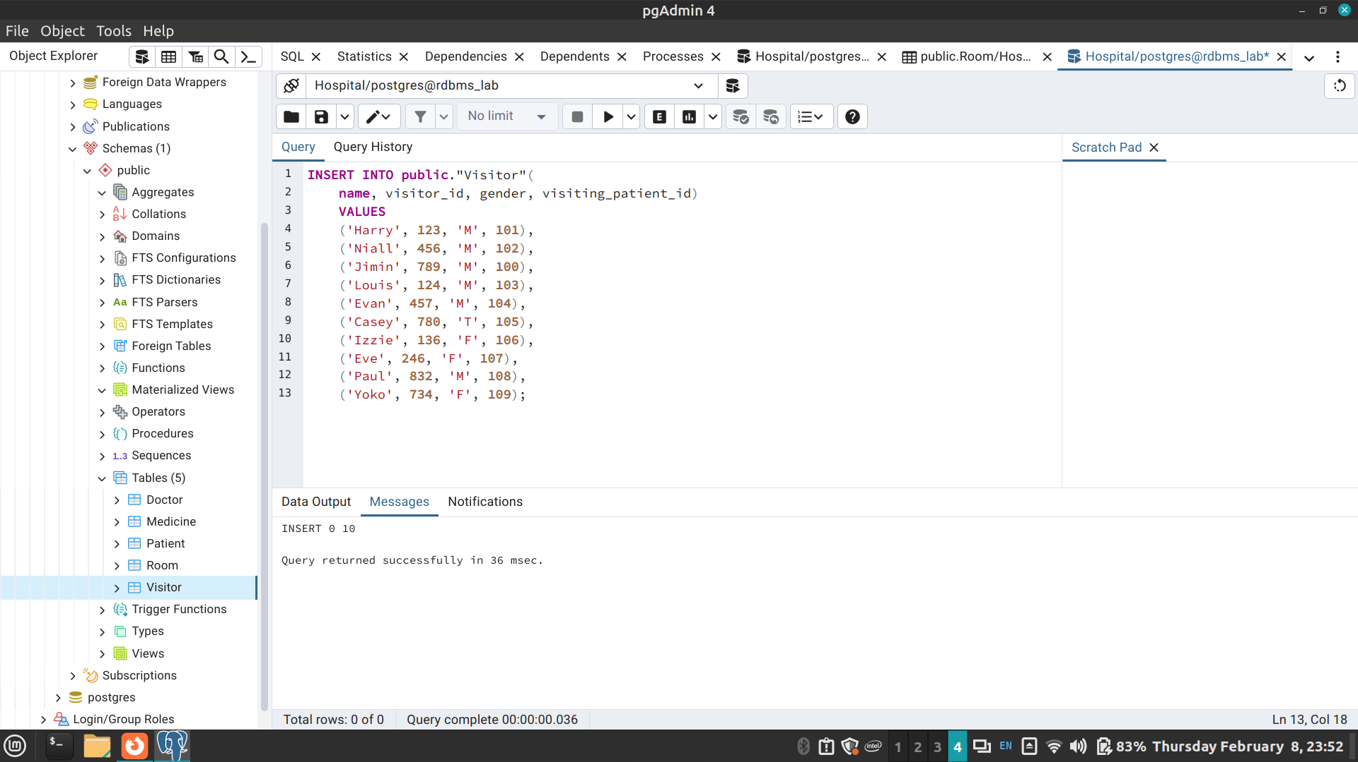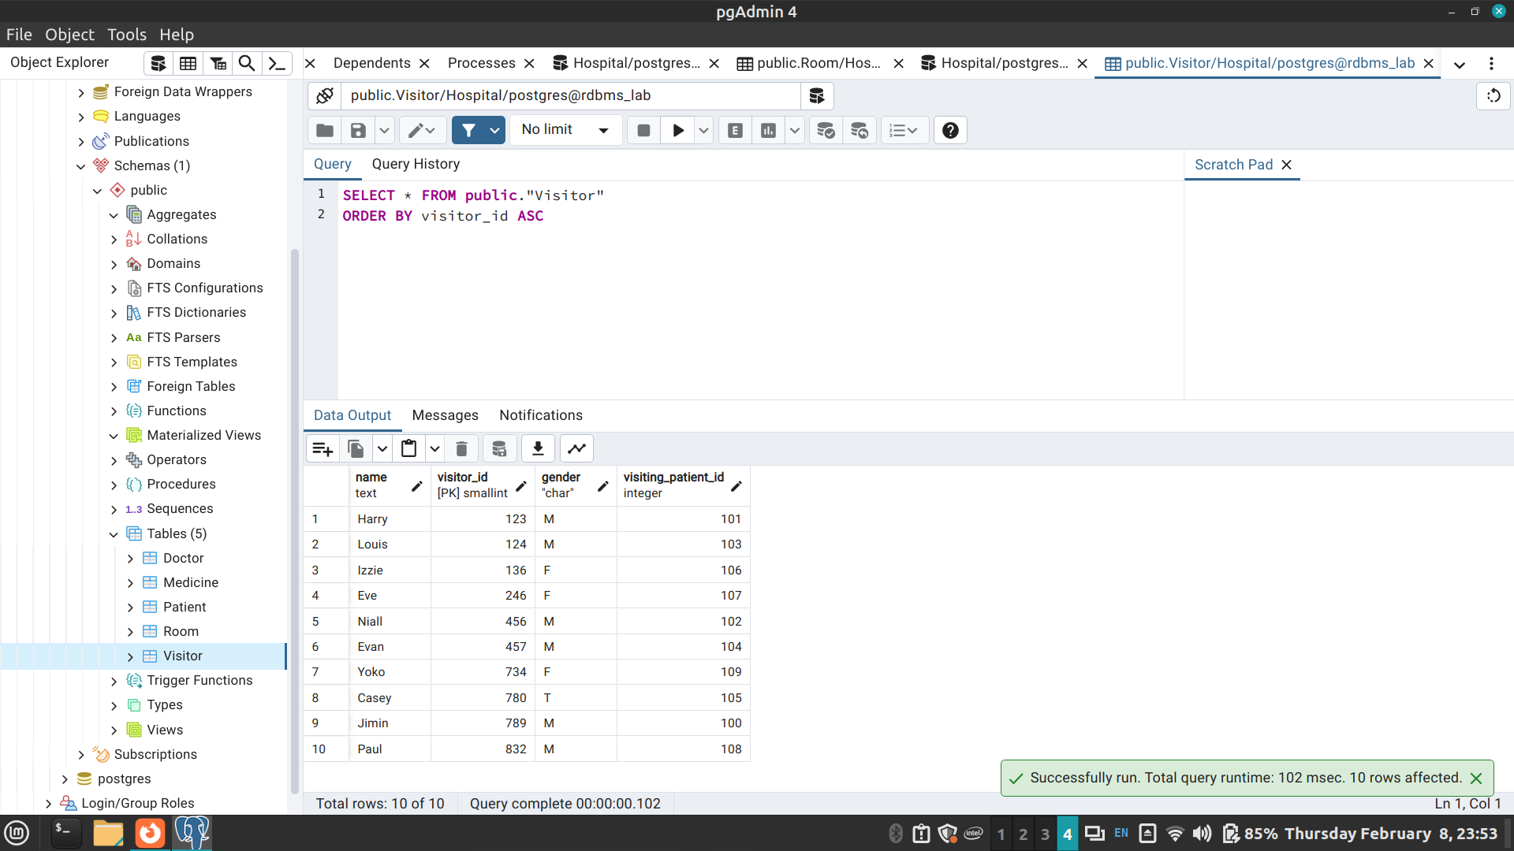
Post Lab Questions:
- Explain in brief the following terms:
- Database
- Types of databases
- SQL Data Types
Answer:
a. Database: A database is a structured collection of data that is stored and organized in a manner that allows for efficient retrieval, management, and manipulation. It can be thought of as an electronic filing system where information can be stored, retrieved, and updated easily.
b. Types of databases:
- Relational Databases: These databases organize data into tables with rows and columns, where relationships between tables are established through keys. Examples include MySQL, PostgreSQL, SQL Server.
- NoSQL Databases: Unlike relational databases, NoSQL databases do not use a tabular schema and are designed to handle unstructured or semi-structured data. They offer flexibility and scalability for handling large volumes of data. Examples include MongoDB, Cassandra, Redis.
- Graph Databases: These databases are designed to represent and store data as graphs, consisting of nodes, edges, and properties. They excel in managing data with complex relationships. Examples include Neo4j, Amazon Neptune.
- Document Databases: Document databases store data in documents, typically using formats like JSON or XML. Each document can contain nested data structures, providing flexibility and scalability. Examples include MongoDB, Couchbase.
3. SQL Data Types: SQL (Structured Query Language) data types define the type of data that can be stored in a column of a database table. They specify the format of the data and the operations that can be performed on it. Common SQL data types include integers, floats, strings, dates, and booleans, among others. These data types help ensure data integrity and efficient storage and retrieval within the database management system.
- What are the different commands to:
- Delete an entire table.
- To view a database.
- To select & view all the columns.
Answer:
- Delete an entire table using the DROP TABLE command.
DROP TABLE table_name;
- To view a list of databases in PostgreSQL, use the \l command in the psql command-line interface. Alternatively, query the pg_database system catalog table using SQL.
SELECT datname FROM pg_database;
This SQL query will return the names of all databases in the PostgreSQL instance.
- Select & view all columns: To select and view all columns from a table,
- use the SELECT * statement.
SELECT * FROM table_name;
This query will return all rows and columns from the specified table.
- For the given ER model, using DDL command: Write syntax to create CREATE Tables with all possible integrity constraints.

Problem Statement:

A small accounting firm wants a simple HR application that will help it to keep track of its employees, their positions, allowances, salary scales, and which company vehicles their employees drive. The application must keep track of all the positions at the firm, the employees filling these positions, the allowances for these positions, the salary scales for these positions, and the company vehicles assigned to these positions.
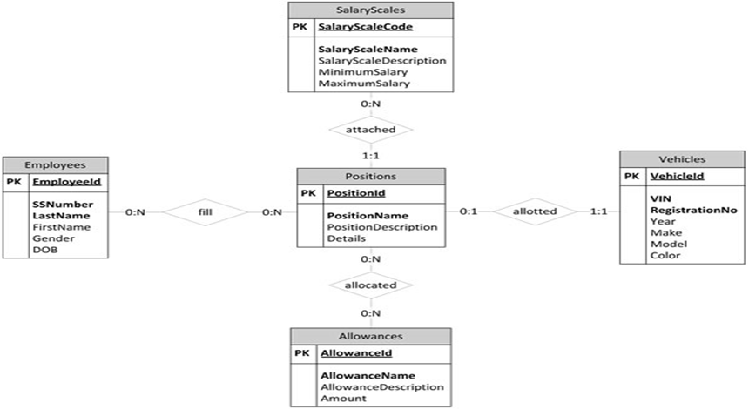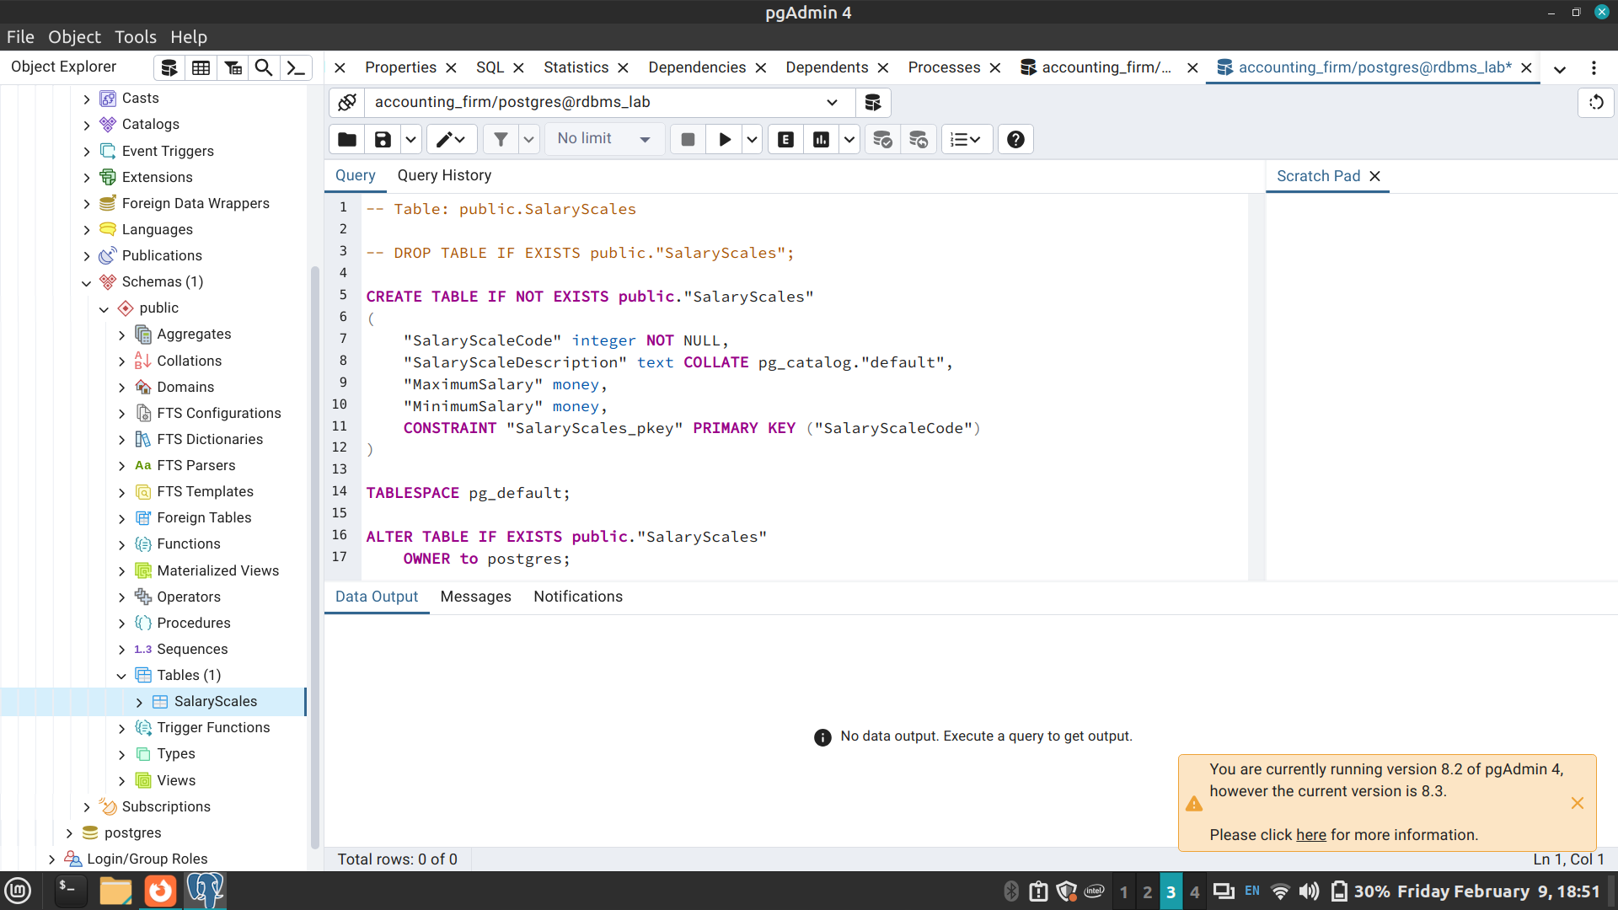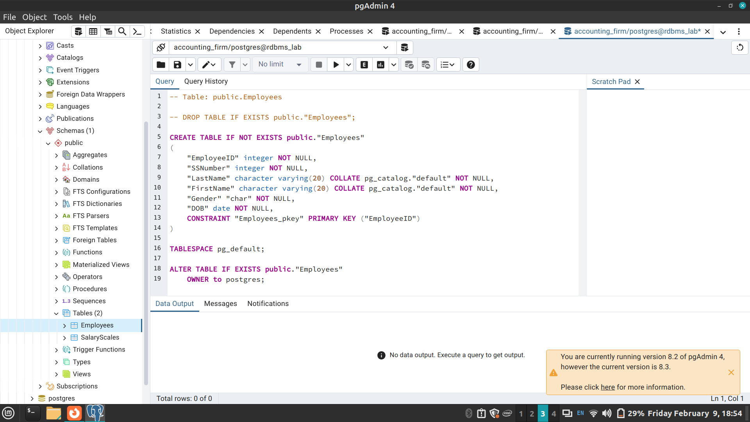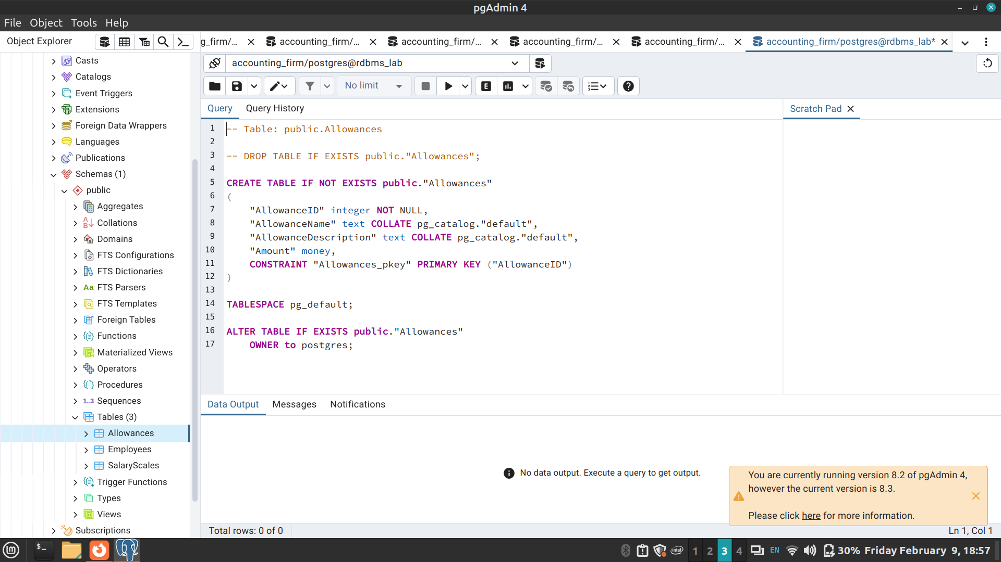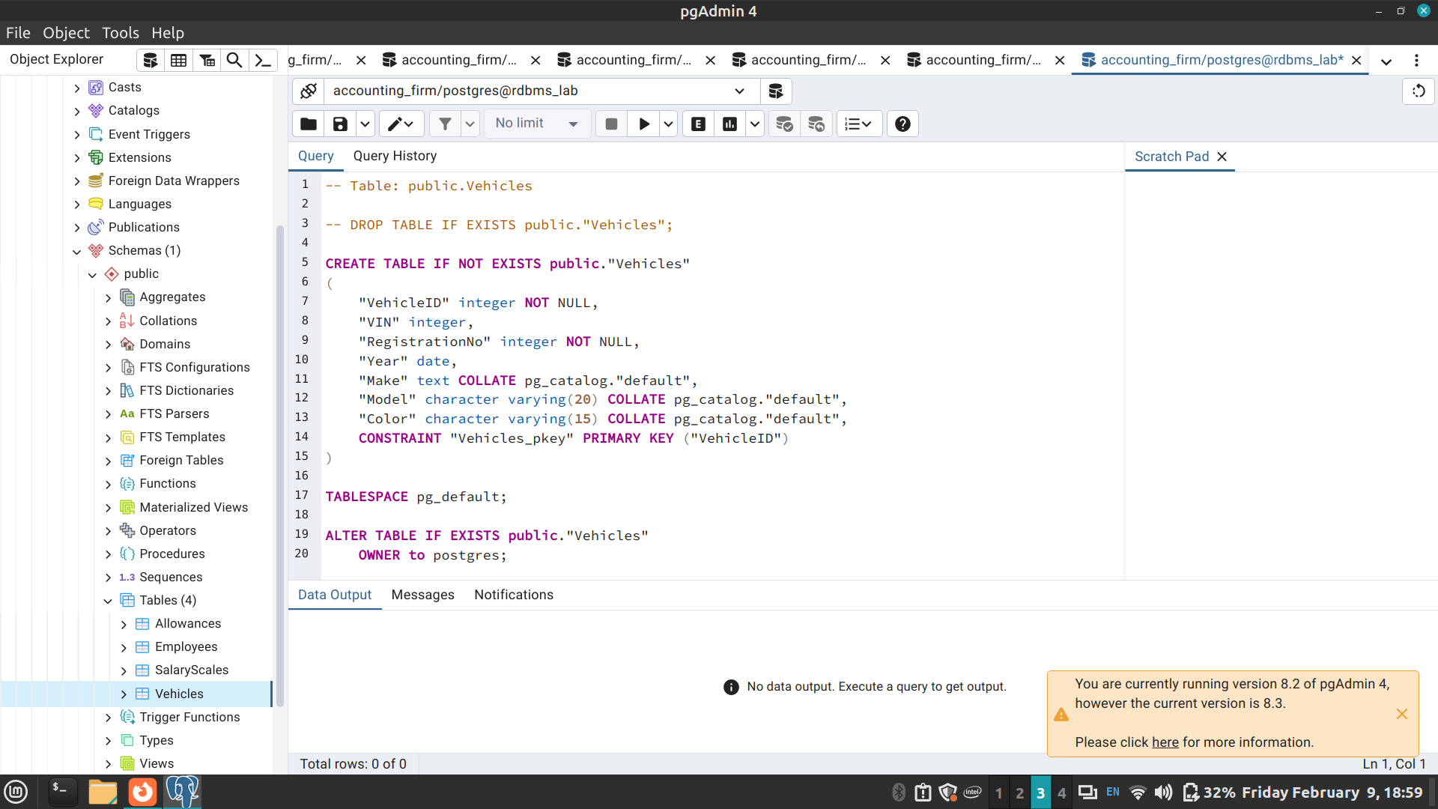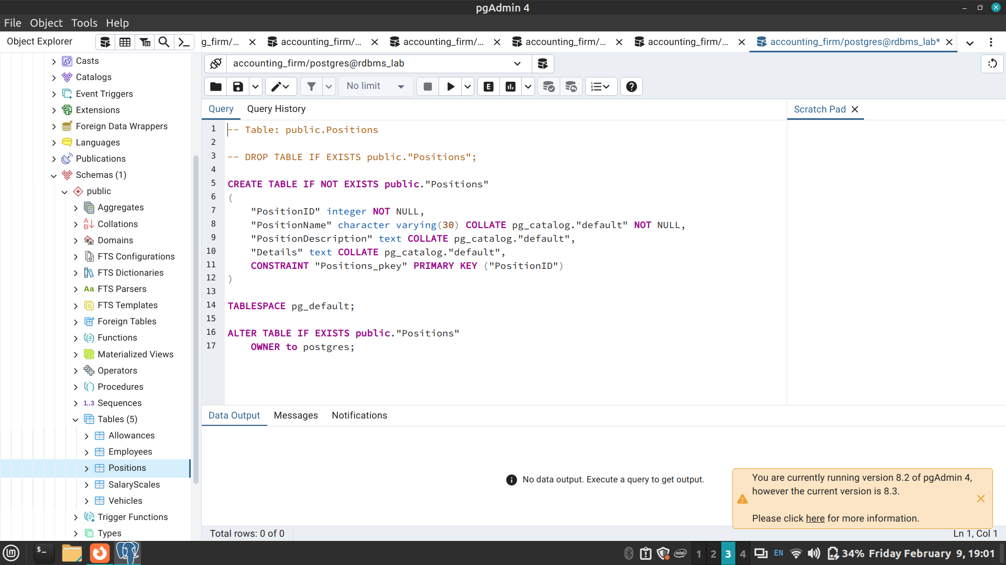

Conclusion:

This experiment enabled a systematic understanding of Data requirements of application and EER diagram design, laying the groundwork for effective and optimized database development

